PEOPLE'S DEMOCRATIC REPUBLIC OF ALGERIA
MINISTRY OF HIGHER EDUCATION AND SCIENTIFIC RESEARCH


UUNIVERSITY OF MOHAMED BOUDIAF-M’SILA
FACULTY OF MATHEMATICS AND
COMPUTER SCIENCE

DEpartement OF COMPUTER SCIENCE

Master thesis

Presented for the graduation of MASTER
Faculty: Mathematics and Computer
Science
Department: Computer science
Field: Information System and Software Engineering

By: TAHMI HASSINA

SUBJECT

Developing an Efficient CNN Model to Recognize Handwritten Digits

Board of Examiners:
Mr. KADRI Said University of M’sila Supervisor

Academic year: 2019 /2020

PEOPLE'S DEMOCRATIC REPUBLIC OF ALGERIA
MINISTRY OF HIGHER EDUCATION AND SCIENTIFIC RESEARCH
UUNIVERSITY OF MOHAMED BOUDIAF-M’SILA
FACULTY OF MATHEMATICS AND
COMPUTER SCIENCE

DEpartement OF COMPUTER SCIENCE

Master thesis

Presented for the graduation of MASTER
Faculty: Mathematics and Computer
Science
Department: Computer science
Field: Information System and Software Engineering

By: TAHMI HASSINA

SUBJECT
Developing an Efficient CNN Model to Recognize Handwritten Digits

Board of Examiners:
Mr. KADRI Said University of M’sila Supervisor

Academic year: 2019 /2020

Table of Contents

List of figures
List of Tables
PREFACE 1
Chapter 1: Handwriting Digit Recognition
1.1. Introduction 5
1.2. Handwritten Digit Recognition 5
1.3. Major problem with handwritten digits 6
1.4. Preprocessing and Feature Extraction 6
1.4.1. Deskewing 6
1.4.2. Thinning 7
1.4.3. Resizing 7
1.4.4. Smoothing 7
1.5. Digit Recognition System 8
1.5.1. System overview 8
1.5.1.1. Form reader 8
1.5.1.2. OCR (Optical Character Recognition) 8
• Approaches to OCR 8
• An Overview of Handwritten OCR 9
1.5.1.3. Consistency check and contextual error correction 9
1.5.1.4. Error Correction 9
1.6. Fragmented Digits vs. Whole Digits 9
1.6.1. Digit Fragments 9
1.6.2. Whole Digits 9
1.7. The architecture of digit recognition system 10
1.8. Conclusion 11
Chapter 2: Artificial Intelligence, Machine Learning and Deep Learning
2.1. Introduction 13
2.2Artificial intelligence 13
2.3. Machine learning 14
2.3.1 Definition 14
2.3.2 Types of Machine Learning 14
2.3.2.1 Supervised Learning 14
2.3.2.2 Unsupervised Learning 15
2.3.2.3 Reinforcement Learning 16
2.3.3. Machine Learning Algorithms 16
2.3.3.1. Logistic Regression(LR) 16
2.3.3.2. Support Vector Machine (SVM) 16
2.3.3.3. Naive Bayes (NB) 17
2.3.3.4. K- Nearest Neighbors (KNN) 18
2.4. Deep learning 18
2.4.1. Definition 18
2.4.2. Deep Learning methods 19
2.4.3. Applications of Deep Learning 21
2.4.4. Deep Neural Network Model 21
2.4.4.1. Artificial neural network 21
2.4.4.2. Recurrent Neural Network (RNN) 23
2.4.4.3. Deep Neural Networks (DNNs) 24
2.4.4.4. Convolution Neural Network (CNN) 24
2.4.5. Machine Learning Vs Deep learning 27
2.5. Conclusion 27
CHAPTER 3: PROGRAMMING ENVIRONMENT
3.1. Introduction 29
3.2. Python 29
3.2.1. Definition 29
3.2.2. Python History 29
3.2.3. Getting start 30
3.2.3.1. Installing Python 30
3.2.3.2. IDLE 30
3.3. Keras 30
3.3.1. Definition 30
3.3.2. How to Make Predictions with Keras 30
3.3.2.1. Input image 31
3.3.2.2. Image Enhancement 31
3.3.2.3. Keras sequential model 31
3.3.2.4. Output 32
3.4. Tensorflow 32
3.4.1. Definition 32
3.4.2. Installation of Tensorflow 32
3.5. Anaconda 33
3.5.1. Definition 33
3.5.2. Installation of Anaconda (Python 3.6) 33
3.5.3. Installing Python packages with Conda 33
3.6. Some Libraries 34
3.6.1. Numpy 34
3.6.2. Scipy 34
3.6.3. Pandas 34
3.6.4. Matplotlib 34
3.7. MNIST Data set 35
3.8. Conclusion 35
Chapter 4: Realized Work
4.1. Introduction 37
4.2. The Proposed Model 37
4.3. Evaluation 38
4.4. Illustration of the Obtained Results 38
4.5. Discussion 41
4.6. Comparison between ML and CNN approaches 42
4.7. Application Interface 43
4.8. Conclusion 46
Conclusion and Perspectives 47

List of Figures

Fig 1. 1: handwritten digit recognition 6
Fig 1. 2 :Two examples of deskewing: (a) and (d): left and right leaning digits, resp.; (b) and (e): deskewed by side slip; (c) and (f): deskewed by rotation. 7
Fig 1. 3: Sequence a-b-c shows the thinning and pruning process 7
Fig 1. 4: Illustration of how 5 can be significantly more than 3 but 6 not significantly more than 2 (see Sect. 3.1, Smoothing) 8
Fig 1. 5: Set of handwritten digits used for training (top) and testing (bottom) 10
Fig 1. 6: Overall digit recognition system architecture. 10
Fig 1. 7: An example image that given to the NAO robot for recognizing digits. 11
Fig 1. 8: The image after the recognition processes 11

Fig 2. 1: Artificial Intelligence, Machine Learning and Deep learning 13
Fig 2. 2:classification and regression 15
Fig 2. 3: Logistic Regression 16
Fig 2. 4: An example of a two-class problem with two separating hyperplanes, B1 and B2 17
Fig 2. 5: Bayes theorem 17
Fig 2. 6: KNN-Machine-Learning-Algorithms 18
Fig 2. 7: Schematic of an artificial neural network 22
Fig 2. 8: A Typical Architecture of Recurrent Neural Network 24
Fig 2. 9: A Typical Architecture of Deep Neural Network 24
Fig 2. 10: Typical convolutional neural network architecture. 25
Fig 2. 11: The output of the convolutional layer is obtained by convolving its input layer and kernel weights. 26
Fig 2. 12: Max pooling with filter 2×2 and stride size. 26

Fig 3. 1: Flow of Project 31
Fig 3. 2: MNIST dataset 35

Fig 4. 1: Handwritten Digit Classification Process 37
Fig 4. 2: Architecture of the proposed CNN model 38
Fig 4. 3: Training accuracy Vs Validation accuracy of the CNN model 41
Fig 4. 4: Training loss Vs Validation loss of the CNN model. 41
Fig 4. 5: Comparison between different Algorithms 43
Fig 4. 6: Illustrative image of the main the application interface. 43
Fig 4. 7: Illustrative image of the help button in in the application interface 44
Fig 4. 8: Illustrative image of the tools button in the application interface 44
Fig 4. 9: Illustrative image of the file button in the application interface 45
Fig 4. 10: Illustrative images of the digit drawn in the panel and the obtained result 46

List of Tables

Table 2. 1: Comparison of Deep learning methods 19
Table 2. 2: Machine Learning Vs Deep learning 27

Table 4. 1: Description of the Proposed CNN Model 40
Table 4. 2: Accuracy after applying different ML algorithms 40
Table 4. 3: Loss value and accuracy value obtained when applying the proposed model 41
Table 4. 4: Comparison between ML approach and DL Approach 42

PREFACE

Artificial intelligence is a science consisting in building smart machines and use them to reproduce mimic human intelligence. It is also an interdisciplinary science with multiple approaches. So, among the goals of AI we note learning and perception. Artificial intelligence relies on deep learning because it makes it more human. Where deep learning is a subfield of machine learning. But both fall under the broad category of artificial intelligence. In another meaning, all machine learning is AI, but not all AI is machine learning and all deep learning is machine learning but not all machine learning is deep learning.
Deep learning known as deep neural learning or deep neural network. It uses neural networks with many layers, it is capable of learn unsupervisedly from data that are unstructured or unlabeled. And models are trained by using a large set of labeled data and neural network architectures that contain many layers. Where deep learning models can achieve state-of-the-art accuracy, sometimes exceeding human-level performance.
On the other hand, machine learning is providing to systems the ability to automatically learn and improve from experience. For example, enables systems technology to recognize patterns on the basis of existing algorithms and data sets. So the required algorithms and data must be fed into the systems in advance and the respective analysis rules for the recognition of patterns in the data stock must be defined.
Handwritten recognition (HWR) is the ability of a computer to analyze and understand intelligible handwritten received from sources such as paper documents, touch-screens and other devices. Few years ago, everything has been digitalized to reduce human effort. Consequently, there comes a need for handwritten digit recognition in many applications. MNIST data set is widely used for recognition process, it is also used by Tensor Flow framework (library), keras and python in their libraries. The problem of handwritten digit recognition has long been an open problem. Where the problem is that handwritten digits are often of the same size, thickness, style, orientation, and similarity between digits such as 1, 7, 5, 6, 3, 8, 2, 5, 2, 7, etc, But advances in machine learning and deep learning allowed a new paradigm shift in every sector, for example handwritten digits recognition. Machine learning uses algorithms to parse data, learn from them, and make decisions based on what they have. We used many machine learning algorithms in our work. Some algorithms such as: K-Nearest Neighbor (KNN), Naive Bayes and Support Vector Machine etc. And on the other hand deep learning structured algorithms in layers to create an "artificial neural network” that can learn and make intelligent decisions on.
We have divided our work into several chapters, which are:
- Starting with a general introduction
- In chapter 1 we described briefly the field of our project which is Handwriting Digit Recognition.
-In chapter 2, we presented some important concepts and definitions, including: Artificial Intelligence, Machine Learning and Deep Learning.
- Chapter 3 describes the programming environment .
- In the last chapter we presented the realized work.
- Finally we concluded our work by a general conclusion.

Chapter 1: Handwriting Digit Recognition

  - Introduction:
The handwritten digit recognition system is used for the reception and the interpretation of handwritten digit input from various sources such as documents, touch-screens and photographs etc. Also, we are able to recognize 10 classes corresponding to the handwritten digits from 0-9 which depend on the handwritten itself.
The difficulty in the handwritten digits is that digits are not always of the same size, width, orientation and justified to margins, and different from writing of a person to another person, so the general problem consists in classifying the digits due to the similarity between digits. We note that his problem has been studied for years by multiple techniques and methods, such as K Nearest Neighbors (KNNs), support vector machines (SVMs), neural networks (NNs), and convolutional NNs (CNNs). [5] [6] [7] [11]

  - Handwritten Digit Recognition:
The handwritten digit recognition is a difficult task for a machine because handwritten numbers are totally different from a person to another person. Also handwritten digit recognition (HDR) is considered one machine learning problems. User enters the respective digit the machine would recognize and show the results with accuracy percentage. Currently, providing neural networks and conventional neural network is the best solutions to many problems in handwritten digit recognition. During the last decade, the use of machine learning and deep learning in handwritten digit recognition has gained a good popularity. To develop a such machine algorithm, we need a proper understanding of digit classification and the difference between the minor and the major points to properly differentiate between different digits which can be only possible with proper training and testing. As conclusion we can say, handwriting recognition is defined as the ability of a computer to understand and interpret input retrieved from sources such as documents, touch screen user input screens, and other devices. [5] [6] [7][9][10]

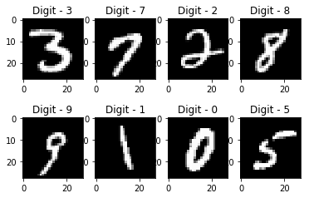
Fig 1. 1: handwritten digit recognition
  - Major problem with handwritten digits:
The difficulty of handwritten digit recognition is mainly in the similarity between digits such as 1 and 7, 5 and 6, 3 and 8, 2 and 5, 2 and 7, etc. As well as they have the same size, thickness, style, orientation. It is difficult to resolve this problem when many people write a single digit with different handwritings. Because the writing style is different from one user to another user. Where the uniqueness and variety in the handwriting of different individuals also influence the formation and appearance of the digits. So, it is not easy for the machine to recognize the handwritten digits accurately like the humans do. Hence, robust feature extraction is very important to improve the performance of machines. [2] [5] [8]

  - Preprocessing and Feature Extraction:
Digits may originate from a range of sources; it is important to make sure that all digits are preprocessed so as to eliminate extra problems. A few techniques to minimize these differences are discussed below. [1] [3]
    - Deskewing :
To help compensate for different handwriting styles (with different slant), digits that are slanting to the left or to the right are deskewed to put them all upright or to at least make them slant under the same angle. And Mane and Kulkarni (2018) have performed various transformations to add the size of the data set. For instance, Horizontal and Vertical skewing: each image is tilted vertically and horizontally by a factor of 0.5, for some examples, see Fig 1.2. [3]

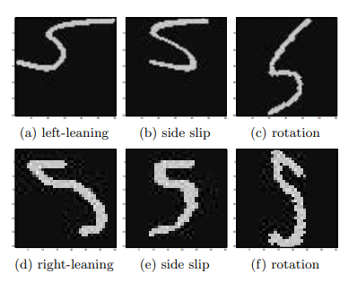
Fig 1. 2: Two examples of deskewing: (a) and (d): left and right leaning digits, resp.; (b) and (e): deskewed by side slip; (c) and (f): deskewed by rotation. [3]
    - Thinning:
Thinning to overcome problems related to differences in the line thickness of the written characters, the digit images are thinned to a thickness of one pixel. This can lead to such spurs, as can be seen from Fig.1. 3: (b). To correct for this, one can remove spur lines of up to a certain length from the resulting thinned image (Fig1. 3: (c)). [3]
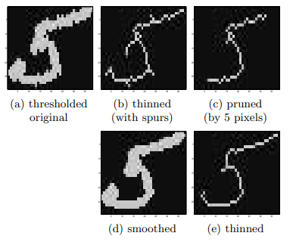
Fig 1. 3: Sequence a-b-c shows the thinning and pruning process. [3]
    - Resizing:
Different digit size is due to different image resolutions and handwriting styles. To minimize the effect of these differences, all digits are resampled / rescaled to the same size in pixels, before being fed to the recognizer. [3]
    - Smoothing:
May cause small artifacts on the digit’s edges. These are removed by a smoothing operation. So smoothing may be useful between several stages of the preprocessing. Effective smoothing can be accomplished by filling tiny gaps in both the foreground and the background. For example, in the layout of Fig 1. 4: (a), 5 is significantly more than 3 and the central pixel can be safely smoothed away, where as in the layout of Fig 1. 4: (b), 6 is not significantly more than 2 as the central foreground pixel cannot be smoothed away without breaking the foreground. [3]
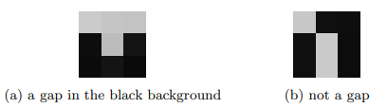
Fig 1. 4: Illustration of how 5 can be significantly more than 3 but 6 not significantly more than 2 (see Sect. 3.1, Smoothing). [3]

  - Digit Recognition System:
Digit recognition system is the working of a machine to train itself or recognizing the digits from different sources. It is important to make sure that all digits are preprocessed so as to eliminate extra problems due to non-class-specific differences. And in real-world for online handwriting recognition on computer tablets or system, recognize number plates of vehicles, processing bank cheque amounts, etc.
    - System overview :
      - Form reader :
The form reader is to extract the image data inside the boxes that constitute the form. These boxes should contain either a digit or a blank space. Once all of the boxes have been processed, it provides a table containing the data in the form. [4]
      - OCR (Optical Character Recognition)
- Approaches to OCR:
OCR is a technique that recognizes printed text in scanned documents. For instance, the Google Translate application contains an OCR technique that works with the device's camera. It captures text from magazines, documents, and other handwritten characters and converts it to another language. And the OCR subsystem also processes the image data provided by the form reader to determine the character to which the data most resembles. The steps involved in OCR are preprocessing, feature selection and classification. [1] [4]
- An Overview of Handwritten OCR:
During the last decades, handwritten OCR applications have been used in several domains, and it becomes one of the most studied area of research. The goal of OCR is the accuracy and speed of digital recognition, where it is considered critical. And according to the handwriting recognition system, one of the factors contributing to success and having an impact on classification is feature extraction. [1] [4]
      - Consistency check and contextual error correction:
The subsystem checks for consistency and corrects the error. Moreover, it detects and corrects customer numbers or products offered. And the existing model avoids errors due to incorrect interpretation of sizes and colors. Always, it depends on colors and sizes to check consistency and correct errors. [4]
      - Error Correction:
This subsystem is intended to be used during an initial stage until the system is considered very reliable and should tend to be used only for visualizing results or forms. Because this subsystem provides a friendly mouse driven user interface which allows correction of introduction. [4]

  - Fragmented Digits vs. Whole Digits:
    - Digit Fragments:
For a particular class of digits, this idea depends on parts of digits and not on the whole digits, but although, individual fragments that are characteristic for that class show less variation than digits as a whole. Kohonen self organizing map facilitates understanding of the fragment’s organization. [3]
    - Whole Digits:
Whole Digits depends on the training method. And it happens when using whole digits as inputs to the networks. The network stores representative examples of all digits during the training stage. More complicated numerals that can be encountered in several forms may cause the network to store more examples. e.g., consider the class “2”, which can be written in very different ways, and the class “0”, which most people write in much more similar ways, as canal so be seen in Fig. 5[3]

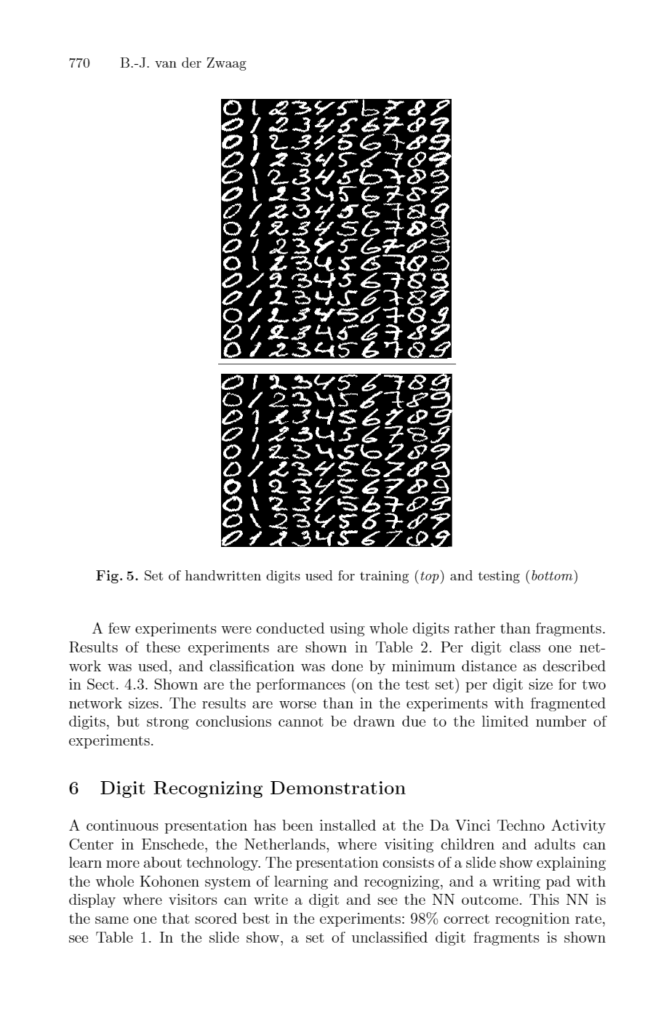
Fig 1.5: Set of handwritten digits used for training (top) and testing (bottom). [3]

  - The architecture of digit recognition system:
The digit recognition system is shown in Fig 1.6.[42]
Fig 1. 6: Overall digit recognition system architecture. [42]
The steps of the system are as below in order;
- The images are taken from NAO’s camera by showing the paper or any surface that contains digits to the robot.
- The images are converted to grayscale format and then binary format.
- The individual contour is scaled as 28*28 pixels.
- Feature extraction process is carried on the contours.
- NAO humanoid robot tells the recognized digits in image from top left to bottom-right. Also robot draws a rectangle around of the all contours and puts recognized digit as text on the top of contour.[42]
Fig 1. 7: An example image that given to the NAO robot for recognizing digits. [42]
Fig 1. 8: The image after the recognition processes. [42]

  - Conclusion:
In this work, I present the problem with handwritten digits where different people have very different writing style; even digits of a same person written in different time are not identical. And how to be preprocessing and feature extraction of features that helps solve of problem with handwritten digits recognition. Also give digit recognition system overview.

Chapter 2: Artificial Intelligence, Machine Learning and Deep Learning

- Introduction:
Nowadays, understanding the latest advancements in artificial intelligence (AI) can seem difficult, many misconceptions are there related to the words machine learning, deep learning and artificial intelligence (AI), most of the people think all these things are same whenever they hear the word AI, You can think of artificial intelligence (AI), machine learning and deep learning as a Russian nesting doll.
We have deep learning is a subset of machine learning, and machine learning is a subset of AI. In other words, all machine learning is AI, but not all AI is machine learning and all deep learning is machine learning but not all machine learning is deep learning. In this chapter we will see many ideas related to deep learning and machine learning. [15][16][17][18][19][12]

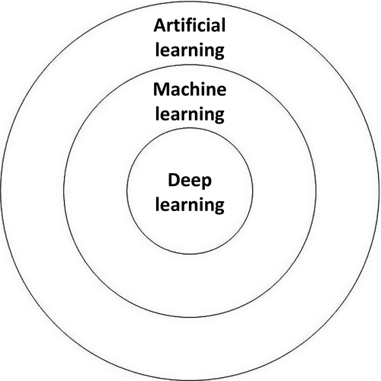
Fig 2. 1: Artificial Intelligence, Machine Learning and Deep learning [12]

- Artificial intelligence:
Artificial intelligence was born in the 1950s, it as an academic discipline was founded in 1956. Artificial intelligence means incorporating human intelligence to machines. That is, the way a human brain thinks works and functions. And is the broader concept starting from Good Old-Fashioned AI (GOFAI) all the way to futuristic technologies such as deep learning. While too mean imparting a cognitive ability to a machine. In AI, machines complete the task based on the stipulated rules and algorithms. AI is an umbrella term for any computer program that has the touch of human intelligence and encompasses ML and DL. [12][15][16][17][18][19]
“AI is a ability of computer program to work like a human brain” AI has three different levels:
- Narrow AI: when the machine can perform a specific task better than a human. [12]
- General AI: when it can perform any intellectual task with the same accuracy level as a human would.[12]
- Active AI: when it can beat humans in many tasks.[12]

- Machine learning:

2.3.1 Definition:
Machine learning is a subset of AI. Where machines take data and ‘learn’ for themselves by themselves using the provided data. Arthur Samuel defined machine learning as “a field of study that gives computers the ability to learn without being explicitly programmed”.
The most important idea behind machine learning is that the computer can be trained to completion tasks that would be impossible for a human being. And machine learning can take decisions with minimal human intervention. When the machine finished parsing data and learns from that data can predict the value or the class of new data point.[12] [15][16][17][18]

2.3.2 Types of Machine Learning:
It is interesting to understand and identify the different types of machine learning we may encounter. For the average computer user, it is can take generally the types of machine learning. But for the practitioners creating these applications, it’s essential to know the types of machine learning. There are many types that you may encounter as a practitioner. But three main methods are used today [15][11][12]:

Supervised Learning:
Is the type of ML algorithms that presupposes both input and output data is initially provided. Its role is to train the model or the machine. Once the model gets trained it can start making a prediction or decision when new data is given to it. In supervised learning, an algorithm is employed to learn the mapping function from the input variable (x) to the output variable (y); that is y = f(x). Such that whenever there is a new input data (x), the output variable (y) for the dataset can be predicted. Because the objective of such a problem is to approximate the mapping function (f) as accurately as possible. Supervised ML algorithms divide into the following subtypes [10] [15][11][12]:
- Classification: is a process of finding a function which helps in separating data into multiple categorical classes i.e. discrete values. In classification, data is categorized under different labels according to some parameters given in input. And relies on certain defined labels in the output data. A computer program is trained on the training dataset and based on that training; it categorizes the data into different classes. The task of the classification algorithm is to find the mapping function to map the input(x) to the discrete output(y) [15][12][13].
- Regression: is a process of finding the correlations between dependent and independent variables or a model for distinguishing the data into continuous real values instead of using classes or discrete values[15][12][13].

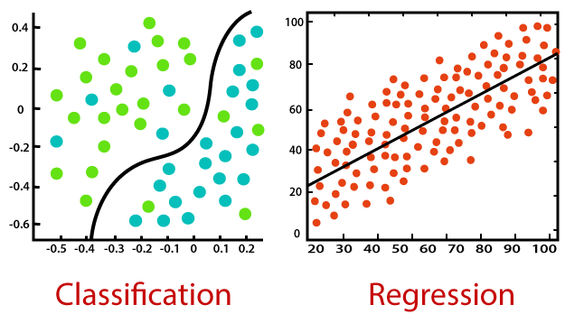
Fig 2. 2: classification and regression[15]

Unsupervised Learning:
is a type of algorithm which works with the input data having no suggestions of the expected output. The means that there is no supervisor who could tell the system right answer; in fact, there are no rights or wrong answers in the first place. And we do not have any target or outcome variable to predict / estimate. Relationships between data points are perceived by the algorithm in an abstract manner, with no input required from human beings. Where The machine tries to structure and sort the data entered according to certain characteristics. Unsupervised learning divides into the following subtypes [10][15][11][12]:
- Association: Is basically making assumptions about some parts of the data where this allows discovering interconnections between portions of data in large datasets. [11][12]
- Clustering: This kind allows simply grouping the pieces of data according to a certain trait. Where we group similar things together. The machine learns from the data itself and clusters the data. [15][11][12]

Reinforcement Learning:
We have a data input layer that goes through some hidden neural network layer and delivers the result as an output. The machine is exposed to an environment where it trains itself continually using trial and error. And the machine is rewarded with a point for a correct answer or penalized with a point for a wrong answer. on the basis of reward points Which Acquired by the machine it gets ready to predict the new data presented to it. [15][11][12]

Machine Learning Algorithms:
Here is the list of commonly used machine learning algorithms. These algorithms can be applied to almost any data problem [12]:

Logistic Regression (LR):
LR is one of the most popular methods used to classify binary data. It is based on the assumption that the value of dependent variable is predicted by using independent variables. Logistic Regression is used to estimate discrete values (Binary values like 0/1, yes/no, true/false ) from a set of independent variables. And is used for classification, not regression. In general, it is similar to a single-layer neural network. Since it predicts the probability, its output values lie between 0 and 1. The goal of logistic regression is to use the training data to find values such that it will minimize the error between the predicted outcome and the actual outcome. And LR is considered as the standard statistical approach to modeling binary data. LR of forms an S-shaped curve [1][2][3][7][6]:
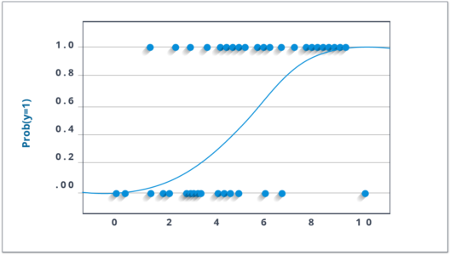
Fig 2. 3: Logistic Regression[3]

Support Vector Machine (SVM):
SVM, which was developed by Vapnik in 1995. SVM is a method of classification in which you plot raw data as points in an n dimensional space (where n is the number of features you have). Where SVM is a set of related supervised learning methods that analyze data and recognize patterns, used for classification. Generally, the main idea or the goal of SVM comes from binary classification, namely to it that attempts to find a linear separator (hyper-plane) between the data points of two classes in multidimensional space and an endeavor to pass a linearly separable hyperplane to order the dataset into two classes. We can say that the SVM is also can be used to train classifiers (even regressors). [1] [2][8][5][4].
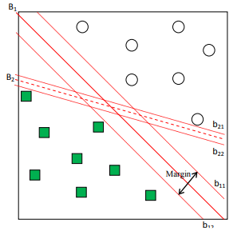
Fig 2. 4: An example of a two-class problem with two separating hyperplanes, B1 and B2 [8]

Naive Bayes (NB):
Naive Bayes is one of the basic, best and ordinarily most common techniques, AI techniques. Since several studies show that it is the most effective one. It is based on statistical approach based on Bayesian theory with an assumption of independence among predictors. This is conditional independence assumption and true in real world applications. Due to this assumption makes the computation of the NB classifiers far more efficient. The classifier performs the binary classification based on Bayesian classification rule. And it is expressed mathematically as the following equation [1][2][3][8][4][9]:
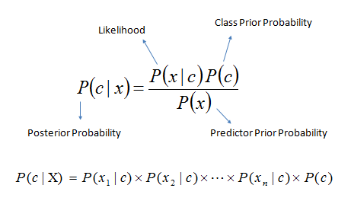
Fig 2. 5: Bayes theorem [9]
Bayes theorem provides a way of calculating posterior probability P(c|x) from P(c), P(x) and P(x|c):
- P(c|x) is the posterior probability of class (target) given predictor (attribute).
- P(c) is the prior probability of class.
- P(x|c) is the likelihood which is the probability of predictor given class.
- P(x) is the prior probability of predictor.

K- Nearest Neighbors (KNN) :
The K-Nearest Neighbors algorithm uses the entire data set as the training set, rather than splitting the data set into a training set and test set. It is a simple algorithm that stores all available cases and classifies new cases by a majority vote of its k neighbors. while All of the training tuples are stored in an n dimensional pattern space. The KNN classifier is a widely used classifier that is based on comparison methods, that is by comparing a given test tuple with training tuples which are similar to it. the “k” is the number of neighbors it checks. And k is always a positive integer. To label a new point, it looks at the labelled points closest to that new point (those are its nearest neighbors), in the pattern space for the k training tuples which are closest to the unknown tuple, because k is a limitation for adjusting the classification algorithms. [1][3][8][7][5]
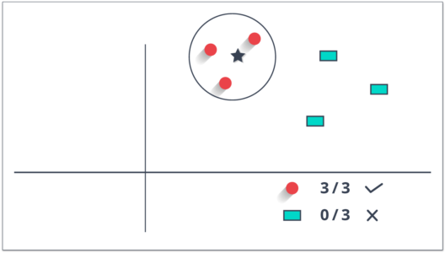
Fig 2. 6: KNN Machine Learning Algorithms. [8]

  - Deep learning:
2.4.1. Definition:
Deep learning is a subset and supplementary of machine learning algorithms. Deep learning deals with many neural networks, the most important of which is the Convolution Neural Network and is most important algorithm to classification. Because it is deals with multi layers. Deep learning is the embodiment of the idea of successive layers of representations. Also the depth of the model is how many layers contribute to a model of the data is called. It contains tens or even hundreds of successive layers of representations. Where it requires deep learning to train itself on huge datasets. Because there are many parameters that a learning algorithm must understand.[43][48][50]
2.4.2. Deep Learning methods:
- Back propagation: This method can be used to calculate the gradient of the function.[46]
- Stochastic Gradient Descent: Ensures this method finding an optimal minimum, depending upon the values of the function and learning rate, using the convex function.[46]
- Learning Rate Decay: At the beginning we make major changes and then gradually reduce the learning rate in the training process. This is what makes it easier for us in the later stages.[46]
- Dropout: Helps tackle the problem of overtraining as dropout reduces overturning and gives improved performance in many tasks.[46]
- Max-Pooling: First we define the filter; this step is then applied and reduces the dimensions using the maximum assembly. The dimensions can be reduced, by using the maximum assembly.[46]
- Batch Normalization: It stabilizes and accelerates the deep neural network, by normalizing the output from layer.[46]
- Skip-gram: Skip gram can be implemented by considering a context containing n of the terms which share a similar context; after train the neural network it skips one of this term. Finally we use the model to predict skipped term. [46]
- Transfer learning: It exploits a model that was previously trained on a task. Where can be transferred the knowledge obtained of network to another network. Which speeds up and improves performance.[46]

Table 2. 1: Comparison of Deep learning methods [46]

Method | Description | Merits | Demerits
Back  propagation | Used in Optimization  Problem | For calculation  of gradient | Sensitive to noisy data
Stochastic  Gradient Descent | To _nd optimal  minimum in  optimization  problems | Avoids trapping in  local minimum | Longer convergence  time, computationally  expensive
Learning  Rate Decay | Reduce learning  rate gradually | Increases performance,  Reduces training time | Computationally  expensive
Dropout | Dropsout units/  connection  during training | Avoids overfitting | Increases number  of iterations  required to converge
Max-Pooling | Applies a max filter | Reduces dimension  and computational  cost | Considers only the  maximum element  which may lead to  unacceptable result  in some cases
Batch  Normalization | Batch-wise  normalization  of input to a layer | Reduces covariant shift, Increases stability of the network,  Network trains faster,  Allows higher  learning rates | Computational  overhead  during training
Skip-gram | Used in word  embedding  algorithms | Can work on any raw  text, Requires less  memory | Softmax function is  computationally  expensive, Training  Time is high
Transfer learning | Knowledge of  first model is  transferred to  second problem | Enhances performance,  Rapid progress in  training of second  problem | Works with similar  problems only

    - Applications of Deep Learning:
Some applications where we can use deep learning networks such: as self- driving cars, Natural Language Processing, Google's Virtual Assistant, Visual Recognition, Fraud detection, healthcare, detecting developmental delay in children, adding sound to silent movies, automatic machine translation, text to image translation, image to image synthesis, automatic image recognition, Image colorization, earthquake prediction, market-rate forecasting, news aggregation and fraud news detection, handwritten digit recognition.[46]
    - Deep Neural Network Model:
      - Artificial neural network :
They are a group of nodes artificial neurons. Where these neurons calculate an output value though an activation function, as shown in Fig. 2.7.
ANN determines using the algorithm weights represented in (wi and b in Fig. 2.7(a)) that minimize a loss function. After appearance the rectified linear unit (ReLU) (Hahnioser et al. 2000; Nair and Hinton 2010) and effective weight initialization (Hinton et al. 2006) which permit to rapidly process a considerable amount of data.[47][51]

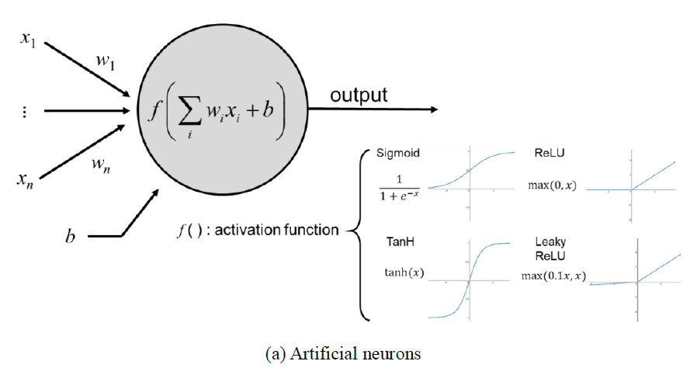
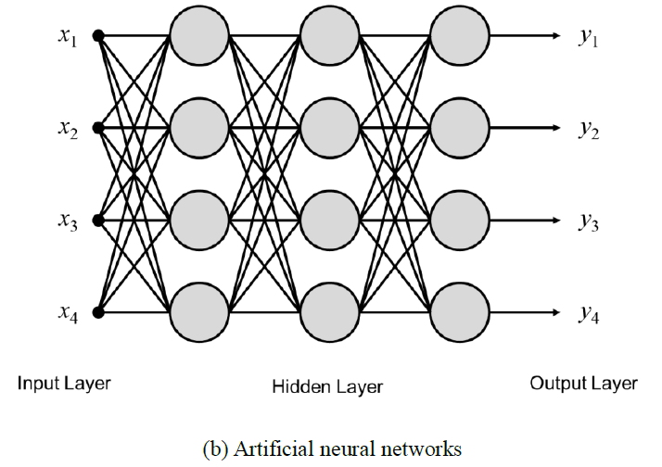
Fig 2. 7: Schematic of an artificial neural network. [51]
- Activation Functions :
- Step function :
A step function is defined as:
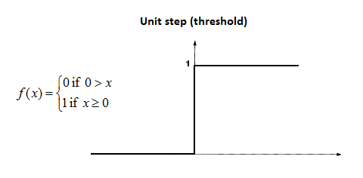
Where the output is 1 if the value of x is greater than equal to zero and 0 if the value of x is less than zero. Where the neural network uses back propagation method to calculate weights of different layers. Since the step function is non-differentiable at zero. This is what fails the weights update task.
To solve this problem the sigmoid functions were used instead of the step function. [43]

- Sigmoid Function :
A sigmoid function or logistic function is defined mathematically as:
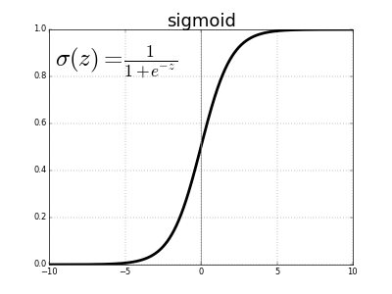

A sigmoid function or logistic function is differentiable throughout. Where defined mathematically as the value of the function tends to zero when z tends to negative infinity and tends to 1 when z tends to infinity. It is used with gradient descent and back propagation approaches for calculating weights of different layers. Sigmoid function suffers from a problem of vanishing gradients. Sigmoid function is Confined input into small output range [0,1].[43][51]

- Tanh Function :
The tanh(z) function is a version of the sigmoid, and its output range is [ − 1,1] instead of [0,1].
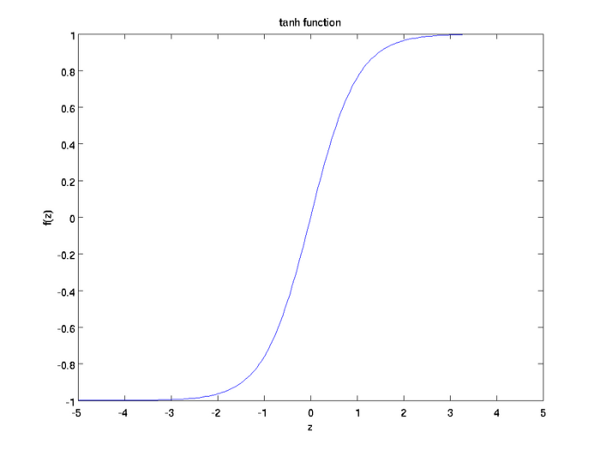
The tanh(z) function is a version of the sigmoid, and its output range is [ − 1,1] instead of [0,1]. Because since data is centered around 0, and the derivatives are higher. A higher gradient helps in a better learning rate. Attached are plotted gradients of two functions tanh and sigmoid. For tanh function, for an input between [-1,1], we have derivative between [0.42, 1].[43]
- ReLU Function :
Used activation function in deep learning models. The function returns 0 if it receives any negative input, but for any positive value x, it returns that value back. So, it can be written as f(x) =max (0, x).
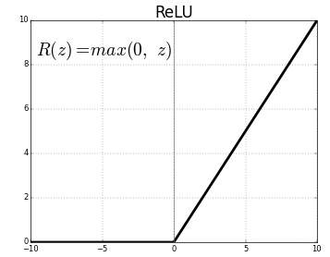

      - Recurrent Neural Network (RNN) :
RNN utilizes its internal memory to proceed with process sequences of inputs, where the feedback is used to output the hidden layers back to the input layer. Although ANN faces a learning problems related to vanishing and exploding gradients.RNN takes current input data and feedback data from previous states. Where RNN computes the current output depending on the outputs of the previous states, not like NN computations from input to output it is unidirectionally. As also RNN is applied on handwriting recognition and speech recognition. There are two main variants of RNN, bidirectional RNN (BRNN) and long short-term memory (LSTM). [44][52]
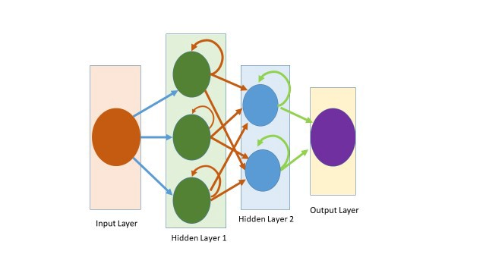
Fig 2. 8: A Typical Architecture of Recurrent Neural Network. [52]
      - Deep Neural Networks (DNNs) :
Deep Neural Network is the transfer of data from the input layer to the output layer without return backward. Although this formula has been successful in many applications, however, the training process is slow and tiring. The DNN is inspired by method the brain’s in processing inputs in the brain that occur at multiple levels. However, next time you have to start from scratch because he has no memory. Unlike the human brain, it does not function this way.[52]
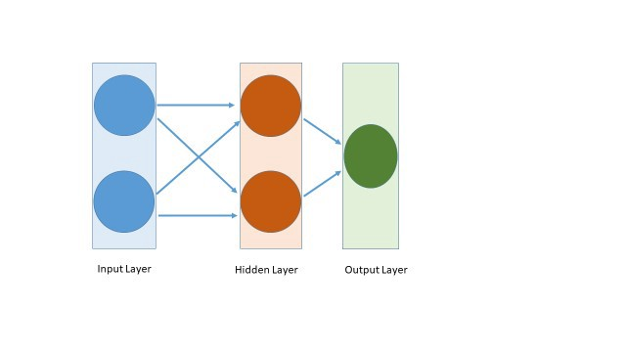
Fig 2. 9: A Typical Architecture of Deep Neural Network. [52]
      - Convolution Neural Network (CNN) :
CNN is a network architecture consisting of several convolutional layers. This method has been suggested by LeCun et al. (1989; 1998) to classify the MNIST database, which includes handwritten digits.
In CNN There are pooling layers between convolution layers. The pooling layer is important for increasing the recognition field. Where it takes a portion of the input layer and results in a smaller output layer. And the last component of CNN is max-pooling; also the max-pooling algorithm is used for extracting the highest values. Therefore CNN is the initial catalyst for widespread adoption of DL. And the architectures that have improved machine learning methods for recognizing handwritten digits are LeNet-5. CNN is independent of human knowledge and used for processing of visual images. Convolutional neural network comprises from the convolutional layer, the pooling layer and the output layer. The typical convolutional neural network architecture is well adapted for the classification of handwritten images as shown in Fig 2.9.[45][49][50]

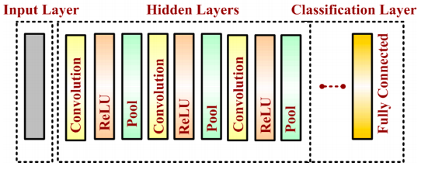
Fig 2. 10: Typical convolutional neural network architecture. [45]

  - Input layer:
In the input layer The input data is loaded and stored, the height, width, and number of image channels are described.[45]
  - Hidden Layer:
In this stage the distinguishable features of handwritten digits are detected. For CNN engineering the hidden layers are the backbone.[45]
  - Convolutional Layer:
The first layer is convolutional layer which are placed above the input image. The output of the convolutional layer is obtained by convolving its input layer and kernel weights. Where the n×n input neurons of the input layer are convoluted with an m×m filter finally in return deliver (n−m 1)×(n−m 1) as output.[45]
Fig 2. 11: The output of the convolutional layer is obtained by convolving its input layer and kernel weights. [45]
  - Pooling Layer:
Exist a pooling layer between two convolutional layers to reduce the input dimensionality. Pooling allows taking the selected values to the next layer with the abandonment of unnecessary values. It works by extracting only one output value from the input images. Where the max-pooling akes the maximum values from each. Operation for converting a 4 × 4 convolved output into a 2 × 2 output with stride size 2 is described in Figure.[45]
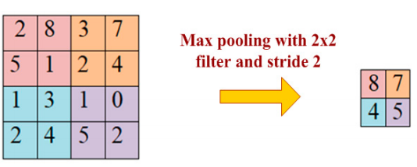
Fig 2. 12: Max pooling with filter 2×2 and stride size. [45]

  - Activation Layer:
CNN architecture contains the activation function. Where the sigmoid function, rectified linear unit (ReLu) and Softmax exploited extensively in deep learning models.[45]
  - Classification Layer:
The last layer in CNN architecture is the classification layer. Mainly adopted as a classifier. The classification layer uses the ‘softmax’ for classifying generated the input image obtained. [45]

    - Machine Learning Vs Deep learning :

table 2. 2: Machine Learning Vs Deep learning

Properties | ML | DL
Amount of data | Small | Big
Features | Need to be created  Manually | Learn automatically
Time | Short | Long
Accuracy | Good | The best
Debugging | Easy(know flow of  information) | Very difficult(Black Box)
Expensive | Less | More

  - Conclusion:
In this chapter we learn about the relationship between deep learning, machine learning and artificial intelligence, as it is embodied in the fact that deep learning is an integral part of machine learning, which in turn is an integral part of artificial intelligence. We also mentioned the different types of Machine Learning as well as some algorithms. We also presented deep Learning methods and deep neural network model. Finally, we established a small comparison between machine learning and deep learning.

CHAPTER 3: PROGRAMMING ENVIRONMENT

  - Introduction :
Python is one language wherein you can build ML and AI outline and see many Python machine learning and Artificial Intelligence projects develop today. Here we have listed the best Python libraries that could be used for machine learning. So In this chapter, we will present our programming environment, we will start by python by giving a simple definition and how we can use it. In addition, we will define what are Keras and its applications, finally we will give a quick review about Tensorflow, as well the used dataset.

  - Python:
    - Definition:
The Python programming language is classified as one of the most popular languages, that can be used for a wide variety of applications. It is an interpreted, interactive, object-oriented programming language, which is increasingly used in academic settings and also in industry. Its language constructs and approach aim to help programmers write clear, logical code for small and large-scale projects. Python is an interpreted, high-level programming language with dynamic semantics. The programming language includes thousands of modules available in the Python Package Index (PyPI). PyPI provides popular standards for different expertise, like NumPy, Pandas, and Mathplotlib for data science. [31][38][40]
    - Python History:
- Start implementation in December 1989 by Guido van Rossum (CWI)
- 16.10.2000: Python 2.0
- Unicode support
- Garbage collector
- Development process more community oriented
- 3.12.2008: Python 3.0
    - Not 100% backwards compatible
- 2007 & 2010 most popular programming language (TIOBE Index)
- Recommendation for scientiﬁc programming (Nature News, NPG, 2015) Current version: Python 2.7.16 and Python 3.7.4
- Python2 will only be supported till end of this year[32][40]
    - Getting start:
      - Installing Python:
Firstly, we need the latest version of python (version 3.8.5 or 3.9 as of this writing) just Go to (www.python.org) and download, but for me I used the version 3.6, because the new version does not recognize some functions that have not been developed yet from the old version.
      - IDLE:
IDLE is a simple integrated development environment (IDE) that comes with Python, It’s an open-source program that allows you to type your programs and run them. IDLE is just an editor.
There are other IDEs for Python, but for now I would suggest sticking with IDLE as it is simple to use. You can ﬁnd IDLE in the anaconda 3 folder on your computer. [33]

  - Keras:
    - Definition:
Keras is the most used API in deep learning; it can be considered is an open-source neural-network library written in Python. Because keras makes python easier to run new experiments and its library more extensible. keras offers simple APIs for human not for machines. And because Keras is integrated with lower level deep learning languages (in particular TensorFlow), it enables you to implement anything you could have built in the base language. In particular, as tf.keras, the Keras API integrates seamlessly with your TensorFlow workflows. [34]
    - How to Make Predictions with Keras:
Fig 3. 1: Flow of Project[5]
      - Input image:
The first step is take image of the digit.
      - Image Enhancement:
The second treatment step is image enhancement. This image enhancement lets the results more accurate and a more clear in display.
      - Keras sequential model:
Is the linear stack of layers where is the easiest way to build a model in keras. It allows you to build a model layers.
      - Output:
In the output it gives the digit that recognized. After all the stages that they passed through.

  - Tensorflow:
    - Definition:
TensorFlow is an API a machine learning library working with python machine made by the Brain Team designed by the Google in 2015. With this library, python developers can now effortlessly leverage AI and ML, because It is intended to make the use easier. And Tensor Flow is built on c, c++ making it very fast. It provides primitives for defining functions on tensors and automatically computing their derivatives
Tensors are fundamental mathematical constructs in fields such as physics and engineering. Historically however, tensors have made fewer inroads in computer science, which has traditionally been more associated with discrete mathematics and logic. This state of affairs has started to change significantly with the advent of machine. [41][36]
    - Installation of Tensorflow:
- pip installtensorflow / tensorflow == 1.2.1
Install the tensorflow with GPU support using pip
- pip install --ignore-installed –upgrade https://storage.googleapis.com/tensorflow/windows/gpu/tensorflow_gpu-1.0.1-cp35-cp35m-win_amd64.whl

  - Anaconda:
    - Definition:
Anaconda is a python distribution that is particularly popular for data analysis and scientific computing. It is free and open source project .It available for Windows, Mac OS X and Linux. And it is accompanies in excess of 1,400 packages as the Conda package. Where called Anaconda Navigator and it is a graphical UI (GUI) Linked into anaconda. Anaconda isn't an editor it’s a python distribution that bundles a bunch of packages (numpy, scipy etc). [41]
    - Installation of Anaconda (Python 3.6):
- Anaconda is easy to install just download Anaconda 64-bits, execute the installer and follow the instruction.
- Search Google for “Anaconda Python” Python V 3.6 for Windows 64 bits
- Install the Anaconda 64-bit installation file for Windows
- Install for option: Just for me
- Modify anaconda packages by typing the two commands:
> conda update conda
> conda update –all
    - Installing Python packages with Conda:
- C:\>conda install jupyter jupyter 1.0
- C:\>conda install scipy The Scipy table library
- C:\>pip install sklearn The machine learning library
- C:\>pip install pandas The machine learning library
- C:\>pip install pandas-datareader ML pandas library reading tools
- C:\>pip install matplolib Install the curve plotting tool
- C:\>pip install pillow ML complementary tools
- C:\>pip install requests ML complementary tools
- C:\>pip install h5py ML complementary tools
- C:\>pip install tensorflow/tensorflow ==1.2.1 Install the machine learning library and the google tensorflow interface.
- C:\>pip install keras/keras==2.0.6 Install the machine learning library and the keras interface.

  - Some Libraries:
    - Numpy:
NumPy is a very popular python library for large multi-dimensional array and matrix processing, with the help of a large collection of high-level mathematical functions. It is very useful for fundamental scientific computations in machine learning. It is particularly useful for linear algebra, Fourier transform, and random number capabilities. High-end libraries like tensorFlow uses numPy internally for manipulation of tensors. [39]
    - Scipy:
SciPy is a very popular library among machine learning enthusiasts as it contains different modules for optimization, linear algebra, integration and statistics. There is a difference between the SciPy library and the SciPy stack. The SciPy is one of the core packages that make up the SciPy stack. SciPy is also very useful for image manipulation. [39]
    - Pandas:
Pandas are a popular python library for data analysis. It is not directly related to machine learning. As we know that the dataset must be prepared before training. In this case, pandas come handy as it was developed specifically for data extraction and preparation. It provides high-level data structures and wide variety tools for data analysis. It provides many inbuilt methods for groping, combining and filtering data. [39]
    - Matplotlib:
Matpoltlib is a very popular python library for data visualization. Like pandas, it is not directly related to machine learning. It particularly comes in handy when a programmer wants to visualize the patterns in the data. It is a 2D plotting library used for creating 2D graphs and plots. A module named pyplot makes it easy for programmers for plotting as it provides features to control line styles, font properties, formatting axes, etc. It provides various kinds of graphs and plots for data visualization, viz., histogram, error charts, bar chats, etc. [39]

  - MNIST Data set
In our experiments, we have used digits mnist dataset is an provided that stands for (Modified National Institute of Standards and Technology) which contains 60,000 training images and 10,000 images for testing of handwritten digits between 0 and 9. Handwritten digits are images in the form of 28*28 gray scale intensities of images representing an image along with the first column to be a label (0 to 9) for every image.
We see today that members of AI, ML and data science working on digits mnist dataset and is often use it as to validate their algorithms.
The researchers use digits mnist like first dataset in the field of ML, because the most important rule they follow is “if doesn’t work on Mnist, it won’t work at all”.
Also, digits Mnist is a widely used and understood dataset, the models are deep learning convolutional neural networks that achieve a classification accuracy of above 99%, with an error rate between 0.4 %and 0.2% on the hold out test dataset. Some numbers from the MNIST dataset are displayed in Fig 3.2.

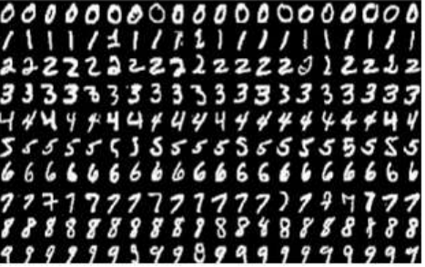
Fig 3. 2: MNIST dataset[5]

  - Conclusion:
In this chapter I presented the environments of work and the libraries I have used to develop my application based on machine learning and deep learning approaches. For programming, I used keras and tensorflow...etc, thus, I tried to explain how to install all these tools. I also talked about MNIST Data set which contains 60,000 training images and 10,000 images for testing of handwritten digits between 0 and 9.

Chapter 4: Realized Work

4.1. Introduction:
In this chapter, we present in detail the proposed CNN model, we have developed and the different ML algorithms used for the same objective, including: LR, LDA, KNN, CART, NB, and SVM. We, also illustrate the obtained results, and establish a comparison between ML and CNN approaches.

4.2. The Proposed Model:
In our work, we have developed an automatic classifier that permits to classify some given images representing handwritten digits integer values from 0 to 9 which is one of 10 classes, based on the classic ML approach and DL approach. Where we initially using many ML algorithms including: LR, LDA, KNN, CART, NB, and SVM, that's to performed the classification task. Then we proposed a CNN model composed of many convolutional layers, one Max-Pooling layer and one full connected layer. Finally, we established a comparison between the different algorithms. Fig 4.1 summarize the classification task based on the two approaches, while Fig 4.2 presents a detailed diagram of the proposed CNN model in order to improve the performance of the classification task.

Fig 4. 1: Handwritten Digit Classification Process
Input Data

Classic ML Approach
DL approach
Predicted Class



0
1
2
3
4
5
6
7
8
9
INPUT
Image 28x28x1
Conv 1
32 filters of Size 7x7
Conv 2
64 filters of Size 7x7
MaxPooling
of Size 2x2
Conv3
128 filters of Size 5x5
MaxPooling
of Size 2x2

Full-connected
(flatten) layer
Output

MaxPooling
of Size 2x2

Fig 4. 2: Architecture of the proposed CNN model

4.3. Evaluation:
To validate our proposed model, we used many performance measures, namely:
- Accuracy: This is a ratio of the number of correctly predicted instances divided by the total number of instances in the dataset multiplied by 100 to give a percentage.
- Loss value: Gives the sum of errors made for each example in the training or validation set. It must be calculated on training and validation datasets.
- Batch normalization: Can be used in a model. Also, batch normalization allows each layer of a network to learn by itself a little bit more independently of other layers.
- The batch size: Is a number of samples processed before the model is updated.
- An epoch: Is comprised of one or more batches. The number of epochs is the number times that the learning algorithm will work through the entire training dataset.

4.4. Illustration of the Obtained Results:
To build the best predictive model and achieve the higher accuracy rate. We have implemented many classic ML algorithms, including: LR logistic regression, LDA linear discriminant analysis, KNN closest neighbors, Gaussian Naïve Bayes NB, and Support Vector Machine SVM. We have also designed a CNN (Convolutional Neural Network) model composed of many layers as it is explained in Fig 4.2 and Table 1.1:
- A first convolutional layer Conv1 constituted of 32 filters of size (7x7).
- A dropout layer to avoid overfitting.
- A MaxPooling MaxPool of size (2x2) allowing to reduce dimensions (weigh, high) of images issued of the previous layer after applying the different filters of Conv1.
- A second convolutional layer Conv2 constituted of 64 filters of size (7x7).
- A dropout layer to avoid overfitting.
- A MaxPooling MaxPool of size (2x2) allowing to reduce dimensions (weigh, high) of images issued of the previous layer after applying the different filters of Conv2
- A third convolutional layer Conv3 constituted of 32 filters of size (5x5).
- A dropout layer to avoid overfitting.
- A MaxPooling MaxPool of size (2x2) allowing to reduce dimensions (weigh, high) of images issued of the previous
- layer after applying the different filters of Conv3
- A full connected layer FC allowing to transform the output of the previous layer into mono-dimensional vector.
- An output layer represented by a reduced mono-dimensional vector having as size the number of classes.
- For all the previous layers a Relu activation function and a softmax function are used to normalize values obtained in each layer.

Table 4. 1: Description of the Proposed CNN Model

Layer Type | Output Shape | Nb. parameters
conv2d_1 (Conv2D) | (None, 28, 28, 32) | 1600
batch_normalization_1 (Batch) | (None, 28, 28, 32) | 128
max_pooling2d_1 (MaxPooling2) | (None, 14, 14, 32)) | 0
conv2d_2 (Conv2D) | (None, 14, 14, 64) | 100416
batch_normalization_2 (Batch) | (None, 14, 14, 64) | 256
max_pooling2d_2 (MaxPooling2) | (None, 7, 7, 64) | 0
conv2d_3 (Conv2D) | (None, 7, 7, 128) | 401536
dropout_1 (Dropout) | (None, 7, 7, 128) | 0
max_pooling2d_3 (MaxPooling2) | (None, 4, 4, 128) | 0
batch_normalization_3 (Batch) | (None, 4, 4, 128) | 512
flatten_1 (Flatten) | (None, 2048) | 0
dense_1 (Dense) | (None, 128) | 262272
dropout_4 (Dropout) | (None, 128) | 0
batch_normalization_4 (Batch) | (None, 128) | 512
dense_2 (Dense) | (None, 10) | 1290
Total parameters |  | 768,522
Trainable parameters |  | 767,818
Non-trainable params |  | 704

Table 4.2 below summarizes the obtained results when applying ML algorithms.

Table 4. 2: Accuracy after applying different ML algorithms
Algorithm | Accuracy
LDA | 86.41
KNN | 96.90
CART | 86.27
NB | 57.04
Tables 4.3 bellow summarizes the obtained results after applying the proposed CNN model
Table 4. 3: Loss value and accuracy value obtained when applying the proposed model
 | Loss value | Accuracy value
Training set | 0.059 | 99.86
Test set | 0.633 | 98.29

Curves
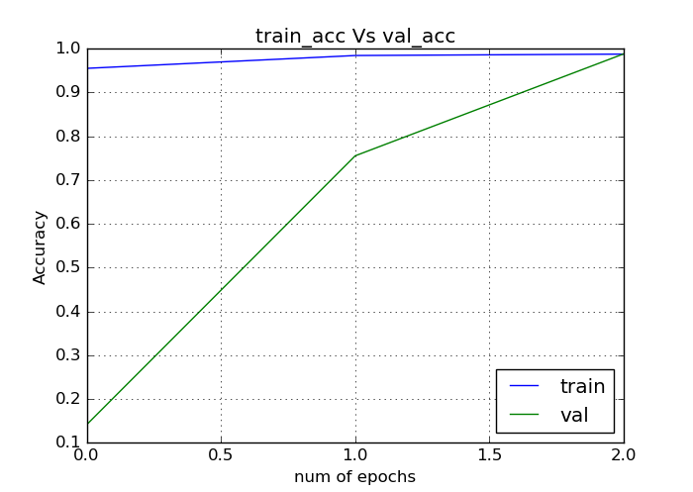
Fig 4. 3: Training accuracy Vs Validation accuracy of the CNN model
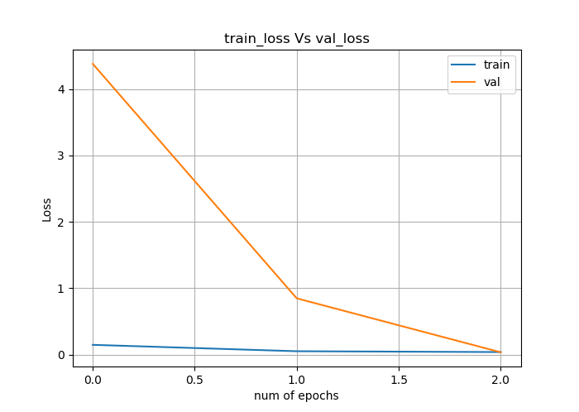
Fig 4. 4: Training loss Vs Validation loss of the CNN model.

4.5. Discussion:

Table 4.2 summarizes the obtained results when applying the different ML algorithms including: LDA, KNN, DT (CART), NB. We observe that LDA, KNN and DT (CART variant) give a high classification accuracy (> 80%), while NB give a relatively low value of accuracy (80%) compared to the previous algorithms. We note also, that the similarity metric used with KNN algorithm influence directly on algorithm performance.
Table 4.3 presents the obtained results when applying the proposed CNN model on the training set and the test set. It the loss value which calculates the sum of errors after training the model, and the accuracy value which gives the rate of correctness.
Similarly, Fig 4.3 plots the evolution of training accuracy and validation accuracy in function of the number of epochs. Contrary to the loss value, the accuracy starts very low and ends very high. This property is clearer with the training set because of its large size.
Fig 4.4 shows the evaluation of training loss and validation loss over time and in function of the number of epochs. It begins very high for the training set and ends very low because of the large number of samples, but its variation for the validation set is not very quick and appears relatively stable.

4.6. Comparison between ML and CNN approaches:
In this section we try to establish a comparison between different algorithms, ML algorithms and the CNN model. The result of this comparison appears on Table 4.4
Table 4. 4: Comparison between ML approach and DL Approach

Algorithm | Accuracy rate
LDA | 86.41
KNN | 96.90
CART | 86.27
NB | 57.04
CNN model | 99.86

Fig 4. 5: Comparison between different Algorithms
According to Table 4.4 and Fig 4.5 the comparison favors CNN model over ML algorithms.

4.7. Application Interface:
When running the software, we will first see an image of the main window as it is shown in Fig 4.6:
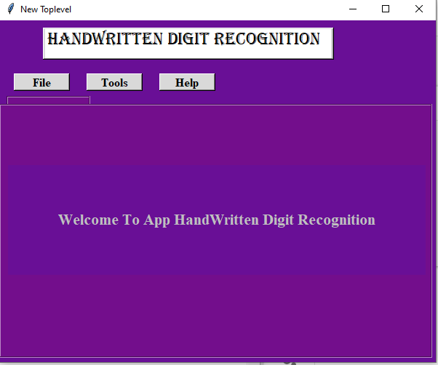
Fig 4. 6: Illustrative image of the main main the application interface.
Firstly, we have the help button. When we click on this button, we find an explanation and a link for help as it is shown in Fig 4.7:

Fig 4. 7: Illustrative image of the help button in in the application interface
Secondly, we have the tools button. When we click on this button, we find these tools such as: the dataset that we used and a link to download it, anaconda with python, and other environment tools such as: keras, tensorflow. And links to download them as it is shown in Fig 4.8:
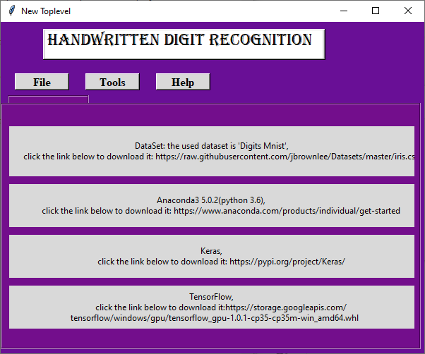
Fig 4. 8: Illustrative image of the tools button in the application interface
Third, we have the file button,when we click on this button, we find a list of buttons, the New button to open a new file, like the Open button to open an old file, and the Save button where we are save a named file as it is shown in Fig 4.9:

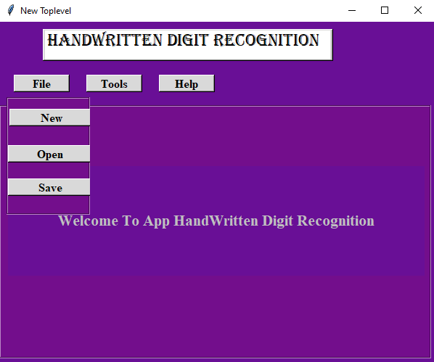
Fig 4. 9: Illustrative image of the file button in the application interface

We have in this window, a panel to draw handwritten digits If we want recognize the drawn digit we must click the Recognize button, the system predicts and classifies the drawn digit. Of course, this is depending on the developed CNN model and the used dataset. The recognition result appears in the label “Recognition result”. When we finish drawing and recognition, we press the Clear button to clear the panel and to begin the same process again with another handwritten digit. All the described process is shown in Fig 4.10:

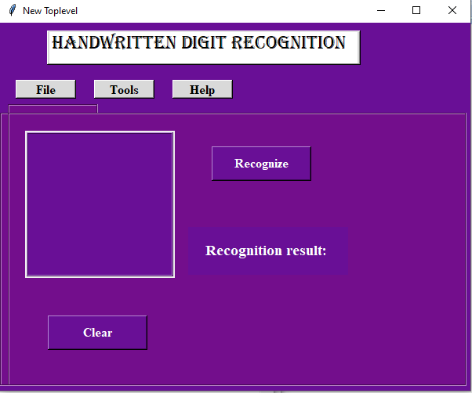
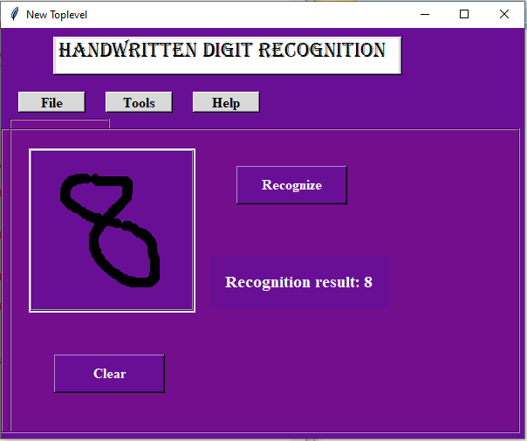
Fig 4. 10: Illustrative images of the digit drawn in the panel and the obtained result

4.8. Conclusion:
This last chapter, in which we presented the performed work , is embodied in the following: Giving the proposed model, the evaluation of the proposed CNN model, the interpretation of the obtained results , and a comparison between the ML and CNN approaches. We also presented the application interface in detail.

Conclusion and Perspectives

During the last years, some important progress on ML area has been made especially with the apparition of a new subfield called deep learning. It is mainly based on the use of many neural networks. Therefore, object recognition is mainly based on ML approach which provides high performance.
For instance, handwritten digits recognition becomes an important area due to its applications in several ﬁelds(Banks, post offices, Education, etc).. In our work we have addressed the problem of recognizing handwritten numbers, due to the similarity of numbers in many characteristics.
Handwritten digit Recognition is an active research area which always needs an improvement in accuracy. In the present work, we have performed a task of classification on a handwritten digit recognition dataset. We have used in a first stage many ML algorithms including: LDA, KNN, DT (CART), and NB. In a second stage, we have built a CNN model to perform the same task of classification. The obtained results where more accurate and very surprising when applying DL approach through the CNN model we have built.
As experimental results, the approach gives best accuracy with a large database with 0.5 % training miss classiﬁcation error rate and 6 % testing miss classiﬁcation error rate.
It is worth mentioning here that CNN architecture consists of three convolutional layers, one with 32 filters with window size 7 × 7, second with 64 filters with window size 7 × 7 and Third with 128 filters with window size 7× 7. The experimental results demonstrate that the proposed CNN framework for MNIST dataset exhibits high performance in terms of time and accuracy as compared to previously proposed systems. Consequently, handwritten digits are recognized with high accuracy (99.86%).
The work we have done during this thesis constitutes an important step and a first contribution for handwritten digit recognition, however we think that it can be improved, and extended by the following points:
- Classification of digits with its Indian and Roman types etc. To expand the field of research.
- Focusing on improving the performance of handwriting digits recognition using other improved deep learning techniques.
- Also different architectures of CNN, namely, hybrid CNN, CNN-RNN and CNN-HMM models, and domain-specific recognition systems, can be investigated. Evolutionary algorithms can be explored for optimizing CNN learning parameters, namely, the number of layers, learning rate and kernel sizes of convolutional filters.
On other hand, the performed work discusses in detail all advances in the area of handwritten digit recognition. With the present work, we hope that we have covered a large part concerning the field of handwritten digit recognition, facilitate the recognition of handwritten digits, and we be able to contribute to the development of similar research in the same area or outside of it.

Notifications of acceptance of papers in conferences

- Nadjet Bouafia, Said Kadri, Hassina Tahmi, Nourelhouda Adouane and Baya Laoues:
Efficient Clothes Categorization Based on Deep Learning Predictive Model, 4th Edition of the National Study Days on Computer Sciences Research JERI'2020, Université de Saida, May 20, 2020.
Dear Authors:
We are pleased to inform you that your paper “Efficient Clothes Categorization Based on Deep Learning Predictive Model,” to JERI’2020 has been accepted for Poster Presentation.
We look forward to seeing you in Saida!
Best regards,
JERI’2020 PC chairs “”

- Hassina Tahmi, Said Kadri , Baya Laoues, Nour Elhouda Adouane and Nadjet Bouafia:Handwritten Digit Recognition:
Developing an Efficient ML and DL Model to Recognize Handwritten Digits, Conférence Nationale sur l ’Intelligence artificielle et les technologies de l'information CNIATI'20, Chadli Bendjedid University El Tarf, Algeria, 2020.
“”Paper ID: 14
Author(s): TAHMI Hassina, Said KADRI, LAOUES Baya, ADOUANE Nour ElHouda, BOUAFIA Nadjet
Title: Handwritten Digit Recognition: Developing an Efficient ML and DL Model to Recognize Handwritten Digits
It is our pleasure to inform you that the paper referenced above has been accepted for Oral presentation at the CNIATI'2020, to be held in El-Tarf, Algeria 17 March 2020. “”
- Nour Elhouda Adouane, Said Kadri , Hassina Tahmi, Baya Laoues and Nadjet Bouafia:
An Efficient CNN Model to Detect Traffic Signs for the Use of Self-Driving Cars, Conférence Nationale sur l ’Intelligence artificielle et les technologies de l'information CNIATI'20, Chadli Bendjedid University El Tarf, Algeria, 2020.
“”Paper ID: 13
Author(s): ADOUANE Nour ElHouda, Said GADRI, TAHMI Hassina, LAOUES Baya, BOUAFIA Nadjet
Title: An Efficient CNN Model to Detect Traffic Signs for the Use of SelfDriving Cars

It is our pleasure to inform you that the paper referenced above has been accepted for Poster presentation at the CNIATI'2020, to be held in El-Tarf, Algeria 17 March 2020. “”

- Nour Elhouda Adouane, Said Kadri , Hassina Tahmi, Baya Laoues and Nadjet Bouafia:
An Efficient CNN Model to Detect Traffic Signs for the Use of Self-Driving Cars, 4th Edition of the National Study Days on Computer Sciences Research JERI'2020, Université de Saida, May 20, 2020.
“”We are pleased to inform you that your paper “An Efficient CNN Model to Detect Traffic Signs for the Use of Self-Driving Cars” to JERI’2020 has been accepted for Oral Presentation.
We look forward to seeing you in Saida!
Best regards,
JERI’2020 PC chairs “”

Bibliography

[1] Recommended Citation Zhao, K. (2018) ,’’Handwritten Digit Recognition and Classification Using Maching Learning’’. M.Sc. in Computing (Data Analytics), Technological University Dublin.
[2] Shah, R., ( 2019), ''Handwritten Digit Recognition'',CSC – Term Project Proposal.
[3]Zwaag,B.J.V.D, (2001),''Handwritten Digit Recognition: A Neural Network Demo'', International Conference on Computational Intelligence, pp762-771.
[4] Vazquez, F. A., & Marin, R. (1992).'' Pattern Recognition Applied to Formatted Input of Handwritten Digits''. IFAC Proceedings Volumes, 25(6), 361–364.
[5] Naitam,N., Bawane,B.,Telang,M., Kulsange,P.,Telang, S., Lichode,R.,''Handwritten Digit Recognition through Supervised Machine Learning'',International Conference on Innovation & Research in Engineering, Science & Technology(ICIREST-19).
[6] Ebrahimzadeh,R.,Jampour,M., (2014), ''Efficient Handwritten Digit Recognition based on Histogram of Oriented Gradients and SVM'', International Journal of Computer Applications (0975 – 8887) Volume 104 – No.9.
[7] Alani,A.A.,(2017), ''Arabic Handwritten Digit Recognition Based on Restricted Boltzmann Machine and Convolutional Neural Networks'',Article,Information 2017, 8, 142;
[8] Tandon, S., Akhter, S., Singh, V.,P., Khan,N.,U.,(2019),''Handwritten Digits Recognition Using Machine learning'', International Journal of Information Sciences and Application (IJISA). ISSN 0974-2255, Vol.11, No.1.
[9] Dutt, A., AashiDutt, (2017),''Handwritten Digit Recognition Using Deep Learning'', International Journal of Advanced Research in Computer Engineering & Technology (IJARCET) Volume 6, Issue 7.
[10] Alwzwazy,H.A., Albehadili,H.M., Alwan,Y.S., Islam,N.E.,(2016),''Handwritten Digit Recognition Using Convolutional Neural Networks'',International Journal of Innovative Research in Computer and Communication Engineering , Vol. 4, Issue 2.
[11] Jain,N., Rahul,K. , Khamaru,I. , Jha,A.K. , Ghosh,A.,(2017),''Hand Written Digit Recognition using Convolutional Neural Network (CNN)'',International Journal of Innovations & Advancement in Computer Science, Volume 6, Issue 5.
[12] Ali, M. A., Svetinovic, D., Aung, Z., & Lukman, S. (2017). Malware detection in android mobile platform using machine learning algorithms. International Conference on Infocom Technologies and Unmanned Systems (Trends and Future Directions) (ICTUS)Khalifa University of Science and Technology Abu Dhabi, United Arab Emirates.
[13] Wang, Y., Zhou, Z., Jin, S., Liu, D., & Lu, M. (2017). Comparisons and Selections of Features and Classifiers for Short Text Classification. IOP Conference Series: Materials Science andEngineering,261,01.

[14] Awoyemi, J. O., Adetunmbi, A. O., & Oluwadare, S. A. (2017). Credit card fraud detection using machine learning techniques: A comparative analysis International Conference on Computing Networking and Informatics (ICCNI).
[15] Sazzadur Rahman, A.K.M., Javed Mehedi Shamrat, F. M., Tasnim ,Z., Roy , J., Hossain ,S.(2019). A Comparative Study On Liver Disease Prediction Using Supervised Machine Learning Algorithms. INTERNATIONAL JOURNAL OF SCIENTIFIC & TECHNOLOGY RESEARCH VOLUME 8, ISSUE 11.
[16] Zain Amin,M., Ali,A..Performance Evaluation of Supervised Machine Learning Classifiers for Predicting Healthcare Operational Decisions.C-Section Classification Database Report, UCI Machine Learning Repository, University of California, Irvine, USA.Department of Computer Science & Engineering University of Engineering & Technology, Lahore, Pakistan.
[17] Ravi Kumar, G.,Dr.Ramachandra, G. A. ,Nagamani, K.(2013).An Efficient Prediction of Breast Cancer Data using Data Mining Techniques.International Journal of Innovations in Engineering and Technology (IJIET).Department of Computer Science & Technology S K University, Anantapur, AP, India, Rayalaseema University, Kurnool, AP, India.Vol. 2 Issue 4.
[18] Ekinci,E. , İlhan Omurca,S. , Acun,N.(2018).A Comparative Study on Machine Learning Techniques using Titanic Dataset .7th International Conference on Advanced Technologies (ICAT'18), Antalya/TURKEY.Kocaeli University, Faculty of Engineering, Computer Engineering Department Umuttepe Campus, Kocaeli, Turkey.
[19] Entezari-Maleki,R., Rezaei,A., and Minaei-Bidgoli,B.(2009).Comparison of Classification Methods Based on the Type of Attributes and Sample Size.Department of Computer Engineering, Iran University of Science & Technology (IUST), Tehran, Iran Journal of Convergence Information Technology Volume 4, Number 3.
[20] Tavasoli ,S.,( 2020).10 Machine Learning Algorithms You Need to Know.
[21] Brownlee,J.,(2019). A Tour of Machine Learning Algorithms. Ltd. All Rights Reserved.
[22] RAY,S., (2017).Commonly used Machine Learning Algorithms.
[23 ] Anirudh, V .K.,(2019). WHAT IS MACHINE LEARNING: DEFINITION, TYPES, APPLICATIONS AND EXAMPLES.
[24] https://idapgroup.com/blog/types-of-machine-learning-out-there/
[25] https://towardsdatascience.com/what-are-the-types-of-machine-learning-e2b9e5d1756f
[26] Tavasoli ,S.,( 2020).14 Different Types of Learning in Machine Learning.
[27] Jakhar,D., Kaur,I.,(2019),''Artificial intelligence, machine learning and deep learning: definitions and differences'',Volume 45, Issue 1.
[28] Panch,T., Szolovits,P., Atun,R.,J Glob Health.(2018);''Artificial intelligence, machine learning and health systems'', 8(2): 020303. Published online .
[29] Nguyen,G., Dlugolinsky,S., Bobák,M.,Tran,V., García, A.L., Heredia,I., Malík, P., Hluchý, L.,(2019),''Machine Learning and Deep Learning frameworks and libraries for large-scale data mining: a survey'',Artificial Intelligence Review.
[30] Matava, C., Pankiv, E., Ahumada, L., Weingarten, B., & Simpao, A. (2019). ''Artificial intelligence, machine learning and the pediatric airway''. Pediatric Anesthesia. Volume 30, Issue 3.
[31] https://python.sdv.univ-paris-diderot.fr/.
[32] St. Graf, S. Linner, M. Lischewski, PYTHON Introduction to the Basics, 2019.
[33]Brian Heinold ,A Practical Introduction to Python Programming, Department of Mathematics and Computer Science Mount St. Mary’s University,2012.

[34] Francois Chollet, Introduction to Keras, 2018.
[35] www.toutrialspoint.com
[36] Bharath Ramsundar, TensorFlow Tutorial ,2015
[37] Reza Bosagh Zadeh, Bharath Ramsundar,(2017),TensorFlow for Deep Learning From Linear Regression to Reinforcement Learning.
[38]https://hackernoon.com/top-8-python-libraries-for-machine-learning-and-artificial-intelligence-y08id3031
[39] Dalcín, L., Paz, R., & Storti, M. (2005). MPI for Python. Journal of Parallel and Distributed Computing.
[40] https://www.python.org/doc/essays/blurb/
[41] Rudraswamimath,V.R., Bhavanishankar, K.,(2019),''Handwritten Digit Recognition using CNN'',International Journal of Innovative Science and Research Technology.
[42] BAŞER, E., ALTUN, Y., (2016), Optical and handwritten digit recognition by using neural network on NAO humanoid robot,Conference , 210
[43] Saha, Roshni, (2019). "Classification of Parkinson’s Disease Using MRI Data and Deep Learning Convolution Neural Networks" Creative Components. 241.

[44] Chen, S., Almamlook, R., Gu, G., wells,L., (2018), Offline Handwritten Digits Recognition Using Machine learning, Proceedings of the International Conference on Industrial Engineering and Operations Management Washington DC, USA, 274
[45] Ahlawat,S., Choudhary, A., Nayyar, A., Singh S.,Yoon,B., (2020), Improved Handwritten Digit Recognition Using Convolutional Neural Networks (CNN).
[46]Mathew,A., P.Amudha, S.Sivakumari, (2020), Deep Learning Techniques: An Overview, Amitha Mathew et al.
[47] Yonggyun Yu, Taeil Hur, Jaeho Jung, and In Gwun Jang, (2018), Deep learning for determining a near-optimal topological design without any iteration, Article in Structural and Multidisciplinary Optimization,
[48] Chollet, F., (2018), Deep Learning with python, by Manning Publications Co. All rights reserved.
[49] Ali, S., Shaukat,Z., Azeem,M. ,Sakhawat, Z., Mahmood, T.,ur Rehman, K., (2019), An efficient and improved scheme for handwritten digit recognition based on convolutional neural network,SN Applied Sciences.

[50] Shashank Mishra, D. Malathi, K. Senthilkumar Dept,( 2018), DIGIT RECOGNITION USING DEEP LEARNING, International Journal of Pure and Applied Mathematics Volume 118 No. 22.
[51] Md. Lizur Rahman, Ifrat Jahan, Akash Saha, Md. Nawab Yousuf Ali, (2018), Efficient Recognition of Bangla Handwritten Digits Based on Deep Neural Network, International Journal of Recent Technology and Engineering (IJRTE) , Volume-7 Issue-4.
[52] Ramzan, M., Awan, S.M., Ilyas, M., Khan,H.U., Akhtar,W., Zamir,A.,( 2018), A Survey on using Neural Network based Algorithms for Hand Written Digit Recognition, (IJACSA) International Journal of Advanced Computer Science and Applications, Vol. 9, No. 9.

ملخص:
يتمحور العمل المعروض في هذه المذكرة حول التعرف على الأشكال، الرؤية بواسطة الكمبيوتر وتصنيف الصور. ومن بين الطرق الأكثر استخدامًا في DLمجال التعلّم العميق ، نجد CNNs (الشبكات العصبية التلافيفية) والتي يمكن اعتبارها أفضل التقنيات المستخدمة حاليا. وفي هذا الإطار، قمنا بتطوير مصنف آلي يسمح بتصنيف بعض الصور ذات التدرج الرمادي التي تمثل أرقامًا مكتوبة بخط اليد في واحدة من 10 فئات (أرقام من 0 إلى 9) بشكل شامل. لهذا الغرض، استخدمنا المقاربتين ML و DL. أولاً ، انتقلنا إلى مهمة التصنيف باستخدام العديد من خوارزميات ML منها: LR و LDA و KNN و CART و NB و SVM. ثانيًا ، اقترحنا نموذجًا جديدًا لشبكة CNN، يتكون من طبقات تلافيفية عديدة. كما قمنا بشرح وتفسير النتائج التي تم الحصول عليها. وأخيرًا، أجرينا مقارنة بين الخوارزميات المختلفة.

الكلمات المفتاحية: التعلم الآلي، التعلم العميق، التعرف على الأرقام المكتوبة بخط اليد، التعرف على الأنماط، الشبكات العصبية، الشبكات العصبية التلافيفية.
Abstract:
The work presented in this thesis is focussed on the pattern recognition, computer vision and image classification. Among the most used methods in deep learning field DL, we find CNNs (Convolutional Neural Networks) which can be considered as the best used technique in the field. Effectively, we have developed an automatic classifier that permits to classify some given grayscale images representing handwritten digits into one of 10 classes (digits from 0 to 9), inclusively. For this purpose, we have used ML and DL approaches. First, we proceeded to the classification task using many ML algorithms including: LR, LDA, KNN, CART, NB, and SVM. Second, we proposed a new CNN model composed of many convolutional layers. We have also explained the obtained results. Finally, we have established a comparison between different algorithms.

Keywords: Machine learning, deep learning, handwritten digit recognition, Pattern Recognition, Neural Networks, Convolution Neural Networks.

Résumé
Le travail présenté dans ce mémoire se focalise sur le domaine de la reconnaissance des formes, la vision par ordinateur et la classification d'images. Parmi les méthodes les plus utilisées en apprentissage approfondi DL, on trouve les CNN (Convolutional Neural Networks) qui peuvent être considérés comme la technique la plus utilisée. Effectivement, nous avons développé un classifieur automatique qui permet de classer certaines images en niveaux de gris représentant des chiffres manuscrits dans l'une des 10 classes (chiffres de 0 à 9), inclusivement. Pour cela, nous avons utilisé les deux approches : ML et DL. Tout d'abord, nous avons procédé à la tâche de classification en utilisant de nombreux algorithmes ML, notamment: LR, LDA, KNN, CART, NB et SVM. Deuxièmement, nous avons proposé un nouveau modèle CNN composé de nombreuses couches convolutives. Nous avons également expliqué interprété les résultats obtenus, et enfin, nous finissions notre travail par l’établissement d’une comparaison entre différents algorithmes.

Mots clés: Apprentissage automatique, apprentissage en approfondi, reconnaissance de chiffres manuscrits, reconnaissance de formes, réseaux de neurones, réseaux de neurones convolutionnels.
ملخص:
يتمحور العمل المعروض في هذه المذكرة حول التعرف على الأشكال، الرؤية بواسطة الكمبيوتر وتصنيف الصور. ومن بين الطرق الأكثر استخدامًا في DLمجال التعلّم العميق ، نجد CNNs (الشبكات العصبية التلافيفية) والتي يمكن اعتبارها أفضل التقنيات المستخدمة حاليا. وفي هذا الإطار، قمنا بتطوير مصنف آلي يسمح بتصنيف بعض الصور ذات التدرج الرمادي التي تمثل أرقامًا مكتوبة بخط اليد في واحدة من 10 فئات (أرقام من 0 إلى 9) بشكل شامل. لهذا الغرض، استخدمنا المقاربتين ML و DL. أولاً ، انتقلنا إلى مهمة التصنيف باستخدام العديد من خوارزميات ML منها: LR و LDA و KNN و CART و NB و SVM. ثانيًا ، اقترحنا نموذجًا جديدًا لشبكة CNN، يتكون من طبقات تلافيفية عديدة. كما قمنا بشرح وتفسير النتائج التي تم الحصول عليها. وأخيرًا، أجرينا مقارنة بين الخوارزميات المختلفة.

الكلمات المفتاحية: التعلم الآلي، التعلم العميق، التعرف على الأرقام المكتوبة بخط اليد، التعرف على الأنماط، الشبكات العصبية، الشبكات العصبية التلافيفية.
Abstract:
The work presented in this thesis is focussed on the pattern recognition, computer vision and image classification. Among the most used methods in deep learning field DL, we find CNNs (Convolutional Neural Networks) which can be considered as the best used technique in the field. Effectively, we have developed an automatic classifier that permits to classify some given grayscale images representing handwritten digits into one of 10 classes (digits from 0 to 9), inclusively. For this purpose, we have used ML and DL approaches. First, we proceeded to the classification task using many ML algorithms including: LR, LDA, KNN, CART, NB, and SVM. Second, we proposed a new CNN model composed of many convolutional layers. We have also explained the obtained results. Finally, we have established a comparison between different algorithms.

Keywords: Machine learning, deep learning, handwritten digit recognition, Pattern Recognition, Neural Networks, Convolution Neural Networks.

Résumé
Le travail présenté dans ce mémoire se focalise sur le domaine de la reconnaissance des formes, la vision par ordinateur et la classification d'images. Parmi les méthodes les plus utilisées en apprentissage approfondi DL, on trouve les CNN (Convolutional Neural Networks) qui peuvent être considérés comme la technique la plus utilisée. Effectivement, nous avons développé un classifieur automatique qui permet de classer certaines images en niveaux de gris représentant des chiffres manuscrits dans l'une des 10 classes (chiffres de 0 à 9), inclusivement. Pour cela, nous avons utilisé les deux approches : ML et DL. Tout d'abord, nous avons procédé à la tâche de classification en utilisant de nombreux algorithmes ML, notamment: LR, LDA, KNN, CART, NB et SVM. Deuxièmement, nous avons proposé un nouveau modèle CNN composé de nombreuses couches convolutives. Nous avons également expliqué interprété les résultats obtenus, et enfin, nous finissions notre travail par l’établissement d’une comparaison entre différents algorithmes.

Mots clés: Apprentissage automatique, apprentissage en approfondi, reconnaissance de chiffres manuscrits, reconnaissance de formes, réseaux de neurones, réseaux de neurones convolutionnels.

