PEOPLE’S DEMOCRATIC REPUBLIC OF ALGERIA
MINISTRY OF HIGHER EDUCATION AND SCIENTIFIC RESEARCH
UNIVERSITY OF MOHAMED BOUDIAF - M’SILA


DOMAIN: FOREIGN LANGUAGES

STREAM: ENGLISH LANGUAGE

OPTION: LINGUISTICS

FACULTY OF LETTERS AND LANGUAGES

DEPARTMENT OF LETTERS AND ENGLISH LANGUAGE

N°:………………………………………..

EFL Learners Use of Self-Regulation to Enhance the Speaking Skill
The Case of Master One Linguistics Students at M’sila University

Dissertation Submitted to the Department of Letters and English Language in Partial Fulfilment of the Requirements for the Master’s Degree in Linguistics

Candidates:
- Abdelmalk Badouche
- Abdelkader Omar Yacine Benaziez
Board of Examiners

Dr. Mohammed Gouffi | University of M’sila | Chairperson
Dr. Mourad Touati | University of M’sila | Supervisor
Dr. Noureddine Refice | University of M’sila | Examiner

2024/2025
Dedication

To our parents, whose peerless efforts and priceless support paved our way.
To our brothers and sisters, who were always there whenever we needed help.
To our friends, with whom we shared the most entertaining and unforgettable moments.
To every person who helped us, even with a single word.
We dedicate this work.

Acknowledgement
First and foremost, we would like to express our sincere gratitude to Allah, the Most Merciful and the All-Merciful, for guiding us all this way along to success and to become what we are now. We thank also our supervisor for his help in conducting this research. We are grateful for our brothers, sisters, friends, and our parents as such for any kind of support they gave from the first day we stepped at elementary school until this very moment.

Abstract
The current study investigates EFL learners use of self-regulation to improve their speaking skill in the case of Master one students in the English Department at Mohammed Boudiaf, University of M'sila. Recognizing that speaking is an emotionally and cognitively demanding ability, the study is concerned with how learners’ implement self-regulation strategies such as goal setting, monitoring, and self-reflection to regulate their behaviour for a better oral performance. Data were collected via Likert-scale questionnaire from a convenience sample of 65 students of an estimated population of 130. The results reveal a positive correlation between higher degrees of self-regulation and better speaking performance in terms of confidence, fluency, and task involvement. These findings suggest that the development of self-regulatory skills might enhance learners’ oral ability to communicate in learning environments. The study focuses on ensuring the integration of self-regulation training into speaking-based curricula to enhance learners’ autonomy and performance.

List of Abbreviations
EFL English as a foreign language
ESL English as a second language
FL Foreign language
LLSs Language learning skill(s)
SL Second language
SR Self-regulation
SRL Self-regulated learning
SRS Self-regulation strategies
SS Speaking skill
TL Target language

List of Figures:
- Figure 01: Zimmzerman's model of self-regulated learning
- Figure 02: Boekaerts model of self-regulated learning
- Figure 03: Distribution of students' gender
- Figure 04: Age range of students.
- Figure 05: Objective setting for speaking skill improvement
- Figure 06: Use of organizational strategies in speaking practice
- Figure 07: Monitoring progress in speaking skills
- Figure 08: Problem solving approaches during speaking tasks
- Figure 09: Frequency of self-assessment in speaking
- Figure 10: Use of peer and teacher’s feedback in speaking development
- Figure 11: Adaptation of strategies for speaking improvement
- Figure 12: Confidence levels when speaking
- Figure 13: Participation rates in speaking activities
- Figure 14: Use of spoken English in daily life
- Figure 15: Reported issues with fluency
- Figure 16: Reported pronunciation difficulties
- Figure 17: Perceived lack of vocabulary
- Figure 18: Reported grammar challenges in speaking

List of Tables:
- Table 01: Table of means and standard deviation
- Table 02: table of correlation and the significance

Table of contents
- Dedication......................................................................................................... I
- Acknowledgement............................................................................................ II
- Abstract........................................................................................................... III
- List of Abbreviations...................................................................................... IV
- List of Figures..............................................................................................….V
- List of Tables...................................................................................................VI
- Table of contents.............................................................................................VII
- General Introduction………………………………………………………...1
- Background Information……………………………………………………….2
- Statement of the problem………………………………………………………4
- Aims of the study……………………………………………………………….5
- Significance of the study…………………………………………………..6
- Research questions……………………………………………………………...6
- Research hypotheses………………………………………………………6
- Research structure………………………………………………………………7
- Chapter One: Self-regulation and speaking performance………………………….8
- Introduction………………………………………………………………..9
1. Self-regulation……………………………………………………………..10
1.1. Definition………………………………………………………………..10
1.2. Self-regulation strategies………………………………………………...11
1.2.1. Goal setting……………………………………………………………12
1.2.2. Monitoring……………………………………………………………..13
1.2.3. Self-reflection………………………………………………………….14
1.3. Self-regulated learning…………………………………………………..15
1.3.1. Self-regulated learning theories………………………………………..16
1.3.1.1. Zimmerman’s cyclical model of SRL……………………………….16
1.3.1.1.1. Forethought phase…………………………………………………17
1.3.1.1.2. Performance control phase………………………………………...18
1.3.1.1.3. Self-reflection phase……………………………………………….20
1.3.1.2. Pintrich’s model of SRL……………………………………………..23
1.3.1.2.1. Regulation of cognition……………………………………………24
1.3.1.2.2. Regulation of motivation and affect……………………………….24
1.3.1.2.3. Regulation of behavior…………………………………………….25
1.3.1.2.4. Regulation of context……………………………………………...26
1.3.1.3. Boekaerts model of SRL…………………………………………….27
2. Speaking…………………………………………………………………...29
2.1. Speaking skill……………………………………………………………29
2.2. Speaking performance…………………………………………………………...30
2.3. Speaking performance features………………………………………………….30
2.3.1. Fluency………………………………………………………………………...30
2.3.2. Accuracy……………………………………………………………………….31
2.3.3. Pronunciation………………………………………………………………….32
3. Self-regulation in EFL context…………………………………………………….33
- Chapter Two: Research methodology, data analysis, and interpretation of the data……………...35
- Introduction…………………………………………………………………..36
1. Population and sampling…………………………………………………..36
1.1. Population………………………………………………………………..36
1.2. Sampling…………………………………………………………………36
2. Research methodology…………………………………………………….37
2.1. Research approach ………………………………………………………37
2.2. Research design…………………………………………………………………37
2.3. Research tool…………………………………………………………………….37
2.4. Validity and reliability of the instrument………………………………………..38
2.5. Data analysis procedures………………………………………………………...38
2.6. Students’ questionnaire………………………………………………………….39
2.6.1. Questionnaire description……………………………………………………..39
2.6.2. Data analysis and interpretation of the questionnaire…………………40
2.6.2.1. Descriptive statistics of close ended questions………………………40
- Section one……………………………………………………………….40
- Section two……………………………………………………………….41
- Section three……………………………………………………………...46
2.6.2.2. Descriptive statistics summary………………………………………50
- Section four………………………………………………………………52
2.7. Discussion of the findings……………………………………………….53
Implications…………………………………………………………………..54
Limitations……………………………………………………………………54
- General conclusion………………………………………………………………55
ملخص………………………………………………………………………….57
Reference list…………………………………………………………………58

General Introduction
Background Information
English has grown to its current position as the major world language and of 4,000 to 5,000 living languages and thus English is by far the most widely used. Barriers such as race, color, and creed are no hindrance to the continuing spread of this language (Broughton et al., 2002). Hence, English is being used as a Lingua-Franca, and knowing more about it becomes a necessity in today’s world because it facilitates communication among native and non-native English speakers (Dudeney & Hockly, 2009).
However, being exposed to a foreign language and knowing more about it does not necessarily mean achieving high levels of proficiency and performance in it. In other words, learners need to develop and improve four main skills which are listening, reading, writing, and speaking (Singh, 2016). With communication as the major objective of language learning, developing speaking skills is of a major role.
According to Apps (2012) learning how to speak effectively is crucial for better communication with others. That is individuals should know how to be better speakers in order to be understood. Hence, speaking is a skill that deserves more attention as much as the other literary skills in both first and second languages. Bygate (1987) stated that speaking is the preeminent vehicle of social solidarity, social ranking, professional achievement, and business which means that is of a major significance in different fields as well as in daily life. Thus, speaking is a main feature for communicating with one another.
What makes the development of SS vital as such is that it affects the speaker’s performance in a foreign language. In other words, the better one’s speaking skills in a foreign language are the better his or her performance will be and vice versa. Rao (2018) claimed that speaking skill plays a significant role in EFL or ESL learning context because learners use it to express their ideas, opinions, as well as impressing others, since good speakers can catch both teachers’ and students’ attention. Ultimately, influencing the interlocutor’s comprehension of the communicated message. Shekhman (2021) stated that the better the individual’s performance in a foreign language is, the easier the communication will be.
Academically, and in an EFL learning context, speaking is seen as the most important skill compared to the other LLS. Mastering speaking is crucial because it plays an important role in EFL learning and teaching context. Thus, EFL learners need to work on it to enhance their performance (Ahmed, 2020). However, speaking is somehow difficult to master for EFL learners since it requires more attention to various aspects such as fluency, accuracy of speech, vocabulary, and grammar. It still a necessity for EFL learners to enhance their speaking performance due to its importance (Karim et al., 2023).
As any other skills, SS can be improved through different strategies. Ahmed (2020) noted that there are several activities such as role playing, storytelling, discussions, and dialogue improvisation...; however, most of these strategies are considered as classroom strategies which are used collectively. Whereas the EFL learners can develop and enhance their speaking skills individually in which they are the instructors of their learning progress. Here comes the concept of self-study. The latter is defined as the study as oneself, one's actions, one's ideas (Ahmed, 2020). For instance, EFL learners may self-study in order to enhance and develop their speaking skills individually. Therefore, EFL learners can make use of self-regulation strategies for a good learning progress and for goals achieving.
The concept of self-regulation can be defined as the process in which the individual actively maintains set points or levels of emotional and cognitive arousal that promote positive adaptation and that lead to the development of a positive sense of efficacy, agency, and sell forth. (Hoyle, 2010). Zimmerman & Schunk (1989) defined self-regulation as a self-oriented feedback loop in learning. That loop refers to a cyclic process in which students monitor the effectiveness of their learning strategies and respond to their feedback differently, ranging from covert changes in self-perception to overt changes in behavior, such as replacing a learning method with another.
In order to learn more about humans’ self-control/ self-regulation, the research on SRS (self-regulation strategies) and academic learning has grown out of more general efforts (Zimmerman & Schunk, 1989). For instance, researchers and reformers were interested in the way students make use of SRS, such as goal setting, self-reinforcement, and self-recording, during their academic learning journey (Zimmerman & Schunk, 1989). Generally, self-regulation is essential for adaptive functioning if people know how to effectively control their thoughts, feelings, and behaviors (Hoyle, 2010).
Academically, SR stands for self-generated thoughts, feelings, and actions meant to attain specific educational goals, such as analyzing a reading assignment, preparing to take a test, or writing a paper (Zimmerman et al., 1996). That is, the used self-regulation strategies differ from a learner to another. The effective use of self-regulatory processes increases students awareness of their academic achievements and develop their use of study skills (Zimmerman et al., 1996). However SR does not only enhance students leanring but their perception of self-efficacy and control over their learning outcomes (Zimmerman et al., 1996).
Statement of the problem
Human beings speak in an early age by nature which makes speaking the first acquired skill compared to the other language learning skills. However individuals do not speak well at first, but they need a lot of practice that lasts for a particular amount of time.
As well as the first language, EFL learners struggle in their learning journey to acquire and develop their skills in English. They tend to use different methods and strategies to do so. And because speaking is one of the most difficult skills if a learners use several methods and strategies to master it. For instance, self-regulation strategies are one of the ways used to achieve the latter.
In the case of Master one Linguistics students in the English Department at Mohammed Boudiaf, University of M'sila, This research investigates the use of self-regulation strategies in improving EFL learners speaking performance. Because the speaking skill plays a vital role in the EFL learning context, understanding what self-regulation strategies EFL learners use and how do they use them is crucial in this context.
Aim of the study
Our aim in conducting this research is to find out whether master one students in the department of English at Mohammed Boudiaf university of M’silla use self-regulation in terms strategies to develop fluency, accuracy and the overall speaking performance. To investigate this issue, this work focuses on identifying and analyzing self-regulation strategies used by students of the English department. R. A. Thompson (1994) identifies this strategy as the ability to monitor and modulate cognition, emotion, and behavior to accomplish one’s goal, and/or to adapt to the cognitive and social demands of specific situations. More precisely, our focus is to study the speaking performance of the students in the classroom and how the use of self-regulation strategies affects it. Simultaneously, we try to explore the strategies used by teachers of master one students in the department of English at Mohammed Boudiaf university to help their students develop their speaking performance.
The reason we choose the speaking skill among the four language skills is that the majority of learners are choosing mainly teaching as a carrier, which requires a high level of fluency and accuracy. Due to the nature of the academic life, the other three skills (reading, writing and listening) are already developed which leaves the speaking skill to be somehow neglected. Therefor this research aims to identify to which extent learners use self-regulation and its impact on their speaking performance.
Significance of the study
This study is of a major significant as it sheds the light on the role of self-regulation in improving speaking performance. By exploring how learners use self-regulation strategies, the findings can contribute to language learning research, teaching practices and curriculum design.
For language learners, understanding self-regulation can help them develop effective techniques to improve their speaking skills, such as setting goals, self-monitoring and self-reflection. For teachers, this study can put strategies that promote individual learning and boost students speaking confidence on the spotlight. Additionally, the findings may be used in curriculum design by integrating self-regulation training into language courses, ensuring a more successful approach to speaking development.
Research questions
On light of what have been mentioned before, the research questions can be imbodied in the following:
- How does self-regulation impact EFL learners speaking performance?
- What self-regulation strategies do EFL learners use to enhance their speaking performance?
Research hypotheses
- Students with high level of speaking performance are more likely to use self-regulation strategies.
- Learners who have a low level of speaking performance find difficulty in using self-regulation strategies.
- The most used self-regulation strategies are goal setting and self-monitoring.
Research structure
In regards to conducting this research, we sought to divide it into a general introduction, two chapters, and a general conclusion. The general introduction represents an overview about the main concepts of this research, a statement of the problem, aims of this study, research questions, research hypotheses, as well as the structure of the study. The first chapter involves two main titles which are 1) Self-regulation and 2) Speaking Performance and some explanatory concepts for each variable of the two. The second chapter on the other hand included the statistical part of the current study (the methodology used -including data collection tool-, graphs, and other calculations. Finally, we attempted to summarize the main concerns of this study, the findings, the implications, and the future studies that may be conducted by other researchers.

Chapter One
Self-regulation and speaking performance

Introduction
Language is not only a thing to be studied but rather a way of seeing, understanding, and communicating about the world. For instance, language users use their language(s) differently to do that. People tend to learn new languages to be able to effectively communicate with other language users (Scarino & Liddicoat, 2009). That is to say, the more we know about a language, the better we will communicate in using it. The effectiveness of a communication depends mainly on the speaker’s language level. The better the speaker’s language is, the easier the communication will be (Shekhtman, 2021). Knowing that languages are learned mainly to communicate, people generally and students as such are mostly interested in improving and enhancing their LLS during the language learning process. For developing a good level in a learned language, learners should focus on four specific skills. Listening, speaking, reading, and writing are four types of skills for a person to master a learned language. Listening and reading are known as receptive skills while writing and speaking are known as productive skills (Singh, 2016).
Because speaking is a productive skill which allows foreign language learners to communicate using the target language, it is always of more importance for ELF learners than the other language learning skills. For instance, speaking skill is the most important skill among all the four LLS because being a good speaker facilitates the communication process. Regardless of the faced difficulties in improving that skill such as the lack of adequate vocabulary or not knowing the grammatical rules, learning to be a good speaker becomes more common among EFL learners as English language is spreading more a day by day (Rao, 2019). Thus, EFL learners may follow or use several strategies to enhance their speaking skill.
The journey of language learning and language improvement could be facilitated if language learners are aware of the range of LLS; therefor, they are encouraged to use a broad range of them for better language development. There are many activities to promote SS in classrooms such as discussions, speeches, and role playing (Sabina, 2018). However, there are other strategies in which the learner is the one who monitor and control the learning process. For instance, self-regulation strategies are one of the strategies used in the learning process and sometimes referred to as self-regulated learning (SRL).
1. Self-regulation
1.1. Definition:
A variety of distinct terms have been used to demonstrate the concept of self-regulation, including self-control, self-management, self-regulated learning, behavior management and control... some researchers distinguished between these terms while others used these concepts and other ones interchangeably (Martin & McLellan, 2008). In applied areas of psychology such as educational psychology, conceptions, models, and definitions of self-regulation have represented it as a mixture of cognitive, affective, and behavioral process. Moreover, a lot of educational psychologists have been influenced by Bandura’s social cognitive theory (1986, as cited in Martin & McLellan, 2008), and they identified SR as a multiple, cyclical, and cognitive-behavioral process that involves the regulation of thoughts, emotions, motivation, and actions in the sake of achieving personal goals (Martin & McLellan, 2008).
For instance, self-regulation definitions differ according to the context and the field of study. In humanities self-regulation refers to the progress aiming to achieve a specific goal set by the person and suggest its correction during that progress (Dictionary of Sociology, as cited in Ozhiganova, 2018). Psychologically, self-regulation is defined as the process in which the individual manages their own psychological and physiological states as well as actions (A Brief Dictionary of Psychological Terms, as cited in Ozhiganova, 2018). In the western psychology, the term self-regulation is considered by many psychologists in relation to humans' goal-oriented activities (Ozhiganova, 2018). For instance, Diehl. S & Schwarzer (2006) argued that self-regulation is related to the control of action and attention and is seen as the ability to keep one’s focus on a particular goal regardless the distractions.
Zimmerman (2002) claimed that SR is a process in which people continuously monitor their progress toward a goal, check results, and redirect the unsuccessful efforts. Self-regulation, hence, is a process in which individuals regularly evaluate their progress toward achieving a specific set goal. Carver & Scheier (2011) asserted “when we use the term of self-regulation, we intend to convey the sense of purposive process and the sense that self-corrective adjustments are taking place as needed to stay on track for the purpose being served. In other words, self-regulation helps individuals to stay on track during learning or performing a process by monitoring and adjusting their conditions. Thus, the process of self-regulation is a process though which individuals adjust, regulate, and control certain aspects (cognition, metacognition, behaviors...) using particular strategies to achieve specific set goals.
1.2. Self-Regulation Strategies:
There is a general consensus that the process of self-regulation involves cognitive, affective, motivational, and behavioral components that allow individuals to control their actions and goals to achieve desired outcomes regarding the environmental conditions (Zeidner et al., 2000, as cited in Martin & McLellan, 2007). Additionally, self-regulation is seen as a dynamic system that entails different mechanisms such as setting goals, developing and implementing strategies to achieve those goals, appraising progress and revising goals and strategies accordingly (Ridder & Wit, 2006). Even though the process of self-regulation involves several strategies and mechanisms, there are some common ones. Martin & McLellan (2007) claimed that self-regulation comprises processes such as setting goals, attending to and concentrating on instruction, using effective strategies for organizing, coding, and rehearsing the information, seeking assistance when needed, managing time...Baumeister & Heatherton (1996) asserted the common models of self-regulation such as the one elaborated by Carver and Scheier (1981, 1982; Carver, 1979) consist of three main components which are ideals/goals (set goals), monitoring the learning/performance progress, and self-reflection (Baumeister & Heatherton, 1996). Hence, these strategies/mechanisms of self-regulation are explained in more details below.
1.2.1. Goal Setting:
Some people may be confused between the two concepts of goal setting and goal striving but as stated in Rubicon model of action phases (Gollwitzer,1990, as cited in Werner & Milyavskaya, 2017) both terms are totally different. While goal setting answers the question of what goals a person will choose as a function of expected value, desirability, and feasibility; goal striving is the process that comes after the setting of goal and it indicates the behavior directed toward existing goals.
Gollwitzer (1990) claimed that goal setting refers to the selection of a specific goal or outcome to pursue and accomplish. Zimmerman (2005) defined goal setting as a process in which individuals decide upon specific outcomes of learning or performance, such as solving a group of division problems in mathematics during a session (Lock & Lathan, 1990). Hence, goal setting is the process of choosing a certain target, goal, or an objective willing to achieve it.
The process of goal setting has a vital role in self-regulation. Baumeister & Heatherton (1996) argued that without a clear and consistent goals or standards, the process of self-regulation will be ineffective which means well set goals lead to better self-regulation. Additionally, the goals systems of highly self-regulated individuals are organized hierarchically such that the proximal set goals function as regulators for more distal ones (Zimmerman, 2005). As any other process, goal setting may be affected by some factors. For instance, self-efficacy beliefs can influence the setting of goals. The more capable people believe themselves to be, the higher the set goals will be and the more consistent they stay toward those goals (Bandura, 1991; Lock & Latham, 1990). For instance, inappropriate standards (goals that are too low or too high) can block self-regulation process (Heatherton & Ambady, 1993). Thus, the process of goal setting plays a significant role in self-regulation.
1.2.2. Monitoring:
Monitoring is somehow a broad concept since there are different aspects that individuals/learners may monitor and control during a learning or a performance progress. That is, monitoring is an inclusive concept because individuals can monitor different features such as their cognition, metacognition, behaviors, and contexts. Pintrich (2004) asserted that the monitoring process involves several aspects such as metacognitive awareness of the self and the performed task, monitoring of effort, monitoring the changing task and context conditions.
According to the self-monitoring theory introduced by Snyder (1974), the process of self-monitoring indicates individuals’ ability to observe, control, and regulate their self-presentation and expressive behaviors. That is, to self-monitor is to control and regulate one’s actions and behaviors in a performance or a learning phase accordingly. Furthermore, Zimmerman (2002) stated that monitoring is a covert form of self-observation. It indicates the cognitive tracking of one’s personal functioning such as observing the frequency of failing at words capitalization when writing an essay. In a learning context, self-monitoring refers to a high-quality self-regulatory strategy that enhances motivation and consequently leads learners to stay focused in their learning (Zimmerman, 2002).
The monitoring strategy is one of the significant strategies in the process of self-regulation. Baumeister & Heatherton (1996) argued that monitoring is a principal element in self-regulating because a successful self-regulation requires a comparison between the actual state of the self and the standards and here comes the role of monitoring. Additionally, the process of monitoring the learning/performance progress is crucial since individuals should periodically monitor their progress towards the goals they are striving for. Moreover, challenges are frequently encountered throughout the pursuit of goals, especially that is common to face temptations that conflict with long-term goals (Leduc-Cummings, 2017) and that is another reason to monitor one’s progress.
1.2.3. Self-Reflection:
The concept of self-reflection has been discussed throughout history by philosophers (Plato & Trans, 1997), spiritual leaders (Lama & Cutler, 1999), and psychologists (Freud, 1901; Beck, 1979; Luthans et al., 2008). These interventions suggest that when individuals engage in self-reflection, they gain insight into themselves and their problems which results in enhanced well-being (Stein & Grant, 2014). That is, self-reflection allows people to know more about themselves which helps in personal development.
Self-reflection (simply reflection) has been defined differently in several sources of literature (Lew & Schmidt, 2011). In Dewey’s work (as mentioned in Lew & Schmidt, 2011), reflection was defined as a active, persistent, and careful consideration of any belief or any form of supposed knowledge in the light of the supporting grounds and the further conclusion to which it tends. In other words, reflection is the ongoing process of analyzing one’s beliefs and prior experiences looking for reasons behind them and where will those experiences lead individual’s progress to. Seibert & Daudelin (1999) noted that the process of self-reflection a cognitive activity used by individuals to understand their experiences which can be implemented in learning. In the process of learning, the concept of self-reflection indicates the process learners go through to recall their past learning experiences and what they did to enable learning to occur and the exploration of connections between the taught knowledge (i.e. self-reflection on how leaning took place and its relation to the knowledge taught) (Lew & Schmidt, 2011).
Thus, it can be understood that self-reflection represents the process-individuals in general and learners as such- undergo to understand the prior experiences and knowledge in a way that help them to learn more about themselves and their progress. However, self-reflection requires conscious efforts in thinking about experiences, understanding and carrying this process out is considered as a critical skill in self-development (Nesbit, 2012). Additionally, it is one of the factors involved in the self-regulatory process that facilitates behavioral change (Grant, Franklin, & Langford, 2002).
1.3. Self-regulated learning:
Self-regulated learning (also called SRL) has emerged as an important new concept in education. This new concept provoked a global debate about school reform. Education psychologists and policy makers argued that the ability to regulate and monitor one’s own learning is a key of successful learning in school and beyond. For instance, SRL has attracted many researchers’ interest (Boekaerts, 1999). This new construct has been in the spotlight over the last three decades and it has been of a great interest to many researchers. In fact, the concept of SRL grabbed the attention among academics and psychologists. It originated from educational psychology and gradually spread in educational and non-educational studies (Boekaerts, 1999). Zimmerman & Martinez-Pons (1990) noted that the emergence of SRL was a result of the curiosity to know how students master their own learning. Furthermore, this concept developed from researches to determine how some learners manage to stay focused and succeed in their learning even when they face challenges.
Zimmerman & Schunk (1989) defined self-regulated learning as the process of self-generated thoughts, feelings, and actions which are systematically oriented to attain students’ own goals. It is also defined as the process through which learners set specific learning goals then attempt to achieve them by monitoring, regulating, and controlling their cognitive and metacognitive processes as well as their learning behaviors (Pintrich, 2000). Despite the several definitions given to the construct of self-regulated learning, it generally refers to the active and independent implementation of self-regulatory strategies (task persistence, restraining covert and overt distractions, and intentionally directing and controlling actions and attention to a particular activity) (Yang, et.al, 2023).
1.3.1. Self-Regulated learning theories:
Different theories/models of self-regulation have been presented by psychologists such as Zimmerman, B.J and others. These models represent and explain how does the process of SRL work. The followings are most common ones.
1.3.1.1. Zimmerman cyclical model of self-regulated learning:
Zimmerman (2005) described the processes of self-regulation as a cyclical process because the feedback given from the former performance is used to adjust the ongoing efforts. Such adjustments are necessary since personal, behavioral, and environmental factors are continuously changing during the process of learning and performance. He added that self-regulation processes are divided into three phases which are: Forethought, Performance/Volitional control, and Self-reflection phase.

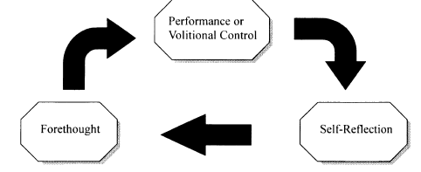
Figure 01: Zimmzerman's Model of Self-Regulated Learning
1.3.1.1.1. Forethought Phase:
This phase involves two distinctive but closely linked categories which are Task analysis and Self-motivational beliefs. Task analysis involves setting of goals and strategic planning. Goal setting for instance refers to choosing a specific and clear goal which the learner is willing to achieve after learning and performing, such as solving a group of division problems in mathematics during a study session (Lock & Latham, 1990). Moreover, the goal systems of highly self-regulated individuals are organized hierarchically. That is to say, the process subgoals serve as proximal regulators of more distal outcome goals. Not only that, but they become a part of personal meaning because they prove the existence of the progress of learning which consequently increases self-efficacy.
The second form of task analysis is strategic planning (Weinstein & Mayer, 1986). Learners need to choose the suitable method for the task and the settings to optimally perform or master a particular skill. Zimmerman (1989) argued that “self-regulated strategies are purposive personal processes and actions directed to acquire or display a skill”. That is to say, well selected strategies facilitate the process of goal achievement. Furthermore, Presseley & Wolloshyn (1995) stated that the appropriate selection of strategies helps in enhancing performance by aiding cognition, controlling affect, and directing motoric execution.
Self-regulatory strategies are not universally suitable for every person. Even if a strategy works for someone, this does not necessarily mean that it will work for all tasks or in all situations. Thus, learners have to choose the self-regulatory strategies wisely and accordingly with their contextual learning changes (Zimmerman, 2005).
1.3.1.1.2. Performance/Volitional Control Phase:
As well as forethought phase, the performance/volitional control phase includes two main processes: self-control and self-observation. Self-control processes such as self-instruction, imagery, attention focusing, and task strategies are used by learners to focus on the task and boost the efforts (Zimmerman, 2005).
Self-instruction involves the description –either overtly or covertly- of how to proceed as one accomplishes a task, such as solving a mathematics problem or memorizing a formula. Research on this issue shows that SI is such an effective strategy to improve students learning (Schunk, 1982).
Imagery or mental picture forming, for instance, is another self-control technique that is used widely. It helps in encoding and performance (Zimmerman 2005). In a series of influential studies, Pressley and colleagues (Pressley 1977; Pressley & Levin, 1977) taught learners to mentally construct some integrative images –a knife piercing a hat as an example in order to enhance their recall of these two items. Furthermore, some sports psychologists taught competitors such as skaters, drivers, and gymnasts to imagine themselves successfully achieving their planned routines to optimize their performance (Garfield & Bennett, 1985).
Attention focusing is designed to keep one’s concentration on the learning or performing processes, and to ignore other covert processes or external events (Zimmerman, 2005). Expert performers reported using several techniques to foster their attentional control, such as environmental structuring and slow-motion task execution to keep themselves focused on their goals as well as to assist coordination (Mach, 1991). Some psychologists as Kuhl (1985), studied the volitional control methods such as ignoring distractions and overlook past mistakes, and these methos were found to be effective. There is evidence that knowing how to concentrate and ignore external events is significant for effective studying (Corno, 1993, Weinstein, Schulte, & Palmer, 1987).
The second form of volitional/performance control is self-observation. The latter refers to the procedure of tracking one’s particular aspects of their own performance, the conditions affecting it, and its outcomes (Zimmerman & Paulsen, 1995). This skill may seem elemental but in fact it is not because the amount of information incorporated in complex performances may lead naive self-observers to disorganized or cursory self-monitoring. Expert observers on the other hand are able to selectively track themselves. For instance, concert pianists monitor their hands positions which allows them to make more fine-grained adaptations than novices (Mach, 1991).
According to Zimmerman (2005), there are several features that can affect self-observation effectiveness. The first one is temporal proximity of one’s self-observation which is a critical variable (Bandura, 1986; Kazdin, 1974). Delayed self-feedback can prevent a person from taking instant corrective action, such as monitoring an individual’s running time after the race is over instead monitoring it during the race (Zimmerman, 2000). The second feature deals with the informativeness of performance feedback (Zimmerman, 2005). Practicing a skill in the right settings can enhance the informativeness of the results (Ericsson & Lehman, 1996). Zimmerman (2005) exemplified that by” practicing sprints on an official 100-meter track permits runners to see if changes in technique improve their competitive speed”. Accuracy of self-observation is the third feature which deals with individuals who misperceive their own actions will not be able to correct them appropriately. For instance, there is evidence that speakers of minority dialects needed special training to distinguish enormous word pronunciations before they could practice in a self-corrective environment on their own (Ellis, 1995). A fourth feature of self-observation is the valence of behavior. Monitoring negative aspects of one’s functioning, such as the amount of smoked cigarettes or the dietary failure, can reduce motivation to self-regulate these activities (Kirschenbaum & Karoly, 1977). That is, sometimes it is better to record achievements rather than deficits because feedback about deficits can lead to self-criticism.
People start noticing frequent patterns of their functioning through observation of covert thought and emotional patterns as well as overt performance patterns, such as when or where a smoker craves for cigarettes or actually smokes them (Zimmerman, 2005).
Self-observation can lead to cycles of self-experimentation (Bandura, 1991). When self-observation of natural variations in behavior does not provide conclusive information, people can engage in personal experiment by changing the questioned aspects of their functioning systematically. For instance, if the urge to smoke seems random and spontaneous, the smoker can test other contextual hypotheses that may seem influential, such as the presence of stress, ash trays, or advertisements. Hence, systematic self-observation leads to greater personal understanding and performance (Zimmerman, 2005).
1.3.1.1.3. Self-Reflection Phase:
Two self-reflective processes that are closely related to self-observation has been identified by Bandura (1986) which are self-judgement and self-reflections. Self-judgement includes self-evaluating one’s performance and assigning causal significance to the results. Judging the relevance of one’s performance is relatively easy when it comes to simple objective outcomes such as judging the ability to swim, drive, or solve a mathematical problem. Whereas, high levels of proficiency can be judged using specific criteria, such as swimming 100 meters in a particular period of time (Zimmerman, 2005). Eventually, the adaptive quality of one’s self-reactions depends on the sensitivity of his/her self-judgments (Zimmerman & Paulsen, 1995). Thus, experts set challenging criteria for themselves (Ericsson & Lehman, 1996).
Zimmerman (2005) mentioned that people use four different types of criteria to evaluate themselves, which are mastery, previous performance, normative, and collaborative. Mastery criteria is based on graduated sequence of tests or test scores from low to high performance, such as the seven-points system used to rate tennis players. This criteria hierarchies have been used also in school for testing and curriculum selection, such as color-coded workbooks for level of expertise (Zimmerman, 2005). Covington & Roberts (1994) noted that the attainment of this criteria helps in the learning process which usually occurs through continuing practice.
Previous performance or self-criteria depends on comparing current performance to earlier levels of individual’s behavior, such as a baseline or the previous performance (Bandura, 1997). For instance, smokers can judge their progress of overcoming this habit by comparing the current and the previous number of smoked cigarettes. As mastery comparisons, self-comparisons involves the evaluation of changes made in functioning and this leads to an improvement in self-evaluation because of repeated practice (Zimmerman, 2005). In other words, using this type of criteria helps individuals or learners to enhance their self-evaluation.
Normative criteria on the other hand involves comparisons of one’s performance with others (classmates or national tested population). This type of criteria is based on the basis of the competitive nature of many human enterprises, such as employment and sales. Social rankings determine who deserves awards. For instance, the golden medal in Olympics is given to the person who comes first either he or she breaks the world’s record or not. Hence, a person must be better than the other competitors. One of the challenges of using the normative criteria is that it shifts one’s attention from selective self-observation to social factors,and consequently emphasizing negative thoughts. For instance, when a racer loses a race, he or she will compare his or her performance to others instead of his or her own previous efforts. In learning context, learners who focus on outcome goals are said to use normative criteria for self-evaluative judgments because achievements are competitively awarded and socially visible, such as grades in school (Zimmerman, 2005).
The last criteria used in self-evaluative judgments is the collaborative one. Bandura (1991) argued that a collaborative criterion is mainly used in team attempts. Under collaborative conditions, success is identified by fulfilling a certain role, such as the point guard on basketball team (Zimmerman, 2005). However, the criteria of success for a point guard are not the same for those in different team positions (Zimmerman, 2005).
Zimmerman (2005) stated that self-evaluative judgments are connected to causal attributions about the results which play a vital role in self-reflection. Attributions of errors to learning strategies are quite efficient in maintaining motivation in weak performance periods (Zimmerman, 2005). However, attributing errors to a fixed ability leads learners to react negatively (Weiner, 1979). Furthermore, self-evaluative attributional judgments are linked to two key concepts of self-reflections that are self-satisfaction and adaptive inferences. Self-satisfaction involves perceptions of satisfaction and dissatisfaction as well as the effect associated no matter how the performance is. The latter is significant since people seek satisfied actions and positive affect while avoiding the negative ones that cause dissatisfaction (Bandura, 1991; Zimmerman, 2005). Adaptive/defensive inferences are decisive decisions that people make to change their self regulatory approach during subsequent efforts to learn or perform (Zimmerman, 2005).; adaptive inferences are crucial because they guide people to adapt new and better forms of performance that help in self-regulation (Zimmerman & Martinez-Pons, 1992). On the other hand, defensive appearances are basically for protecting individuals from future dissatisfaction. These inferences include helpless procrastination task avoidance…(Zimmerman, 2005).
Because Zimmerman’s model of SRL is a cyclical one in which phases are interconnected, he (2005) claimed that these self-reactions influence forethought processes cyclically as well as future actions of one’s most important goals. For instance, self-satisfaction reactions reinforce self-efficacy beliefs about mastering an academic skill, learning goal orientations (Schunk, 1996), and intrinsic interest in the task (Zimmerman & Kitsantas, 1997). All these self-motivational beliefs construct a sense of personal agency about maintaining cyclical self-regulatory efforts and ultimately goals achievement.
1.3.1.2. Pintrich’s model of self-regulated learning:
Pintrich (2004) argued that there are four general assumptions that SRL models have in common. The active and constructive assumption which is the first one follows a cognitive perspective. Learners are seen as active participants in the learning process. They are assumed to construct their own meaning, goals, and strategies from the information available in both external and internal (their minds) environment. The second assumption stated by Pintrich (2004) is the potential for control assumption. It suggests that learners can potentially monitor, control, and regulate particular aspects of their own cognition, motivation, and behavior as well as some features of their environment. However, this does not mean that they are able to control every aspect at all times or all contexts. The third assumption is titled goal, criterion, standard assumption. It assumes that there is a type of goal, criterion, standard against which learners compare their efforts to assess themselves and decide whether the learning process should continue as it is or there are changes to be made. For instance, learners may set specific goals to strive for, monitor their learning progress, then adapt and regulate their cognition, motivation, and behavior to achieve their goals. The last assumption is that self-regulatory activities are mediators between personal and contextual characteristics and actual achievements or performance. That is, learners' achievements and learning process are not only influenced by their cultural, demographic, and personality characteristics but also by their self-regulation of the cognitive, motivational, and behavioral aspects (Pintrich, 2004).
Based on the mentioned assumptions, Pintrich (2004), in his article “A Conceptual Framework for Assessing Motivation and Self-Regulated Learning in College Students” suggested a conceptual framework for self-regulated learning. This framework involves four phases with four areas of regulation. The first phase he mentioned is “The Forethought, Planning, and Activation Phase” which deals with the cognitive and metacognitive processes. It involves planning, goal setting, activation of perception and the prior knowledge about the performed task as well as the context (Pintrich, 2004). The second phase stated by Pintrich (2004) is “The Monitoring Phase”. It is concerned with several processes that are related to metacognitive awareness of distinct aspects of the self, task, or context. The third phase is “The Control Phase” which involves different efforts made by individuals to control and regulate particular aspects of the self, task, or context. The last one is “The Reaction and Reflection phase”. However, Pintrich (2004) emphasized more on the areas of regulation which are explained below.
1.3.1.2.1. Regulation of Cognition:
Cognitive control and regulation include the types of cognitive and metacognitive activities, strategies, and tactics that individual learners rely on to adapt and change their cognition to achieve their goals effectively. For instance, it is assumed that attempts to control, regulate, and change cognition should be related to cognitive monitoring activities that provide information about the individual’s current progress in relation to the set goal. For example, if a student reads a textbook not only to finish it (as an assignment) but to understand it as well, when the student monitors his/her comprehension, this monitoring process helps that student to decide whether to change reading strategies or not (Pintrich, 2000).
1.3.1.2.2. Regulation of Motivation and Affect:
As well as the regulation of cognition, the regulation of motivation and affect is another aspect of self-regulation. Motivation and affect regulation includes attempts to regulate several motivational beliefs such as goal orientation (purposes for doing a task), self-efficacy (judgements of competence to perform a task), perceptions of task difficulty and task value beliefs (beliefs about the importance, utility, and relevance of the task)... (Pintrich, 2004).
In addition to these motivational beliefs, students can control their affect and emotions using several adapting strategies that help them manage negative affect such as fear and anxiety (Boakaerts, 1993; Boakaerts & Niamivirta, 2000). Moreover, the motivational self-regulatory strategies involve attempts to control self-efficacy using positive talk (Bandura, 1997). Students may also try to increase their extrinsic motivation for performing a task by promising themselves rewards or making positive activities (watching TV, taking a nap, talking to a friend...)
1.3.1.2.3. Regulation of Behavior:
Another aspect of self-regulation is behavior regulation. Individuals attempt to control their own overt behavior. In academic learning, students rely on effort planning and time management as a kind of behavioral control. Efforts control includes attempts to control learners’ efforts to do better in a specific course. Time management on the other hand refers to the students' strategies to schedule their time for studying. For instance, students who engage in time management activities are said to be high achievers (Pintrich, 2004). Another behavioral strategy that can be very helpful for learning is help-seeking (Pintrich, 2004). Apparently, good students and good self-regulators are aware of when, why, and from who to ask for help when needed (Karabnick & Sharma, 1994; Newman, 1998; Ryan & Pintrich, 1997). Additionally, help-seeking is listed as a behavioral strategy because it involves the person’s own behavior (when, why, and whom to ask).

1.3.1.2.4. Regulation of Context:
Contextual control processes involve efforts to regulate and control the task and context that students encounter in the learning environment (Pintrich, 2004). Task or context control may be much more challenging compared to cognition, motivation, and behavior regulation because both the task and the context are always under the students’ direct control. In traditional classrooms, the teacher/instructor regulate most aspects of the learning environment. Thus, there may be little chance for students to engage in contextual control. On the other hand, in more student-centered classrooms, students are required to regulate and control the academic tasks, context, and classroom climate/structure more (Pintrich, 2004).
Students are often asked to design their own projects/experiments, work collaboratively, design how their groups will collect data or perform a task, and even consult with the teacher to determine how their evaluation will be. This type of classes helps student become more responsible and autonomous because they have more opportunities to control and regulate the tasks and context (Pintrich, 2004).
Even outside classrooms and lecture halls, students have to be able to control and regulate their studying environment. Learners monitor the study environment to be more conductive for studying by avoiding distractions such as music, TV, talkative people, or even having an organized place only for studying (Pintrich, 2004).

1.3.1.3. Boekaerts Model of Self-Regulated Learning:
: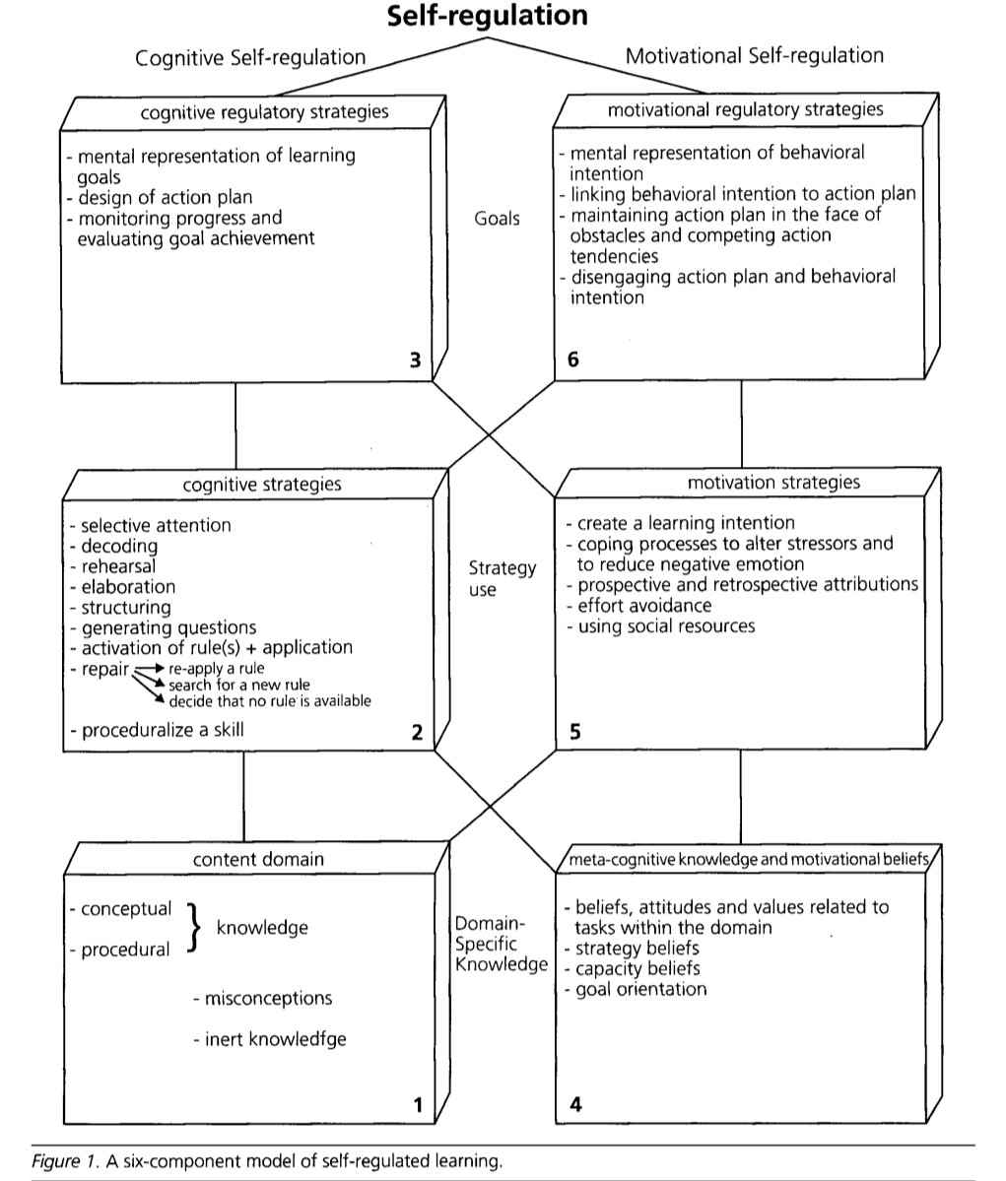Figure 02: Boekaerts Model of Self-Regulated Learning
Boekaerts (1996), proposed a new model for SRL. This model involves two parallel but strongly interrelated regulatory systems, namely the cognitive self-regulation system and the motivational self-regulation system. These two systems share three key aspects which are domain-specific knowledge, strategy use, and goals. Moreover, the strategies used by learners differ at each level and from a system to another. For instance, within the cognitive self-regulation system and at the level of goals, learners construct a mental representation of the learning goals. In contrast, they form mental representation of behavioral intention within the motivational self-regulatory system.
To clarify her model of SRL, Boekaerts (1996) used an imaginary example of a student who has to prepare for a history exam. The student "Theresa" has already an idea about the self-regulatory activities that will help her to pass the exam. She firstly orients herself on the type of material she is going to study. Then, she organizes that material into several meaningful sets and allocates time for the study of each set. After that, she begins studying the first material set, determining the most important points, and writing them down in her scrap book. Theresa tries to organize these points in a way that helps her revise them when she completes reading the other sets. She uses several strategies such as incorporating the examples given by the teacher in classroom or the ones she picked up from the TV, summarizing the material in form of charts, tables, or diagrams. When the material is finally clear and understood, she lists the major points in her own order to save time and effort. Because she sees a steady progress, Theresa feels motivated to continue the learning activities. When she encounters a difficulty in mastering the learning material, she does not feel discouraged, but she attempts to represent it in other ways to find the most helpful representation. In case Theresa feels that there is no way to master the learning material, her anxiety levels increase. Her teacher coached her in self-regulation, and she is totally aware that anxiety has a negative effect on motivation, and it will make her less self-regulated. Thus, she realizes that anxiety is a part of exams preparation, and all her peers feel the same as she does. Hence, Theresa feels less anxious and change the task to an easier one which makes her more motivated (Boekaerts, 1996).
That is to understand from this example is that cognitive and motivation strategies are linked aspects of self-regulation. Furthermore, the three levels mentioned earlier affect one another. For instance, at the level of strategy use, when a learner fails to focus or maintain attention on the learning material (within the cognitive self-regulation system), he/she will not be able to create a learning intention (within the motivation self-regulation system). Thus, according to Boekaerts (1996), the two systems are intertwined and influenced by one another under the broader concept of SRL.
2. Speaking
2.1. Speaking Skill
Speaking is an undervalued skill compared to the literary skills; perhaps, it is because we take this skill for granted (Bygate, 1987). Because of the latter, we forget how we struggled to acquire the ability of speaking. For instance, we have to do it all again when learning a foreign language (Thornbury, 2005).
When talking about someone who is said to know a language, usually we are referring that this person is able to speak by producing meaningful sentences in that language (Kürüm, 2016). That is to say, speaking is a significant indicator if a person knows a certain language or not.
In literature, speaking skill has been defined in many ways. One of those that SS is a basic need for humans which allows them to express their thoughts, views, and opinions (Akhter, 2021). Furthermore, it is said that speaking skill is a compound process that involves both sound and meaning which are implemented in real-life situations; complete speaking instruction should address contextual discourse issues and phonemes as isolated and contrasting sounds simultaneously (Egan, 1999). Another definition that addresses SS is that it is a skill used mainly for communicative purposes such as informing, persuading, and problem solving. For instance, it is a basic element in our daily life that we use it to give directions and asking for or providing information (Mead & Rubin, 1985). Levelt (1994) defined it as a form of goal-oriented behavior in which the speaker conceptualizes some communicative intention, and eventually informs the interlocutor about something, commit a speech act such as request, or share irritation or elation about something. Thus, in all these cases, the speaker must select an expression to present his or her information.
Hence, speaking is considered as one of the most important skills in human beings’ lives that allows them to communicate and exchange thoughts and information using verbal expressions.
2.2. Speaking Performance:
The concept of performance refers to the overtly observable and concrete ability to manifest one’s underlying knowledge of a system, event, or a fact. Hence, it is the actual doing of something such as walking, singing, or speaking (Brown, 2014). Linguistically speaking, performance is individuals’ ability to use language in concrete situation and their actual production (speaking, writing) or comprehension (listening, reading) of linguistic events (Chomsky, 1965; Brown, 2014). According to the previous definitions, speaking performance can be defined as individuals’ (learners in our case) ability to perform the act of speaking in real-life situation by using meaningful sentences and expressions.
2.3. Speaking Performance Features:
2.3.1. Fluency:
One of the main goals of second language learning is to reach communicative fluency which is the ability to use language effectively and naturally in real-life conversations (Brown, 2014). In order to reach this goal, ESL or EFL learners need to acquire several key concepts that are adequate vocabulary, good pronunciation, accuracy, as well as acceptable fluency (Rao, 2018). Fluency is of a major importance in EFL learning context because it facilitates the communication process by providing a meaningful speech that sounds like a native speaker side by side to the other features (Rao, 2018). Hence, fluency is considered as the ability to speak smoothly, almost like a native speaker. According to Richards (2006), fluency is the spontaneous use of the language in meaningful contexts where the speaker can manage to carry on with a conversation regardless the faced limitations in language ability. Although fluency also involves reading and writing, it is generally related more with speaking, and listening fluency gets overlooked (Brown, 2017). That is, speaking fluency is of more interest compared to writing, reading, and listening fluency.
Due to its significance in EFL context, students attempt to develop their fluency levels. There is usually a conflict between teachers and students at this level. Teachers believe that communicative activities are most effective for fluency development. However, ESL/EFL students tend to believe that traditional learning activities such as grammar exercises and rote memorization are better (Troyer et al., 1996).
There are different techniques in which fluency development can be addressed. For doing so, teachers can encourage students to make constructive errors by stating that errors making is a part of the learning progress which helps them commit more to speaking. They can also generate opportunities for their learners to practice their language more because focused practice on oral English for a long period of time enhance fluency (Papajohn, 1998). Another way to improve EFL learners’ fluency is by creating activities that force students to focus on fluency rather than accuracy such as role playing and debates. Additionally, teachers may assess students’ fluency using interactive tests as interviews (Troyer et al., 1996).
2.3.2. Accuracy:
It is well-known that EFL learners must respect some elements in language learning for better speaking, such as grammatical structures, appropriate vocabulary use, and a certain extent of accuracy. Alongside fluency, accuracy is one of the necessary features of the speaking skill (Golkova & Hubackova, 2014).
In EFL learning context the concept of accuracy (as one of the speaking skill’s features) has been defined by many researchers and scholars. Derakhshan et al., (2016) noted that speaking accuracy is learners’ ability to use target language vocabulary, grammar, and pronunciation appropriately. Accuracy was defined by Nuan (2015) as the extent in which learner’s speech is grammatically accurate with clear and comprehensible pronunciation and appropriate vocabulary choice. He (2015) defined it also as the extent to which a non-native speaker’s pronunciation is close to that of a standard variety of the target language. Accuracy has been defined also as one’s ability to produce similar linguistic structures to the target language with less errors (Housen et al., 2009).
According to these definitions, accuracy hence, plays a pivotal role in the process of EFL learning. That is, it addresses significant elements, such as the correctness of grammatical structures, well-chosen vocabulary, and the appropriate pronunciation of target language sounds, which are crucial features for enhancing learners’ speaking skills.
2.3.3. Pronunciation:
When learning a SL or a FL, learners must be careful that TL consists of essential skills such as writing, reading, or speaking, and other subskills such as pronunciation. The latter is a significant aspect of effective communication and represents a fundamental aspect of language proficiency. Accurate pronunciation does not only enhance overall language skills but rather leads to clear and comprehensible interaction (Mahmoud, 2024).
As well as speaking fluency and accuracy, pronunciation plays a vital role in language learning and in speaking skill as such since it is connected with the productive sounds system. Hence, pronunciation is a main feature of speech production and without it there will be no spoken language and no communication (Gilakjani & Sabouri, 2016; Gong, 2002).
When we talk about the concept of pronunciation, we are usually referring to the interconnected system of sounds and prosody that deliver meaning through categorical contrasts (e.g., phonemes), systematic variations (e.g., allophones), and individuals variations that may mark gradient differences such as gender, age, and origins (Levis, 2018). Hussain (2017) defined pronunciation as the way of speaking a language using the appropriate stress, rhythm, and intonation. In a bit old literature, Kenworthy (1987) explained the concept of pronunciation as a complex process in which individuals produce oral utterances depending on the combination of sounds (vowels and consonants), the linkage of these sounds (the construction of words), word stress, and the rhythms (the tone used to utter the words). Sardegna & Jarosz (2023) noted that learning English pronunciation depends on learning to produce speech which is different in many aspects from the learners’ first language. That is, pronunciation is a compound process that requires language learners to focus on a lot of elements such as sounds articulated, words, and rhythms.
Pronunciation is the most important sub-skill of English language besides other sub-skills such as grammar, vocabulary, and pragmatics. With good pronunciation the message will be delivered intelligibly, but if the speaker’s pronunciation is bad, he or she will not be understood (Fraser, 2000).
- Self-Regulation in EFL Context:
It is documented that self-regulation is the bedrock for healthy psychological functioning. Individuals who are regularly successful at self-regulation benefit from a sense of psychological stability and personal control that allow them to manage their perception of themselves as well as how they are perceived by others. People who usually fail to maintain self-regulation experience none of the psychological benefits that are derived from psychological stability, and they struggle with mild to severe forms of psychopathy. Hence, self-regulation is an essential element for adaptive functioning (Hoyle, 2010).
Academically, self-regulation plays an important role as it functions as a mean of developing life-long learning skills. For instance, self-regulated students focus on the way they activate, alter, and maintain specific learning practices in social and solitary context (Zimmerman, 2002). Applying self-regulatory processes increases students' awareness about their academic achievements. Learners who are self-regulated does not enhance their overall achievements only but their perception of self-efficacy, control over the learning process, and their studying skills (Zimmerman et al., 1996). Thus, EFL learners may implement SRS to setting the suitable strategies, monitoring the behavioral and contextual conditions, and reflecting on the learning process to enhance and develop their levels. Öztürk & Ünal Çakıroğlu (2021) stated that self-regulated learning strategies positively affect EFL learning skills namely grammar, writing and speaking. Hence, SRS are vital in the learning process as well as in EFL learning context as it enables students to regulate and keep on track their learning progress.

Chapter Two
Research methodology, data analysis, and interpretations of the findings

Introduction:
In this chapter, we present, analyze and discuss when we carried out this investigation on Master one students at the English department about the impact of self-regulation on students speaking performance
1. Population and sampling
1.1. Population
The population of this study is Master One students in the English department at Mohamed Boudiaf M’silla, during the academic year 2024/2025. The reason why this population was chosen is that they have the suitable academic level, meaning that they already have an established foundation in English language use and academic speaking tasks. At this level of study, the students are expected to engage in various speaking activities, such as presentations, discussions, and oral exams, and thus, they make a viable population for studying the relationship between self-regulation and speaking performance. The total population is made up of approximately 130 students.
1.2. Sampling
The present study employs a convenience sampling method in selecting the participants from the target population. A total of 65 Master One students took part in the survey. Convenience sampling was utilized due to time constraints, accessibility, and voluntary nature of participation. This non-probability sampling technique allows the researcher to gather data in a quick and efficient way by enlisting the participants who are readily accessible and agreeable to participate. While the process may limit generalizability, it provides a viable means for exploratory research on the topic.

2. Research methodology:
2.1. Research Approach
This study utilizes a quantitative research paradigm. The quantitative paradigm was used as it allows the researcher to measure and investigate the relationship between variables—i.e., the use of self-regulation strategies and students’ speaking performance. With numerical information collected using a structured questionnaire, this approach allows for objective investigation and derives patterns and relationships present within the target group. The use of standardized data collection also achieves maximum reliability and comparability of findings.
2.2. Research Design
The research uses a descriptive correlational design. The rationale for this is that the research aims to describe how high or low Master One students are, in terms of self-regulation, and explore the potential correlation between their self-regulation and speaking ability, without intervening with any variable. The descriptive element allows one to properly describe the participants’ attitudes and behavior, whereas the correlational element allows one to test whether there is a statistically significant relationship between the two independent variables. The design can be applied to study naturally occurring incidents in an educational context.
2.3. Research Tool:
The findings of this paper are based on one data collection tool. Because it is easy to use and the most suitable tool in our case, since students feel more comfortable and able to express themselves about the topic. The questionnaire was handed out during normal TD sessions to master one English students.

2.4. Validity and Reliability of the Instrument
Before use of the questionnaire, face validity was established via two academic supervisors whose feedback on the items made them clear, relevant, and in line with research objectives. Their feedback served to make the questionnaire appear appropriate and understandable to the intended participants.
A test-retest procedure was employed in an effort to determine the reliability of the instrument. The same group of students filled out the questionnaire on two occasions, and there was a 5-day break between the two test sessions. The test was administered online, and data analysis was performed using Pearson’s correlation in Excel to determine whether the results were stable across time.
The self-regulation items obtained a correlation coefficient of r = 0.963, while that of speaking performance section was r = 0.960. These are measures of extremely high reliability, confirming internal consistency and temporal stability in the questionnaire.
2.5. Data Analysis Procedures
After the data had been collected, the answers were entered and examined through Microsoft Excel. The analysis was done to search for trends and relationships among students’ self-regulation strategies and speaking performance.
The following statistical measures were used for interpreting the data for purposes of interpretation:
Mean: To determine the mean response level per item and to search for common trends among the participants.
Standard Deviation (SD): To find the degree of variation or dispersion from the mean, which was utilized in order to find out how homogeneous or heterogeneous the students’ answers were.
Pearson Correlation Coefficient ®: In order to examine the relationship between self-regulation and speaking performance and test whether higher levels of self-regulation are associated with better speaking performance.
Significance Level (p-value): In order to test if the observed correlation was significant or random.
These software packages provided a comprehensive overview of the information and helped in responding to the research questions adequately.
2.6. Students’ questionnaire
2.6.1. Questionnaire description
The soul objective of this instrument is to gather date for analyzing the impact of self-regulation on student’s speaking performance. It consists of two main sections. The first section gathers demographic information, the second section contains 14 items designed to measure two variables: self-regulation and speaking performance.
The self-regulation section includes items that targets its main aspects such as goal setting, self-monitoring, time management and self-evaluation. While the speaking performance section aims for assessing student’s confidence, accuracy and fluency.
All the items are measured using 5-point Likert scale, ranging from strongly disagree (1) to strongly agree (5). The questionnaire was distributed to 65 master one English language students using convenience sampling.

2.6.2. Data analysis and interpretation of the questionnaire
2.6.2.1. Descriptive statistics of close ended questions:
Section one: demographic information
- Gender distribution:
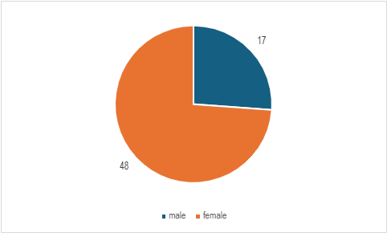

Figure 03: Distribution of students' gender
Based on the data that is shown in the pie chart above, the female participants outnumber the males in our sample. 74% is the percentage of female participants, representing 48 students while the male students make up only 26% that equals 17 participants, the dominance that the female part has on this field of study can be attributed to multiple factors such as socio-cultural and demographic factors.
- Age :
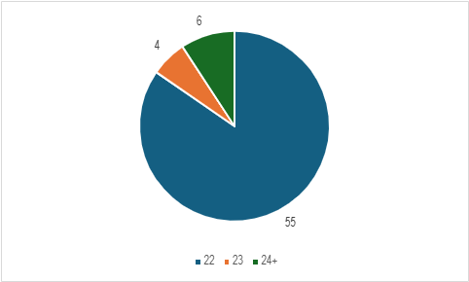

Figure 04: Age range of students
The aim of the question was to identify the age groups of the students in our population. The dominant age group in our sample is 22 years old students by 55 participant which represents 85% of the whole sample, while students older than 24 represent 9% (6 students) and the age group of 23 years old students account for 6% of the sample (4 students).
Section two:
- I set specific goals to improve my speaking skills.
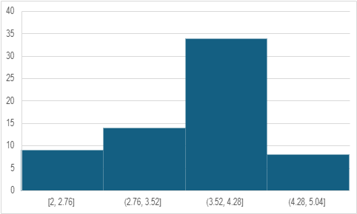
Figure 05: objective setting for speaking skill improvement
The data shows that 56.9% of students, which represents 37 participant from our sample, choose “agree” and “strongly agree” this indicates that students have a good self awareness since they can identify what the need to learn and what to improve. Some students replied negatively to the statement by choosing “disagree” this could be due to multiple reasons such as lack of ambition and motivation or simply being good enough from their perspective.
- I organize my speaking practice affectively.

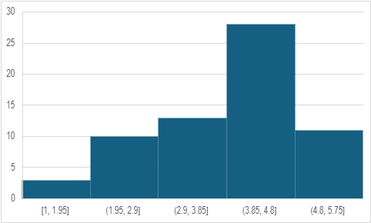
Figure 06: Use of organization strategies in speaking practice
Most students choose “agree” and “strongly agree”, the group of students who choose positive replies contains 39 student which represents 60% of the sample. This indicates a good planning skill and foresight, however some students choose negative replies. 20% (13 students) of the participants choose “disagree” and “ strongly disagree” this can be the result of various reasons like ignorance and lack of training.
- I monitor my speaking progress regularly.
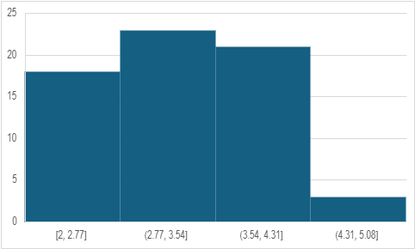
Figure 07: Monitoring progress in speaking skills
The data in the graph above indicates that students monitor themselves and the progress they made. This lines up perfectly with the data from the previous graphs, in this one 40% (24 students) of the participants replied positively while 26% (17 students) replied negatively. The reason behind the negative reply can be due to various reasons such as the focus on the other academic skills that are seen as more important in the academic path.
- When I face difficulties in speaking, I look for solutions.
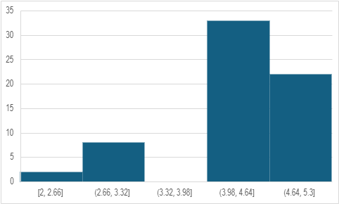
Figure 08: Problem solving approaches during speaking tasks
Most students choose “agree” and “strongly agree” they make 85% (55 students) of the whole sample this data prove even further that students are self-aware and able to think critically. Some students, 15% (10 students), did answer with “disagree” and “strongly disagree” this could be due to their poor problem-solving skill and the lack or the limited ability to think critically
- I reflect on my speaking performance to identify my weaknesses.
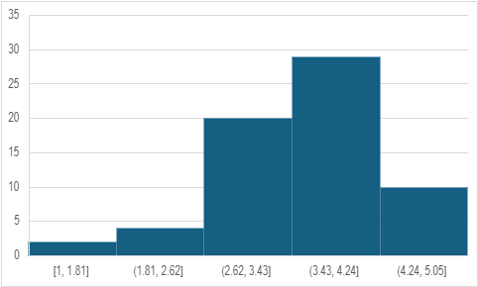
Figure 09: Frequency of self-assessment in speaking
The graph above expresses students self-assessing skill. It shows that the majority reflects on itself to identify their weaknesses, the students that choose “ agree” and “strongly agree” represents 60% (39 students) of the sample while only 9% (9 students) choose “disagree” and “strongly disagree” this can be because of different reasons such as the lack of desire to improve or the lack of self-awareness.
- I ask my peers or teachers for feedback to improve my performance.
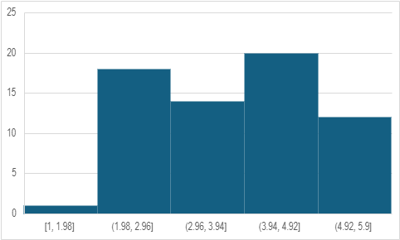
Figure 10: Use of peer and teacher's feedback in speaking development
Most students choose “agree” and “strongly agree” where the first category contains 20 student while the second contains 12 student, combined they make 32 participants which is 49% of our sample. This confirms that asking for feedback is the strategy that students use when looking for solution. Students who gave negative responds “disagree” and “strongly disagree” are in total 19 student which makes 29% this could be due to several reasons such as lack of interest or lack of social skills.
- I change my speaking strategy according to my progress
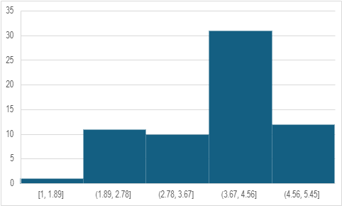

Figure 11: Adaptation of strategies for speaking improvement
The data in the graph shows that the majority of the students choose positive responses “agree” and “strongly agree” where both groups combined equals 66% ( 43 students) of our sample. This indicates that students possess good cognitive abilities that help them navigate and adapt while being in the process of learning and according to their progress. Some students replied negatively with “ disagree” and “ strongly disagree” 18% ( 12 students) this could be to various reasons like lacking a goal and a learning strategy from the beginning.

Section three:
- I feel secure when speaking in English.
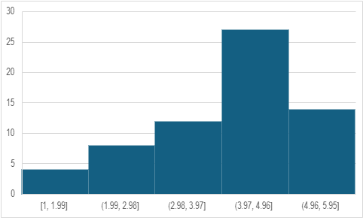
Figure 12: confidence levels when speaking

Most students choose “agree” and “strongly agree” where the first category contains 27 students while the second one has 14 students, combined they make a total of 41 student which is 63% of the sample. This result shows that students have high sense of self esteem which is natural for those who use self regulation regularly. Students who gave negative responds “disagree” and “strongly disagree” are in total 12 student which makes 18% this could be due to several reasons such as their lack vocabulary, proper accent or grammatical error.
- I participate actively in speaking activities (e.g. classroom discussions)
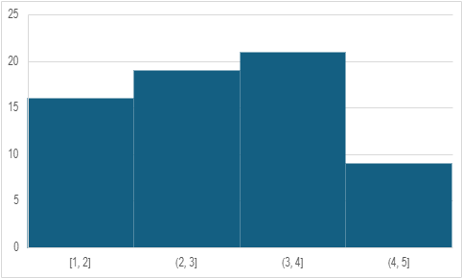
Figure 13: Participation rates in speaking activities
As it is shown in the graph, the majority of the students avoid being active in classroom speaking activities as they make 55% (35 students) of the sample, they all responded negatively with “disagree” and “strongly disagree”. This can be due to social anxiety, performance pressure or the topics and nature of the classroom.
- I practice speaking English outside classroom.
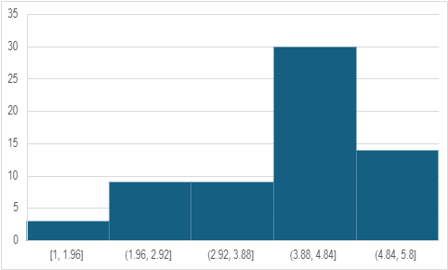
Figure 14: Use of spoken English in daily life

The data in the graph above indicates that students use and practice the spoken language in day to day communication. 67.6% (44 students) of the sample picked “agree” and “strongly agree” this leads us to believe that the lack of participation in the classroom discussions can be due to performance pressure and the nature of the topics. While only 18.4% (12 students) choose “disagree and “strongly disagree”, this could be due to a set of different reasons among them lack of partners.
- I struggle with fluency when speaking.
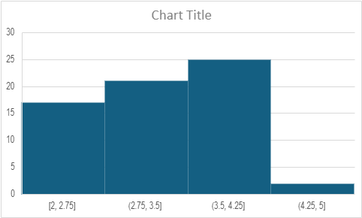

Figure 15: Reported issues with fluency

The data shows that students have a problem when it comes to fluency, this can be the result of the lack of exposure to authentic materials. 41.5% (27 students) choose “agree” and “strongly disagree” while 26% (17 students) choose to disagree with the statement. It can reflect a variety of reasons like lack of research knowledge or the absence of guidance.
- I struggle in pronunciation when speaking.
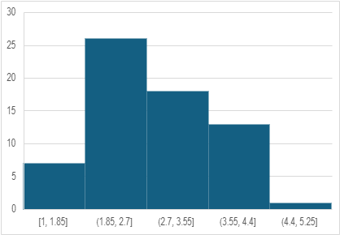
Figure 16: Reported pronunciation difficulties
As shown in the histogram, students do not have an issue in pronunciation ; since 33 students, which equals 50.7% of the sample, choose “disagree” and “strongly disagree’’, this can be the result of daily conversations, extensive listening and exposure to authentic audio materials.
- I struggle with vocabulary when speaking
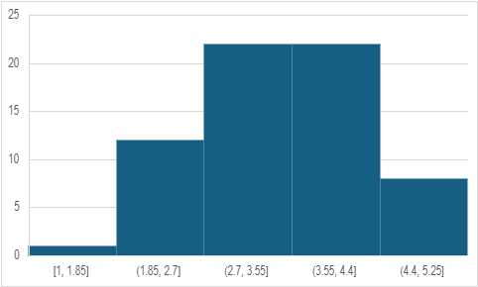
Figure 17: Perceived lack of vocabulary
Most students choose “agree” and “strongly agree” where the first category contains 22 students while the second one has 8 students, combined they make a total of 30 student which is 46% of the sample. This can be due to lack of reading and research. Students who gave negative responds “disagree” and “strongly disagree” are in total 13 student which makes 20% this means that they find no struggle in finding vocabulary when speaking.
- I struggle with grammar when speaking
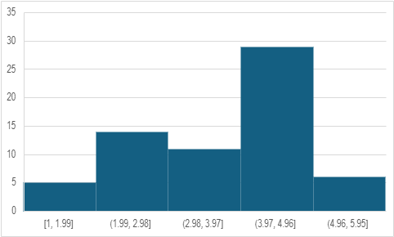
Figure 18: Reported grammar challenges in speaking
As it shown in the graph above, most students choose “agree” and “ strongly agree” they make in total 54% (35 students) they all have an issue with grammar, this can be a result of lack of practice and lack of knowledge. Some students choose “ disagree” and “strongly disagree” they make 29% ( 19 students) these students have no problems regarding grammar and its application in the speaking process.
Table 01: Table of means and standard deviation
Means and Standard Deviation.
 | Self-regulation | Speaking performance
Overall mean | 3.5 | 3.2
Standard deviation | 0.54 | 0.52

2.6.2.2. Descriptive Statistics Summary
The descriptive statistics revealed that students reported a moderate level of self-regulation within their speaking behavior, with a mean score of 3.5 (SD = 0.54) on a 5-point Likert scale. This means that, overall, participants are using self-regulatory behaviors—e.g., goal-setting, self-monitoring, and seeking feedback—on a fairly frequent basis. The low standard deviation is indicative of a relatively uniform pattern of responses throughout the sample.
Similarly, the mean rating of speaking ability was 3.2 (SD = 0.52), reflecting a slight to neutral self-rating of speaking ability on the part of the respondents. Again, the low standard deviation suggests that student responses bunched tightly around the mean, reflecting a consensual perception of speaking ability.
These findings provide a good foundation for research on the relationship between speaking performance and self-regulation. The moderate levels and low variability in both variables indicate that the students view their self-regulation and their speaking abilities within a similar range, which provides assurance for conducting a correlational analysis on the two measures.
Table 02: Table of correlation and significance
Correlation between self-regulation and speaking performance.
Variables | r | t-value | p-value
Self-regulation and speaking performance | 0.28 | 2.31 | 0.023

Note: n= 65, significance level= 0.05
As it is shown in Table 02, a Pearson product-moment correlation coefficient was calculated to establish the correlation between speaking performance and self-regulation among the Master One students. The results were significant at p =.023, r(63) = 0.28, which indicates a positive correlation between the two variables. It suggests that students’ speaking performance is likely to enhance as levels of self-regulation are high. The t-value of the correlation was 2.31, greater than the critical value at the 0.05 significance level, once more proving the validity of the result. While the strength of the correlation is classified as modest by the standards of Cohen (1988), statistical significance indicates that the relationship obtained will not happen by chance. These findings verify the hypothesis that self-regulation has a considerable impact in cultivating students’ oral performance in learning contexts.

Section four: open-ended questions
Question one:
The answers to the open-ended question, “What strategies do you use to enhance your speaking skills?” demonstrated students’ dependence on independent learning habits. The most repeated theme was resorting to authentic materials—films, podcasts, and songs—indicating natural language exposure for listening and pronunciation enhancement. This falls under Zimmerman’s (2000) self-regulatory model, mainly during the forethought and performance stages when students set goals and engage in strategic action. In addition, native speaker interaction was also mentioned by a number of participants, which is a sign of active use and utilization of social interaction as a learning strategy. Furthermore, some of the students indicated that they monitor and assess their speaking performance, which shows the presence of metacognitive strategies for self-regulated learning.
These findings confirms the idea that successful learners actively engage in managing their language development through deliberate strategy.
Question two:
In response to the question, “What are the challenges you encounter in your speaking practices?” students identified a number of shared challenges. Among the most frequently mentioned challenges was the lack of time management and discipline, which indicates a deficiency in the planning and doing phases of self-regulated learning. In addition, most participants mentioned linguistic constraints such as poor vocabulary, grammatical problems, and low fluency, all of which can deter confidence and motivation to practice speaking activities. Most also mentioned anxiety, in the form of fear of making errors or being evaluated, which can interfere with the self-reflection stage and prevent learners from initiating or maintaining practice. Finally, some responses suggested an absence of support or direction, suggesting that while students are willing to self-regulate, they do not necessarily have the scaffolding or feedback they require to do this effectively.
These concerns underline the merit of both internal processes, such as self-discipline and emotional regulation, and external processes, such as instructional support, in affecting learners’ abilities to regulate their speaking development.
The open-ended responses provided more information about the participants’ perceptions about self-regulation. Students predominantly named time management as a significant feature of both self-regulation and speaking performance. These perceptions are confirmed by the quantitative data, where there existed a positive correlation between self-regulation and speaking performance (r = 0.28, p =.023). It seems that students who felt more in control of their study habits were more confident and effective with their speaking tasks.
2.7. Discussion of the findings
The present study aimed to investigate the relationship between self-regulation and speaking performance of Master One students. The results showed a statistically significant positive correlation between the variables, r(63) = 0.28, p =.023. This suggests that students with higher levels of self-regulation perform better in speaking tasks. Although the correlation is small by Cohen’s (1988) standards, that it is significant supports the stance that self-regulation can have a major influence on academic oral performance.
Qualitative comments from the participants provided further insight into this relationship. The majority of students credited good speaking performance to their ability to remain disciplined, focused, and organized in their study habits. These responses are in line with the statistical results and provide real-world context to support the claim that self-regulated learners have a greater likelihood of performing well in speaking situations. Besides, some students listed emotional regulation and motivation as factors, highlighting the multidimensionality of language learning self-regulation.
Implications
The findings of this study have some pedagogical implications in EFL learning and teaching. The positive relationship between self-regulated behaviors and speaking performance suggests that self-regulation strategies can be a good tool to enhance learners’ oral proficiency. Teachers may consider the integration of SRS such as planning, goal setting, self-monitoring, and self-reflection into classroom activities. These strategies encourage EFL learners to be more independent in their learning which helps in the development of greater fluency, greater motivation, and self-efficacy.
Moreover, curriculum designers can recognize the importance of psychological and metacognitive factors in language development. Hence, the teaching instructions may include training in learners’ SRL techniques. Providing learners with opportunities to plan, regulate, and evaluate themselves maintains a sustained learning progress and overall engagement.
In summary, the results of this study support the contention that self-regulation is highly related to speaking performance among university-level language learners. The results contribute to the current body of evidence for the application of self-regulation strategies in language teaching to enhance learners’ academic and communicative proficiency.
Limitations
As any other research, the current study has some limitations. The fact that only 65 students were sampled in one department and in a single academic level hinders the generalizability of the findings. Additionally, the convenience sampling may result in bias as the participants may not represent the general population. Moreover, this study utilizes self-reported information that can influence the participants’ willingness to provide honest answers.
Future research can address these constraints through sampling a larger and a more representative population across multiple institutions. Experimental or longitudinal designs can also be used to examine the causal effect of self-regulation training on speaking performance at different time points, as well as on role of self-regulation in the development of other language learning skills such as writing, reading, or listening. Examining individuals’ integration of only one self-regulatory strategy such as planning or goal setting can also provide greater insight into their effects on speaking performance as well as on the other LLSs.
General Conclusion
Self-regulation refers to the way individuals control and manage different aspects such context, behaviors, and metacognition for better learning outcomes or a better performance. Because of that, SR plays an important role in the process of learning. Thus, EFL learners may benefit from self-regulation strategies to enhance their language learning skills and mainly speaking due to its importance.
The current study’s data were collected through an analytical Likert-scale questionnaire. A convenience sample of 65 students was selected from a population estimated 130 students. The data revealed a significant correlation between the implementation of SRS and speaking performance of EFL master one Linguistics students of Mohammed Boudiaf-University of Msila.
The data revealed a significant correlation between the implementation of self-regulation strategies and EFL learners speaking performance i.e., SR has an impact on EFL M1 Linguistics students in M’sila University speaking performance. The students reported the application of planning, monitoring their learning progress for better speaking, and reflecting on the results in order to adjust their plans.
The findings support previous research that emphasized the role of self-regulated learning strategies to enhance language and academic performance proficiency. Self-regulation enables students to plan, monitor, and reflect on the learning process, which can actually influence their speaking confidence and preparation. The positive correlation identified in this study may be an index of students’ ability to manage time, beat anxiety, and practice regularly—factors widely known to influence speaking ability.

ملخص
تسعى هذه الدراسة إلى استكشاف كيفية استخدام متعلمي اللغة الإنجليزية كلغة أجنبية لاستراتيجيات التنظيم الذاتي بهدف تحسين مهارة التحدث، وذلك من خلال دراسة حالة طلبة السنة الأولى ماستر بقسم اللغة الإنجليزية في جامعة محمد بوضياف بالمسيلة. وانطلاقًا من أن التحدث مهارة معقدة تتطلب مجهودًا معرفيًا وانفعاليًا في آن واحد، تركز الدراسة على كيفية تطبيق المتعلمين لاستراتيجيات التنظيم الذاتي مثل تحديد الأهداف، والمراقبة الذاتية، والتفكير التأملي، من أجل تنظيم سلوكهم وتحسين أدائهم الشفهي.تم جمع البيانات باستخدام استبيان قائم على مقياس ليكرت، وشمل عينة ميسّرة مكونة من 65 طالبًا من أصل 130 طالبًا يشكلون المجتمع الأصلي. وقد كشفت النتائج عن وجود علاقة إيجابية بين ارتفاع مستوى التنظيم الذاتي وتحسن الأداء الشفهي، خاصة من حيث الثقة بالنفس، والطلاقة، والانخراط في المهام. وتشير هذه النتائج إلى أن تنمية مهارات التنظيم الذاتي قد تسهم في تعزيز قدرة المتعلمين على التواصل الشفهي داخل بيئات التعلم. وتخلص الدراسة إلى ضرورة إدماج تدريب المتعلمين على التنظيم الذاتي ضمن المناهج التعليمية التي تركّز على مهارة التحدث، وذلك بهدف دعم استقلالية المتعلم وتحسين أدائه.

Reference List
Ahmed, M. Y. A. (2020). Developing the speaking skills of English as a foreign language (EFL) preparatory schooler using self-study strategies. Journal of The Faculty of Education (48), 184-234. https://doi.org/10.21608/jfes.2020.113972
Apps, J. (2012). Voice and Speaking skills for Dummies. John Wiley & Sons.
Bandura, A. (1986). Social foundations of thought and action. Englewood Cliffs, NJ
Bandura, A. (1991). Self-regulation of motivation through anticipatory and self-reactive mechanisms. In R. A. Dienstbier (Ed.), Perspectives on motivation (Vol. 38, pp. 69–164). University of Nebraska Press.
Bandura, A. (1997). Self-efficacy: The exercise of control. W. H. Freeman.
Baumeister, R. F., & Heatherton, T. F., (1996). Self-regulation failure: An overview. Psychological Inquiry 7(1), 1-15. https://doi.org/10.1207.s15327965pli0701_1
Boekaerts, M. (1993). Being concerned with well-being and with learning. Educational Psychologist, 28(2), 149–167. https://doi.org/10.1207/s15326985ep2802_4
Boekaerts, M. (1996). Self-regulated learning at the junction of cognition and motivation. European Psychologist, 1(2), 100–112. https://doi.org/10.1027/1016-9040.1.2.100
Boekaerts, M. (1999). Self-regulated learning: Where we are today. International Journal of Educational Research, 31(6), 445–457. https://doi.org/10.1016/S08830355(99)000142
Boekaerts, M., & Niemivirta, M. (2000). Self-regulated learning: Finding a balance between learning and ego-protective goals. In M. Boekaerts, P. R. Pintrich, & M. Zeidner (Eds.), Handbook of self-regulation (pp. 417–450). Academic Press.
Broughton, G., Brumfit, C., Pincas, A., & Wilde, R. D. (2002). Teaching English as a foreign language. Routledge.
Brown, H. D. (2014). Principles of language learning and teaching: A course in second language acquisition (6th ed.). Pearson Education.
Brown, P. S. (2017). What is fluency and how do we develop it? TESL Ontario Contact Magazine, 43(1), 5–14.
Bygate, M. (1987). Speaking. Oxford university press.
Carver, C. S., (1979). A cybergenetic model of self-attention processes. Journal of Personality and Social Psychology 37(8), 1251-1281. https://doi.org/10.1037/0022-3514.37.8.1251
Carver, C. S., & Scheier, M. F. (1981). Attention and self-regulation: A control-theory approach to human behavior. Springer-Verlag.
Carver, C. S., & Scheier, M. F. (1982). Control theory: A useful conceptual framework for personality-social, clinical, and health psychology. Psychological Bulltein 92(1), 111-135. https://doi.org/10.1037/0033-2909.92.1.111
Carver, C. S., & Scheier, M. F. (2011). Self-regulation of action and affect. In K. D. Vohs & R. F. Baumeister (Eds.), Handbook of self-regulation: Research, theory, and applications (2nd ed., pp. 3–21). The Guilford Press.
Chomsky, N. (1965). Aspects of the Theory of Syntax. Cambridge, MA: MIT Press.
Cohen, J. (1988). Statistical power analysis for the behavioral sciences (2nd ed.). Lawrence Erlbaum Associates.
Corno, L. (1993). The best-laid plans: Modern conceptions of volition and educational research. Educational Researcher, 22(2), 14–22. https://doi.org/10.3102/0013189X022002014
Covington, M. V., & Roberts, B. W. (1994). Self-worth and college achievement: Motivational and personality correlates. In P. R. Pintrich, D. R. Brown, & C. E. Weinstein (Eds.), Student motivation, cognition, and learning: Essays in honor of Wilbert J. McKeachie (pp. 157–188). Lawrence Erlbaum Associates.
Dalai Lama XIV, & Cutler, H. C. (1999). The art of happiness: A handbook for living. London: Hodder & Stoughton.
De Ridder, D. T. D., De Wit, J. B. F., (2006). Self-regulation in health behavior: Concepts, theories, and central issues. In D. T. D. De Ridder & J. B. F. De Wit (Eds.), Self-regulation in health behavior (pp. 3-23). John Wiley & Sons.
Derakhshan, A., Khalili, A. N., & Beheshti, F. (2016). Developing EFL learners’ speaking ability, accuracy and fluency. English Language and Literature Studies, 6(2), 177–186. https://doi.org/10.5539/ells.v6n2p177
Diehl, M., Semegon, A. B., & Schwarzer, R. (2006). Assessing attention control in goal pursuit: A component of dispositional self-regulation. Journal of Personality Assessment 86(3), 306-317. https://doi.org/10.1207/s15327752jpa8603_06
Dudeney, G., & Hockly, N. (2009). Learning English as a foreign language for dummies. John. Wiley & Sons.
Egan, K. B. (1999). Speaking: A critical skill and a challenge. CALICO Journal, 16(3), 277-293.
Ellis, D. (1995, April). The role of discrimination accuracy in self-monitoring of dialect acquisition. Paper presented at the annual meeting of the American Educational Research Association, San Francisco, CA.
Ericsson, K. A., & Lehmann, A. C. (1996). Expert and exceptional performance: Evidence of maximal adaptation to task constraints. Annual Review of Psychology, 47, 273–305. https://doi.org/10.1146/annurev.psych.47.1.273
Fraser, H. (2000). Coordinating improvements in pronunciation teaching for adult learners of English as a second language. Department of Education, Training and Youth Affairs (DETYA), Australia.
Freud, S. (1901). The Psychopathology of Everyday Life. London: T. Fisher Unwin.
Garfield, C. A., & Bennett, H. Z. (1985). Peak performance: Mental training techniques of the world's greatest athletes. Warner Books.
Gilakjani, A. P., & Sabouri, N. B. (2016). How can EFL teachers help EFL learners improve their English pronunciation? Journal of Language Teaching and Research, 7(5), 967–972. https://doi.org/10.17507/jltr.0705.18
Golkova, D., & Hubackova, S. (2014). Productive skills in second language learning. Procedia - Social and Behavioral Sciences, 143, 477–481. https://doi.org/10.1016/j.sbspro.2014.07.520
Gollwitzer, P. M. (1990). Action phases and mind-sets. In E. T. Higgins & R. M. Sorrentino (Eds.), The handbook of motivation and cognition: Foundations of social behavior (Vol. 2, pp. 53–92). Guilford Press.
Gong, J. (2002). Introducing English rhythm in Chinese EFL classrooms: A literature review. Post-Script, 3(1), 26–42.
Grant, A. M., Franklin, J., & Langford, P. (2002). The Self-Reflection and Insight Scale: A new measure of private self-consciousness. Social Behavior and Personality: An International Journal, 30(8), 821–835. https://doi.org/10.2224/sbp.2002.30.8.821
Heatherton, T. F., & Ambady, N. (1993). Self-esteem, self-prediction, and living up to commitments. In R. F. Baumeister (Ed.), Self-esteem: The puzzle of low self-regard (pp. 131–145). Plenum Press.
Housen, A., & Kuiken, F. (2009). Complexity, accuracy, and fluency in second language acquisition. Applied Linguistics, 30(4), 461–473. https://doi.org/10.1093/applin/amp048
Hoyle, R. H. (2010). Handbook of personality and self-regulation. Wiley-Blackwell.
Hussain, S. (2017). Teaching speaking skills in communication classroom. International Journal of Media, Journalism and Mass Communications, 3(3), 14–21.
Karabenick, S. A., & Sharma, R. (1994). Seeking academic assistance as a strategic learning resource. In P. R. Pintrich, D. R. Brown, & C. E. Weinstein (Eds.), Student motivation, cognition, and learning: Essays in honor of Wilbert J. McKeachie (pp. 189–211). Lawrence Erlbaum Associates.
Karim, S. A., Hamzah. A. Q. S., Anjani, N. M., Prianti, J., & Sihole, I. G. (2023). Promoting EFL students’ speaking performance through ELSA Speak: An artificial intelligence in English language learning. Journal of Languages and Language Teaching 11(4). 655-668. https://doi.org/10.33394/jollt.v11i4.8958
Kazdin, A. E. (1974). Self-monitoring and behavior change. In M. J. Mahoney & C. E. Thoresen (Eds.), Self-control: Power to the person (pp. 218–246). Brooks/Cole.
Kenworthy, J. (1987). Teaching English pronunciation. London: Longman.
Kirschenbaum, D. S., & Karoly, P. (1977). When self-regulation fails: Tests of some preliminary hypotheses. Journal of Consulting and Clinical Psychology, 45(6), 1116–1125.
Kuhl, J. (1985). Volitional mediators of cognition–behavior consistency: Self-regulatory processes and action versus state orientation. In J. Kuhl & J. Beckmann (Eds.), Action control: From cognition to behavior (pp. 101–128). Springer-Verlag.
Kürüm, E. Y. (2016). Teaching speaking skills. Annals of the University of Oradea: Economic Science, 25(1), 264–273.
Leduc-Cummings, I., Werner, K. M., & Milyavskaya, M. (2017). Self-regulation. In V. Zeigler-Hill & T. K. Shackelford (Eds.), Encyclopedia of Personality and Individual Differences (pp. 1–9). Springer International Publishing. https://doi.org/10.1007/978-3-319-24612-3_1179
Levelt, W. J. (1994). The skill of speaking. International perspectives on psychological science, 1, 89-103.
Levis, J. M. (2018). Intelligibility, oral communication, and the teaching of pronunciation. Cambridge University Press.
Lew, M. D. N., & Schmidt, H. G. (2011). Self-reflection and academic performance: Is there a relationship? Advances in Health Sciences Education, 16(4), 529–545. https://doi.org/10.1007/s10459-011-9298-z
Locke, E. A., & Latham, G. P. (1990). A theory of goal setting and task performance. Prentice Hall.
Luthans, F., Avey, J. B., & Patera, J. L. (2008). Experimental analysis of a web-based training intervention to develop positive psychological capital. Academy of Management Learning & Education, 7(2), 209–221. https://doi.org/10.5465/amle.2008.32712618
Mach, E. (1991). Great contemporary pianists speak for themselves. Dover Publications.
Mahmood, R. Q. (2024). Teaching pronunciation in EFL classes: An investigative study among Kurdish EFL teachers. MEXTESOL Journal, 48(4), Article n4.
Martin, J., & McLellan, A.-M. (2008). The educational psychology of self-regulation: A conceptual and critical analysis. Studies in Philosophy and Education 27, 433-448. https://doi.org/10.1007/s11217-007-9060-4
Mead, N. A., & Rubin, D. L. (1985). Assessing listening and speaking skills. ERIC Digest.
Nesbit, P. L. (2012). The role of self-reflection, emotional management of feedback, and self-regulation processes in self-directed leadership development. Human Resource Development Review, 11(2), 203–226. https://doi.org/10.1177/1534484312439196
Newman, R. S. (1998). Adaptive help seeking: A role of social interaction in self-regulated learning. In S. A. Karabenick (Ed.), Strategic help seeking: Implications for learning and teaching (pp. 13–37). Lawrence Erlbaum Associates.
Nunan, D. (2015). Teaching English to speakers of other languages: An introduction. Routledge.
Ozhiganova, G. V. (2018). Self-regulation and self-regulatory capacities: Component, levels, models. Journal of Psychology and Pedagogics 15(3), 255-270. https://doi.org/10.22363/2313-1683-2018-15-3-255-270
Öztürk, M., & Çakıroğlu, Ü. (2021). Flipped learning design in EFL classrooms: Implementing self-regulated learning strategies to develop language skills. Smart Learning Environments, 8(1), Article 2. https://doi.org/10.1186/s40561-021-00146-x
Papajohn, D. (1998). Toward speaking excellence: The Michigan guide to maximizing your performance on the TSE Test and SPEAK Test. University of Michigan Press.
Pintrich, P. R. (2000). The role of goal orientation in self-regulated learning. In M. Boekaerts, P. R. Pintrich, & M. Zeidner (Eds.), Handbook of self-regulation (pp. 451–502). Academic Press.
Pintrich, P. R. (2004). A conceptual framework for assessing motivation and self-regulated learning in college students. Educational Psychology Review, 16(4), 385–407. https://doi.org/10.1007/s10648-004-0006-x
Plato. (1997). Apology (J. J. Helm, Ed.). Bolchazy-Carducci Publishers.
Pressley, M. (1977). Imagery and children's learning: Putting the picture in developmental perspective. Review of Educational Research, 47(4), 585–622. https://doi.org/10.3102/00346543047004585
Pressley, M., & Levin, J. R. (1977). Task parameters affecting the efficacy of a visual imagery learning strategy in younger and older children. Journal of Experimental Child Psychology, 24(1), 53–59.
Pressley, M., & Woloshyn, V. E. (1995). Cognitive strategy instruction that really improves children's academic performance (2nd ed.). Brookline Books.
Rao, P. S. (2018). Developing speaking skills in ESL or EFL settings. International Journal of English Language, Literature and Translation Studies, 5(2), 286–293. https://doi.org/10.33329/ijelr.52.286
Rao, P. S. (2019). The importance of speaking skills in English classroom. Alford Council of International English & Literature Journal, 2(2), 6-18
Richards, J. C. (2006). Communicative language teaching today. Singapore: SEAMEO Regional Language Centre.
Ryan, A. M., & Pintrich, P. R. (1997). “Should I ask for help?” The role of motivation and attitudes in adolescents’ help seeking in math class. Journal of Educational Psychology, 89(2), 329–341.
Sabina, Z. (2018). The importance of teaching listening and speaking skills. World Science, 7(34), 52-55. https://doi.org/10.31435/rsglobal_ws/12062018/5881
Sardegna, V. G., & Jarosz, A. (Eds.). (2023). English pronunciation teaching: Theory, practice and research findings (Vol. 160). Channel View Publications.
Scarino, A., & Liddcoat, A. J. (2009). Teaching and learning languages: A guide.
Schunk, D. H. (1982). Verbal self-regulation as a facilitator of children's achievement and self-efficacy. Human Learning, 1(4), 265–277.
Schunk, D. H. (1996). Goal and self-evaluative influences during children's cognitive skill learning. American Educational Research Journal, 33(2), 359–382.
Seibert, K. W., & Daudelin, M. W. (1999). The role of reflection in managerial learning: theory, research, and practice. Westport, CT: Quorum Books.
Shekhtman, B. (2021). How to improve your foreign language immediately (4th ed.) MSI Press.
Singh, S. (2016). Skills in English language learning. Journal of English Studies, 11(1), 146-150.
Singh, S. (2024, October). Skills in English language learning. Dept Journal. https://www.researchgate.net/publication/384611111
Snyder, M. (1974). Self-monitoring of expressive behavior. Journal of Personality and Social Psychology, 30(4), 526–537. https://doi.org/10.1037/h0037039
Stein, D., & Grant, A. M. (2014). Disentangling the relationships among self-reflection, insight, and subjective well-being: The role of dysfunctional attitudes and core self-evaluations. The Journal of psychology, 148(5), 505-522. https://doi.org/10.1080/00223980.2013.810128
Thornbury, S. (2005). How to teach speaking. Longman.
Troyer, G. V. (1996). On JALT 95: Curriculum and evaluation. In Proceedings of the JALT International Conference on Language Teaching and Learning (22nd, Nagoya, Japan, November 1995). Japan Association for Language Teaching.
Weiner, B. (1979). A theory of motivation for some classroom experiences. Journal of Educational Psychology, 71, 3-25.
Weinstein, C. E., & Mayer, R. E. (1986). The teaching of learning strategies. In M. C. Wittrock (Ed.), Handbook of research on teaching (3rd ed., pp. 315–327). Macmillan.
Weinstein, C. E., Schulte, A. C., & Palmer, D. R. (1987). Learning and Study Strategies Inventory (LASSI). Clearwater, FL: H & H Publishing.
Yang, Y., Wen, Y., & Song, Y. (2023). A systematic review of technology-enhanced self-regulated language learning. Educational Technology & Society, 26(1), 31–44. https://doi.org/10.30191/ETS.202301_26(1).0003
Zeidner, M., Boekaerts, M., & Pintrich. P. R. (2000). Self-regulation: Directions and challenges for future research. In M. Zeidner., M. Boekaerts., & P. R. Pintrich (Eds.), Handbook of self-regulation (pp. 749-768). Academic Press.
Zimmerman, B. J. (1989). A social cognitive view of self-regulated academic learning. Journal of Educational Psychology, 81(3), 329–339. https://doi.org/10.1037/0022-0663.81.3.329
Zimmerman, B. J. (2002). Becoming self-regulated learners: An overview. Theory Into Practice 41(2), 64-70. https://doi.org/10.1207/s15430421tip4102_2
Zimmerman, B. J. (2005). Attaining self-regulation: A social cognitive perspective. In M. Boekaerts, P. R. Pintrich, & M. Zeidner (Eds.), Handbook of self-regulation: Research, theory, and applications (pp. 13–39). Elsevier Academic Press.
Zimmerman, B. J., & Kitsantas, A. (1997). Developmental phases in self-regulation: Shifting from process to outcome goals. Journal of Educational Psychology, 89(1), 29–36. https://doi.org/10.1037/0022-0663.89.1.29
Zimmerman, B. J., & Martinez-Pons, M. (1990). Student differences in self-regulated learning: Relating grade, sex, and giftedness to self-efficacy and strategy use. Journal of Educational Psychology, 82(1), 51–59. https://doi.org/10.1037/0022-0663.82.1.51
Zimmerman, B. J., & Martinez-Pons, M. (1992). Perceptions of efficacy and strategy use in the self-regulation of learning. In D. H. Schunk & J. L. Meece (Eds.), Student perceptions in the classroom: Causes and consequences (pp. 185–207). Lawrence Erlbaum Associates.
Zimmerman, B. J., & Paulsen, A. S. (1995). Self-monitoring during collegiate studying: An invaluable tool for academic self-regulation. In P. R. Pintrich (Ed.), Understanding self-regulated learning (pp. 13–27). Jossey-Bass.
Zimmerman, B. J., Bonner, S., & Kovach, R. (1996). Developing self-regulated learners: Beyond achievement to self-efficacy. American Association
Zimmerman, B. J., Schunk, D. H. (Eds). (1989). Self-regulated learning and academic achievements: Theory, research, and practice. Springer.

