PEOPLE'S DEMOCRATIC REPUBLIC OF ALGERIA
MINISTRY OF HIGHER EDUCATION AND SCIENTIFIC RESEARCH

UNIVERSITY MOHAMED BOUDIAF - M’SILA
DOMAIN: MATHEMATICS AND COMPUTER SCIENCE
BRANCH: COMPUTER SCIENCE
OPTION: RTIC

FACULTY OF: MATHEMATICS AND INFORMATICS DEPARTEMENT: COMPUTER SCIENCE

N° :………………………………………..



Submission Presented For Obtaining
Of The Master Degree
By: Hannachi Malika
Supervisor :M^{r} Azeddine Attir
Entitled :

Defended Before The Jury Composed Of:
Full Name Teacher
Azeddine Attir University of M’sila Supervisor
Chikouche Noreddine University of M’sila president
Saoudi Laalia University of M’sila examiner

College year : 2019 /2020

PEOPLE'S DEMOCRATIC REPUBLIC OF ALGERIA
MINISTRY OF HIGHER EDUCATION AND SCIENTIFIC RESEARCH

UNIVERSITY MOHAMED BOUDIAF - M’SILA
DOMAIN: MATHEMATICS AND COMPUTER SCIENCE
BRANCH: COMPUTER SCIENCE
OPTION: RTIC

FACULTY OF: MATHEMATICS AND INFORMATICS DEPARTEMENT: COMPUTER SCIENCE

N° :………………………………………..

Submission Presented For Obtaining
Of The Master Degree
By: Hannachi Malika
Supervisor :M^{r} Azeddine Attir
Entitled :

Defended Before The Jury Composed Of:
Full Name Teacher
Azeddine Attir University of M’sila Supervisor
Chikouche Noreddine University of M’sila president
Saoudi Laalia University of M’sila examiner

College year : 2019 /2020
DEDICATION
REMERCIEMENTS
Tout d’abord je remercie Allah .
je voudrais remercier mon encadreur Mer Attir Azeddine d’avoir été tout le temps disponible et attentif, ce qui m’a permis de venir à bout de cette thèse. Je le remercie pour ses bons conseils, ses bons réflexes, sa disponibilité et surtout pour tout le savoir qu’il m’a transmis.
Je tiens à exprimer, aussi, mes plus vifs remerciements à tous mes enseignants de l'informatique qui m’ont soutenu tout au long de mon cursus à l'université .
Sans oublier d’exprimer tous mes remerciements à l’ensemble des membres de mon jury :
Mer Attir Azeddine ,M^{ame} Saoudi Laalia et MerChikouche Noreddine .
Je remercie mes amis : Nassira , Samira ,Zineb, Samia, Radhouane , Alilou , kamel, Assam....
et toute mes collègues pour leur soutien sans faille et leur encouragement continu.
J’adresse toute ma gratitude à l'ensemble de la famille de Sallmi Nassira pour leurs soutiens
indéfectibles, ainsi qu’à tous mes ami(e)s et toutes les personnes qui ont contribué de loin
ou de près à la réalisation de ce travail.
Je ne saurais terminer sans remercier toutes les personnes formidables que j’ai rencontrées ou croisées à l'université, avec qui j’ai vécu des moments agréables de savoir, de sympathie et de partage.

Summary
FIGURES LIST | VI
TABLES LIST | VIII
LIST OF ABRIVIATION | IX
GENERAL INTRODUCTION | 01
CHAPTER 1: INTERNET OF THINGS
1.1 Introduction……………………………………………………………………. | 02
1.2. IOT Definition………………………………………………………………..  ................................ | 02
1.3 History of IoT………………………………………………………………... | 02
1.4 Applications of IoT………………………………………………………….. | 03
1.4.1 Smart home………………………………………………………………. | 03
1.4.2 Surveillance and Security ……………………………………………….. | 04
1.4.3 HealthCare Systems……………………………………………………… | 04
1.4.4 Industrial Automation …………………………………………………… | 04
1.4. 5 Agricultural Automation………………………………………………… | 05
1.5 Benefits and Risks……………………………………………………………. | 05
1.5.1 Benefits ……………………………………………………………………… | 05
1.5.2 Risks…………………………………………………………………………. | 06
1 .6 IOT and cloud computing ……………………………………………………. | 06
1 .7 Embedded system …………………………………………………………….. | 07
1 .8 Artificial intelligence in IOT………………………………………………….. | 08
1.9 The future of IOT……………………………………………………………… | 08
1.10 Conclusion …………………………………………………………………… | 08
CHAPTER 2: IoT COMMUNICATION PROTOCOL AND DEVICES
2.1 Introduction ……………………………………………………………………. | 09
2.2.IoT communication protocol…………………………………………………… | 09
2.2.1 Bluetooth ……………………………………………………………………. | 09
2.2.2 Wi-Fi……………………………………………………………………….. | 09
2.2.3 ZigBee ……………………………………………………………………… | 10
2.2.4. MQTT IoT…………………………………………………………………… | 10
2.2.5. CoAP………………………………………………………………………… | 11
2.2.6 RFID………………………………………………………………………… | 11
2.2.7 Z-Wave……………………………………………………………………. | 11
2.2.8. DDS…………………………………………………………………………. | 12
2.2. 9. LoRaWAN…………………………………………………………………. | 13
2.3 Which protocol is the best……………………………………………………… | 13
2.3. 1 Why MQTT and not another?..................................................................... | 13
2.3. 2 MQTT: How does it work?.......................................................................... | 14
2.3. 3 Which open-source MQTT Broker to choose?........................................... | 15
2.3.4 Mosquitto why?............................................................................................ | 15
2.3.5 MQTT message……………………………………………………………… | 15
2.3.6 QoS (Quality of service)…………………………………………………….. | 16
2.3.7 Security………………………………………………………………………. | 16
2.4 The hardware components…………………………………………………….. | 16
2.4.1 Raspberry PI…………………………………………………………………. | 17
2.4.1.1 Presentation of Raspberry PI ………………………………………………. | 17
2.4.1.2 Raspberry PI models……………………………………………………… | 17
2.4.1.3 Raspberry PI components…………………………………………………. | 18
2.4.1.4 Cases of uses……………………………………………………………….. | 20
2.4.1.5 Raspberry PI 3 model B features………………………………………….. | 20
2.4.1.6 General purpose input output of the Raspberry GPIO…………………….. | 20
2.4.1.7 The functioning……………………………………………………………. | 21
2.4.1.8 Operating system…………………………………………………………… | 21
2.4.2 Types of sensors……………………………………………………………… | 22
2.4.2.1 Temperature and humidity sensor (DHT11)……………………………….. | 22
2.4.2.2 MQ-2 gas sensor…………………………………………………………… | 23
2.4.2.3 PIR motion detector module………………………………………………. | 23
2.4.2.4 Raspberry PI camera module……………………………………………… | 24
2.4.2.5 Programmable remote control socket……………………………………… | 25
2.4.2.6 433Mhz WL RF transmitter+ receiver module……………………………. | 25
2.5 Conclusion…………………………………………………………………….. | 26
CHAPTER 3: IMPLEMENTATION
3.1 Introduction…………………………………………………………………….. | 27
3.2 Proposed system ……………………………………………………………… | 27
3.3 Architecture…………………………………………………………………….. | 28
3.3.1 The proposed architecture of home controlling……………………………… | 28
3.3.1.1 Strategy architecture……………………………………………………….. | 28
3.3.1.2 Logical architecture………………………………………………………… | 29
3.4 The software component……………………………………………………….. | 30
3.4.1 For the Raspberry PI …………………………………………………………. | 30
3.4.1 .1 Programming for Raspberry Pi……………………………………………. | 30
3.4.1 .1 . 1 Presentation of the python……………………………………………. | 30
3.4.1 .1 . 2 Presentation of the C language………………………………………. | 30
3.4.1.2 Installing Raspbian Operating System (ROS)…………………………….. | 30
3.4.1 .3 Establish wireless communication with Raspberry Pi 3, using Putty……. | 31
3.4.1.4 Remotely Control Raspberry Pi3 Using VNC Protocol…………………. | 31
3.4.1.5 Node-RED ……………………………………………………………….. | 32
3.4.2 For the application …………………………………………………………. | 32
3.4.2.1 Android ………………………………………………………………….. | 32
3.4.2.1.1 Android Studio…………………………………………………………. | 33
3.5 Home controlling (Connecting and programming sensors) …………………. | 33
3.5.1 Connecting sensors to the Raspberry pi……………………………………… | 33
3.5.1.1 DHT11 sensor ………………………………………………………….…. | 33
3.5.1.2 MQ-2 sensor : | 33
3.5.1.3 PIR Motion Detector sensor connected to the raspberry Pi………………. | 34
3.5.1..4 433Mhz Transmitter Receiver Module…………………………………… | 34
3.5.1..5 Connect the camera………………………………………………………… | 35
3.5.2 Programming the Sensors……………………………………………………. | 36
3.5. 2 .1 For DHT11……………………………………………………………….. | 36
3.5. 2 .2 For MQ-2………………………………………………………………… | 37
3.5. 2. 3 For the motion detector sensor …………………………………………… | 37
3.5. 2.4 For manual control………………………………………………………… | 38
3.6 Programming the Android Application……………………………………….. | 38
3.6 .1 Creation of the database…………………………………………………….. | 38
3.6 .2 Configuring the MQTT client and service on Android…………………….. | 40
3.7 Interface ………………………………………………………………………. | 41
3.7 .1 Temperate, Humidity and Gas interfaces………………………………….. | 42
3.7 .2 Interfaces Window Shutter, Lamps, Sockets………………………………. | 42
3.7.3 Surveillance Camera Interfaces, Intelligent Settings……………………….. | 43
3.7.4 Smart Settings Interface…………………………………………………….. | 44
3.8 conclusion…………………………………………………………………….. | 45
GENERAL CONCLUSION | 46
REFERANCES | 47
ANNEXE | 48

Figures list
CHAPTER 1:INTERNET OF THINGS
Figure 1.1 IOT internet of things | 02
Figure 1.2 IOT Applications | 03
Figure 1.3 A smart home system | 03
Figure 1.4 A smart healthcare system | 04
Figure 1.5 Industrial automation | 04
Figure 1.6 State of IoT and agricultural | 05
Figure 1.7 Iot in cloud computing | 07
CHAPTER 2: IOT COMMUNICATION PROTOCOL AND DEVICES
Figure 2.1 Bluetooth role in the future of iot | 09
Figure 2.2 Wifi with IOT | 09
Figure: 2.3 ZigBee | 10
Figure: 2.4 MQTT | 10
Figure: 2.5 CoAP The Web of Things Protocol | 11
Figure 2.6 RFID IoT Connectivity Protocols | 11
Figure: 2.7 Z-Wave in home controlling | 12
Figure 2. 8. LoRaWAN | 13
Figure 2.9. Publication / Subscription on MQTT Broker | 14
Figure 2.10 MQTT message format | 15
Figure 2.11 Raspberry pi card | 17
Figure 2.12 Standard component of raspberry | 18
Figure 2.13 USB power supply | 19
Figure 2.14 Some cases of uses of raspberry pi | 20
Figure 2.15 GPIO Pins Descriptions of Raspberry Pi. | 20
Figure 2.16 Raspbian and Windows 10 IoT operating system logo | 21
Figure 2.17 Temperature and Humidity Sensor (DHT11). | 22
Figure 2.18 MQ-2 Gas Sensor | 23
Figure 2.19 PIR Motion Detector Module | 23
Figure 2.20 Raspberry PI Camera Module | 24
Figure 2.21 Programmable Remote Control Socket | 25
Figure2.22 433Mhz Transmitter Receiver Module | 25
Figure2.23 Breadboard | 26
CHAPTER 3: IMPLEMENTATION
Figure 3.1 The interactions between the objects of a house and an application | 27
Figure 3.2 Conceptual architecture | 28
Figure 3.3 Logical architecture. | 29
Figure 3.4 Logo python language | 30
Figure 3.5 C language logo | 30
Figure 3.6 PuTTY | 31
Figure 3.7 Desktop for Raspberry Pi | 31
Figure 3.8 Node-RED | 32
Figure 3.9 Android logo | 32
Figure3.10 Android studio logo | 33
Figure 3.11 DHT11 sensor connected to the Raspberry Pi | 33
Figure 3.12 MQ-2 sensor connected to the raspberry Pi | 34
Figure 3.13 PIR Motion Detector sensor connected to the raspberry Pi. | 34
Figure 3.14 433Mhz Transmitter Receiver Module connected to the raspberry Pi | 35
Figure 3.15 Camera connected to the raspberry | 35
Figure 3.16 Link of the different temperature and humidity Nodes with their topics | 36
Figure 3.17 Interface Login | 39
Figure 3.18 Interface inscription | 39
Figure 3.19 Graphic Interface of Menu My home controlling | 41
Figure 3.20 Interface of Gas state | 42
Figure 3.21 Interface of temperature | 42
Figure 3.22 Interface of humidity | 42
Figure 3.23 The lamps interface | 42
Figure 3.24 Window Shutter interface | 42
Figure 3.25 The sockets interface | 42
Figure 3.26 Surveillance Camera Interface | 43
Figure 3.27 Interface of Intelligent Settings | 44

Tables list
Table2.1 Different versions of the Raspberry Pi | 17
Table 3.1 Connecting DHT11 with raspberry Pi | 33
Table 3.2 MQ-2 sensor connected to the raspberry Pi | 33
Table 3.3 PIR Motion Detector sensor connected to the raspberry Pi | 34
Table 3.4 433Mhz Transmitter Receiver Module connected to the raspberry Pi | 34

List of abbreviations
IOT : Internet of things
MQTT : Message Queue Telemetry Transport
UIDs: Unique Identifiers
RFID: : Radio Frequency Identification
IP: Internet Protocol
AI : Artificial intelligence
AIOT : Artificial intelligence of things
IDC: International data corporation
DDoS: Denial of service attack
BLE : Bluetooth Low Energy.
Wi-Fi: Wireless Fidelity.
IT: Information Technology .
TCP: Transfer Communication Protocol .
CoAP : Constrained Application Protocol.
RFID : Radio Frequency Identification .
DDS: Data Distribution Service.
DDA: Data Distribution
OMG :Object Management Group.
DCPS: Data-Centric Publish-Subscribe.
DLRL : Data-Local Reconstruction Layer.
LoRaWAN : Long Ranged Wide Area Network.
DIY: Do it yourself
OTP: One Time Password
M2M:Machine to Machine
QoS :Quality of service
SSL : Secure Socket Layer
TLS: Transport Layer Security
DHT: Digital humidity temperature
PIR: Passive infrared
GPU: Graphics Processing Unit
HDMI : High Definition Multimedia Interface
SoC: System on chip
RCA: Radio Corporation of America
LCD: Liquid crystal display
SD :Secure Digital
BCM :Body Control Module
GPIO :General Purpose Input Output of the raspberry
LPG: Liquid Petroleum Gas
DC : Direct Current
ROS: Raspbain Operating System
SSH : Secure Shell
SCP: Secure Copy
TCP :Transfer communication protocol
VNC :Virtual Network Computing
IBM : International business Machines

GENERAL INTRODUCTION
The Internet of Things, commonly referred as IoT is an ubiquitous concept where physical objects are connected to the Internet and have an ability to communicate over a network. IOT has many applications, one of the most important is home automation, IOT provides user with monitoring and controlling of home comfort living homes, home controlling will control lighting, climate, entertainment systems, ... and appliances. It may also include home security such as access control and alarm systems. When connected home devices with the Internet are an important constituent of the Internet of Things.
Home is the castle of the inhabitants and castle must be protected at all times, Of course, they are not always at home they have got to go to work and they need vacation, to get away from work ! so how can they keep a watchful eye over their homes and make sure their precious belongings are safe when they are away?
The technology of home controlling is currently being implemented for entire house, with the appearance of home controlling and Internet of Things (IOT), the world have been provided with a solution to facilitate daily life in all aspects and to provide the inhabitants with sophisticated monitoring and control over the home .
Our objective is developing an android application to control and monitor the house
(temperate and humidity, gas, security, window,... .) using several sensors with the controller raspberry pi and the MQTT(Message Queue Telemetry Transport) protocol to communicate between them through the internet and showing the status of the house by the Smartphone .
The system will be dedicated not only at home but can be implemented on any local we want to secure or to keep a watchful eye.
This work is organized as follows:
chapter1: provides an overview of “Internet of things”, and its applications.
In chapter2: the IOT communication protocols and devices using in our home controlling system .
In chapter 3: the implementation of the proposed system ,that presented an android application .

CHAPTER 1
INTERNET OF THINGS
1.1.Introduction :
Internet and its applications have become an integral part of today’s human lifestyle. It has become an essential tool in every aspect. Due to the tremendous demand and necessity, researchers went beyond connecting just computers into the web.
The Internet of Things (IoTs ) can be described as connecting everyday objects like s mart-phones, Internet TVs, sensors and actuators to the Internet where the devices are intelligently linked together enabling new forms of communication between things and people, and between things themselves.
Internet of Things (IoT). Communication over the internet has grown from user to user interaction to device to device interactions these days. The IoT concepts were proposed years back but still it’s in the initial stage of commercial deployment. [1]
1.2 IOT Definition:
Internet of things (IoT) is a system of interrelated computing devices, mechanical and digital machines provided with unique identifiers (UIDs)and the ability to transfer data over a network without requiring human to human or human to computer interaction . [2]
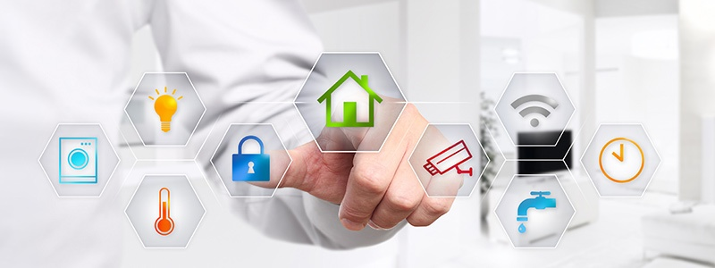
Figure 1.1: IOT internet of things[2].
1.3. History of IOT :
The term Internet of Things is 16 years old. But the actual idea of connected devices had been around longer, at least since the 70s. Back then, the idea was often called “embedded internet” or “pervasive computing”. But the actual term “Internet of Things” was coined by Kevin Ashton(inventor in IoT) in 1999 during his work at Procter&Gamble(It meant using the Internet to empower computers to sense the world for themselves).. Ashton who was working in supply chain optimization, wanted to attract senior management’s attention to a new exciting technology called RFID(Radio Frequency Identification). Because the internet was the hottest new trend in 1999 and because it somehow made sense, he called his presentation “Internet of Things”.
Even though Kevin grabbed the interest of some P&G executives, the term Internet of Things did not get widespread attention for the next 10 years.[3]
1.4 Applications of IOT :
There are diverse set of areas in which intelligent applications have been developed. All of this applications are not yet readily available ; however ,preliminary research indicates the potential of IOT in improving the quality of life in our society. Some uses of IoT applications are in home automation fitness tracking, health monitoring, environment protection, smart cities, and industrial settings.(figure 2)
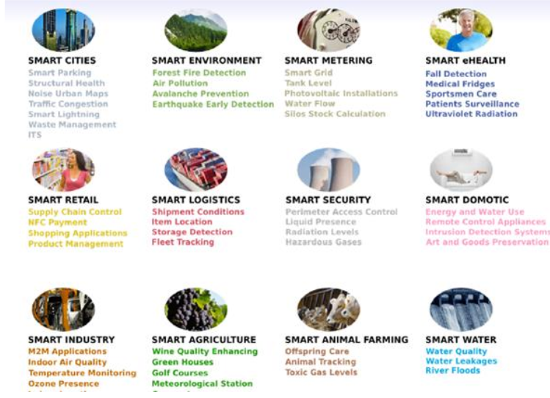
Figure 1.2 : IOT Applications[2].
1.4 .1 Smart Home
Smart home are becoming more popular today because of two reasons. First, the sensor and actuation technologies along with wireless sensor networks have significantly matured, second, people today trust technology to address their concerns about their quality of life and security of their homes (figure3).[4]
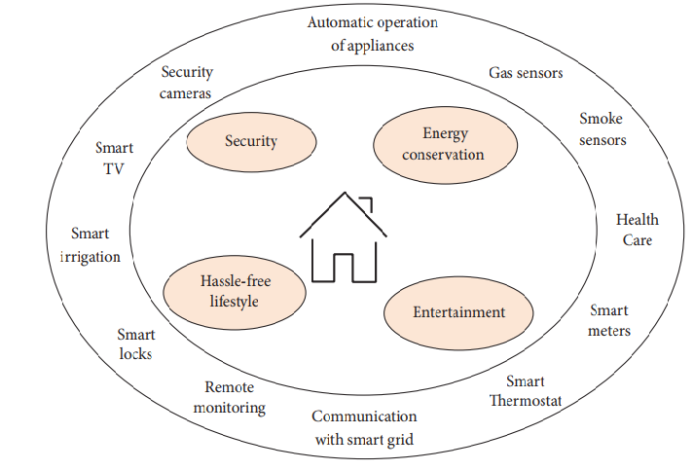
Figure 1.3 : A smart home system.[4].

1.4.2 Surveillance and Security:
Burglar alarm, break detectors fitted in house or shops can be connected to Internet.
This will give a high priority alert to owners and nearby police stations.[5]
1.4.3 HealthCare Systems:
IoT appliances have proven really beneficial in the health and wellness domains. Many wearable devices are being developed, which monitor a person’s health condition Health applications make independent living possible for the elderly and patients with serious health conditions. Currently, IoT sensors are being used to continuously monitor and record their health conditions and transmit warnings in case any abnormal indicators are found. If there is a minor problem, the IoT application itself may suggest a prescription to the patient.
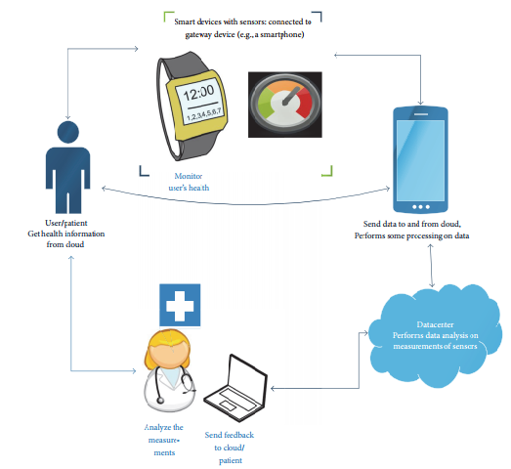
Figure 1.4 A smart healthcare system[14]
1.4.4 Industrial Automation:
Automation in industry is very critical, as there are harsh and unpleasant conditions for
human beings. Instead of following manual processes, when taking a step further with
automated control – by connecting the systems and controlling over the Internet, it gives great
control for the employer/manager and monitoring since you can monitor not only from the
company’s premise but from anywhere. This facilitates productivity and ensures tasks/people
can be monitored simultaneously.
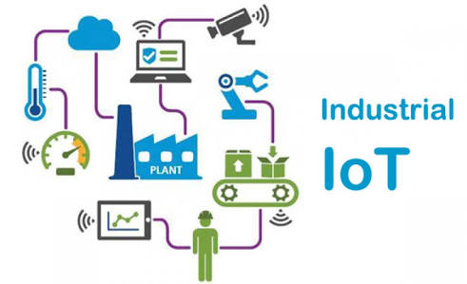
Figure 1.5 : Industrial automation[15]

1.4. 5 Agricultural Automation:
Agricultural fields can be fitted with various sensors like soil moisture, humidity temperature and even water pumps can be connected to Internet. All this can be controlled and monitored over Internet.
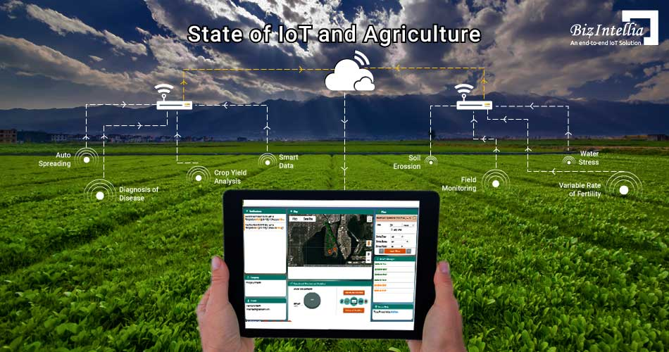
Figure 1.6 :State of IoT and agricultural.[2]
1.5 Benefits and Risks
As any new technology, the IoT presents huge benefits and risks.
1.5.1 Benefits:
The internet of things offers a number of benefits ,here’s a closer look at some of the biggest benefits that home controlling provides.
Savings: Smart thermostats and smart light bulbs save energy, cutting utility costs over time.
Safety: Many home controlling technologies fall under the umbrella of home security . and motion sensors help people enter doors and walk hallways late at night.
Security cameras offer benefits through either remote monitoring of package deliveries or real-time video of home inhabitants or unwanted visitors.
Control: to better control functions within the home, can know what’s happening inside a home at all times.
Comfort: . Connected devices can also help create a comfortable atmosphere—they provide intelligent and adaptive lighting, sound, and temperature, which can all help create an inviting environment.
Peace of Mind: many consumers invest in home controlling technology for peace of mind. if they can’t remember whether they closed the garage after them left, they can verify remotely with an app.
Real time monitoring The devices that are given Internet access will be updating their status or condition periodically or on user request. This gives users the exact information of the condition of that device at that instant which enables you to take necessary actions.
Real time data logging
In previous systems data used to be logged on to system either by taking manual readings
or through other wired protocol. But this limitation can be overcome by giving the device to
update its data over Internet..
1. 5.2 Risks
Here is a list of some of IoT main problems.
1.IoT can cause vulnerabilities in each device
2.IoT systems do not have well-defined perimeters, are highly dynamic, and continuously change because of mobility.
3.IoT systems may additionally embrace “objects” not designed to be connected to the net.
4.IoT systems, or portions of them, may be physically unprotected and/or controlled by different parties.
5.The network plays a vital role in providing an additional comprehensive interconnection capability, effectively and economy of association, as well as authentic quality of service in IoTs.
6. Encryption on bound occasions adds information to packets that provide how for tracing, e.g. sequence number, IP sec- Security Parameter Index, etc
7.One of the main challenges that have got to be overcome so as to push the net of Things into the important world is security.
8.The things powered by IoT (e.g. household appliances, street lights) square measure physically set in an exceedingly bound surrounding. Instead of destroying them, an active attacker can try to extract the information they contain.
9.The size and heterogeneous of the IoT additionally affect its trust and governance.[6]
1 .6 IOT and cloud computing :
There is a need to introduce cloud computing along with IoT which goes hand in hand. The server storage waste will get reduced on physical servers with the introduction of cloud computing . The way of looking at the cloud needs to be changed as more and more business are adopting IoT devices.
working of IOT with cloud computing leads to rising of edge computing ,All the data which is generated by the IOT will be processed by cloud computing . Tons of data will be created by IOT devices which need not be processed and should be handled by the cloud.
This problem can be solved with the introduction of Edge Computing. Edge computing will reduce the effect of cloud computation, storage, bandwidth and leaves high power on the cloud .
Edge computing processes data closer to IoT sources before sending it to the cloud. Edge computing will only help balance the workload that the cloud system has to do, preventing IoT from flooding cloud power. Edge computing will not completely eliminate the cloud requirements for IoT. Indeed, most IoT devices will still depend on the cloud to store all processed data.[7]
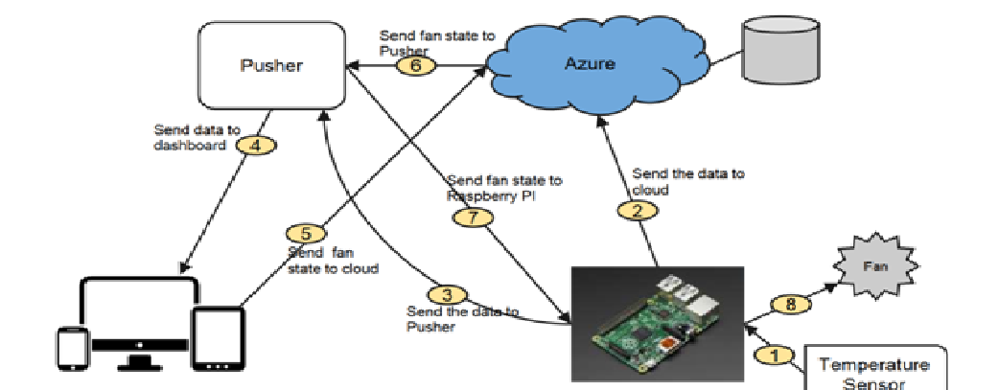
Figure 1.7 Iot in cloud computing[]

1.7 Embedded system :

An embedded system is a combination of computer hardware and software, either fixed in capability or programmable, designed for a specific function or functions within a larger system. Industrial machines, agricultural and process industry devices, automobiles, medical equipment, cameras, household appliances, airplanes, vending machines and toys, as well as mobile devices, are possible locations for an embedded system.
The internet of things builds on an embedded systems base, while some embedded systems can be relatively simple, a growing number either supplant human decision-making or offer capabilities beyond what a human could provide. For instance, some aviation systems, including those used in drones , are able to integrate sensor data and act upon that information faster than a human could, permitting new kinds of operating features.[8]

1.8 Artificial intelligence in IOT :
Artificial intelligence ‘AI’ is when a system can complete a set of tasks or learns from data in a way that seems intelligent .Therefore ,when artificial intelligence is added to the internet of things it means that those devices can analyses data and make decision and act on that data without involvement by humans .
Individually, the internet of things and artificial intelligence are powerful technologies. When you combine AI and IOT, you get AIOT the artificial intelligence of things devices as the digital nervous system while artificial intelligence is the brain of a system .[9]

1.9 The Future of IoT:
As far as the reach of the Internet of Things, there are more than 25 billion devices that can currently connect to the Internet, and researchers at IDC(international data corporation ) estimate that by 2021 there will be 26 times more connected things than people.
Consumer applications will drive the number of connected things, while enterprise will account for most of the revenue. IoT adoption is growing, with manufacturing and utilities estimated to have the largest installed base of Things by 2021.
By 2025, it is estimated that there will be more than to 21 billion IoT devices. Cybercriminals will continue to use IoT devices to facilitate DDoS(Denial of service attack ) attacks. More cities will become “smart”. Artificial intelligence will continue to become a bigger thing. Routers will continue to become more secure and smarter.5G Networks will continue to fuel IoT growth. Cars will get even smarter. IoT-based DDoS attacks will take on more dangerous forms.5G’s arrival will also open the door to new privacy and security concerns. Security and privacy concerns will drive legislation and regulatory activity.[10][11]
1. 10 CONCLUSION :

We reviewed IoT from different angles , the emerging idea of the Internet of Things (IoT) is rapidly finding its path throughout our modern life, aiming to improve the quality of life by connecting many smart devices, technologies, and applications. Overall, the IoT would allow for the automation of everything around us. An embedded system is a combination of computer hardware and software, either fixed in capability or programmable,

designed for a specific function or functions within a larger

CHAPTER 2
IoT communication protocol and devices

2.1 Introduction :
The IOT protocols is such a system that will transfer data in the online .But it will transfer data only when the communication network between the two connected devices is safe .
The IoT devices communicate using a different set of protocols available for communication such as, home controlling.
This chapter presents IoT communication protocols and different devices uses in the home controlling system.
2.2 IoT communication protocols:
2.2.1 Bluetooth:
One of the most broadly used wireless technologies of short-range is Bluetooth. the recently introduced Bluetooth protocols among the IOT protocols is BLE or Bluetooth Low Energy protocol it will afford the range of conventional Bluetooth in combined with lower power consumption supremacy .
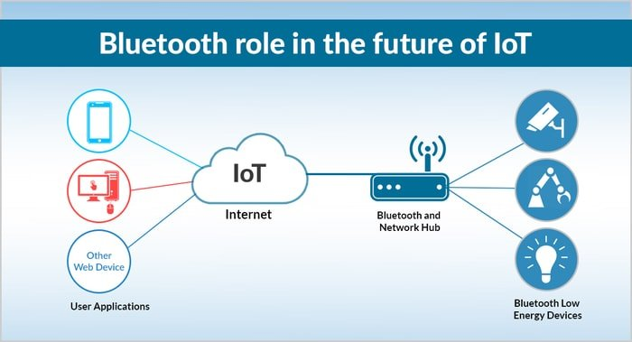
Figure 2.1 Bluetooth role in the future of iot.[12]
BLE is not designed for transferring large files and will go perfectly with the small portions of data . [12]
2.2.2 Wi-Fi:
Wi-Fi is a favored choice according to many electronic designers .it is because of the infrastructure it bears it has quick data transfer rates along with aptitude to control a large quantity of data .
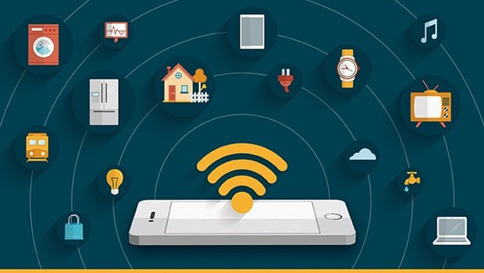

Figure 2.2 Wifi with IOT .[12]
2.2.3 ZigBee :
There is a vast user base of ZigBee . Among the internet of things protocols . It usually operates at a frequency of 2.4GHz. This is ideal for the industrial sites where data is generally transferred over small rates amongst home or a building.[12]
.
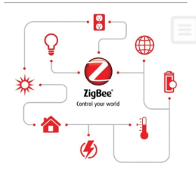
Figure: 2.3 ZigBee[12]

2.2.4. MQTT IoT:
MQTT IoT is a message protocol and full form is Message Queue Telemetry Transport. This is mostly used for monitoring from a remote area in IoT. The principal task that MQTT does is obtaining data from so many electrical devices.
It also conveys them to the IT communications or infrastructure. A hub-and-spoke architecture is fundamentally ordinary for MQTT IoT Protocol. It works on top of the TCP for supplying reliable yet simple streams of data. [12]
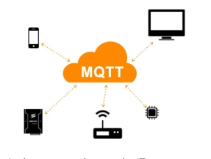
Figure: 2.4 MQTT[12]

2.2.5. CoAP:
The CoAP or Constrained Application Protocol, an internet productivity and utility protocol, is mainly developed for the restricted smart gadgets. The design of CoAP is for using it among the devices that have an identical restricted community. It includes general nodes and devices on the internet and different restrained networks and devices that are joined on the internet. [12]
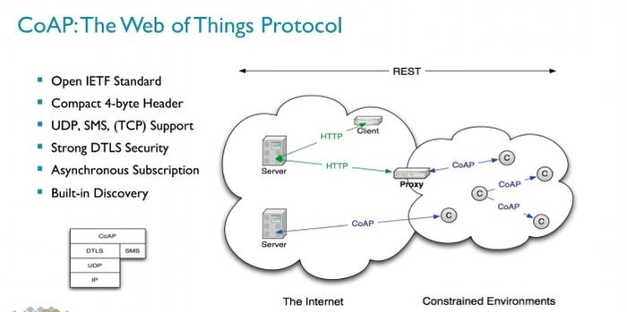

Figure: 2.5 CoAP The Web of Things Protocol [12].

2.2.6 RFID:
The Radio Frequency Identification of RFID works with the help of wireless technology. It uses the electromagnetic fields so that it can identify objects. The short ranged Radio Frequency Identification is around 10 cm. But the long-range Radio Frequency can go up to 200 mm. The best part of RFID IoT Connectivity Protocols is they do not need any power.[12]
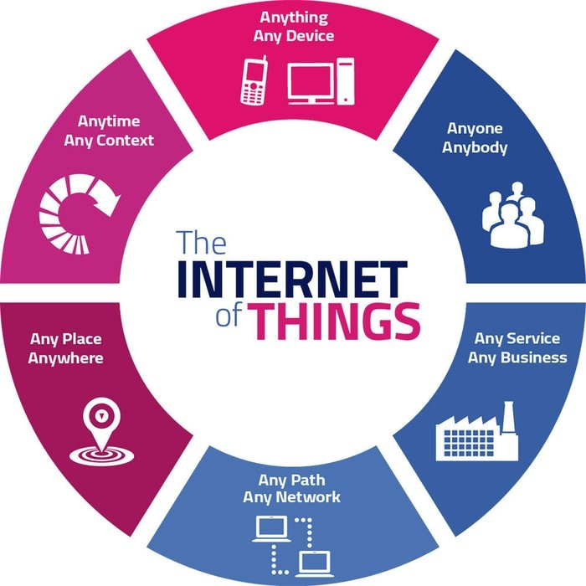

Figure 2.6 RFID IoT Connectivity Protocols [12].

2.2.7 Z-Wave
Z-Wave IoT Protocols affords the low-power Radio Frequency communications. We typically use these in our home automation applications. The sensors, lamp controllers, etc. are the low-power Radio Frequency. This technology of low-latency also has more features of shielding from wireless technologies (such as the WiFi.) This works with the help of functioning in the sub-1GHz band.
Designers are concerned with the simple and rapid development process of IoT Protocols. They are working for the easy setup of Z-Wave IoT Protocols. The frequency of Z-Wave Internet of Things Protocols is 900MHz, and the range is about 30-100m. It provides you Cloud access and requires a bridge for it. Data rates of this protocol are 40-100kbit/s. [12]

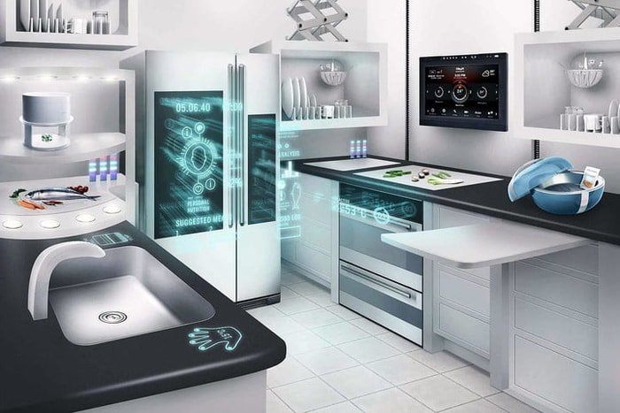
Figure: 2.7 Z-Wave in home controlling[12].

2.2.8. DDS:
Amongst the internet of things protocols, the IoT Messaging Protocols – DDS or Data Distribution Service is a standard for high-performance, expandable and real-time machine-to-machine communication. The Data Distribution Service – DDA is developed and designed by OMG or Object Management Group. With the help of DDS, you can transfer data both in the low-footprint devices and with the Cloud platforms. [12]
The Data Distribution Service includes two significant layers. Those are the DCPS and the DLRL. The DCPS or Data-Centric Publish-Subscribe works by delivering information to the subscribers. The DLRL or Data-Local Reconstruction Layer does its job by providing an interface to the Data-Centric Public-Subscribe functionalities. [12]

2.2. 9. LoRaWAN:
LoRaWAN or the Long Ranged Wide Area Network is one of the IoT Protocols for the wide area networks. LoRaWAN IoT Network Protocols is specifically designed for supporting the vast networks with the help of million low-power devices. Smart cities use this kind of protocol.
Including the low-cost mobile communication, LoRaWAN is also famed in scores of industries for protected bi-directional communication. The frequency of LoRaWAN may vary from network to network. The data rates of this Internet of Things Protocols runs between 0.3-50 kbps. In the urban areas, the range LoRaWAN varies from 2 km to 5 km. In the suburban areas, the range of this IoT protocol is about 15 km.[12].
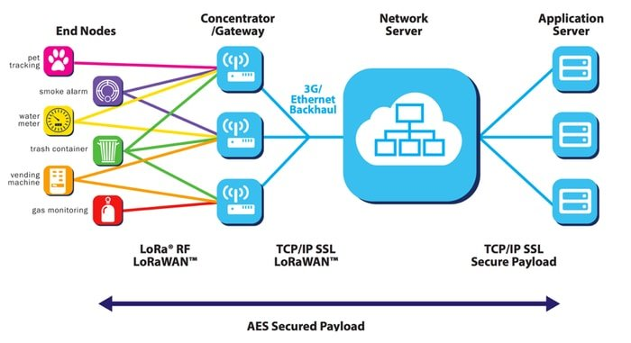
Figure 2. 8. LoRaWAN[12].
2.3 Which protocol is the best:
There are various protocols available out there to choose from if we are working on any IoT Project. For making our decision easier than ever, we are presenting these protocols with all the excellent points. So which one are we going to choose?
Before selecting the appropriated protocol, know the bandwidth, range, power consumptions and node of the protocols.
The preferred protocol is MQTT. It is clearly offer much more and it is important to start from our home controlling development needs.
2.3. 1 Why MQTT and not another? :
MQTT is open, simple, light and easy to implement. It is ideal for meeting the following needs:
• Particularly suitable for using a very low bandwidth.
• Ideal for use on wireless networks.
• Low energy consumer.
• Very fast, it allows a response time better to other standards.
• Allows a high reliability if necessary.
• Requires little processor and memory resources.
2.3. 2 MQTT: How does it work?
The publication / subscription model (also called pub / sub) offers an alternative to traditional client-server architecture. In the client-server model, a client communicates directly with an end point. The pub / sub-model dissociates the client who sends a message (the publisher) from the client (s) receiving the messages (subscribers). Editors and subscribers never contact each other directly. In fact, they are not even aware that the other exists. The connection between them is managed by a third component (the Broker). The Broker job is to filter all incoming messages and distribute them correctly to subscribers. [5]
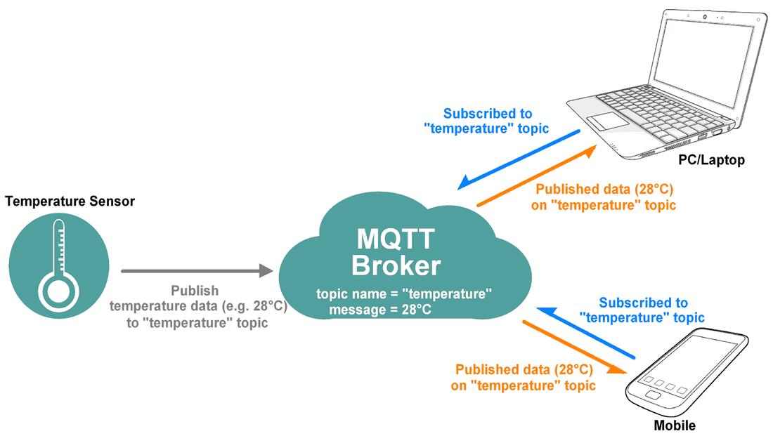
Figure 2.9. : Publication / Subscription on MQTT Broker.
The most important aspect of pub / sub is the decoupling of the publisher from the recipient's message (subscriber). Decoupling has three dimensions: space, time and synchronization:
• Decoupling of space: The publisher and the subscriber do not need to know each other (for example, no IP address and port swaps).
• Time decoupling: The publisher and the subscriber do not need to run at the same time.
• Decoupling of synchronization: The operations on the two components did not need to be discontinued upon publication or receipt.
2.3. 3 Which open-source MQTT Broker to choose?
Here are the main projects of Open Source brokers:
• ActiveMQ allows to add MQTT to an Apache web server (Developed by Apache foundation)
• JoramMQ for the integration of MQTT in Java.
• Mosquitto, the open-source broker most used in DIY projects supported by the eclipse.org foundation
• RabbitMQ, an open source project also available with commercial support
• EMQTT, a project developed in Erlang / OTP available for Windows, Mac Os X and
Linux designed to receive a very large number of connections. It is possible to create a cluster (server network) to increase the number simultaneous connections.
ActiveMQ and JoramMQ are fairly specific brokers. RabbitMQ is more oriented company with its commercial offer.
In our project the best choice is Mosquitto.
2.3.4 Mosquitto why?:
Mosquitto is a very good choice. It is available on all platforms and can be installed in a few minutes. As MQTT is an OASIS standard, whatever your choice, it is possible to communicate with connected objects in the same way.
Mosquitto is an Open Source MQTT server (Broker), easy to install on a Raspberry Pi but also on almost all platforms (macOS, Windows, Linux…). MQTT facilitates communication between connected objects (M2M) while saving the battery.
2.3.5 MQTT message:
The MQTT protocol represents an ideal messaging protocol for the IoT and M2M communications and is able to provide routing for small, cheap, low power and low memory devices in vulnerable and low bandwidth networks.[13]
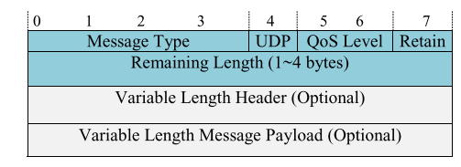
Figure 2.10 : MQTT message format [13].
2.3.6 QoS (Quality of service):
MQTT natively integrates the concept of QoS. Indeed, the editor has the possibility of defining the quality sound message.
Three levels are possible:
• A QoS level 0 message “At most once” will be delivered at most once. What means that the message is sent without guarantee of reception, (the broker does not inform the sender of the sender received and the message).
• A QoS level 1 message “At least once” will be delivered at least once. The customer
repeatedly send the same message, until the Broker confirms that a was transmitted over the network.
• A QoS level 2 message “exactly once” is the highest level of service in MQTT. This level guarantees that each message is received only once by intended recipients.
QoS 2 is the safest and most level of quality of service loaned. The guarantee is provided by at least two request / response flows between the sender and the recipient. The sender and the recipient Use the packet identifier of the original PUBLISH message to coordinate the message delivery.
2.3.7 Security:
The exchanged of data can be very critical, it is possible to secure exchanges at several levels:
• Transport in SSL / TLS,
• Authentication by SSL / TLS certificates,
• Authentication by login / password.
2.4 The hardware components:
hardware components used are Raspberry Pi with some Sensors (e.g., DHT11 temperate and humidity sensor , MQ-2 Smoke sensor , 433Mhz WL RF Transmitter + Receiver Module, Programmable Remote Control Socket, PIR(passive infrared) Motion Detector Module, Raspberry PI Camera Module), the details of hardware components are illustrated in this section.
2.4.1 raspberry PI:
2.4.1.1 presentation of Raspberry Pi:
The Raspberry Pi is a series of small single-board computers developed in the United
Kingdom by the Raspberry Pi Foundation to promote the teaching of basic computer science
in schools and in developing countries. The original model became far more popular than
anticipated, selling outside its target market for uses such as robotics. It does not include
peripherals (such as keyboards, mice and cases). However, some accessories have been included in several official and unofficial.[5]
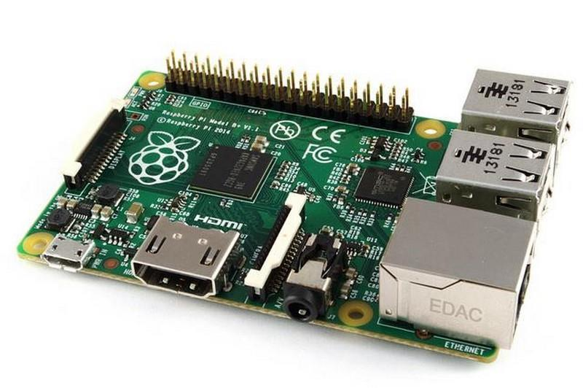
Figure 2.11 : Raspberry pi card .
2.4.1.2 The Raspberry Pi models :
it’s one of several devices, there are different versions of the Raspberry Pi .
 | Raspberry Pi 3 Model B | Raspberry Pi 2 Model B | Raspberry Pi Model B+ | Raspberry Pi M  odel A+ | Raspberry Pi Zero & Zero W
Processor Chipset | Broadcom BCM2837 64-bit quad-core processor | Broadcom BCM2837 64-bit quad core processor | Broadcom BCM2835 32-bit single-core processor | Broadcom BCM2835 32-bit single-core processor | Broadcom BCM2835 32-bit single-core processor
Processor Speed | 1.2 GHz | 900 MHz | 700 Mhz | 700 Mhz | 1 GHz
RAM | 1 GB | 1 GB | 512 MB | 256 MB | 512 MB
Storage | MicroSD | MicroSD | MicroSD | MicroSD | MicroSD
Output | 4 USB ports | 4 USB ports | 4 USB ports | 1 USB port | 1 micro-USB port
GPIO | 40-pin | 40-pin | 40-pin | 40-pin | 40-pin
Ethernet Port | Yes | Yes | Yes | No | No
Wi-Fi | Yes | No | No | No | No (Zero)/Yes (Zero W)
Bluetooth | Yes | No | No | No | No (Zero)/Yes (Zero W)
Table2.1 : Different versions of the Raspberry Pi .

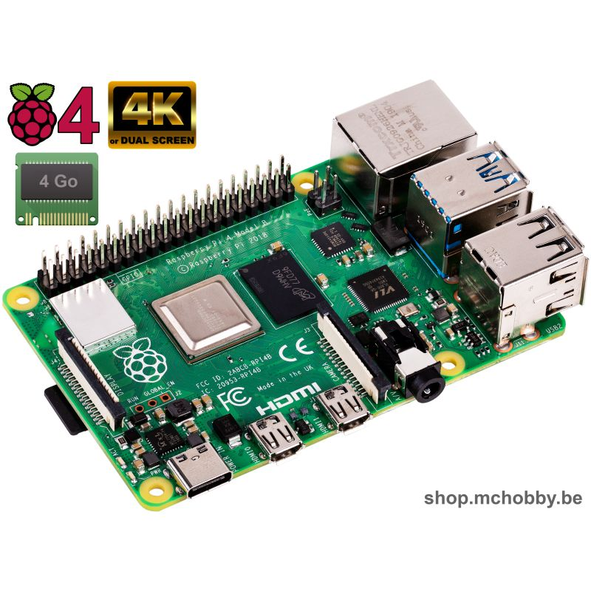
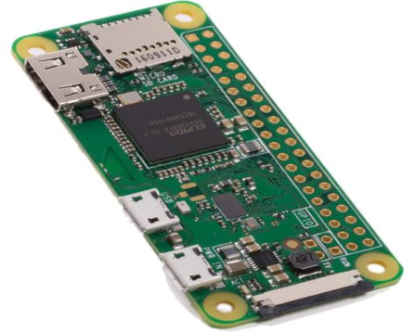
raspberry PI 4
Raspberry PI zero
model B
model B⁺
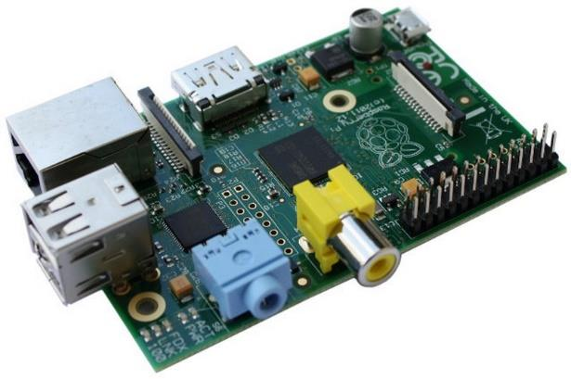
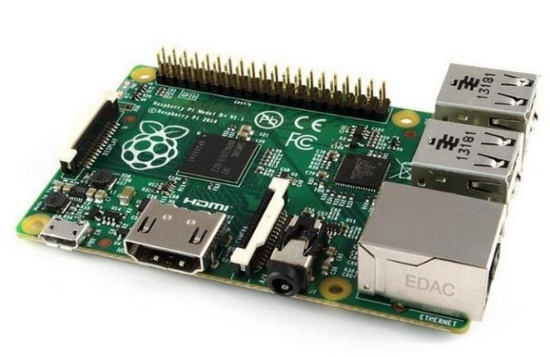
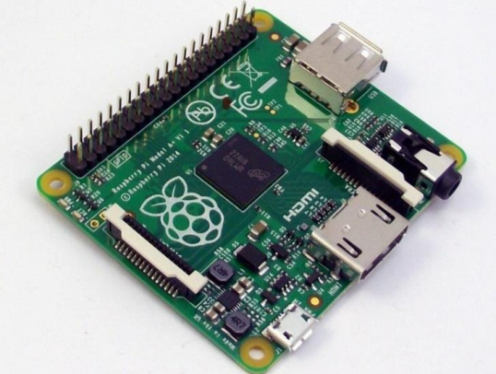
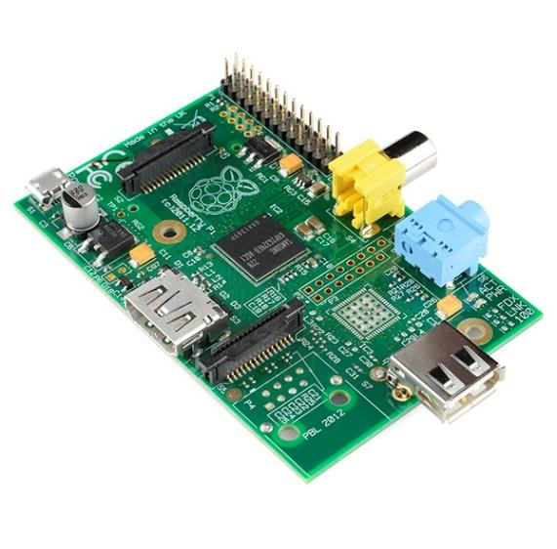
Model A
modelA⁺

2.4.1.3The Raspberry Pi Components:
The Raspberry Pi device looks like a motherboard, with the mounted chips and ports
exposed (something you'd expect to see only if you opened up your computer and looked at
its internal boards), but it has all the components you need to connect input, output, and
storage devices and start computing.
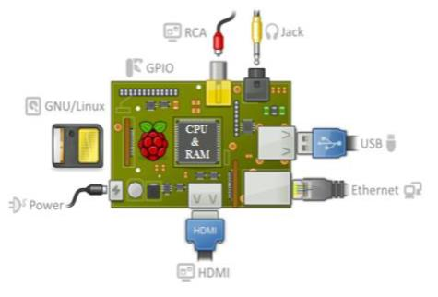

Figure 2.12: Standard component of raspberry [5].

Here are the various components on the Raspberry Pi board
- ARM CPU/GPU: is a Broadcom BCM2835 System on a Chip (SoC) that's
made up of an ARM central processing unit (CPU) and a Video core 4 graphics processing unit (GPU).
- RAM memory: It is a memory space where Raspberry places data during its processing, it has a capacity of 512MB.
- Varied connectivity:
1. HDMI : « High Definition Multimedia Interface » connects the Raspberry Pi to a compatible device: LCD screen or video projector ...
2.USB 2.0 port: « Universal Serial Bus » is a serial port which is used to connect the
Raspberry to other devices, and there are 4 USB ports. The Raspberry Pi Works with
virtually any USB keyboard and mouse. Can also use most of the wireless keyboards and mouse .
3. Ethernet port: This is a port that corresponds to the international Ethernet protocol packet-switched local area network.
4. RCA socket: "Radio Corporation of America" is an electrical connector used in the audio / video field via jack.
5. SD card slot: Raspberry requires additional external memory to work.
Indeed, the slot allows you to connect the external memory. It is possible to use your own SD card in the Raspberry Pi, but it should be prepared with a disk image of an operating system.
6. A jack: It is an audio-video connection its dimension is equal to 3.5 mm.
7. Power supply: Classic with a USB-A to micro-USB cable.
The figure below shows the USB power supply.[5]
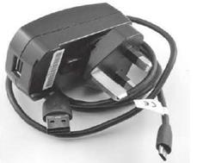
Figure 2.13 USB power supply

2.4.1.4 Cases of uses :
Automation (domotic)
an interface solution for communicating with internal equipment
Small sever web
to temporarily hibernate sites to show the customer
Embedded system
encourage programming learning
Server to version via git
setting up a server to create different versions for different projects
Simple computer
a computer. Small, inexpensive, and It provides an alternative
standard computer.
It also encourages the learning of programming.
Raspberry pi use as a

Figure 2.14 Some cases of uses of raspberry pi .
2.4.1.5 Raspberry Pi 3 Model B Features:
• Now 10x Faster - Broadcom BCM2387 ARM Cortex-A53 Quad Core Processor powered
Single Board Computer running at 1.2GHz!
• 1GB RAM so you can now run bigger and more powerful applications
• Fully HAT compatible
• 40 pins extended GPIO to enhance your “real world” projects.
• Connect a Raspberry Pi camera and touch screen display (each sold separately)
- Stream and watch Hi-definition video output at 1080
- Micro SD slot for storing information and loading your operating systems.
- 10/100 BaseT Ethernet socket to quickly connect the Raspberry Pi to the Internet.[5]
2.4.1.6 General Purpose Input Output of the raspberry GPIO :
These pins are a physical interface between the Raspberry Pi and the outside world.[5]
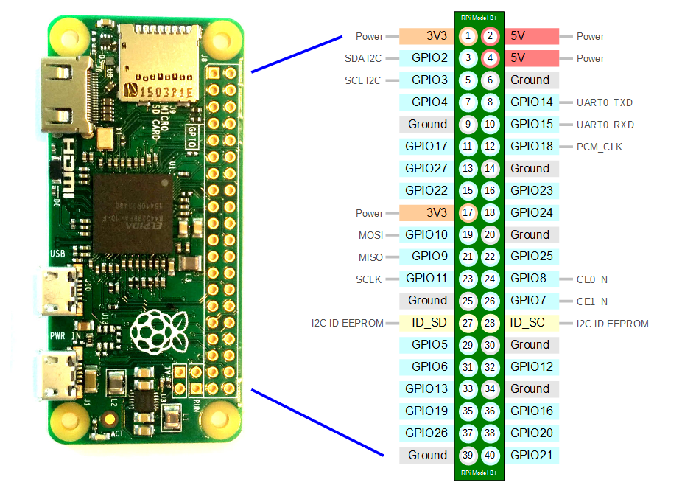

Figure 2.16 GPIO Pins Descriptions of Raspberry Pi.
2.4.1.7 The functioning:
By default, the Raspberry pi is bare, which means that it is sold without accessories. To can use it, it is essential to have:
• A micro SD card compatible with the Raspberry pi model.
• A standard micro USB power cable
• An RJ45 cable to connect to the network (or a WiFi key)
• An HDMI cable to connect the Raspberry pi to a screen or television.
• A keyboard for entering commands.
2.4.1.8 Operating system :
The Raspberry Pi was designed for Linux operating system, and many Linux distributions now have a version optimized for the Raspberry Pi. Two of most popular option is Raspbian, which is based on the Debian operating system and Pidora, which is based on the Fedora operation system. Raspbian operating system is the best operating system for Raspberry Pi3.
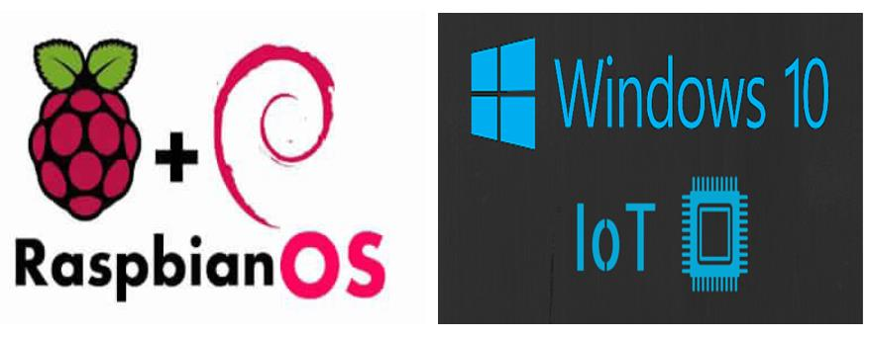
Figure 2.17 Raspbian and Windows 10 IoT operating system logo.
2. 4.2. Types of Sensors:
In the proposed system, five types of sensors were used .
The details of each sensor is as follows.
2 .4.2.1 Temperature and Humidity Sensor (DHT11):
The DHT11 is a low-cost and popular digital sensor for measuring temperature and humidity. It uses a capacitive humidity sensor and a thermal resistor (thermostat) for measuring the temperature and humidity of the surrounding air.
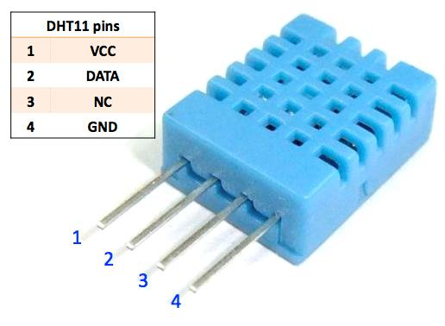
Figure 2.18: Temperature and Humidity Sensor (DHT11).
Feature of temperature and Humidity Sensor :
1) Humidity measurement range: 20 - 90% RH
2) Temperature measurement range: 0 - 60
3) Digital output signals indicating temperature and humidity
4) Operating voltage: 5V DC; Card size: 2.0 x 2.0 cm
5) Humidity measurement accuracy: ± 5% RH
6) Temperature measurement accuracy: ± 2
2 4.2.2 MQ-2 Gas Sensor:
is a flammable gas and smoke sensor which detects combustible gas concentrations in the air and displays the value read as analog voltage. Sensor can measure gas concentrations flammable between 300 and 10,000 ppm. The MQ-2 gas sensor is sensitive LPG, i-butane, propane, methane, alcohol, hydrogen and smoke.[5]
- Characteristics :
1) Supply voltage: 5V
2) Sensitive to H2, LPG, CH4, CO, alcohol, smoke or propane
3) Analog and digital output
4) The digital output is high or low depending on an adjustable preset threshold.
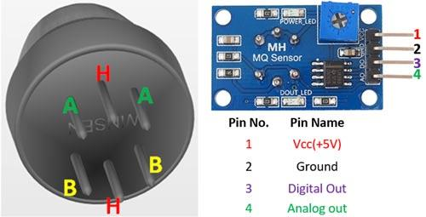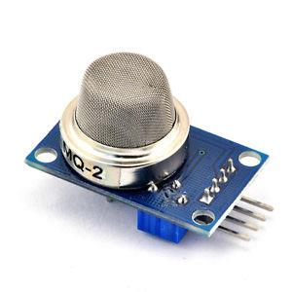
Figure 2.19 MQ-2 Gas Sensor.
2.4.2.3 PIR Motion Detector Module: Passive Infrared Sensor
PIR Motion Passive Infrared Detector Module is An infrared sensor allows detect a Movement in his field of vision based on infrared. We also talk about Pyroelectric or PIR sensor. The PIR sensor is a Digital sensor:
If a movement is detected, the output signal from the sensor is set to HIGH (1).
If no movement is detected the signal at the output of the sensor is set to LOW
(0). By default its value is 0.
Characteristics :
1) Power source: 3 ... 12 V DC.
2) Coverage Surroundings: 4 m to 12 m.
3) Bandwidth signal: 0.2 Hz to 10 Hz.
4) Coverage angle Horizontal ± 50 °, Vertical ± 30 °.
5) Functional temperature range: -20 ° C ... 60 ° C.
6) Ambient humidity: 0 ... 90% RH.
7) Dimensions: 25 mm x 25 mm x 20 mm Mounting diameter ∅ 24 mm.
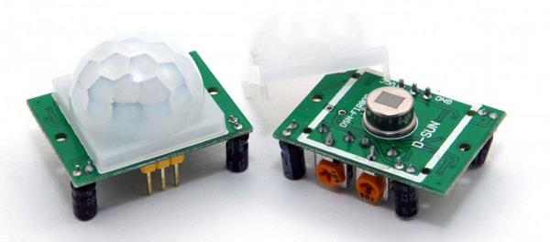
Figure 2.20 PIR Motion Detector Module.

2 4.2. 4 Raspberry PI Camera Module:
The Raspberry Pi Camera Module can be used to take high definition videos, as well as photographs, the module has a five megapixel fixed focal length camera that supports modes 1080p30, 720p60 and VGA90 video, as well as still image capture. It connects via a 15 cm ribbon cable to the CSI port of the Raspberry Pi using the MMAL and V4L APIs. The camera module is very popular in home security applications and in wildlife photo traps.
Characteristics :
1) 5MP sensor.
2) Wider image, capable of 2592x1944 still images, 1080p30 video.
3) 1080p video supported.
4) CSI.
5) Size: 25 x 20 x 9 mm
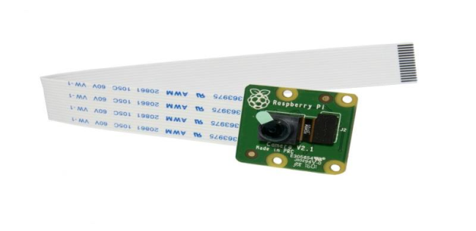
Figure 2.21 Raspberry PI Camera Module.
2 4.2.5 Programmable Remote Control Socket:
Most household equipment operate with electrical outlets. Thus, catch control requires sockets programmable remote control.

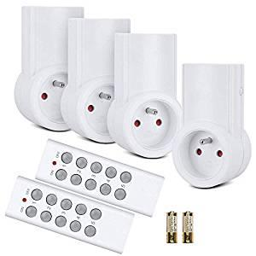
Figure 2.12 : Programmable Remote Control Socket
2 4.2.6 433Mhz WL RF Transmitter + Receiver Module:
radio transmission in the 433 MHz range provide great user comfort and are very popular. Devices such as: remote control, station wireless weather, wireless headset, wireless doorbell, HF alarm system and HF data transmission, etc.
The Receiver is used to encode signals from the remote control for outlets, lamps, electric garage, window shutters, etc.
The Transmitter is used to send these signals using Raspberry PI.
Characteristics :
1) Bandwidth: 420 - 450 MHz
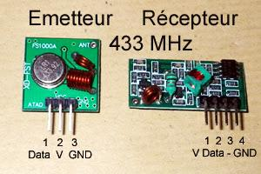
2) Supply voltage: 4.5 V
3) Batteries: 3 x LR44
4) Consumption: 3.5 mA when empty
5) Dimensions: 90 x 50 x 16 mm

Figure2.23 433Mhz Transmitter Receiver Module.
- Lamp Bulb Wireless remote control: To control the lamps of the House.
- 16 GB SD card: Useful for installing the operating system on Raspberry pi and y
store information (storage unit).
- M / M and M / F jumper cables: Connects the sensors to the GPIO ports of the
Raspberry pi.
- Wi-Fi USB key: For the connection between the Raspberry pi and the router.
Router: the Router is an essential tool in our project because it plays two roles: as a direct intermediary between the application and the Raspberry pi locally and also acts as an intermediary between the web server and the Raspberry pi if the user is outside the house.
2.4.3 Breadboard:
A thin plastic board used to hold electronic components (transistors, resistors, chips, etc.)
that are wired together. Used to develop prototypes of electronic circuits, the boards can be
reused for future jobs.[5]

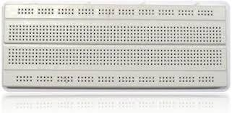
Figure2.24 Breadboard
2.5 Conclusion
After showing diffrent iot communication protocols to find which one is the better for a home controlling system , and some devices with presentation of their characteristics . we conclude that the MQTT is the best iot communication protocol , and select the heart of the communication between the remote user and the home devices will be used in our system.
CHAPTER 3
Implementation

3.1 Introduction :
The Home controlling system we designed has three major parts:
- Hardware .
- Software/application .
- Communication protocols .
Each of these parts is equally important in building a truly smart home experience .
3.2 Proposed system :
scenario:
The general idea is to create a system that allows a house to interact with events taking place indoors automatically. A system that allows user to control his house from anywhere, he must realize an intelligent system internal and a mobile application for remote control, the diagram below illustrates this idea...
Programmable Remote Control Socket
Raspberry PI
Application
camera
PIR Motion Detector Module

MQ-2 Smoke sensor
DHT11
request response
+action notification
+actuator sensor

Figure 3.1 The interactions between the objects of a house and an application.
The figure above illustrates the interactions between the objects in house and an application.
The application performs an action or receives a notification from the web server, the web server is the intermediary between the application and the Raspberry pi, the server sends a request and the Raspberry PI resumes, the Raspberry manages the connected objects, it receives information from the sensor or request service from an actuator.

3.3 Architectures:
3.3.1 The proposed architecture of home controlling:
The proposed system consists on the combination of software and hardware components. together to form home controlling system to be used in the monitoring activities of all the users entering of the IoT applications.
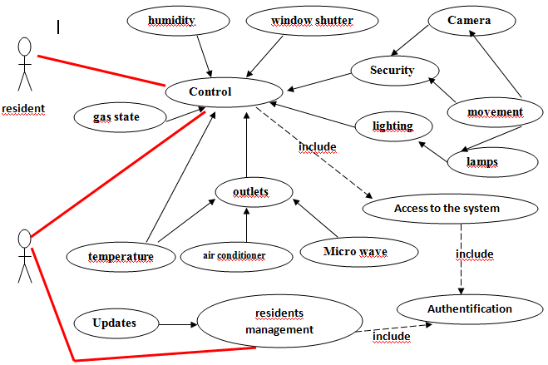

Figure 3.2 :Conceptual architecture.
3.3.1.1 Strategy architecture:
Like a human-machine interface, the mobile application allows interaction with the control system, without requiring advanced knowledge on the part of the user to be configured and used. This application includes an overview of the system, the tools management of modules, configuration views, control windows and scenarios. This software part is deployed on the mobile device side of the smart home resident.
The controller, "The Raspberry Pi" is the heart of the project: it acts as an intermediary between the user and the house itself. through the communication via the internet it must be able to organize the user's instructions to return them in a request for the various actuators and collect information from sensors to bring them back to the user.

3.3.1.2 Logical architecture:
The proposed solution is to allow users to control their smart homes. A typical user via their smart phone, tablet has an application allowing him to send instructions and receive information from his House. the house endowed with intelligent techniques are capable on one side to receive user orders and on the other hand to transmit the data in question.
As we have just described, this architecture allows us to divide our system into three subparts, which are:
Data presentation: this layer is the visible part for the user. it takes in responsible the management of the graphical interface and human-machine interaction. It allows to relay user requests to the profession layer, and present the information returned.
profession logic: this layer is the heart of the system, it is the functional part describing operations operating on data according to user requests.
Data access: the purpose of this layer is to store data in a structured manner. We uses for this part relational database management systems allow to share the data contain.
The figure below represents the architecture of our system except that the data is located on two different levels. Part of the data is saved in a database data and the other comes directly from all the sensors installed in homes connected to the system.
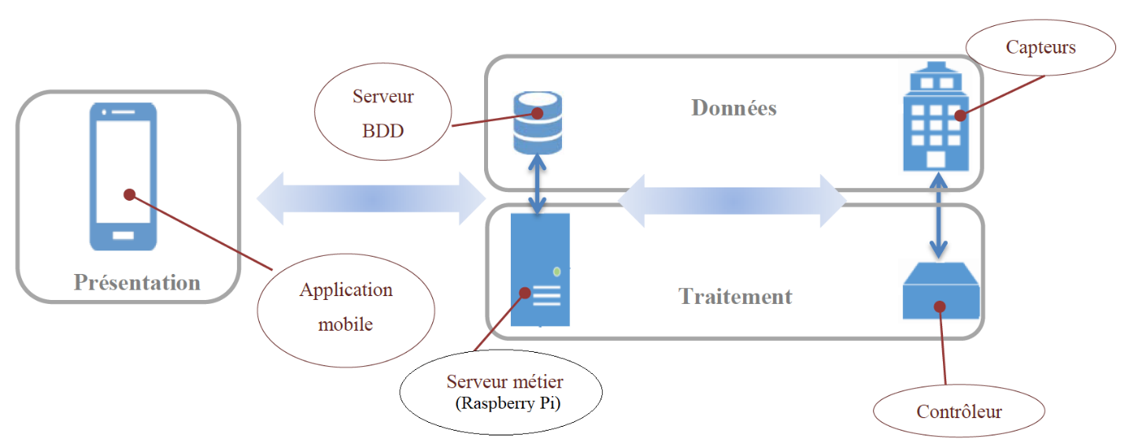
Figure 3.3 Logical architecture.

3.4 The software component:
3.4.1 For the Raspberry PI:
3.4.1 .1 Programming for Raspberry Pi:
In our project, the creation of the code embedded on Raspberry Pi is based on two languages, Python and the C language. These two languages have the advantage of being easy to learn while being powerful enough to create interesting programs.
3.4.1 .1 . 1 Presentation of the python:
Python is a programming language, the first version of which was released in 1991. Created by Guido van Rossum, the Python Software Foundation, created in 2001 .

Figure 3.4 logo python language .
Python is a powerful language, both easy to learn and rich in possibilities. So there are so-called libraries that help the developer to work on specific projects. Python is an interpreted programming language.
3.4.1 .1 . 2 Presentation of the C language :
It is a general imperative programming language. Invented in the early 1970s for rewrite UNIX. The C language has become one of the most used languages. Many languages more modern like C ++, C #, Java and PHP have a syntax similar to C and resume in part its logic.

Figure 3.5 C language logo .
3.4.1.2 Installing Raspbian Operating System (ROS):
Installing Raspbian on the Raspberry Pi is pretty straightforward. We’ll be downloading Raspbian and writing the disc image to the SD card, then booting the Raspberry Pi to that SD card.

3.4.1.3 Establish wireless communication with Raspberry Pi 3, using Putty:
Putty is an open source application that supports multiple network protocols, such as - SSH, Telnet, SCP, rlogin, serial port and raw socket connection. Putty communication is established over a TCP/IP socket, such as Putty, but it uses the secure socket with public key encryption. [5]
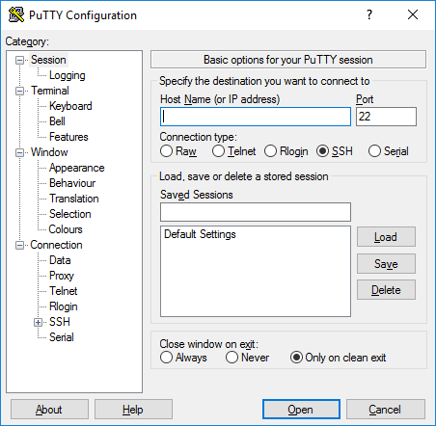
Figure 3.6 puTTY.
3.4.1.4 Remotely Control Raspberry Pi3 Using VNC Protocol:
VNC Stands for Virtual Network Computing; it mainly allows viewing the Raspberry Pi
desktop on any other device with a VNC Client/Viewer, regardless of the type of the
operating system.
We will see the desktop of the Raspberry Pi inside a window on our computer or mobile device. we'll be able to control it as though you were working on the Rapsberry Pi itself.[5]
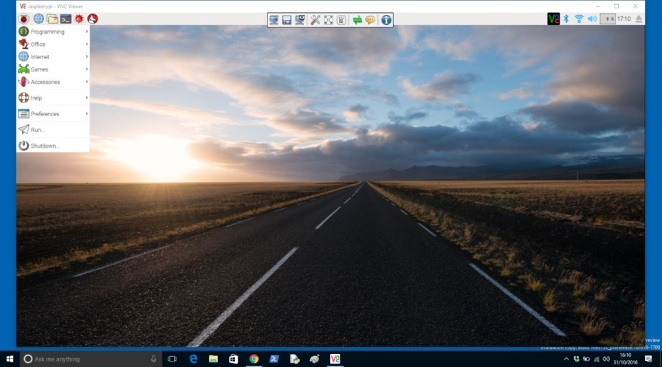
Figure 3.7 Desktop for Raspberry Pi

.

3.4.1 .5 Node-RED :
Node-RED is a powerful open source tool for building Internet of Things (IoT) applications with the goal of simplifying the programming component. It uses a visual programming that allows you to connect code blocks, known as nodes, together to perform a task. The nodes when wired together are called flows. Node-RED is open source and developed by IBM. The Raspberry Pi runs NodeRED perfectly. With Node-RED we can spend more time making cool stuff, rather than spending countless hours writing code.[5]
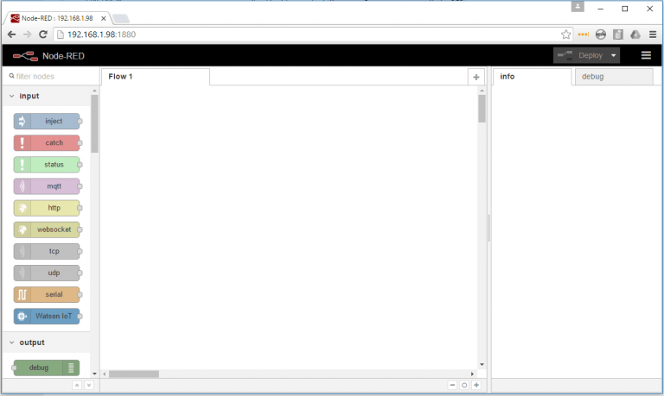
Figure 3.8 Node-RED.

3.4.2 For the application :
3.4.2.1 Android :
With the explosion of Smartphone sales in recent years, Android has taken a place important in everyday life. This operating system allows you to install various applications: games, office automation, multimedia, etc. For this reason, and in order to control a smart home, we favored the use of an Android mobile application.

Figure 3.9 :Android logo

3.4.2.1.1 Android Studio:
Android Studio is a development environment for developing applications Android mobiles. It is based on IntelliJ IDEA and uses the Gradle production engine. It can be downloaded under Windows, macOS and Linux operating systems.

Figure3.10 android studio logo.
3.5 Home controlling (Connecting and programming sensors) :
3.5.1 Connecting sensors to the Raspberry pi:
3.5.1.1 DHT11 sensor :
Capteur | Raspberry PI
• VCC PIN  • OUT PIN  • GND PIN | • 5V PIN  • 7 PIN  • GND PIN

Table 3.1 connecting DHT11 with raspberry Pi .
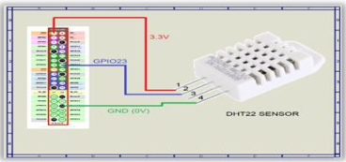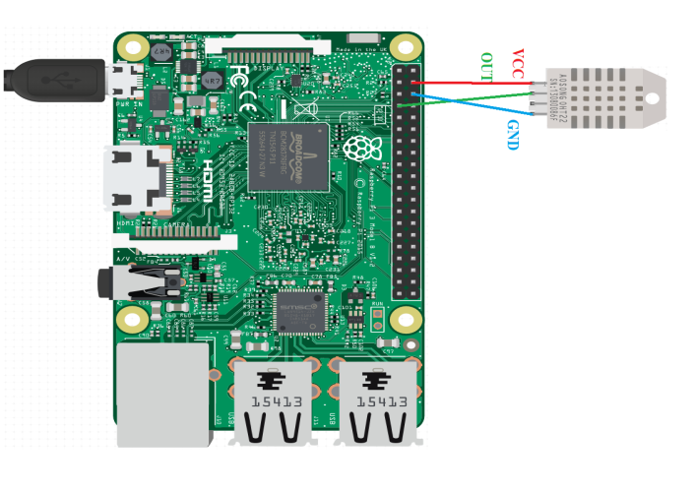
Figure 3.11: DHT11 sensor connected to the Raspberry Pi
3.5.1.2 MQ-2 sensor :
Capteur | Raspberry PI
• VCC PIN  • GND PIN  • DO PIN | • 5V PIN  • GND PIN  • 35 PIN

Table 3.2: MQ-2 sensor connected to the raspberry Pi .
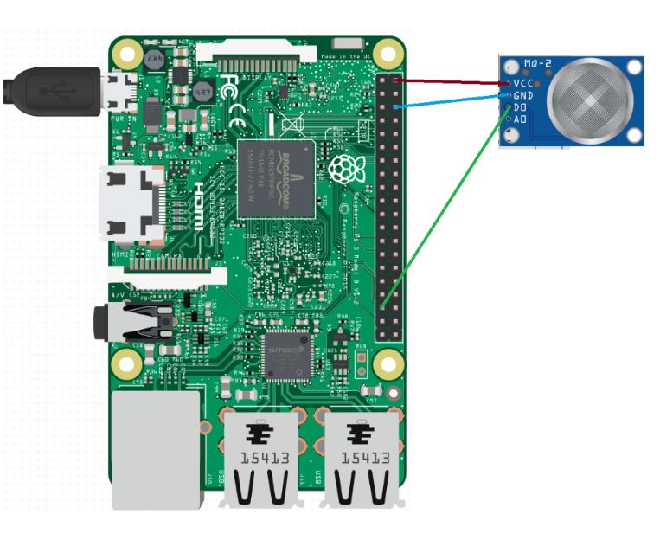
Figure 3.12: MQ-2 sensor connected to the raspberry Pi .
3.5.1.3 PIR Motion Detector sensor connected to the raspberry Pi.
Capteur | Raspberry PI
• VCC PIN  • OUT PIN  • GND PIN | • 5V PIN  • 26 PIN  • GND PIN

Table 3.3 : PIR Motion Detector sensor connected to the raspberry Pi.
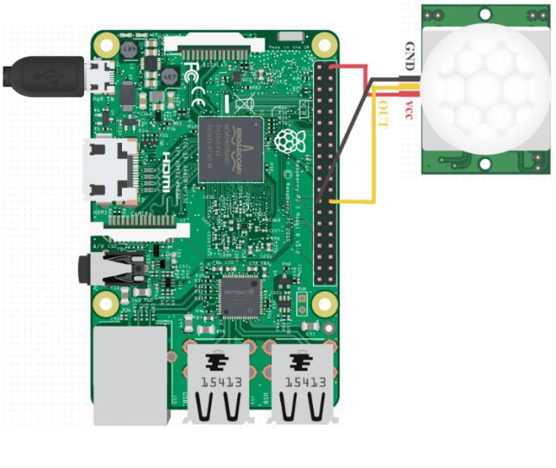
Figure 3.13: PIR Motion Detector sensor connected to the raspberry Pi.
3.5.1.4: 433Mhz Transmitter Receiver Module:
Transmitter | Raspberry PI
• VCC PIN  • GND PIN  • DATA PIN | • 5V PIN  • GND PIN  • 11 PIN
Receiver | Raspberry pi
• VCC PIN  • DATA PIN  • GND PIN  Table 3.4 : 433Mhz Transmitter Receiver Module connected to the raspberry Pi | • 5V PIN  • 13 PIN  • GND PIN
.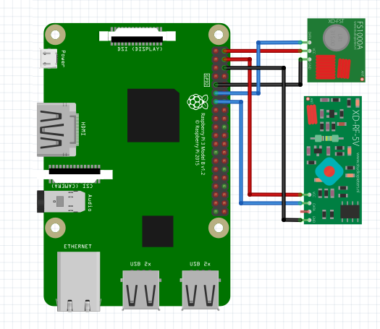
Figure 3.14 433Mhz Transmitter Receiver Module connected to the raspberry Pi.
3.5.1. 5 : Connect the camera :
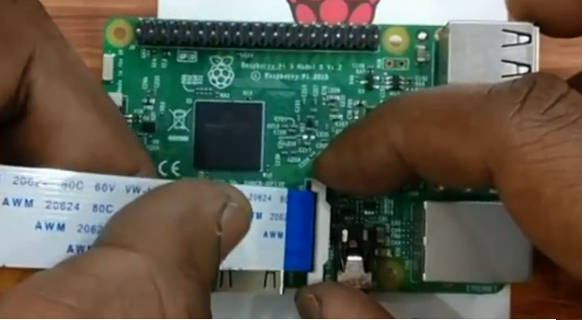
Figure 3.15: Camera connected to the raspberry pi .
Through these figures and tables, we see how to connect an electronic device to a Raspberry pi. A sensor or actuator consists of three necessary pins, VCC is Ground, GND in for earth, and Data for sending or receive a signal. The Raspberry pi consists of 40 pins, 4 5Vpower pins and 3.3V to power the sensors and actuators and we can add other sources
external power supply, plus 8 pins for GND, plus 26 pins GPIO (General Purpose Input / Output) to receive or send a signal, and two other reserved pins.
It is essential to cover each VCC of a sensor with a 5V or 3.3V pin of the Raspberry Pi to power it, and each GND of the sensor with GND of the Raspberry Pi, and each Data with a GPIO.
3.5.2 Programming the Sensors:
After the connection phase of sensors, we move now to the programming as follows:
3.5. 2 .1 For DHT11:
we chose the Node-RED to program the temperature and humidity sensor, because on one side the Node-RED is easier than Python and C language, on the other quoted temperature and humidity values ​​which are change in a time interval and the Node-RED gives the possibility of testing our sensor at each precise time interval, finally avoid loops and the active wait of Raspberry PI processor.
The following figure illustrates the link of different Nodes to capture the Temperature and the humidity and publish them in the “Temperature” and “Humidity” Topics.
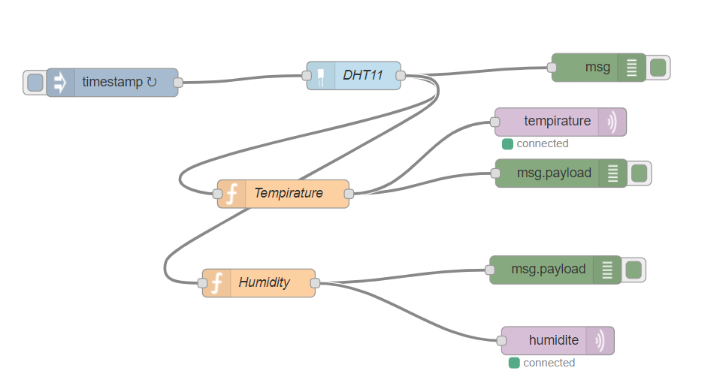
Figure 3.16 Link of the different temperature and humidity Nodes with their topics .

3.5. 2 .2 For MQ-2:
For the gas sensor MQ-2 we used the language C because this sensor receives an analog signal continues, and our Raspberry pi needs a digital signal, and to convert it into a signal digital we should use another device, and therefore, we chose to rely on the C language which offers a <wiringPi.h> library to facilitate this task. The piece of code below illustrates if the gas sensor detects a gas, and consequently, in the Topic GAZ the message "GAZ DETECTED", if not, it publishes the message "COOL ENVIRONMENT "so that our client receives the gas status of his house at all times.
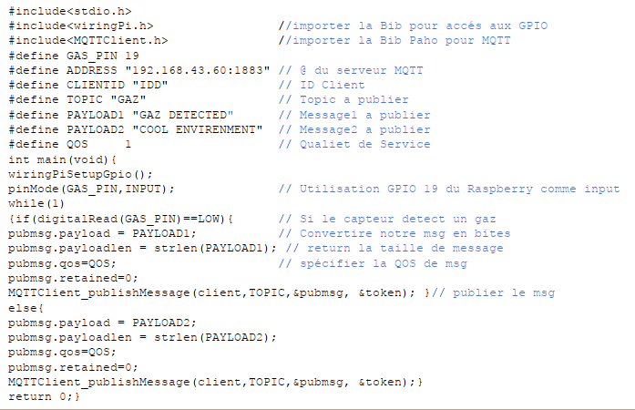

3.5. 2. 3 For the motion detector sensor :
For the motion detector and the 433MHz signal transmitter, implement the scenario next: if the motion detector detects motion, the 433Mhz Transmitter will send a signal to turn on the lamp. For this scenario we will use the Python language. The piece of code below illustrates this scenario.
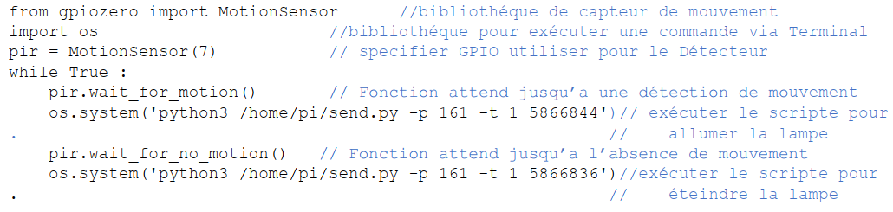

3.5. 2.4 For manual control:
For manual control, the mobile client subscribes to the different Topics available, then it send messages to these Topics to perform an action, will implement the scenario for turn on the air conditioner: if the customer clicks on the Button ON, the socket turns on, but if it does click on OFF the socket goes out.
To achieve this scenario we will create a Python script for a client MQTT which subscribes on the Topic "Prize" if this client receives an "ON" message it will switch on air conditioner, otherwise it will turn it off. The following piece of code illustrates the scenario.
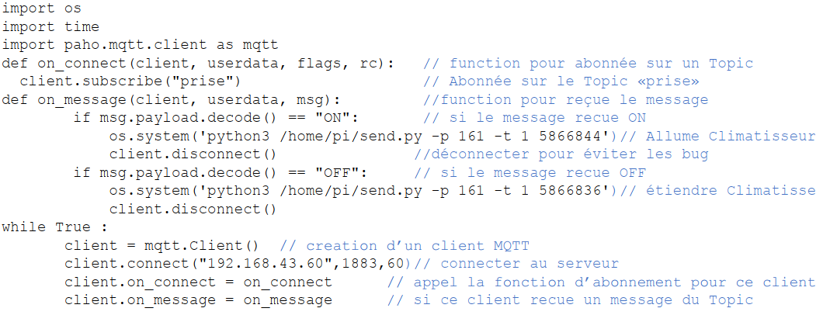
The same principle for the rest of the scenarios.
3.6 Programming the Android Application:
Once the Raspberry Pi, the Sensors, the actuators, are all ready. We will controlled of these objects using an Android application.
3.6 .1 Creation of the database:
The design phase, it starts with the Authentication state, and registration so we need a database.
Android offers a lightweight SQLite database management system so that's what we want to do .
To implement it on Android, we created a DatabeHelper class which inherits the SQLieOpenHelper class to use the SQLite DBMS. The following code tip shows the methods that used for authentication and registration of the user of our application.
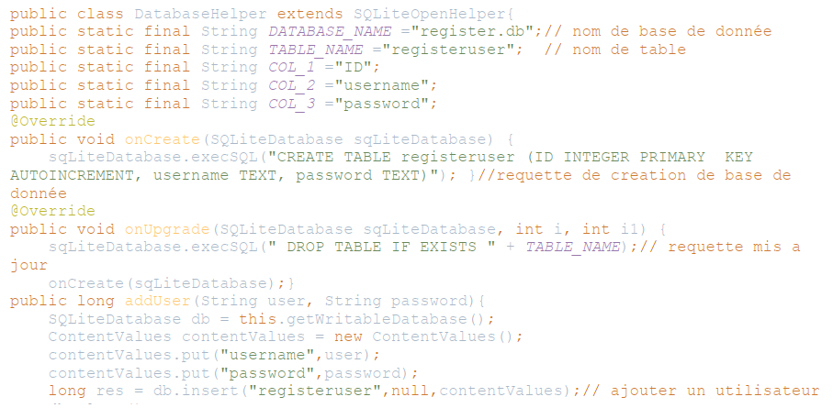
Here are the graphics interfaces of login and inscription.
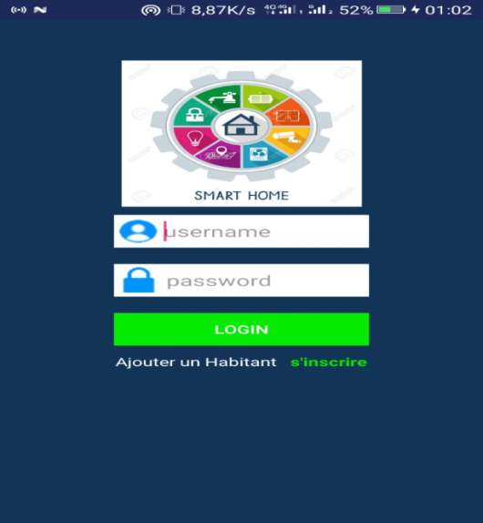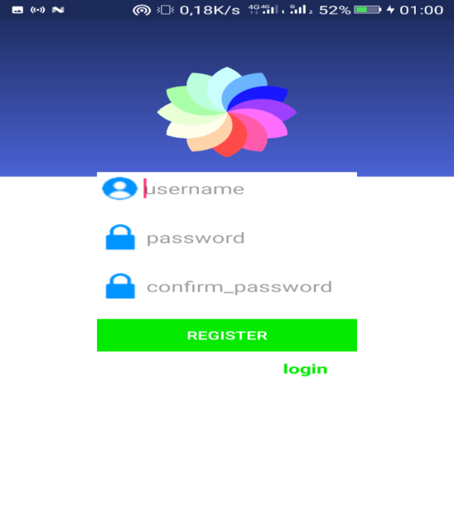
Figure 3.17 : Interface Login . Figure 3.18: Interface inscription.
After the user authenticating, the exchange of information between the house (Raspberry Pi) and the user (the Application) can start. So we go to implement the same principle Publish / Subscribe on the application, the client subscribes to the different Topics to receive Notifications and command actions to connected objects.
To configure the client and an MQTT service in our Android application, we must arrange dependencies which are necessary libraries , we use the Paho MQTT client and the Android service provided by Eclipse. , we will simply add these lines to our build.gradle (project).
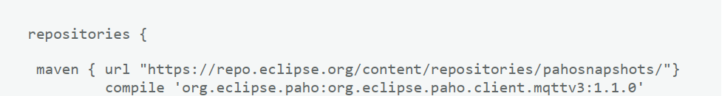
3.6 .2 Configuring the MQTT client and service on Android:
Let's start by creating a new Activity called My Home controlling Activity in our application, which will contain the MQTT connection parameters.
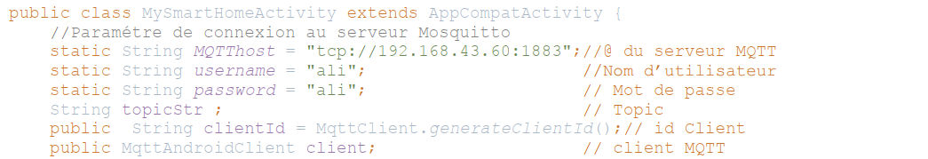
The client can connect to the server, the org.eclipse.paho library offers two onSuccess () methods if the client is well connected and onFailure () in the opposite case.
The setSubscibe () method in onSuccess (), implies if the client is well connected so he can subscribe on different Topics, in this method, we will use both methods predefined subscribe() and setCallback () of the class MqttAndroidClient.
The bit of code below illustrates the use of these two methods.
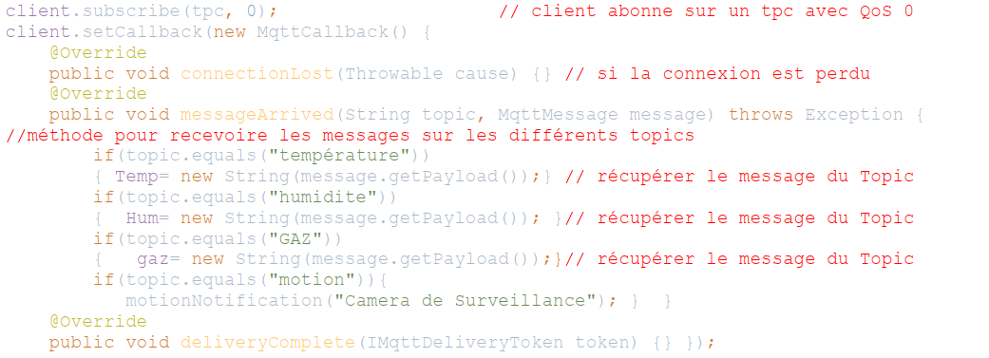
In this code the client is ready to receive all the information from the different topics temperature, humidity, GAS and motion.

3.7 Interface:
Here is the graphical interface corresponding to the main menus My home controlling .
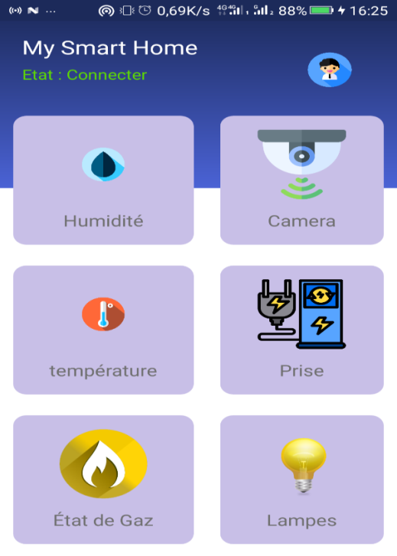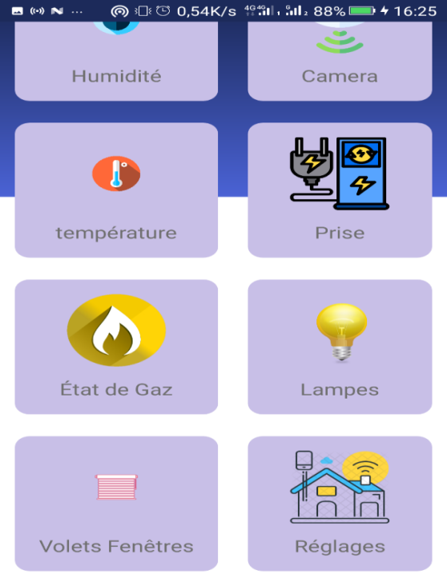
Figure 3.19 Graphic Interface of Menu My home controlling .
The graphical interface shows the different services provided by the application, the resident can consult the temperature and humidity of the house, can see the surveillance camera, can check the gas status, and even can adjust your home with other features.
We have to order actions (turn on the lamp, turn on the air conditioner, etc.), the principle remains the same but it must be published on topics so that each script from our Raspberry pi receives a client message and then triggers an action. Publication in Android done in one line:
The same principle can be applied for all cases of Actuators, we present the rest of the services of our Application.

3.7 .1 Temperate, Humidity and Gas interfaces :
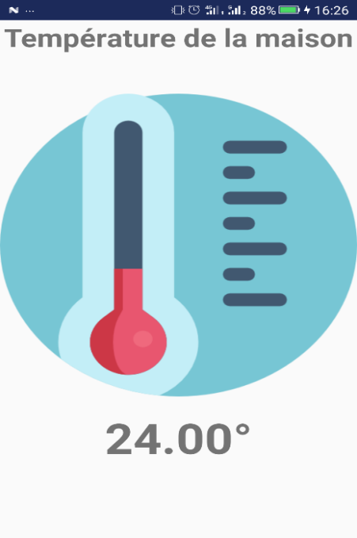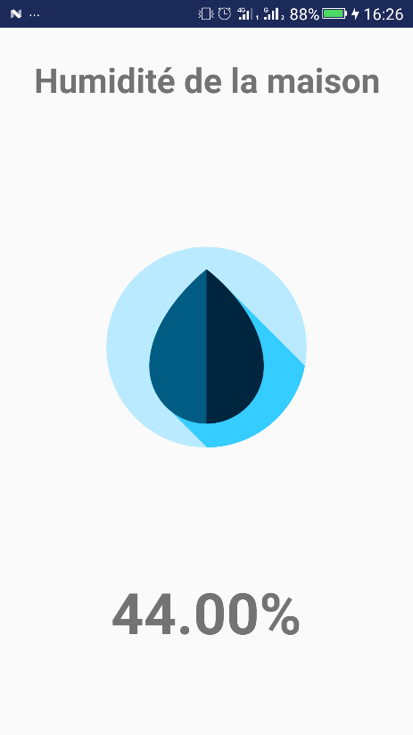Figure 3.20 Interface of Gas state. Figure 3.21 Interface of temperature. Figure 3.22 Interface of humidity .

The Temperature interface shows the house temperature ,its value is returned from the Topic ‘Temperature’, and the same case for humidity.
To consult the temperature and humidity of the home we click on the temperature or humidity button in the main My Home controlling menu.
The Gas Status interface shows us the kitchen gas status, if the gas sensor detects a gas, a notification is triggered to tell us that there is a gas leak in the home.
3.7 .2 Interfaces Window Shutter, Lamps, Sockets:
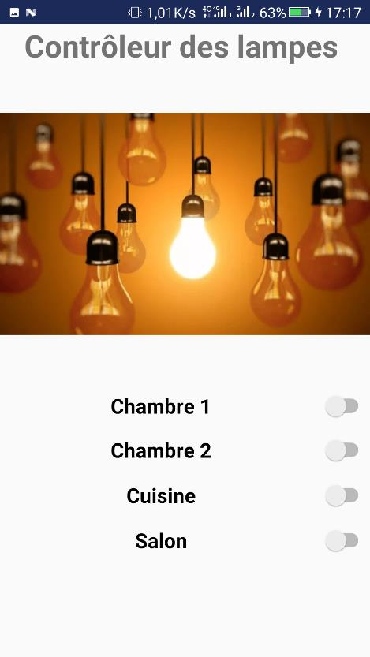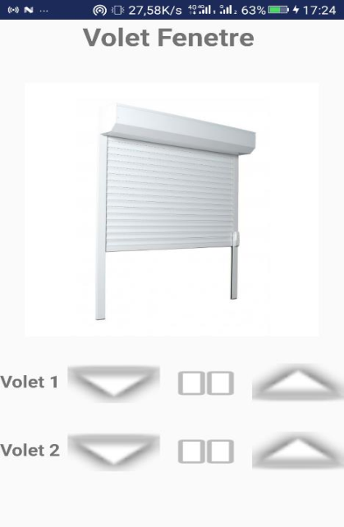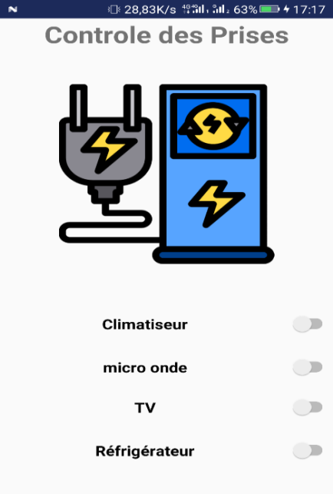
Figure 3.23 The lamps interface Figure 3.24 Window Shutter interface Figure 3.25 The sockets interface

The Lamps interface: switch on various lamps in the home manually, if we activate the switch the lamp lights up, and if you deactivate the switch the lamp, switch off . We can check the lights in bedrooms 1 and 2, kitchen and living room.
The Window Shutter interface: to control the shutters of home windows, there are three options to control a shutter: open, close, stop.
The sockets interface: to control the sockets in the home manually, if we activate the switch the socket activates the electricity, and if we deactivate the switch the socket deactivates the electricity. We can check the following sockets: Air conditioner socket, microwave socket, TV socket, Refrigerator socket.

3.7.3 Surveillance Camera Interfaces, Intelligent Settings:
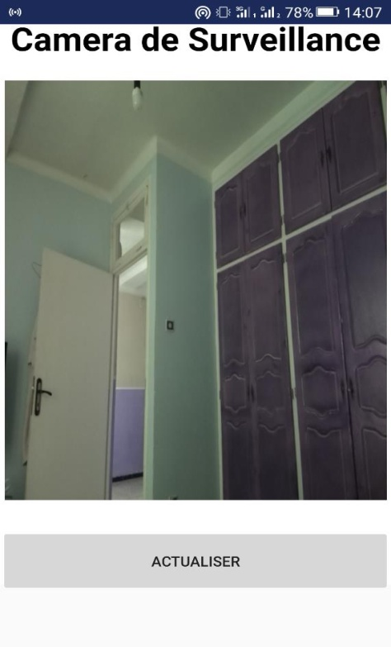
Figure 3.26 Surveillance Camera Interface.
Surveillance Camera Interface: to view the surveillance camera of the house.

3.7.3 Smart Settings Interface:
Consists of four smart options.
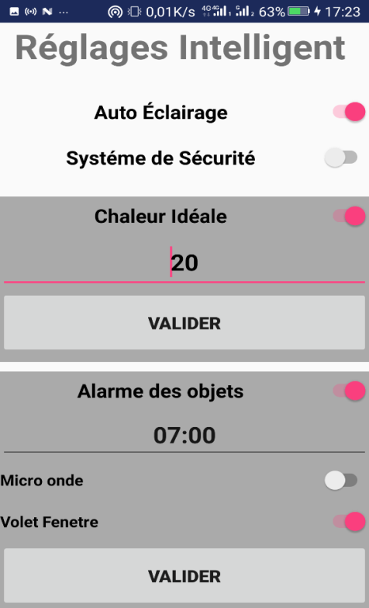
Figure 3.27 Interface of Intelligent Settings.

Smart Settings Interface consists of four smart options:
- Auto Lighting: if this option is activated all the lamps in the home light up automatically when approaching a lamp using a motion detector.
- Security System: When we leave the house we activate this function, if a stranger enter the house, the motion detector detects its presence, it sends a notification to the application to tell us that someone is in the house, if we click on the notification, the closest surveillance camera to the sensor shows us this person.
- Ideal heat: if we activate this option then enter our ideal heat for example 20 °, the house air conditioner turns on automatically until our house has this temperature, then stops automatically.
- Object alarms: if we activate this option, then it is time of our alarm, then we activate the desired objects (for example microwave and window shutters), When the alarm arrives, all activated objects start automatically.

3.8 Conclusion:
In this chapter we implement our application using the raspberry PI 3and sensors according to the architecture proposed for a home controlling system . It gives basics ideas how to control various home objects , provide security , and smart settings .
For the future work ,some novel ideas can be made like new sensors that keep a permanent watch on kids to our system .
GENERAL CONCLUSION
We all know how amazing the internet can be, it provides us access to all sorts of information with a click of a button ,it can help us control our home and save our money, That’s right! The future is no longer just science fiction – it’s here and it’s now! home incorporates advanced automation systems to provide the inhabitants with sophisticated monitoring and control over the building's functions so how can they do it?
Home controlling is a system using IOT and technology, this system is used to monitor and control the home through the internet. In this work, the developed system consists of two parts : hardware and software, the hardware consists of many units such as Smartphone, raspberry pi, motion detector sensor, temperate and humidity sensor ,gas sensor , camera , 433Mhz WL RF transmitter+ receiver module. The software is the second part of this system, it is concist to programming the Raspberry Pi, programming the Sensors and an android application. The raspberry PI used as the controller, it is as a heart for communicating between the remote user and the devices, after we connected sensors to raspberry pi and programmed them, we created the android application and configured the MQTT protocol, the captured data is collected and sent to the raspberry pi , the data is displayed to the user in real time via the mobile application, this application connected to the hardware devices and sensors throuth the interent, in this system, temperature and humidity sensor ,gas sensor, and motion detecter sensors work correctly,so we recive a message when some of this sensors sensing some thing is not normal.

We have achieved the objective of our project, we have successfully developed a system that provides an effective home controlling solution based on IoT Technologies.
In perspective, we can develop an intelligent security system that can increase growing home protection by developing live streaming techniques and image recognition.

REFERANCES

[1] P. Suresh1J. Vijay Daniel2,Dr.V.Parthasarathy, A state of the art review on the Internet of Things (IoT), International Conference on Science, Engineering and Management Research, Department of Computer Science Vel TechMultitech DrRangarajanDrSakunthala Engineering
College, Chennai, India, 2014 .
[14] Pallavi Sethi and Smruti R. Sarangi, Internet of Things: Architectures, Protocols, and Applications, Department of Computer Science, IIT Delhi, New Delhi, India, Hindawi
Journal of Electrical and Computer Engineering, 26 January 2017.
[2] wikipedia http :// en .m wikipedia .org /
[3] https:// Iot - analystics .com
[4] https:// doi.org/10.1155/2017/9324035
[5] Djema Noureddine , Security and home automation based on Raspberry Pi, Arduino Uno and Node MCU, master 2 ,Université Mohamed Khider de Biskra Faculté des Sciences et de la Technologie Département de génie électrique,2017 - 2018.
[6] https://www.techiexpert.com/9-security-and-privacy-risks-of-iot-in-2019/
[7] https://www.techiexpert.com/affect-of-internet-of-things-on-cloud-computing/
[8] https://internetofthingsagenda.techtarget.com/definition/embedded-system
[9] https://www.Forbes.com
[10] https://stonefly.com/blog/role-cloud-computing-internet-things
[11] https://www.webopedia.com/TERM/I/internet_of_things.html
[12] http://www.ubuntupit.com/top 15 Standard IoT Protocols That You Must Know About
[13] Ala Al-Fuqaha, Mohsen Guizani, Mehdi Mohammadi, Mehdi Mohammadi, Moussa Ayyash, Internet of Things: A Survey on Enabling Technologies, Protocols, and Applications, IEEE communication surveys & tutorials, 17, NO. 4, fourth quarte,r2015 2347.
[15]https://www.google.com/imgres?imgurl=https%3A%2F%2Fblog.econocom.com%2Fwp-content%2Fuploads%2F2018%2F03%2FIIot-internet-des-objets-industriel.jpg&imgrefurl=https%3A%2F%2Fblog.econocom.com%2Fen%2Fblog%2Fhow-the-internet-of-things-is-revolutionising-industry%2F&docid=14DnUSp9tamuBM&tbnid=Ww1bdXhg8beIrM&vet=1&w=900&h=549&source=sh%2Fx%2Fim.

ANNEXE
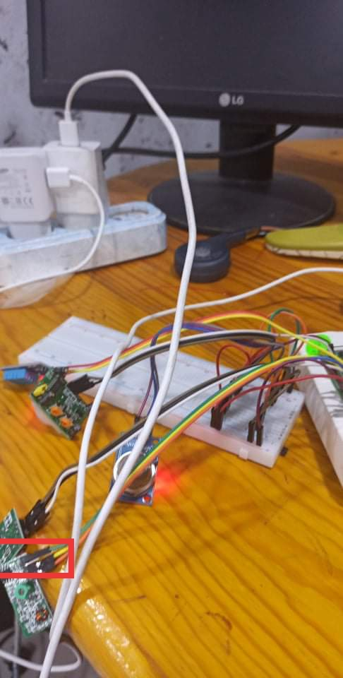

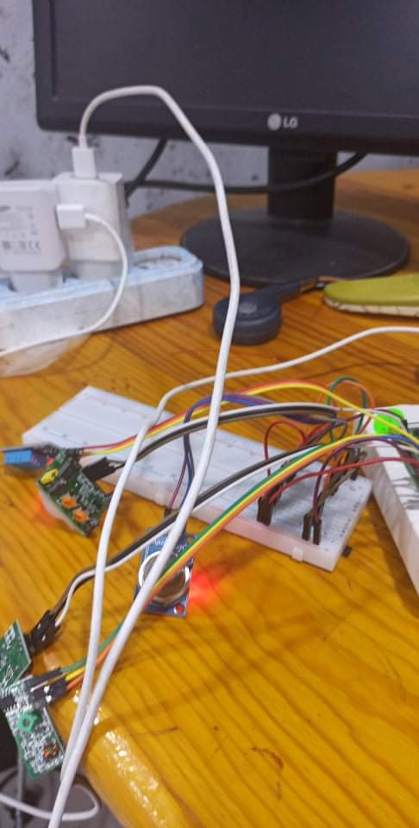

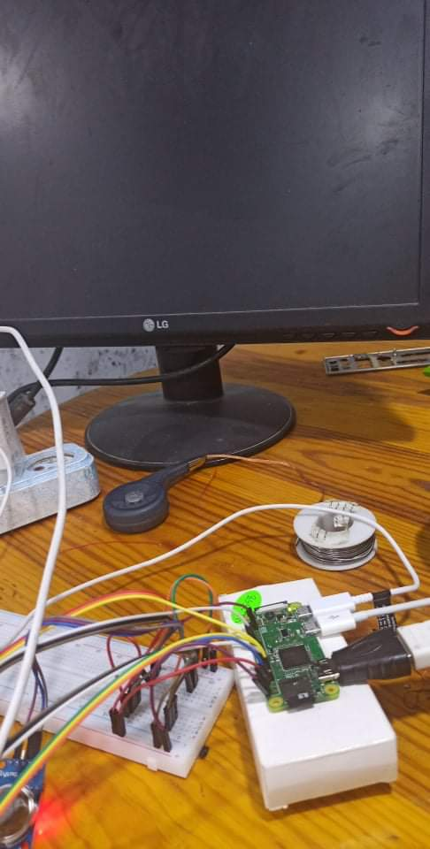

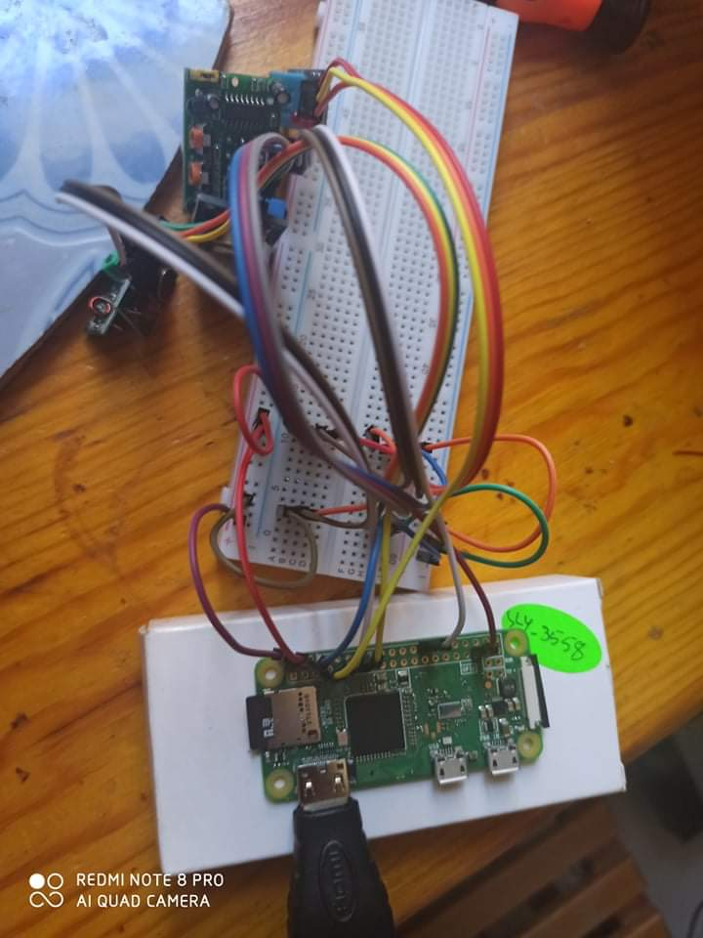

ملخص:
تقنيات المراقبة في المنزل ، أصبحت الحياة أسهل وأبسط ، عندما تراقب منزلك وتتأكد من أن ممتلكاتك الثمينة آمنة عندما تكون بعيدًا ، والهدف من هذه الرسالة هو إنشاء نظام لمراقبة المنزل والتحكم فيه عن طريق الانترنيت. مع تطبيقات IOTانترنت الأشياء ، يتكون نظام التحكم في المنزل من إنشاء تطبيقAndroid الأندرويد للتحكم في منزل مجهز بأجهزة استشعار مختلفة مثل مستشعر درجة الحرارة و الرطوبة ، ومستشعر الحركة ، ومستشعر الغاز ، والمصابيح ، والمقابس ، ومصاريع النوافذ ، وكاميرا المراقبة.
الكلمات المفتاحية : انترنت الأشياء ، مراقبة المنزل ، الراسبيري باي ، الأندرويد
Abstract :
Home controlling technologies , life is getting easier and simpler ,when keep a watchful eye over your home and make sure your precious belongings are safe when you are away, The aim of this thesis is to build a system to monitor and control home through the Internet. With applications of IoT, The home controlling system consists to create an Android Application for controlling a home equipped with various sensors like temperature and humidity sensor, motion sensor, gas sensor, Lamps, sockets, Windows shutters, surveillance camera, actuators and the Raspberry Pi.
Keywords : IoT, Home controlling, Raspberry Pi, Android.

Technologies de contrôle à domicile, la vie devient plus facile et plus simple, lorsque vous surveillez votre maison et assurez-vous que vos biens précieux sont en sécurité lorsque vous êtes absent. Le but de cette thèse est de développer un système de surveillance et de contrôler d’une maison depuis l’Internet. Avec l’application de l'IoT, le système de contrôle à domicile consiste à créer une application Android pour contrôler une maison équipée de divers capteurs tels que capteur de température et humidité, capteur de mouvement, capteur de gaz, lampes, prises, volets fenêtre, caméra de surveillance, actionneurs.

Mots clés : Internet des objets, contrôle d’une maison à distance, Raspberry Pi, Android.

