

PEOPLE'S DEMOCRATIC REPUBLIC OF ALGERIA
MINISTRY OF HIGHER EDUCATION AND SCIENTIFIC RESEARCH
UNIVERSITY MOHAMED BOUDIAF - M'SILA

FACULTY: Mathematics and computer Science DEPARTMENT: Computer Science N°:……………………………………
DOMAIN: Mathematics and Computer Science
BRANCH: Computer Science OPTION: RTIC

Dissertation submitted to obtain Master degree

By: Bouras wafa

SUBJECT

Security mobile inspired quantum cryptography

Publicly defended before the jury composed of:

Mr. Chikouche Noureddine | University of M'sila | President
Mr. Mohammed Benouis | University of M'sila | Supervisor
Mr. abdessattar ghemougui | University of M'sila | Supervisor
Mr. Fares MEZRAG | University of M'sila | Examiner

Academic year: 2019/2020

Acknowledgment

First of all, I’d love to show my appreciation and gratitude to Allah the Almighty who made the perfect condition for this work to see the light.
Anxiety and depression and the korona situation were overwhelming while trying to finish this project and it was only possible to fight through it with the support of some people that I want to thank individually.
I shall give the credit of leading this project to my supervisor Mr. Mohammed Benouis, who offered me the opportunity to work on this project and had enough patience to review and correct my work over and over. Let alone sharing her wise guidance and unclouded thoughts to make this project go on the right path. So, thank you, it was pleasure to work with you even though I couldn’t give my 100.
I wish to thank to Mr. abdessattar ghemougui who always offer the help whenever I ask.
I wish to thank the board of examiners Dr. Chikouche Noureddine, Dr. Fares MEZRAG, for accepting to evaluate this thesis.
Thanks to my parents who were supportive during my educational career over the years, they were the one who had always faith in me despite all.
Thanks to all the teachers who teach me and make me understand the great things in scientific research, they made me feel in science and how the curiosity in science is so amazing.
Thank you all.
Bouras wafa

Dedication
I dedicate this achievement to two very important beings in my life, two missing so that I shine in the sky of science. Two people who sacrificed themselves, and who got tired and who wanted
without conditions to give a very stable and happy study life:
My father: sadek
My mother: Saliha
Many thanks for everything.
To my support in this world my brothers:
Mohamed Amine, Aymene Salim.
To my dear sister:
Imene.
I wish my God to protect them and give them good health.

Table of content

title | page
Table of content | iii
Table of figures | v
Table of tables | vi
Table of equation | vi
Abbreviation table | vii
General Introduction
General Introduction | 1
Objective | 2
Contribution | 2
Report outline | 2
Chapter1: Classical cryptography
Introduction | 4
- The history of classical cryptography | 4
- The classical cryptography | 6
- The simple model of cryptography | 7
- One-time pad | 10
- The objective of cryptography | 10
- Limits of classical cryptography | 11
- Evolution towards quantum cryptography | 11
The conclusion | 11
Chapter2: Quantum cryptography
Introduction | 13
- The general idea about the quantum cryptography | 13
- Quantum key-distribution | 14
- Quantum entanglement | 15
- Quantum key distribution | 15
- Quantum key distribution performance | 15
- The quantum protocols | 16
- Quantum protocol in mobile communication | 17
Conclusion | 18
Chapter3: Comparative study between quantum protocols
Introduction | 20
- Related works | 20
- Implementation tools | 21
- The five protocols and its simulation | 23
- The scenario of experience | 25
- Implementation in experience | 26
- The comparative study of protocols | 27
Conclusion | 29
Chapter4: Quantum attacks
Introduction | 31
- The cyber-attacks into the communication systems | 31
- Different attacks in quantum security | 32
- The implementation of eavesdropping attack and how can be detected | 35
Conclusion | 38
General conclusion
General conclusion | 40
References
References | 42
Abstract | 44

List of figures:
figure | page
Figure 1 1: the Morse code | 5
Figure 1 2: ADFGVX Cipher | 5
Figure 1 3: The Enigma machine | 6
Figure 1 4: the cryptography way | 6
Figure 1 5: the model of cryptography | 7
Figure1 6: The symmetries model | 8
Figure 1 7: the step of AES algorithm | 9
Figure 1 8: the DES step | 9
Figure1 9: the asymmetries model | 10
Figure2 1: the block sphere | 15
Figure2 2: the basis of BB84 | 17
Figure2. 3 the basis of BB92(the photons that work into) | 17
Figure2. 4: sarg04 protocol photons | 17
Figure3. 1: android studio | 22
Figure3. 2: QR code section | 22
Figure3. 3: peer devices with Wi-Fi Direct | 23
Figure3. 4: theP2P group | 24
Figure3. 5: vysor application | 24
Figure3. 6 the way that share an entangled state to Alice and Bob | 25
Figure3. 7 The quantum analyzer | 26
Figure3. 8: the application procedure | 27
Figure3. 9the algorithm that simulate Entanglement | 28
Figure3. 10: the entangled state | 29
Figure3. 11: the results of experiences | 30
Figure4. 1: the attack in system communication | 32
Figure4. 2create Alice registers | 36
Figure4. 3bob generate the key and receive Alice keys | 37
Figure4. 4the result in safe channel sharing key | 37
Figure4. 5result of eve between Alice and Bob communication | 37
Figure4. 6CHSH inequality | 38
Figure4. 7experience of CHSH correlation | 38
Figure4. 8condition of CHSH | 38
Figure4. 9results of communicating without eve | 38
Figure4. 10result of communication with eve | 38

List of tables:
Table | page
Table 1:quantum protocols | 18
Table 2: encrypt and decrypt message into QOTP | 24
Table3: the classical attacks | 32

List of equation
Equation | page
Equation 1cesar equation | 4
Equation 2RSA encryption method | 10
Equation 3RSA decryption method | 10
Equation 4: mathematical representation of qubit | 14
Equation 5: the first rule to identify a qubit | 14
Equation 6: qubit’s characteristics | 14
Equation 7: inner-product of ket and bra | 14
Equation 8: tensor product | 14
Equation 9: low of p of outcome | 15
Equation 10: the Hadamard basis | 15
Equation 11: representation of α and β in sphere | 15
Equation 12: the transmission rate calculation | 28

Abbreviation table

Century AD | Century Anno Domini
ADFGVX | The six possible letters used in ciphertext
AES | Advanced Encryption Standard
DES | Data Encryption Standard
RSA | Ron Rivest, Adi Shamir, Leonard Adleman
QKD | Quantum Key Distribution
BB84 | Bennet ,Brassard 1984
BB92 | Bennet ,Brassard 1992
SARG04 | V.Scarani, A.Acin, G.Ribordy, N.Gisin 2004
KMB09 | Muhammad Mubashir Khan, Michael Murphy and Almut Beige 2009
S09 | Eduin Esteban Hernadez Serna 2009
S13 | Eduin Esteban Hernadez Serna 2009
PNS | Photon number splitting
SDK | Software Development kit
QR | Quick Response
P2P | Peer to Peer
E91 | Eckert 1991
EPR | Einstein Podolsky Rosen
WI-FI | Wireless Fidelity
CA | Certificate Authenticate
RE | Router Extractor
DDOS | Distributed Denial- of-Service
MITM | Man In The Middle
QC | Quantum computer
WLP | Weak Laser Pulses
QND | Quantum non-demolition
WCP | Weak Coherent Pulses
CHSH | John Clauser, Michael Horne, Abner Shimony, and Richard Holt
QOTP | Quantum One Time Pad
DARPA | Defense Advanced Research Projects Agency

General introduction

GENERAL INTRODUCTION

The security issue has drawn a lot of attention along with the development of wired and wireless networks. Cryptographic techniques are widely used for secure communications. The critical concern is finding the light protocol to hide the data as well to protect any systems from any attacks. The characteristics of kind of this system (i.e, mobile computing) pose both challenges and opportunities in achieving security goals: confidentiality, authentication, integrity, availability, access control and no repudiation. For several decades, the conventional cryptographies either based on symmetric or asymmetric have been successfully tested in many real applications, however, the growing a number of computers with high speed calculation (quantum computing) and a few works about machine learning security have become the big concern which many governments and companies are launching a new program and meeting to find a transforming security that may meet the requirement of the industry 4.0. Moreover, To the best of our knowledge, it is expected that about 50 billion devices will be connected to the internet up to 2020. Embedded technology is used in devices and sensors. Wireless technology enables them to connect with other devices or internet. Mobile computing is becoming a part of our lives, in which QR code bar are performed in various contexts such as consumer advertising, commercial tracking, ticketing and marketing. Besides a multiple of outcomes, QR image generator often implies distinct security attacks of which the average user is mostly unsafety. To deal with this issue, Recent advancements in quantum technology (i.e., IBM and Google have been successfully making a quantum computer) especially in terms of hardware memory capability, have motivated the application of quantum security in different areas of life. As a matter of fact, quantum security applications have reported significant breakthrough in domains such as fibre transmission, wireless network, mobile computing, cyber security. Basically, quantum security algorithms have been built for solving vulnerability issues. And it has been considered as an alternative tool that could generate a strong key with few quantum operations, thus providing an effective means for obtaining secure channel. Towards providing an effective way to make any operation from smartphone, which could hide the data of users and its privacy, provide a light secure application for real time, an application for mobile computing that contains the well exiting quantum algorithms was proposed for the QR scanner towards smartphone application. The feasibility and performance of the proposed application was investigated and compared in term attacks to that of the previously used algorithms in the classical security.

Objective
In this work, our aim is to develop a QR code scanner based on quantum cryptography, the exiting quantum cryptographies have carried on smartphone and compared with the classical security algorithms.

Contributions
To fulfil our task, we introduced the following contributions:
- How to preform the quantum algorithm into a classical machine.
- A several experiences has been done in terms transmission rate and the consuming time.
- A new algorithm has been developed where inspired from the advantage of each quantum algorithms such as.

Report outline
This work has been divided into four chapters:
- The First chapter: We have explained the classical systems and move on to discuss the limits of classical cryptography and what’s the motivation behind the quantum cryptography.
- The Second chapter: Focusing into the quantum world from the basics and try to give the essential mathematical concept which were borrowed from the physics quantum theory.
- The Third chapter: We explain our framework design and the different experiments by showing the advantage and weakness of each protocol. Based on these results, we have made a comparison to show the benefit of quintom concept against classical security system.
- The Fourth chapter: Contained the classical attacks against the quantum cryptography and mentioned a few quantum attacks.
And finally, a general conclusion for project.

Chapter 1

The classical cryptography

Introduction:
In few decades and with the development of the mobile technology, the scientists evolve the ways for get more secure to get the privacy and the security of communication between the phones, one of this ways is the classical cryptography, in this chapter, we will discuss a brief historical about a classical cryptography, then we will talk about some definition and concepts. In the end, we will move to explain the most important points of cryptography and his algorithms within their limits and the way throw the quantum cryptography.

1.The history of classical cryptography:
For decades, the secure of information into communication was a big concern in many countries, in particular the military sector, government and technology sector.
If we talk about the cryptography, we refer to the well-known history (By the 9th Century AD) where the Roman used Julius Caesar Cipher to hide them messages from the enemies. Its rule was done by encrypting each letter by another one which defined by the index that come as result of sum of the index of letter of message with the index of the key.

 | $$E=index\left(l\right)+index\left(key\right).$$ | (1)

Then, there is many ciphers were being com by developing a new idea, called Vigenère Cipher which encrypts more letter instead of one letter.
Besides the both algorithms apparition, the Greeks was considered the first inventor who used a transposition encryption technique by just modify the index of letters in the original message. They used a scytale .it was a ribbon (a cylinder) on which we rolled up a strip of paper, the text was then written in straight lines successive, the ribbon which constitutes the encrypted text was then unrolled and sent to the recipient who had to rewind it on an axis of the same diameter, the text therefore appears in clear, without the knowledge of the diameter of the ribbon which played the role of the key, it was impossible to decipher the message.
During the first world war, the military sector had developed a new cipher that used in the radar communication like the Morse code, that then further designed to use in telegraph message

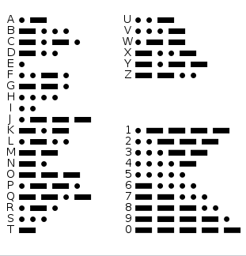
Figure 1 1: the Morse code
The ADFGVX Cipher is an algorithm that comes in world first war by German’s army, it works by put the letters of secret message in matrix of 6X6, while each line and column refer to each one of those six letters respectively as the figure shows.

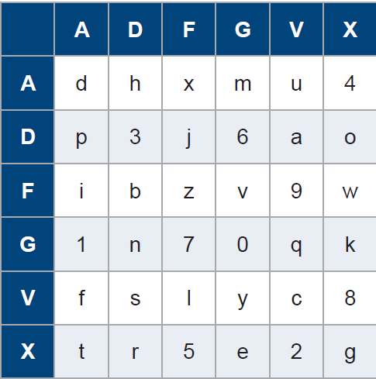
Figure 1 2: ADFGVX Cipher
There is also the Enigma cipher that comes in 20th century, used by German in world war two, this was famous by the impossibility of crack this cipher until 1939 by Polish expert John Gallehawk.

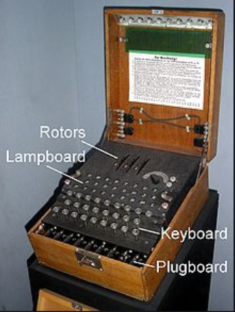
Figure 1 3The Enigma machine
Since the 17s centuries, the classical cryptology had been grown through the machine development and many concepts were used to further secure information into the computer science world and the communication way.

2.The classical cryptography:

2.1. The cryptography
It used to transfer the clear text into unreadable text within high confidential.
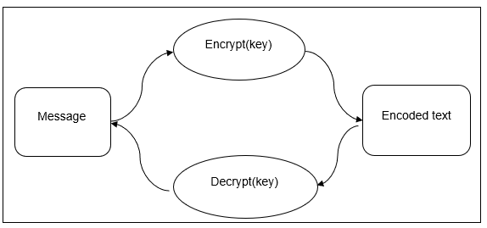
Figure 1 4the cryptography way
As shown in the above figure, the cryptography is consisting of four part:
- Message: is the clear text that will be encrypted.
- Encoded text: the result of cypher text.
- Encrypt: the function to generate the key.
- Decrypt: the operation to recover the original text.

2.2. Cryptanalyze:
It’s the paradigm of deferent cryptographic analysis to study the behavior of each crypto algorithm in terms complexity, attack, function encryption.

2.3. Cryptology:
It’s the science that studies the theory behind the cryptography and cryptanalyze.

2.4. The cryptographic algorithms:
It described the functions that be performed in the machine are used into encrypting and decrypting the information.

3. The simple model of cryptography:
Since the information was important for get secure, the scientist never get enough for looking about the perfect way for this, and throw this way, we can define two type of algorithms, the symmetries and symmetries ones.
We can suppose Alice and Bob as two persons who communicate through an encrypted channel as shown in the following figure:
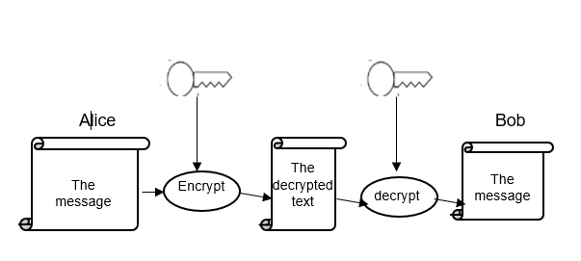
Figure 1 5the model of cryptography

3.1. The symmetries algorithms:
This kind of this algorithm uses the same key for the encryption and decryption step.

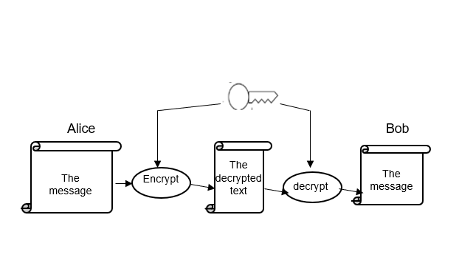
Figure 1 6 The symmetries cypher text model

3.1.1. The type of a symmetries model:
There is two type:
- Block encryption: In this encryption, the clear text is dived into subblock with a fixed length and then each of them will be encrypted. The size of those blocks is essential for the security of communications, which if the size is longer, the system will be more secure but the complexity scheme will be also more sophisticated.
- Stream encryption: Unlike the pervious method, these algorithms don’t need to split the message into sub blocks, they encrypt messages bit by bit.

3.1.2. Example of symmetric algorithms:
- AES (Advanced Encryption Standard): The message block with 128 bits encrypted with a key has a length 56 bits, the main idea of the encryption and the decryption are well described in the following flowchart.

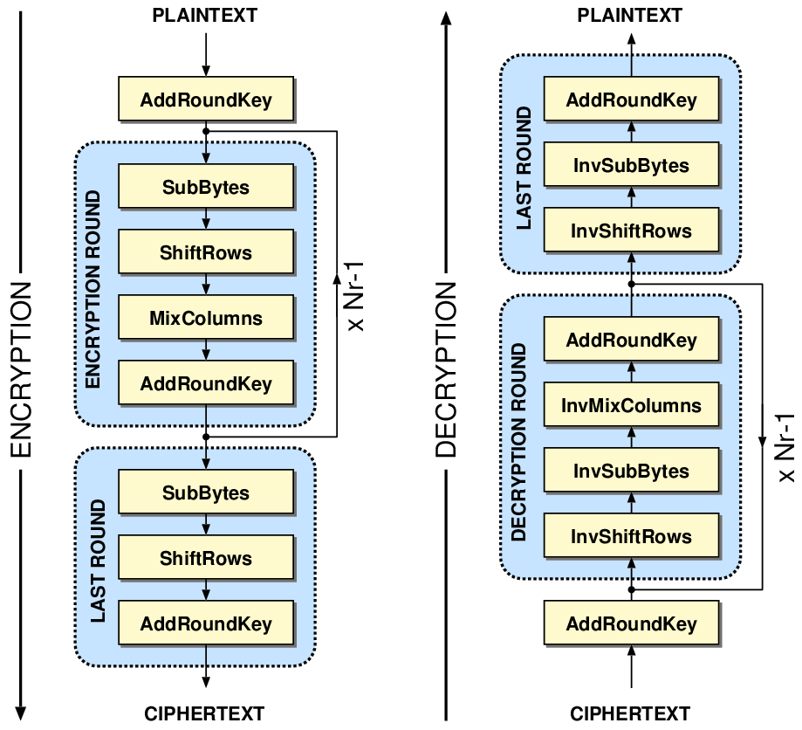
Figure 1 7the step of AES algorithm

- DES (Data Encryption Standard): The message block with 64 bits encrypted with a key of 56 bits, the figure 18 explains the essential step of the encryption and decryption step.
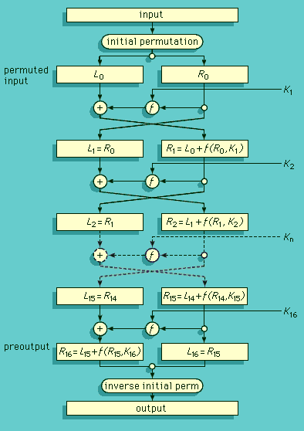
Figure 1 8the DES step
- Advantages:
- Suitable for the large data stream to be encrypted.
- Simple and easy to implement.

3.2. The asymmetries algorithms:
This one work with two deferent keys
Figure 1 9: the asymmetries model
As the shown in the above figure and unlike the symmetric model, Alice et Bob don’t use the same key for the encryption and decryption step.
When Bob receive the encrypted text, he will decrypt it with his own key (private key), this key is associated with public key which is known for Alice et Bob.

3.2.1. Example of asymmetric algorithm:
RSA: The most famous algorithm is successfully used in many applications, which resisted to many attacks for a more couple of years, however recently its broken by Shor algorithm [2]. This algorithm generates two keys (private key K2 and public key k1) as the following functions:
 | $$E=M^{k1}mod n$$ | (2)
And decrypt by:
 | $$M=E^{k2}mod n$$ | (3)

3.2.2. The advantage and disadvantages of asymmetric algorithm:
Advantage
- Exchange messages securely.
- Sender and recipient no longer need to share secret keys via a secure transmission channel.
- Communications channel between Alice and Bob share only the public keys and the private key is generated at the receiver.

Disadvantages
- Data processing is slow and requires a lot of computation to generate primary values.
- Assurance that the public key belongs to the person you want communicate the encrypted data.

4. One-time pad:
It is an encryption mechanism that use the random function to get cipher in condition that Alice and Bob get the pre-shared key first. This kind of cryptography cannot be cracked. the main idea for encrypt and decrypt the massage is by using the Xor with the key.

5. The Objective of Cryptography:
The objective of the security of a computer system is the protection of information and resources against any devaluation, modification or destruction.
The goal of cryptography is to adequately meet the following objectives:
- Confidentiality: it is to keep information secret from everyone except people authorized.
- Authentication: allows you to prove authenticity by confirming the identity of an entity.
- The integrity of the information: guarantee that the data is not modified (by unauthorized users) during storage or transfer.
- Non-repudiation: this consists in ensuring that none of the partners can deny the transaction completed.
- Availability: guarantee access to a service or data.
- Access control: limit access to resources to privileged people.
- Authentication message: confirmation of the source of the information.
- Signature: the means of linking information to an entity.

6. Limits of classical cryptography:
- In conventional cryptography, a secret key can only be used once, and cannot be authenticated if it is known to more than one person. In addition, using the same key for encryption and decryption limits confidentiality.
- With regard to public key cryptography, the encryption and decryption algorithms are slow and require a large number of calculations.
- In order to remedy these limits and in particular the problem of distribution of secret key, which must be as long as the message and changed with each new transmission, new techniques have appeared, namely quantum cryptography.

7. Evolution towards quantum cryptography
Quantum cryptography, more correctly called quantum key distribution, designates a set of protocols allowing to distribute a secret encryption key between two distant interlocutors, while ensuring the security of the transmission thanks to the laws of quantum physics and information theory. This secret key can then be used in a symmetric encryption algorithm, in order to encrypt and decrypt
Confidential data. Indeed, this method allows not only to unmask any attempt to spy thanks to the properties of quantum mechanics, but also to reduce the amount of information held by a possible spy to an arbitrarily low level. Quantum cryptography therefore constitutes a precious tool for symmetric cryptography systems where the two interlocutors must imperatively have the same key.
The quantum cryptography system is used primarily to communicate a key, not the message itself, because the bits of information communicated by quantum cryptography devices can only be random. This is not suitable for a message, but perfectly suited for a key. The foundations of quantum cryptography were established, among other things, by the work of Charles H. Bennet and Gilles Brassard in 1984 and the first ideas were put forward by Stephen Wiesner in the 1970s [2]

Conclusion:
By studying the basic principles of classical cryptography, we have been able to understand the strengths and limits of the various cryptographic schemes. In order to overcome these limits and particularly the problem of key distributions, recently the quantum computing open a new avenue to develop a strong cryptography algorithm to protect the data and the privacy of human especially regarding the current revolution technology, which is the main subject of the following section.

Chapter 2

The quantum cryptography

Introduction:
Recently, the cryptography has been adopting the quantum theory as new alternative way to overcome the weakness of the classical security system. The quantum relies upon the mathematic and the quantum physical (i.e., the quantum physical was invented by Albert Einstein) to model the information in the machine as quantum bit instead of binary bit. So, in this section, we will discuss the essential of Quantum cryptography, the basics and the Quantum key-distribution, then we explain the Quantum entanglement, Quantum key distribution scenario and then showing the Quantum key-distribution performance. At this end, we will present the well-known protocols, and their application in the mobile computing.

1.The General Idea about the Quantum Cryptography:
The Quantum Information: is the way that represent information in Quantum cryptography, because in the classical machine (Von Neuman architecture) the information coded only by 0 or 1 it. However, in the quantum theory the message is coded by an amount of 1 and 0, called a qubit. It can be written as the following:

 | $$\left|ψ> = α\right|0> +β|1>$$ | (4)

Where
 | $$α^{2}+β^{2}=1$$ | (5)

We can write the standard basis as vertex like:$|0> =\left({1 \atop 0}\right)$ and $|1> =\left({0 \atop 1}\right)$
Any qubit represent by amount (probability) of ket and bra:
 | $$Ket=\left({α \atop β}\right)$$  $$Bra= {\left(|ψ> *\right)}^{T}$$ | (6)

The operation between two qubits are doing by Inner product as the following operation:
 | $$<ψ|ψ> =\left(α^{*} β^{*}\right)\left({α \atop β}\right)= α^{*}α+β^{*}β={\left|α\right|}^{2}+{\left|β\right|}^{2}=1$$ | (7)

1.1 Combine two qubits for combine two Qubit we |A> and |B> will use a Tensor product:
 | $$|ψ> =|A>⊗|B>$$ | (8)

1.2 Measuring a qubit: get the probabilities p of outcome
 | $p=\left|<ψ\right|ϕ>{\left.​\right|}^{2}$: probability of outcome of $ϕ$ | (9)
The Hadamard standard basis: is a computational basis, superposition of the basis state created as result of application of Hadamard transform
 | $|+> = \frac{1}{\sqrt{2}}$ (|0>+|1>)  $|-> = \frac{1}{\sqrt{2}}$ (|0>-|1>) | (10)

1.3 Block sphere representation:
Is a representation of block sphere we can put α and β like complex number and the representation note the polarization of vertex in 3 space of sphere.
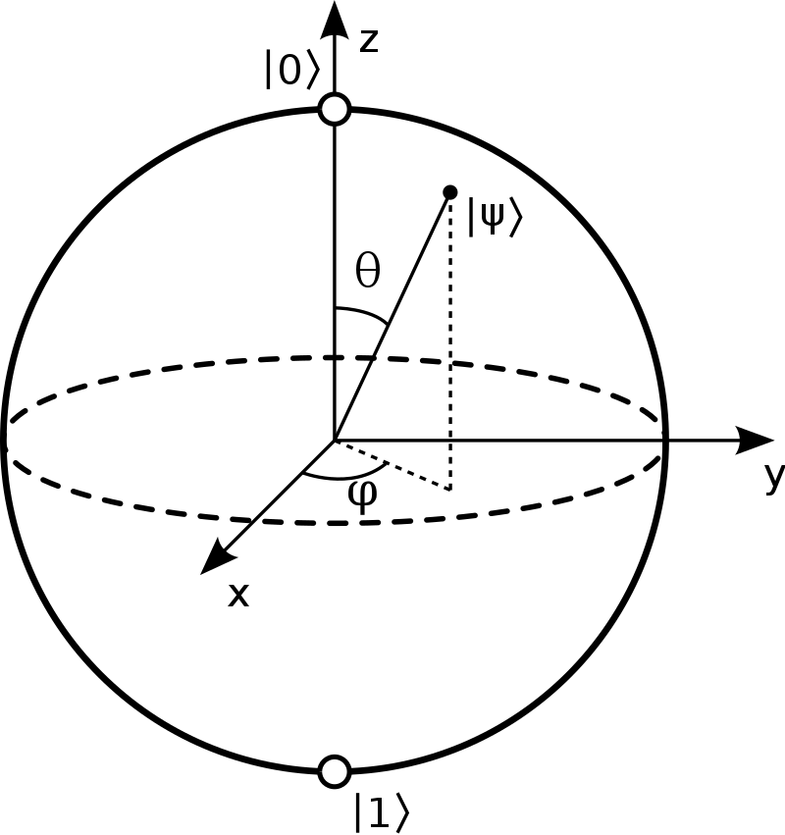
Figure2. 1: The block sphere

So, the value of α and β will be writhed by the φ and θ
 | $$α= e^{ψ}\cos{\frac{θ}{2}}$$  $$β=e^{i(ψ+θ)}sin\frac{θ}{2}$$ | (11)

2. Quantum key-distribution:
The Quantum-Key- distribution is the concept that the scientists created in 1970s but it become to be important in 1980s, the main idea of this concept was simple until the 1990, when the communication start to use the entanglement, that make the physicists start to get really interested. Later, this progress has achieved a remarkable development, especially when the most protocols based on quantum mechanics be possible to be made it in the communication channel.
One of these protocols, the Quantum key distribution (QKD) protocol is a key establishment protocol. The main idea is to generate a symmetric key using a quantum property of light, thus leads to generate a random key from sender and receiver.
The QKD protocol has two principal features, one of using the entanglement as a basis Qubits for the key generator and the second for the design by using the Heisenberg’s Uncertainly Principle.

3. Quantum entanglement:
Quantum entanglement is a quantum mechanical phenomenon in which the quantum states of two or more objects have to be described with reference to each other, even though the individual objects may be spatially separated.
To be in realistic scenario, if we use the example of Alice and Bob when they get the same qubit that they actually get from the message.
This phenomenon makes a lot of scientists in argument such Einstein and Bohr. The main idea is if Alice and Bob contain an entangled states and Alice tries to measure her state. The state of Bob changes his spin the moment that she does that. It means that there is mastery power between those state which is Entanglement. in 1964, John Bell suggest an experiment about if we imagine some rules and applied it into the Quantum way, we will find that the qubit of Bob isn’t actually down if Alice doesn’t measured her qubit because in somehow they are correlated, it’s seems like the act of Alice effect spookily in the qubit of Bob.

4. Quantum key distribution scenario:
The most important way for get the comparison between the protocols, is to figure out the role of each one into this scenario, Alice ,the sender, who starts the key transmission ,Bob the receiver, has the rule of extract the key , and there is the dark side which is Eve , the eavesdropper, who try always to get the key from the quantum channels.
Of course, if there is the simulation of this scenario with quantum machine for each one, it’s appear that there is two channel between Alice and Bob the first one is classical, which use it for the encrypted text transmission and there is the quantum channel , the one that use for the key transmission.

5. Quantum key distribution performance:
For any protocols use the Quantum lows, it’s important to mention that the performance can be defined by know the key rate and the maximal secure distance, those two features are the aspect of QKD in any protocols.
The key rate is defined like an average of final key bits from the repetition, or in another word a frequency, it gives a hint for calculate the speed of getting the correct key by sender and receiver by multiplying the pulse repetition.
The maximal secure distance is defined for the post-processing scheme as the maximal QKD transmission distance that can yield a positive key rate, for more understand the definition, it’s important to mention that the channel for qubits in quantum machines is optical fiber because the quantum machines work by product the photons from atoms and electronics.

6. The Quantum protocols:
As the classical encryption process, the quantum encryption uses a set of rules and protocols to make the channel communication more secure:
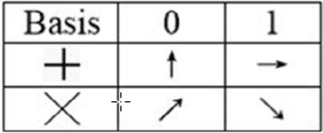
6.1. BB84: is the first protocol that implement the idea of quantum concept, his idea is by generate a key randomly using the QKD protocol and measure the Qubit information by four basis |0>, |1>, |+> and |->.
Figure2. 2:the basis of BB84

6.2. BB92: it’s seems like the same of mechanism of BB84 but it uses two basis, no-orthogonal basis, and this give it a benefit as the table shown.
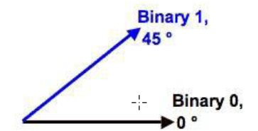
Figure2. 3 the basis of BB92(the photons that work into)
6.3. SARG04: it uses a new mechanism which is a six state when every state belongs to be it’s identification like the picture.

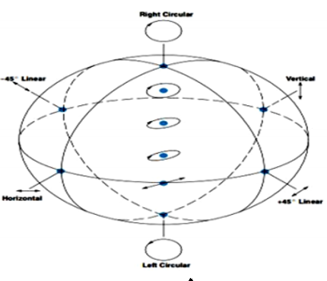
Figure2. 4: sarg04 protocol photons

6.4. Other protocols:
Of course, it still a lot of protocols exist with the development of security, we can take like example KMB09, S09, S13 and MPR.
Of course, the most important thing to know is that any quantum protocol use QKD protocol for generate the keys.
Table 1quantum protocols
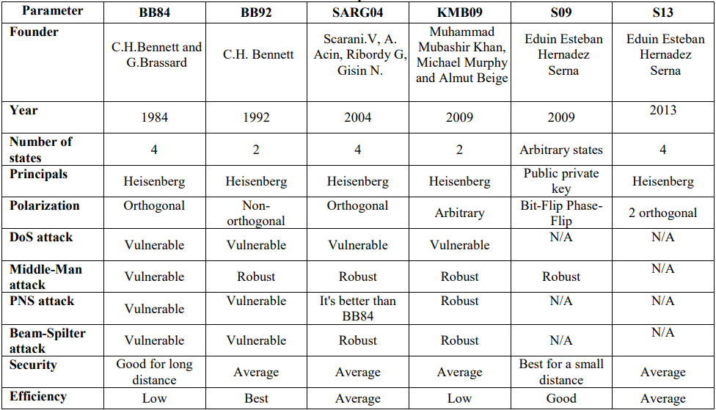

7. Quantum protocol in the mobile communication:
In last few decades, the wireless network get used into a most respects of life, that’s refers to its benefits specially that give the access to network from short to far distances, for that, the mobile network get used in most environments like coffee shops, airports, hotels, offices, universities and other public places that need communication. It gives a lot of benefits but unfortunately, this technology isn’t secure.
The security is the most important for keep the information safe, that’s problem go to be a big concern, let’s imagine that someone get connected to WI-FI network, and sends information throw mobile applications or websites, with no secure this information can be public to someone else.
Wireless network has a large amount of data, which is vulnerable to interceptions of wired networks. This make the users always in danger of attacks, even if those users try to choose encryption methodologies. that’s with no mention the fact that the users today use this kind of networks to do the money exchanges and the payment.
And with all of that, The classical encryption is the key to get some probability of secure information into the WI-FI, still ,with possibility of attacks that destroy the security and keep it unsafe, that’s fact that make the scientists go throw the physics world, Specifically, into a quantum world to get the data into WI-FI network surround with the quantic lows to get more safe.
Indeed, the studies identify that the quantum encryption is in somehow can’t be attacked with 85% of protection.
In order to make secure communications around a wireless network, communication between node and base station to other nodes should be handled carefully by use the Quantum key management.
Quantum Key Distribution using quantum cryptography is a new method in key distribution scheme which make sharing the key in a network easy and into a hide channel with absolute confidentiality. This kind of method solve many problems in security word by consider classical information like a quantum information and provide the secure in any communication and network.

Conclusion:
In this chapter, we have discussed the benefit of quantum theory which arrived to overcome the weakness of classical cryptography in terms key distribution. Based on the quantum cryptography, the scientists are still trying to find an efficient protocol based on QKD to achieve a secure channel in real quantum application. As results, the researchers have shown that the protocol of QKD may use in wireless network to share an efficient key and it harder for an eavesdropper to interrupt communication.

Chapter 3

Comparison study between the quantum protocols

Introduction
Motivated by the previous security protocols, we assessed the QR codes in reader applications by using these protocols to protect the user against malicious QR codes. We have tested those protocols in a classical machine to show the advantage and disadvantages of each one of them.
In this chapter, we have discussed some related work, then we move on to explain our framework by its implementation tools. Five protocols have been discussed and compared to show its weakness and performance.

Related works
Closely to our aim, [3] [4],and [3] is explained how to use the quantum key distribution for get shared keys in quantum one time pad, the author discuss the correlation between characteristics of QR code and transmission rate to find in result the fact that QR code improve the performance system under optimised system .While the [4] discuss the same experiment to discuss the comparison between the four protocol to exchange key and propose the SeKeQ protocol for avoid the man in middle and share the key in secret and improve the strength point of this protocol against the protocols that use Diffie-Hellman key.
In [5], the authors made a comparison between two protocols, BB84 and E91, this simulation is tested in different kind of networks such as wireless network, local network and a others local network. The result shown the BB84 is easy to simulate while the E91 is heavier.
In [6], they invented a new protocol, called BB94 protocol they explained its benefit in coin tossing.
In [7], they explained the mechanism of E91 protocol and how exploit bell theorem for make the Entanglement enter the QKD mechanism .
In[8], the authors explain the EPR and how it work in mechanism that made us understand that this algorithm come to include the big bang protocol and QKD mechanism .
in[9], we notice that in the author speaks about the quantum cryptography and the principal of BB84 protocols. They made a simulation about the different attack in quantum channels.
In [10], a GitHub project is created by IBM company as open platform for developers to make their own quantum protocols using python language, it named qiskit.

Implementation tools
In this Section, we will discuss the tools that we will use in our implementation that we made:

Android Studio:
Is an environment for build the android application, we use in our implementation android studio 3.6.3 and target Sdk version is 26 API, while the minimum one is 19. The language that we use into this implementation is java with JDK-14 and xml for design the front of application.
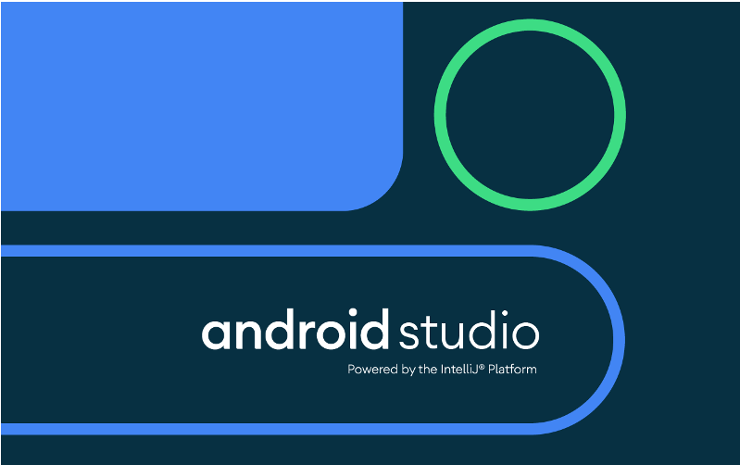
Figure3. 1:Android studio

QR code:
Is a technology developed by Denzo, we use it for send the information in real time, this communication happens by scanning the qr code symbol by a camera, this symbol can be providing in 8 patterns:

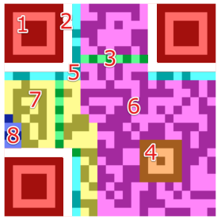
Figure3. 2: QR code section
Pattern 1 - Finder Pattern: which used for enable scanner organize the QR code and locate orientation.
Pattern 2 – Separators: for improve the recognizability of finder patters.
Pattern 3 - Timing Pattern: enable the decoder software to determine the width of single module.
Pattern 4 - Alignment Patterns: support the decoder to compensate for moderate image distortions.
Pattern 5 - Format Information: stores the 15 bits of information about the error correction of the QR code.
Pattern 6 – Data: convert the data into a bit stream, then stored onto this section.
Pattern 7 - Error Correction: stored the 8-bit long code words
Pattern 8 - Remainder Bits: this one is empty in case that data or error correction bits cannot divided into 8-bit code words without the remainder.

WIFI Direct:
Is a technology in an android System, this technology allows us to exchange the information with a peer discovery module that establishes the connection between mobile phones.
Wi-Fi Direct is a wireless local network based on IEEE 802.11 standards. It is similar to Bluetooth, and multiple connected devices can transfer data at typical Wi-Fi speeds. It has P2P technique for connect with no access point, by create the ad-hoc wireless network. It belongs to Wi-Fi alliance technology. Peer to peer communication -that this technology support- allows to be connected even if they are from different manufacturers. Wi-Fi Direct can implement Wi-Fi Protected setup (WPS) to guarantee security with minimal user intervention.
This technique can establish one peer device to work as a temporary access point for all device that connected with as the figure shown.
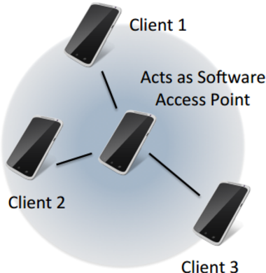
Figure3. 3: peer devices with Wi-Fi Direct
In communication of Wi-Fi direct, there is a device who called the owner group, this one act like a host to the rest of connected devices, those ones act like the clients to the GO (group owner).
To understand more we can say that the connection build based on the group owner, if the group owner decides to leave the connection will be unavailable until the new GO decide to build the new session, the clients that connect in the session called the P2P group.
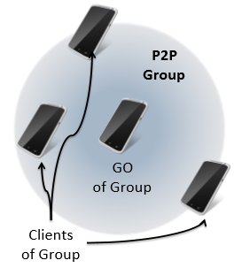
Figure3. 4: theP2P group

Vysor:
Vysor lets us view and control our Android on our computer. And that for represent the result of our application into the pc desktop and screen


Figure3. 5: vysor application

The five protocols and its simulation
In this section we will explain each protocol that we implement and how we implement it into the classical machines:

The quantum one-time pad:
This is the first protocol that change to be quantum for save the quantum money in 1970s. the main idea is using the quantum operator for encrypt the qubits with sharing the two keys between the sender and receiver before the sharing key.
Table 2: encrypt and decrypt message into QOTP
Encrypt | Decrypt
|𝑒 > = 𝑋 ^{𝑘1}𝑍 ^{𝑘2} |𝑚 > 𝑋|𝑚 > = |𝑚 ⊕ 1 > 𝑍|𝑚 >  = (−1) ^{𝑚}|𝑚 > | |𝑚 > = 𝑍 𝑘2𝑋 𝑘1 |𝑒 > = 𝑍 ^{𝑘2}𝑋 ^{𝑘1} (𝑋 ^{𝑘1}𝑍 ^{𝑘2} |𝑚 >)

So, in our implementation we consider that the sender and receiver contain a private list of keys, and the both of sender and receiver have to choose key by the index and give it with a random way or a function, that only the other side of communication knew.

The BB84 protocol:
It is a protocol that invited by Charles Bennett and Gilles Brassard in 1984, its main idea is by use Heisenberg principal in the nature of sharing key and this include five way if we take Alice and Bob as sender and receiver:
- Alice generate a random string--the key you wish to give to Bob.
- Alice convert your string bits into corresponding qubits.
- Alice send those qubits to Bob, after she randomly rotate some into a superposition. This effectively turns Alice’s key into random noise.
- Bob receives Alice qubits and randomly rotates some qubits in the opposite direction before measuring.
- Alice and Bob publicly share which qubits they rotated. When they both did the same thing, they know the original key bit value made it to Bob.
- Alice and Bob create their keys. Alice modifies her original key by keeping only the bits that she knows made it to Bob. Bob does the same.

E91 protocol
That’s protocols appear after creation of E91 protocol, the protocol that use bell theory into a QKD mechanism, the most important steps are
- There is the singlet state preparation device which create a sequence of entangled state and send A to Alice and B to Bob like the picture shows:
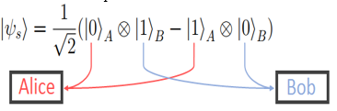
Figure3. 6 the way that share an entangled state to Alice and Bob
- Alice and Bob create a string of states based in what they get from singlet state preparation device and measure spin projection of their qubit.
- They record the measurement by a sequence of ai while ai = ±1;
- They check that they obtain the opposite results by sending the strings that found in step2 in classical channel.
- Finally, according to the result that they get, Alice and Bob notice if there is an interference in quantum channel.

EPR protocol
For know how the EPR protocol works, we should define first the ping pong protocol and QKD mechanism:

QKD mechanism
Is the mechanism that created by Bennet and Brassard in 1984 for share the key.

The ping pong scheme
This is a famous protocol in engineering, we can find it in ICMP protocol, this is a protocol that build in base of alternation between two entities or more.
So, the EPR protocol use those two mechanisms for create a new step for QKD based on entanglement and dense coding, it’s prosses work in this follow step:
- Alice generate a sequence of classical bits N a number the bits in order Alice.
- Alice generate enough EPR states in sequences based on the order of classical bits. And generate a series of particles S order (which is not the same order of classical bits)
- Alice remember the entanglement states and location of each one of bits of order S.
- Alice send S to Bob in quantum channel and tell the real location of bits in classical channel.
- Bob receive Sand location from Alice and generate a sequence of bell basis according to the information that he receives,
- bob choose a measurement results randomly and tell Alice.
- Alice tell bob the original place in quantum channel, for make sure that there is no eavesdropper in channel.
- for more safety, Alice and bob share the rest qubits.

The scenario of experience
We build the mobile application that communicate in network to share the keys using the QR code and socket communication by the WI-FI direct tool and the quantum protocols simulation.
The structure of source code can be considered as a three-tier architecture which contains different modules:
- devices discover connection by Wi-Fi direct connection and peer discovery.
- The exchanges of keys by encoding the QR code keys
- The communication using the sockets

Figure3. 7The quantum analyzer
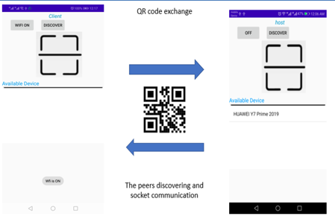
Figure3. 8: the application procedure

Implementation in experience
The experience is about analyze the protocols in mobile network using QR code, the idea is by simulate the quantum channel in the exchange of QR code data by scanner and the classical channel is a socket communication of Wi-Fi direct network. We implement the scenario in each protocol with java program language by implement the qubit as class for generate a quantum information.

Implement the quantum one-time pad:
For implement this quantum one time pad we need to receive a list of keys and choose one of those keys and send it throw the socket communication. For analyze this protocol we should calculate the time that need to share the key in each time according to data that display by QR code and time of auto focus. With mention that we need a qubit and operator gate for implement the function of algorithm.

Implement the BB84:
For implement this BB84, we have those class for simulate a quantum information:
- qubit.java: class that contain the characteristic of qubit in mathematic perspective: value which is 1 or 0, a vector which is represent the value according to the basis (in BB84 we have standard basis and Hadamard basis), plus the functions that we need to measure qubits.
- Rotator.java: class that we need to execute the second step of bb84 protocol before sending the qubits.
And we simulate the scenario using the interaction between client and server socket and QR code generator and scanner.

Implement the E91:
For implement this E91, we have those class for simulate a quantum information, the singlet state preparation device.
For simulate the quantum information we use a qubit class that we mention before, for implement the singlet state preparation device we need to two class:
CA.java: the class that generate N and M, while N is a sequence of qubits that they need to generate and M is a list of A and B that use for generate entanglement qubits while A2+B2 = 1, this class send A and B to server and client in order.
For add the noise coding of qubits and entanglement, the we use RE class after define the scenario that the picture illustrate:
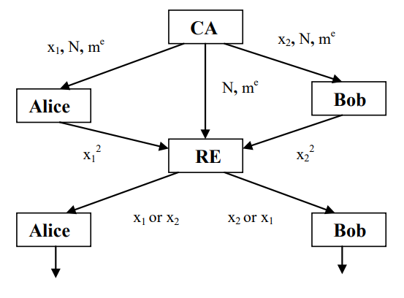
Figure3. 9the algorithm that simulate Entanglement
By RE class enter to the scenario became where x12 = x22modulo N and x2 ≠ N-x1.

Implement the EPR:
For implement this EPR, we have those class for simulate a quantum information, the S particular class for sequence that Alice generate in step 2 while int contain the sequence and index of each qubits from tables that generate.

The comparative study of protocols:
First, we analyze scenario according to characteristics of each protocols and complexity of each them by considering the principal and power point of each them then we analyze them according to the performance into the experience by use some specify metrics for calculate the Transmission rate which are:
- m: the QR code size
- r: the display rate (n/total time for one experience)
- n: the quantity of QR code per cycle
- t: the time between camera autofocus intervals
the low is:
 | $$Transmission rate= \frac{m*n}{t}$$ | (12)

Security Analysis
In this section we discuss the performance of each protocol and complexity under the classical machines ‘s implementation:
As the experience shows the first quantum one time pad is so easy and simple for sharing the keys list throw a quantum channel, in our experience, we implement the keys list channel as QR code scanner and generator which means that make the attacks got a low percent for happen, but if we consider a quantum channel as a network channel between sender and receiver, that make the possibility to get the keys list or ruin the list data augment especially with eavesdropper.
Well, the quantum one time pad recently start work with QKD mechanism that we implement in BB84 protocol, this protocol has the power of uncertainly theory, that make the possibility of guessing the shared key got lower but still could be attack by a lot of attacks one of them is when the hacker has the possibility to put a fake state into the quantum channel, that got to implement the method for detecting the channel by sending a message throw classical channel to represent the if the shared key is true.
The QKD mechanism has an interest of a lot of scientist, until the entanglement protocols start comes with E91 protocol, that's protocol is hard to implement into the classical machines, the main idea is that there is third part in communication that gives sender and receiver the entanglement state, actually the phenomena is interesting, it give the possibility of know that there is a hacker into the channel that because an interaction between the state that Alice and Bob has, and with CHSH inequality
The eavesdropper always can detect with a higher possibility, but this protocol can be attacked by noises, in our implementation we consider once that Alice is the singlet state preparation device, but if we represent that into the quantum machines, the possibilities of attacks got higher because eve can change the first states that Alice gives to Bob as his Entangled states, so we move to the mechanism that shows in fig2,and that even easy considering that the results shows as 3 entangled states to Alice and three others to Bob as the figure illustrate:
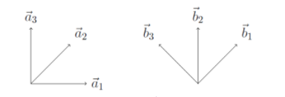
Figure3. 10: the entangled state
The protocol EPR comes as a protocol that made as a possibility to improve the QKD mechanism by putting the Entanglement states as basis and made noises coding by manipulating the order of key sequence while Alice sharing key with Bob, by this method the possibility of attacks comes lower against the shared key, and even if the attack happen Alice and bob will know.

Discuss the Results
In our result we put the shared the keys in different length (display rate) and we took the results according to this result as the figure illustrate:
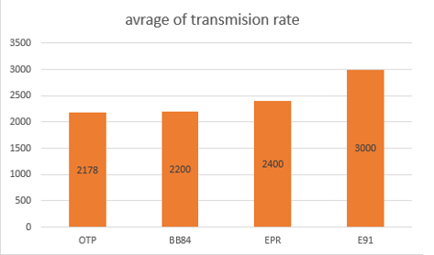
Figure3. 11: the results of experiences
So, and s we see the exchange of key according to protocols is building by transmission of data of QR code and if the clients could find the key in perfect time.
As we the figure shown, entangled protocols has the big value in transmission rate then the uncertainly protocol has, and that because we implement entanglement and that’s refers to the fact that implementation of entanglement give the results of generating key between Alice and bob are similar with 0.5 as maximal value to each basis that we have into the states that generated.
According the result, we see also that the EPR protocol also made a large value to transmission rate and that refers to the fact that each Alice and Bob know the place of each qubit that they use in each qubit for generate a key that why we see that the transmission rate increase.
About BB84, it almost gets the value of the Quantum one-time pad, and that refers to the fact that the qubits that be chosen in randomly and uncertainly source which made the probability of getting the same qubit from Alice and Bob too small.

Conclusion
In quantum protocols, we notice that the algorithm that we have in each scenario are complex to be implemented into the classical machines, that what make us use the mathematical calculation for simulate them. Actually, there is some countries in the world who start work with these protocols as Tokyo, DARPA quantum network….
The matter of this chapter is using a limited technology (comparing with quantum protocols) that we have for simulate a comparison study between quantum protocols which improve that the entanglement has it power to improve that quantum security systems.

Chapter 4

Attacks in quantum security

Introduction
With the fact that the quantum cryptography improves the security systems, the vulnerabilities get reduce against the classical attacks specially with the detecting the eavesdropper mechanism, but there is no security system get to be perfect, and that what the quantum attacks prove even if quantum system jump to the perfection.
In this chapter, we mention few classical attacks against the quantum security and mention the quantum attacks and how they work against the protocol that we simulate.

The cyber Attacks into the communication systems
A security attack is an unauthorized act to steal, damage, or expose data from an information system such as a website, communication system …, in other mean is an algorithms that create by hackers to reach the secret information using the vulnerabilities of a security system, the general way that attacks happens in communication is like the figure illustrate:

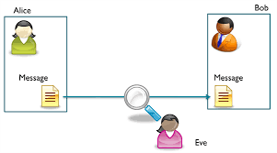
Figure4. 1: the attack in system communication

For years ago, there is a lot of attacks that appear against the classical cryptography, the famous ones of them still considering as a real threat, especially the ones that mentioned below:
Table 3the classical attacks
Attack | Definition
Distributed Denial- of-Service (DDoS) attack | The attacks accomplish this mission by overwhelming the target with traffic or flooding it with information that triggers a crash.
Eavesdropping Attack | These attacks target weakened transmissions between the client and server that enables the attacker to receive network transmissions.
Man-in-the-Middle (MITM) Attacks | The attack occurs between two legitimate communicating parties, enabling the attacker to intercept communication they should otherwise not be able to access. Thus, the name “man-in-the-middle.”

Different attacks in quantum security
While the Quantum Protocol seems more efficient than the traditional protocol, they often suffer from various types of attacks. We tried to give the various types of attacks on Quantum key distribution protocols some idea here:
  - Interception and resubmission:
The simplest method of attack is intercept and resend. The attacker tests the quantum states (photons) received by Sender and then sends replacement states, prepared in the attacker's measured state, to receiver. This approach works in BB84 because in this case the attacks have a complete way of giving Bob the photons that construct on the basis that he thinks depending on the message the possibility of obtaining a correct guess from the sender is increased as the number of bases used reduces. But in case he feels the message is misunderstood by bob then the calculation gets the probability of 50 per cent incorrect, which makes the results go incorrect. These forms of attack It happens in a perfect setting where neither Alice nor Bob will see the attack.
The detection of this attack will occur if we assume that the attacker does not disrupt the classical channel, which allowed the detection test for both Alice and Bob to understand that the Quantum channel has listeners.
In the case of encroachment protocols, the state is already linked by encroachment which reduces the likelihood of these protocols.

  - Man-in-the-middle attack
The man in the center could attack any security system that doesn't even use the quantum authentication. Even if this concept were valid, the sender and receiver might solve the authentication problem if they rely on a shared message they have before sharing key and then receive it encrypted after that phase.
Man-in-the-middle (MITM) attacks can be carried out in many ways. The earlier MITM attacks are not operating on QC systems as quantum mechanics rules are interfering. The Interceptor will intercept the transmitted messages with conventional MITM attacks, and send a copy in its place. However, due to the physics of the QC systems (the nature of qubits), this is impossible, although non-traditional MITM attacks are possible. It works by pretending the attacker is the receiver's sender, and the sender's receiver. Thus, he could decide on the shared key given to Alice and bob, and listen to them without notice. The only thing he has is authentication. How does this mean when identities can be checked can be stopped? Certain approach can be used by MITM. Together with the fact that it is difficult to realize a single transmission photon in the real world, most mysterious systems use tiny bursts of coherent transmission pulses. The Attacker can theoretically break a single proton off the burst without being detected. He could then store the stolen photons before announcement is made of the basis used to build them. EPR pairs can be used for a three-stage, possibly secure protocol that can prevent man-in-the-middle attack. But distribution of the EPR pairs during transit could corrupt them.

  - Faked States Attack
This is a popular Quantum Security attack; it is a specified Intercept / send attack event. The Attacker sends out the self-derived signal in this process to monitor the entire communication. In this form of attack "Absolute detector efficiency mismatch" is important. The signal the receiver receives from the Attacker after intercepting the Sender's signal has a time shift that does not detect signals if the receiver selects the basis other than the Attacker's for that reading signal. His detector would be blinded, in generic terms. And, Attacker remains undetected in this operation. The different steps in this Attachment.
In BB84 protocol, the various steps in this attack are:
- Attacker carries out a simple Intercept / Resend attack on its own basis over the transmitted signals and steps.
- Then the attacker sends a pulse to the receiver to contain the opposite bit value in the opposite condition. This sets the signal time-shift such that the receiver can only calculate the signal while using the same basis (as the Attacker's). Measurement would result in nothing at other bases.
- The Attacker now tests the signal using the foundation of the Sender. The recipient would have the same outcomes as the Attacker's.
- The Intruder now has complete control over the Receiver's scheme. This technique of attack relies on Detector Synchronization and Performance.

  - Denial of service
QKD 's new implementations include a dedicated fiber optic line between the sender and the receiver, or a line of sight in free space. This assault may occur by taking the channel and attempting to disrupt the contact between sender and receiver with several of attacks. It is one of the reasons for the creation of quantum key distribution networks, which in case of disruption will route communication through alternate links.
In QKD system DoS attack is performed in two ways:
First, the quantum cryptographic hardware is compromised, and second, the QKD system introduces extra noise. By simply cutting off or blocking the optical cable, QKD systems which use fiber optic channels can be put out of service by simply tapping into the pipe, the fibre-optic channel can easily be rendered unusable. The QKD equipment itself could be compromised by using a random number generator algorithm to produce unsecured random photons.
A DoS attack may also be mounted against a QC system if noise can be inserted into the communication system. Such noise will be indistinguishable from eavesdropping, meaning that a number of photons would be discarded by the Sender and the Receiver. Unless the additional noise in the contact channel can be maintained, the sender and the receiver can increase their error to compensate for noise that would encourage the eavesdropping.

  - Trojan Horse Attacks
Quantum mechanics can not secure the apparatuses of the Sender and the Receiver. Even it is vulnerable to security bugs and exploits as soon as the information is encoded in a classical physics program. The Sender and the Receiver must secure their instruments by means of standard defenses. Practical implementations of abstract QKD use (and are constrained by economic constraints) present technology.
This results in a deviation from the ideal scheme. In Trojan Horse Attacks, the Intruder focuses on the cryptographic devices used by Sender and the Receiver, unlike the previously defined attack which try to extract the information from the photons that are being transmitted in the channel. This strategy is implemented by sending out the light pulses towards the sender’s or receiver’s setup, that comes in return as a mirrored pulse and joins the detection scheme which is also Eve's possession. Eve can use the reflected signal information, and can intercept the photon preparation basis used by Alice. Now, if Eve can get this information before the photon hits the receiver side, then Eve can conduct and calculate simple Intercept / Resend attack and measure it to get the exact secret string of qubits.
Then Eve will get enough information without being identified. It is therefore vitally necessary for QKD to thoroughly examine the implications of these compromises. In reality, some compromises could make the whole system completely insecure. Trojan Horse attacks works by exploiting target vulnerabilities in the implementation of a QKD protocol, or shortcomings in the physical device components used in the QKD framework construction. If the equipment used in the quantum key distribution can be tampered with, a random number generator attack could be used to produce keys that were not protected. Trojan horse attack is also known as attack by light injection.

  - Photon number splitting attack
A true single photon source is hard to produce outside laboratory environments, so instead the Sender uses weak Laser Pulses (WLP) generators. A Poisson distribution is accompanied by the coherent light pulse so emitted.
During this attack, the Attacker substitutes a lossless channel for the high loss channel used by the Sender and the Receiver. The Attacker then performs a calculation of quantum non-demolition (QND) at each pulse, thereby extracting information without disrupting the encoded pulse bases. If a pulse is transmitted with a single photon then the Attacker simulates the loss of the initial pulse by blocking a fraction of these pulses.
When a pulse with multiple photons arrives the Attacker splits and stores a photon in a quantum memory from that pulse. The Attacker transfers the remaining pulse to the Receiver after transport. Once the Sender and the Receiver declare the bases used for each pulse, the Attacker recovers the photons from the quantum memory and thus obtains a large fraction of the key without detection. Every signal pulse usually includes a number of photons. Usually, cryptographic devices depend on the Weak Coherent Pulses. A WCP is a pulsed photon with low mean number of photons. PNS attack takes advantage of this weakness and is a powerful attack by targeting several pulses of photons.
Nevertheless, the PNS attack is relatively complex. The Attacker will test the multiple photon pulses continuously. That requires complex algorithms and hardware.

  - Spectral Attacks
Quantum Key Distribution has the property to detect any third party 's presence attempting to obtain knowledge of the Key. This is the product of an important feature of quantum mechanics:
In general, the method of measuring a quantum system disturbs the system. Therefore, if the Intruder wants to eavesdrop on the switch, then he has to test it in some way leading to device disruption.
It leaves traces. A communication device that prevents eavesdropping can be introduced by using quantum superposition or quantic entanglement and transmitting information in quantum states.
If the eavesdropping level is below a certain threshold, then a secure key can be generated otherwise no secure key can be generated and communication is aborted.
One way around this, though, is by calculating the spectral properties of the photons involved, rather than their polarization. And if the Attacker tests each photon's colour then the polarization states won't be disrupted to leave traces.

The implementation of eavesdropping attack and how can be detected
This implementation is in python with qiskit package that created by IBM company the one of the companies has the first quantum computer. In our implementation we implement BB84 as uncertainly protocol and E91 as entanglement protocol. With Jupyter notebook.
We review a few instructions that we use for generate the steps of protocols as we see how could eve can be detected in BB84 and E91.
  - BB84 protocol:
In this protocol, we need first to create a quantum register and classical register as the figure shows:
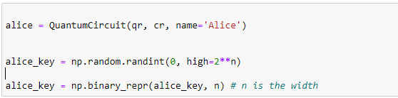
Figure4. 2create Alice registers
In this figure we see how easily could generate the classical key randomly with QuantumCircuits () function that allow us to generate a simulate state for Alice and n include the length of quantum key that generated.
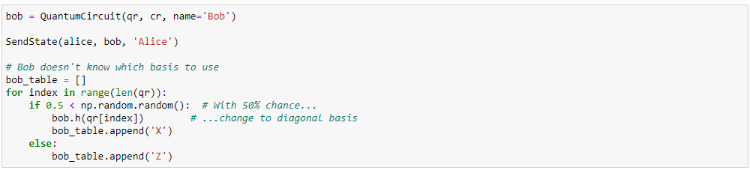
Figure4. 3bob generate the key and receive Alice keys
This figure illustrates the comparison between Alice and bob keys building on perspective observables (X or Z).
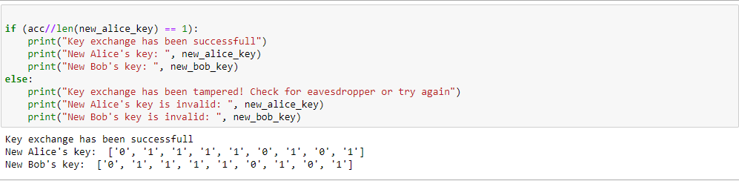
Figure4. 4the result in safe channel sharing key
We see that both of allice and bob get the same key, now if eve enter the quantum channel how can they detect her:
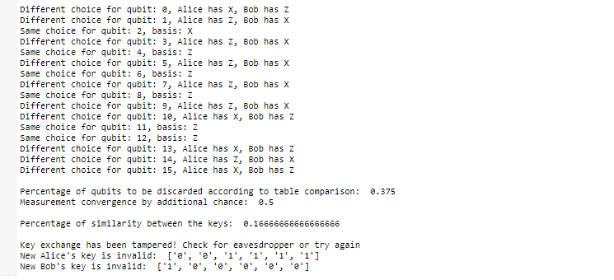
Figure4. 5result of eve between Alice and Bob communication
As the shown in the figure 4, we compute the percentage of similarity between Alice and Bob, so if this percentage more than 75% the message is well protected right otherwise is eavesdropper.

  - E91 protocol:
As we known, that protocol need to entanglement states device and that what we simulate it by singlet that generate Alice and bob states. We were trying to simulate eve attack. We consider that eve tack the possibility to all perspective to generate the keys but the main idea is how they detect eve.

CHSH inequality
This is a theory that we use for calculate to detect eve
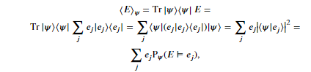
Figure4. 6CHSH inequality

As figure shows is quote complex to calculate the tensor product of each qubits with each entangled state. In our implementation we use:
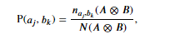
Figure4. 7experience of CHSH correlation

So, this calculation is replacing the first one with one conduction:
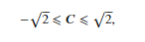
Figure4. 8condition of CHSH
And that what we improve in our implementation:
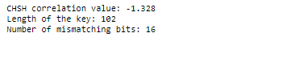
Figure4. 9results of communicating without eve
And with eve:
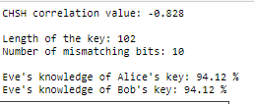
Figure4. 10result of communication with eve

So more that eve enter to know the qubits of the keys, more that CHSH coloration value got away from $2\sqrt{2}$ or $-2\sqrt{2}$ respectively.

Conclusion
In this chapter, we conclude that the quantum protocols have power concept to resist some exiting attacks, however there is some leakage against the threats of quantum attacks and noises that can show some weakness in term sharing key issue.

General Conclusion

GENERAL CONCLUSION

The classical cryptography has been so vulnerable against the attacks of today, so the quantum cryptography comes to fix the cryptography system and improve the security against the attacks and threats. This type of security system work in quantum machines. In our project we try to implement the quantum protocols to get a comparative study between them, the results show the important of entanglement in quantum protocols as an effect for improve a security.
This project was as jump throw a classical difficulty with mathematical perspective for simulate the quantum lows.
Our research contributed through maintaining the following critical points:
    - Simulate a quantum package in java program language.
    - Implement the entanglement in the mathematic perspective.
    - Improve the power of entanglement against the attacks of eavesdropping.
    - Improve the quantum key distribution with uncertainly theory.
    - Implantation of detecting eavesdropping by CHSH inequality.
    - Improve the power of secret communication by QR code transmission.
    - Know a few quantum attacks.
In this work, we implement the quantum protocols according to the few simulating protocols in python languages to get the comparative study by calculation of transmission rate into each protocol.
During our experimentation, we focused on the strength and weakness point of quantum protocols.
We discuss a few of quantum attacks to know how could it work and how could it reach the quantum security system, and we implement and attack to see how is powerful detecting the attacks.

References

References

Articles:

[1] ‘Shor’s Algorithm – Breaking RSA Encryption | AMS Grad Blog’. https://blogs.ams.org/mathgradblog/2014/04/30/shors-algorithm-breaking-rsa-encryption/ (accessed Aug. 26, 2020).
[2] D. Bruß and N. Lütkenhaus, ‘Quantum Key Distribution: from Principles to Practicalities’, Appl. Algebra Eng. Commun. Comput., vol. 10, no. 4–5, pp. 383–399, May 2000, doi: 10.1007/s002000050137.
[3] L. Qin, Yu Wanjiaman., ‘Quantum Inspired Security on a Mobile Phone’, 2017.
[4] Z. Belghazi, N. Benamar, A. Addaim, and C. A. Kerrache, ‘Secure WiFi-Direct Using Key Exchange for IoT Device-to-Device Communications in a Smart Environment’, Future Internet, vol. 11, no. 12, p. 251, Dec. 2019, doi: 10.3390/fi11120251.
[5] ‘International Journal of Modern Communication Technologies & Research (IJMCTR)’, vol. 4, no. 9, p. 10, 2016.
[6] ‘WITHDRAWN_Quantum_cryptography_Public_key_distribu.pdf’. .
[7] A. K. Ekert, ‘Quantum cryptography based on Bell’s theorem’, Phys. Rev. Lett., vol. 67, no. 6, pp. 661–663, Aug. 1991, doi: 10.1103/PhysRevLett.67.661.
[8] J. Li, N. Li, L.-L. Li, and T. Wang, ‘One Step Quantum Key Distribution Based on EPR Entanglement’, Sci. Rep., vol. 6, no. 1, p. 28767, Jun. 2016, doi: 10.1038/srep28767.
[9] A. Falahati and H. Meshgi, ‘Using Quantum Cryptography for Securing Wireless LAN Networks’, in 2009 International Conference on Signal Processing Systems, Singapore, 2009, pp. 698–701, doi: 10.1109/ICSPS.2009.216.

Web sites:

[1] quantum protocols tutorial ‘qiskit-community/qiskit-community-tutorials’, GitHub. https://github.com/qiskit-community/qiskit-community-tutorials

Abstract

Nowadays, the quantum cryptography starts crawling throw the world to improve more security into the mobile communication, wireless network system and IoT devices. this development makes the simulation of quantum protocols so easy. In this research, we will review a comparative study between a quantum protocols (QOTP, BB84, E91, EPR) in classical machine. To evaluate the performance of these protocols, we run a testbed using devices with a Wi-Fi Direct communication interface. We review also an implementation of one of attacks of quantum and see how can be detect throw the power of quantum lows in cryptography systems.

Keywords. Quantum cryptography, BB84, E91, EPR, QR code, WI-FI direct.

ملخص

في الوقت الحاضر ، يبدأ التشفير الكمي في الزحف في العالم لتحسين المزيد من الأمان في الاتصالات المحمولة ونظام الشبكة اللاسلكية وأجهزة إنترنت الأشياء. هذا التطور يجعل محاكاة البروتوكولات الكمومية سهلة للغاية. في هذا البحث سنراجع دراسة مقارنة بين البروتوكولات الكمومية (QOTP، BB84، E91، EPR) في الآلة الكلاسيكية. لتقييم أداء هذه البروتوكولات ، نقوم بتشغيل اختبار باستخدام أجهزة ذات واجهة اتصال Wi-Fi Direct. نراجع أيضًا تنفيذ أحد هجمات الكم ونرى كيف يمكن الكشف عن قوة قوانين الكم في نظام التشفير..

الكلمات الدالة. تشفير الكم ، BB84 ، E91 ، EPR ، رمز الاستجابة السريعة ، WI-FI مباشر.

Résumé

De nos jours, la cryptographie quantique commence à se répandre dans le monde entier pour améliorer la sécurité des communications mobiles, des systèmes de réseaux sans fil et des dispositifs IoT. Ce développement rend la simulation des protocoles quantiques si facile. Dans cette recherche, nous passerons en revue une étude comparative entre un protocole quantique (QOTP, BB84, E91, EPR) dans une machine classique. Pour évaluer les performances de ces protocoles, nous effectuons une étude comparative en utilisant des appareils dotés d'une interface de communication Wi-Fi Direct. Nous examinons également une implémentation de l'une des attaques quantiques et voyons comment détecter la puissance des creux quantiques dans les systèmes de cryptographie.

Mots-clés. Cryptographie quantique, BB84, E91, EPR, code QR, WI-FI direct.

