PEOPLE'S DEMOCRATIC REPUBLIC OF ALGERIA

MINISTRY OF HIGHER EDUCATION AND SCIENTIFIC RESEARCH



UUNIVERSITY OF MOHAMED BOUDIAF-M’SILA

FACULTY OF MATHEMATICS AND

COMPUTER SCIENCE

DEpartement OF COMPUTER SCIENCE
Master thesis

Presented for the graduation of MASTER
Faculty: Mathematics and Computer
science
Department: Computer science
Field: Information System and Software Engineering
By: ADOUANE Nour El Houda

SUBJECT

Traffic signs recognition for autonomous cars

Board of Examiners:
Mr. KADRI Said University of M’sila Supervisor
Mr. BENOUIS Mohamed University de M’sila Chairman
Ms. HELASSA Madiha University de M’sila Examiner

Academic year: 2019 /2020

PEOPLE'S DEMOCRATIC REPUBLIC OF ALGERIA

MINISTRY OF HIGHER EDUCATION AND SCIENTIFIC RESEARCH

UUNIVERSITY OF MOHAMED BOUDIAF-M’SILA

FACULTY OF MATHEMATICS AND

COMPUTER SCIENCE

DEpartement OF COMPUTER SCIENCE
Master thesis

Presented for the graduation of MASTER
Faculty: Mathematics and Computer
science
Department: Computer science
Field: Information System and Software Engineering
By: ADOUANE Nour El Houda

SUBJECT

Traffic signs recognition for autonomous cars

Board of Examiners:
Mr. KADRI Said University of M’sila Supervisor
Mr. BENOUIS Mohamed University de M’sila Chairman
Ms. HELASSA Madiha University de M’sila Examiner

Academic year: 2019 /2020
Appreciations:
I would like to thank all the people who contributed to the success of this thesis.
I would first like to thank my supervisor Said GADRI, for his patience, his availability and above all his judicious advices.
I would like to thank my dear grandfather, may God have mercy on him, because he is the reason for any success that I reach.
I thank my dear family and my friends specially Achouak ABDELKRIM for their encouragement and positive energy.
I thank also all professors of computer science department, in particular, Mr. M BENOUIS for his encouragement to us.

Table of contents:
General Introduction: ………………………………………………………………….…13
Chapter1: Autonomous cars and traffic sign recognition
- Introduction.....……………………………………………………………………..16
- Definition of autonomous cars.…………………………………………………….16
- History of autonomous cars.……………………………………………………….16
- Autonomous cars levels……………………………………………………………17
  - Level 0 « No Automation »...……………………………………………….17
  - Level 1 « Driver Assistance ».. …………………………………………......17
  - Level 2 « Partial Automation »...……………………………………………18
  - Level 3 « Conditional Automation »…...…………………………………...18
  - Level 4 « High Automation »...……………………………………………..18
  - Level 5 « Full Automation »...………………………………………………18
- Technology of autonomous cars….………………………………………………..20
  - Car navigation system...…………………………………………………….20
  - Global Path planning...……………………………………………………...21
  - Environment perception……………………………………………………..22
  - Vehicle control………………………………………………………………23
- Autonomous car benefits….…………………………………………………….....24
- Challenges of autonomous cars……………………………………………………24
- Traffic sign recognition……………………………………………………………25
- Traffic sign detection.……………………………………………………………...25
- Traffic sign detection methods…….………………………………………………25
- Traffic sign classification………………………………………………………….26
- Conclusion.………………………………………………………………………...26
Chapter 2: Machine learning and Deep learning
- Introduction.……………………………………………………………………….28
- Machine Learning.…………………………………………………………………28
  - Definition.…..……………………………………………………………….28
  - Machine Learning techniques...…………………………………………..…28
- Deep Learning……………………………………………………………………..34
  - Definition...………………………………………………………………….34
  - Deep Neural Network...……………………………………………………..34
  - Deep Neural Network types...……………………………………………….37
- ML vs DL………………………………………………………………………….42
- Conclusion.………………………………………………………………………...42
Chapter 3: Environment tools
- Introduction.……………………………………………………………………….44
- Dataset.…………………………………………………………………………….44
  - Dataset description…………………………………………………………..44
  - Dataset Classes...……………………………………………………………46
- Anaconda environment.……………………………………………………………48
  - Anaconda downloading...…………………………………………………...48
- Python language…………………………………………………………………...49
  - Python strengths...…………………………………………………………..49
- Python libraries.……………………………………………………………………49
  - Scikit-Learn…………………………………………………...…………….49
  - SciPy…………………………………………………………...……………50
  - Pandas…………………………………………………………...…………..50
  - NumPy………………………………………………………………...…….50
  - Matplotlib………………………………………………………………...…51
  - TensorFlow………………………………………………………………….51
  - Keras………………………………………………………………………...51
  - TkInter………………………………………………………………………52
- Conclusion.………………………………………………………………………...52
Chapter 4: The realized work and obtained results
- Introduction.……………………………………………………………………….54
- Preprocessing of the used dataset.………………...……………………………….54
- Convolutional Neural Network model.……………………………………………55
  - The proposed model………………………………………………………...55
  - Model evaluation concepts.…………………………………………………58
- Application interface.……………………………………………………………...59
  - Home page…………………………………………………………………..60
  - Tools page…………………………………………………………………...61
  - About page…………………………………………………………………..62
- Conclusion.………………………………………………………………………...62
General conclusion: ………………………………………………………….…………..64
Notifications of acceptance of papers at conferences: ……………………….…………..65
References: ………………………………………………………………………………67

List of figures:
Fig 1.1: Structure of car navigation system. …….………………………………………21
Fig 1.2: Typical perception scheme of self-driving car. ……………...…………………22
Fig 2.1: Artificial Intelligence paradigms. ………………………………………………28
Fig 2.2: Machine Learning techniques. …………………………………….……………29
Fig 2.3: Decision tree example. ……………………………….…………………………30
Fig 2.4: Logistic Regression example. ……………………………….….………………30
Fig 2.5: Nonlinear and linear SVM classification example. ..……...……………………31
Fig 2.6: Naïve Bayes classification example. …………………...………………………31
Fig 2.7: KNN classification example. …………………………………...………………32
Fig 2.8: Deep Neural Network architecture. …………………….………………………35
Fig 2.9: Sigmoid function curve. ………………………………..………………………36
Fig 2.10: ReLU function curve. …………………………………………………………36
Fig 2.11: TanH function curve. ……………………………………………………….…37
Fig 2.12: Deep Feed-Forward Network architecture. ………………………………...…38
Fig 2.13: Convolutional Neural Network architecture. …………………………………39
Fig 2.14: Recurrent Neural Network architecture. …………………………………...…41
Fig 3.1: Training images distribution. …………………………………………………..45
Fig 3.2: Testing images distribution. …..……………………………………………..…45
Fig 3.3: Anaconda 5.2.0 downloading. ……………………………………………….…48
Fig 4.1: Application of load_data function source code. ……………………………..…54
Fig 4.2: Resizing of images source code. ………………………………………….……54
Fig 4.3: Grayscale source code. …………………………………………………………54
Fig 4.4: Architecture of the proposed CNN model. ………………………………….…55
Fig 4.5: Training loss Vs Validation loss of the CNN model. ……………………….…57
Fig 4.6: Training accuracy Vs Validation accuracy of the CNN model. …………….…57
Fig 4.7: Home page. ………………………………………………………………….…60
Fig 4.8: Upload event in home page. ………………………………………………...…60
Fig 4.9: Classify event in home page. ………………………………………………..…61
Fig 4.10: Tools page. …………………………………………………………….………61
Fig 4.11: About page. ……………………………………………………………………62

List of tables:
Table 1.1: Autonomous car levels. …………………………………………………...…19
Table 3.1: Dataset classes IDs and labels. ………………………………………………46
Table 4.1: Description of the Proposed CNN Model. …………………………………..56
Table 4.2: Loss value and accuracy value obtained. ……………………………………57

List of abbreviations:
SAE: Society of Automotive Engineers
ADS: Automated Driving System
DDT: Dynamic Driving Task
DARPA: Defense Research in the United States the Project Agency
AV: Autonomous Vehicle
TSR: Traffic Sign Recognition
SVM: Support Vector Machine
CNN: Convolutional Neural Networks

General Introduction
General Introduction:
Artificial intelligence is a branch of computer science, and the term artificial intelligence can be defined as the ability of machines and digital computers to do certain tasks as smart objects do, such as the ability to think or to learn. Artificial intelligence also aims to reach systems that have intelligence and behave in the way that humans behave in terms of learning and understanding. Artificial intelligence is a broad and multidisciplinary field, it has many domains, among its domains the neural networks.
Neural networks are one of the most beautiful programming paradigms. In the traditional approach to programming, we tell the computer what to do, and break down big problems into small tasks that the computer can easily do. On the contrary, in the neural network, we do not tell the computer how to solve our problem. Instead, it learns from the input data, and discovers its own solution to the problem given. Artificial neural networks are a variety of deep learning technology which comes under the broad domain of Artificial Intelligence. There are many types of artificial neural networks: Feedforward Neural Network, Radial Basis Function Neural Network, Multilayer Perceptron, Convolutional Neural Network (CNN), Recurrent Neural Network (RNN), Modular Neural Network, and Sequence-To-Sequence Models, probabilistic neural network, self-organization network, spike neural network, quantum neural network, fuzzy neural network and so on.
Convolutional Neural Network (CNN or ConvNet) is one of the neural network models for deep learning. CNNs have won several competitions in:
- handwriting recognition (MNIST, Arabic HWX - ISDIA)
- OCR in the wild (2011), Streetview house numbers (NYU)
- Traffic sign recognition (2011), GTSRB competition (IDSIA, NYU)
- Pedestrian detection (2013), INRIA datasets and others (NYU)
- Object recognition (2012), ImageNet competition
- Human Action Recognition (2011), Hollywood II dataset (Stanford)
Traffic sign recognition system (TSRS) is an advanced driver assistance system that can recognize traffic signs. The traffic sign recognition systems composed of two phases detection and recognition (Classification).
The present work focuses on the recognition aspect of the TSRS in which we try to detect signs and then classify them to help driver to avoid road risks. Our manuscript can be divided into:
- A general introduction.
- The first chapter talks about the autonomous vehicles and TSR.
- The second chapter that contains both of machine learning and deep learning.
- In chapter three we present the programming environment.
- In the last chapter we illustrate the realized work and the obtained results.
- Finally, we conclude our manuscript with a general conclusion that summarizes the realized work, and exposes some benefits and difficulties.

Chapter One:

Autonomous cars and traffic signs recognition
- Introduction:
This chapter is an introduction to the project field, in this chapter we talk about autonomous cars, their definition, history and some companies which produce this kind of new cars, we talk also about autonomous car levels.

- Definition of autonomous cars:
The term of autonomous cars or self-driving cars defines, itself; Driverless cars refer to vehicles driven by digital technology without any human intervention. They can drive and navigate on the road by perceiving the environmental impact. With the help of a system composed of different sensors, hardware components and complex software. Cars can safely travel from one place to another. Its appearance aims to reduce the space occupied on the road to avoid traffic jams and reduce the possibility of accidents. [1]
These cars are composed of two parts, hardware like sensors and cameras and all tools of collection of data and software which is the algorithms of processing of the collected data and classification algorithms and so one.

- History of autonomous cars:
The dream of self-propelled cars can be traced back to the Middle Ages, that is, centuries before the invention of cars. Leonardo De Vinci's sketch provided evidence for this statement, in which he made a rough plan. Later, it appeared in literature and science fiction. The first driverless car was prototyped in the 1920s. [2]
Since the 1930s, science fiction writers have been dreaming of the future of self-driving cars, but the idea of ​​self-driving cars received public attention for the first time at the 1939 World Exhibition in New York sponsored by General Motors.
1980 to 2003: During this period, University Research Centers studied two visions for automotive automation. The first is the automated highway system, where relatively "clumsy" cars rely on highway infrastructure to guide them, while other teams work on autonomous vehicles that do not require special roads.
2003-2007: Advanced Defense Research in the United States, the Project Agency (DARPA) held three sessions of "Grand Challenge" significantly accelerates progress. The first two times in autonomous driving technology are held in the rural environment, and the third time in the urban environment. These are encouraged University research team develops technology.
Since 2007: Private companies have advanced the research of AVs. [3]
Below we briefly introduce some private companies that play the most important role in autonomous vehicle innovation: General Motors (GM), Google, Tesla, BMW, Audi, nuTonomy.

- Autonomous cars levels:
The SAE (Society of Automotive Engineers) defines six vehicle automation levels, the classification is based on the degree of driver intervention required rather than the vehicle capabilities the first three levels (0,1 and 2) belong to the category ‘human driver monitors the environment’ and the last three levels belong to Automated driving system category.

4.1. Level 0 « No Automation »:
In this type of cars, the dynamic driving task controlled manually by the driver.

4.2. Level 1 « Driver Assistance »:
For this level, the driver takes on the task of dynamic driving moreover, there is a driver assistance system that helps the driver in the Execution of Steering and Acceleration/Deceleration by using information about the driving environment, so we can say that the control shared between the driver and the driver assistance system this level is hands on stage.

4.3. Level 2 « Partial Automation »:
Called also “hands off” a driver assistance system will execute acceleration /deceleration system by using information about the driving environment in other side the driver completes the object and event detection and response subtask and supervises the automation system.

4.4. Level 3 « Conditional Automation »:
This level means that the dynamic driving task is executed by the system (ADS) and the human driver will respond just when he receives a request to intervene, it named also “eyes off”.

4.5. Level 4 « High Automation »:
In this level, an automated driving system (ADS) will execute all sides of the dynamic driving task even if human driver is on mode "mind off", For this reason, this level is called "minds off".

4.6. Level 5 « Full Automation »:
This level means that all sides of DDT are executed by the ADS full time and under all roadway and environmental conditions and no human intervention is required in this case. [3][4]
The SAE resumes all this levels in “J3016-201806 document” which we put it in the table below (Table 1.1):

Table 1.1: Autonomous car levels.
SAE  level | Name | Narrative Definition | Execution of Steering and Acceleration  /Deceleration | Monitoring of Driving Environment | Fallback Performance of Dynamic Driving Task
Human driver monitors the driving environment
0 | No Automation | The full-time performance by the human driver of all aspects of the dynamic driving task, even when enhanced by warning or intervention systems. | Human driver | Human driver | Human driver
1 | Driver Assistance | The driving mode-specific execution by a driver assistance system of either steering or acceleration/deceleration using information about the driving environment and with the expectation that the human driver performs all remaining aspects of the dynamic driving task. | Human driver and System | Human driver | Human driver
2 | Partial Automation | The driving mode-specific execution by one or more driver assistance systems of both steering and acceleration/deceleration using information about the driving environment and with the expectation that the human driver performs all remaining aspects of the dynamic driving task. | System | Human driver | Human driver
Automated driving system (“system”) monitors the driving environment
3 | Conditional Automation | The driving mode-specific performance by an automated driving system of all aspects of the dynamic driving task with the expectation that the human driver will respond appropriately to a request to intervene. | System | System | Human driver
4 | High Automation | The driving mode-specific performance by an automated driving system of all aspects of the dynamic driving task, even if a human driver does not respond appropriately to a request to intervene. | System | System | System
5 | Full Automation | The full-time performance by an automated driving system of all aspects of the dynamic driving task under all roadway and environmental conditions that can be managed by a human driver. | System | System | System

- Technology of autonomous cars:
Autonomous cars technology is divided into many parts, called car navigation system, path planning, environment perception and car control, we will illustrate them in detail.

5.1. Car navigation system:
In self-driving, the car must be able to automatically and intelligently locate its position and perform the path planning to destination. For this objective, the on-board car navigation system is deployed on the self-driving car, Fig1.1 presents the structure of car navigation system.

Location System
Vehicle location

Path planning
Map-matching

Digital map database

Driving route

Fig 1.1: Structure of car navigation system

- Location system: The main purpose of the location system is to determine the position of the vehicle; the current position of the self-driving car is obtained by adding the moving distance and direction to the previous position

- Digital map database or Electronic Map (EM): Used for digital map information storage, mainly including geographical features, traffic information, building information, traffic signs, road facilities, etc.

- Map matching: Map matching, which is the foundation of the path planning, it uses geographic information in GPS and map information in EM to calculate the location of the car. During the calculation, the advanced fusing technique is employed to fuse the longitude and attitude or other coordinates information into the EM.
5.2. Global Path planning:
Global path planning is used to determine the best driving path between the start point and the end point. Generally, typical path planning algorithms such as Dijkstra algorithm, Bellman-Ford algorithm, Floyd algorithm and heuristic algorithm are used to fuse EM information and calculate the best path.

5.3. Environment perception:
Environment perception is the second key part of a self-driving cars. In order to provide the necessary information for the car's control decisions, the car must independently sense the surrounding environment. The main methods of environment perception include laser navigation, visual navigation and radar navigation, Self-driving cars fuse data from laser sensors, radar sensors and visual sensors together and produce a perception of the surrounding environment, Fig1.2 represent A typical perception scheme of self-driving car.

Road edge stone
Laser
Car
location
map

Environment perception
Obstacle
Radar

Road sign
Vision

Fig 1.2: Typical perception scheme of self-driving car.

This perception scheme is composed of:
- Laser perception:
The laser perception system is type of radar system. In laser sensing, a continuous laser or laser pulse is emitted to the target, and the reflected signal is received at the transmitter. By measuring the reflection time, the reflected signal strength and the operating frequency deviation, the cloud data of the target point can be generated, and then the test object information can be generated.
Laser sensor is the main sensor in environment perception. According to the dimension of sensed information, laser sensor can categorize into single-line laser radar, multi-line laser radar and three-dimensional omnidirectional laser radar. These lasers usually work in complicated outdoor environment, Laser sensors are used to bridge between the real world and the data world.

- Radar perception:
Radar sensing is usually used for distance detection, which is achieved by calculating the return time of the millimeter wave transmitted by the radar sensor.

- Visual perception:
Visual perception is necessary for a self-driving car, because it is necessary to identify and recognize the traffic signals. In addition, machine vision is also used for location, navigation, to judge the motion and so on.

5.4. Vehicle control:
Vehicle control mainly includes vehicle speed and direction control, its function is the vehicle’s status perception, the information including environment perception and driving knowledge are input into the perception module, then passed into the vehicle control system. Finally, the vehicle control system executes these instructions to control the vehicle’s direction, speed, light, horn and so on.[5]
- Autonomous car benefits:
Many benefits of autonomous cars can be cited here, notably:
- Safe and reduce human errors that make humans are responsible for 90% of accidents.
- Since autonomous vehicles can connect to each other and monitor each other's location, it can improve traffic efficiency and reduce congestion rates.[6]
- Assuming they are electric, it should also reduce road pollution and improve citizens health.
- Autonomous driving provides convenience for people who are currently unable to drive, including the elderly.[7]

- Challenges of autonomous cars:
There exist also several challenges to develop this new technology of cars, such as:
- Heavy Weather: when the autonomous cars operate in bad weather such as snow, heavy rain, fog, or other severe weather conditions, and operating during night time especially in areas with dim light may affect the image quality of the captured images.
- System Reliability and Cybersecurity: the connectivity of autonomous vehicles to each other, to infrastructure, or to the Internet makes it vulnerable to cyber-attack, so among the challenges is the vulnerability of autonomous vehicles which can be exploited by malicious hackers for serious attacks.

- Job losses: Expectation that most taxis become autonomous cars, which leads to a drastic job loss.

- High cost autonomous cars: new technology It is often expensive before entering mass marketing stage.
- Traffic sign recognition:
Traffic signs recognition is the process of identifying which class a traffic sign belongs to. Self-driving cars are equipped with traffic sign recognition (TSR) technology, so they can recognize traffic signs on the road. This is part of the function collectively known as ADAS (Advanced Driver Assistance System). The process of traffic sign recognition usually includes two stages: traffic sign detection and classification. Traffic sign detection is the process of detecting and locating signs. Then, the detected traffic sign is used as the input of the traffic sign classification methods.

- Traffic sign detection:
Traffic images are captured by on-board cameras installed on smart cars. However, under different external conditions, the quality of the acquired images is not uniform, and these qualities must be effectively detected based on the inherent characteristics of traffic signs (such as color and shape).
- Traffic sign detection methods:
  - Color Based Detection:
Most existing traffic sign recognition systems include color segmentation process that extracts out the color road sign objects from the background for recognition. Sign detection using colors is based on five typical colors defined in the standard Traffic signs (red, blue, yellow, white and black).

  - Shape Based Detection:
Shape based detection forms is the second largest technology group for predicting road signs. Shape is an important attribute, and its detection does not require color information. Shape detection requires robust boundary detection or matching algorithms to detect relevant shapes. This becomes difficult when road signs appear relatively small in the image, which usually happens in low-resolution cameras.[8]
- Traffic sign classification:
After traffic sign detection, traffic sign recognition is performed to classify the detected traffic signs into correct classes and rejecting detected images if there is no matching model. The main classification methods include binary-tree-based classification, Support Vector Machine (SVM), K-NN and Convolutional Neural Network (CNN), etc.

- Conclusion:
Driverless car or autonomous vehicle is a paradigm of robotics and represents an ambitious project which requires the fusion of many technologies like electronics and communications, mechatronics, software engineering and artificial intelligence. So, in this chapter we presented generalities about driverless car and its main operation which is traffic sign recognition.
The major issue is safety, so, efforts is mainly concentrated to test the safety of the ADAS, but there is also a sustained work on standardization, the development of models and algorithms.

Chapter Two:

Machine Learning and Deep learning
- Introduction:
This chapter is about machine learning and deep learning, their methods, their algorithms and the increasing use of their methods in different domains, presentation of supervised and unsupervised learning ...etc.
Three definitions are the key words of this chapter; Artificial intelligence AI, Machine Learning ML, and Deep Learning DL. Artificial intelligence is the field that helps computer systems to become intelligent and able to make decisions. Machine learning helps to achieve artificial intelligence on the system, and deep learning helps to achieve the machine learning goals on the system more systematically.

Machine
Learning
Artificial
intelligence
Deep
Learning

Fig 2.1: Artificial Intelligence paradigms

- Machine Learning:
  - Definition:
Machine learning is a subfield of computer science, which originates from the study of pattern recognition and computational learning theory in artificial intelligence. Machine learning methods may be referred to as predictive analytics on data. " A field of study that gives computers the ability to learn without being explicitly programmed. "[9]

  - Machine Learning techniques:
There are four machine learning techniques described in Fig 2.2.

Machine Learning technique

Supervised learning
Unsupervised learning
Semi supervised learning
Reinforcement learning

Concerned with labeled data
Concerned with unlabeled data
No data
Concerned with mixture of labeled and unlabeled data

Fig 2.2: Machine Learning techniques.

    - Supervised learning:
The supervised learning is a classic machine learning type. The training data consists of tuples (x_{i}, y_{i}), where x_{i} is the input and y_{i} the corresponding target class. Meaning, the case in which the target value y_{i} is discrete (known, labeled). The goal of supervised learning is to build an artificial system that can learn the mapping between input and output and predict the output of the system given new inputs. Supervised learning tasks are divided into two categories: classification and regression.

      - Supervised Learning Algorithms:
- Decision trees: It is a supervised algorithm for classification. It can be used for regression in some cases. It classifies the input data by sorting the input data based on attributes or feature values. The decision tree model is composed of nodes, each node represents the function in the instance we want to classify, and each branch represents the value of the node. Instances are classified from the root node and sorted according to their characteristic values. The decision rule is the path from the root node to the last node in the tree.[10]
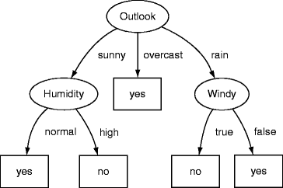

Fig 2.3: Decision tree example.[11]

- Logistic regression: It is a supervised classification algorithm used to classify data to corresponding classes by using the sigmoid/logit function to return probability values ​​ (between 0 and 1), thereby classifying the data into a set of discrete classes (identified classes). If there are many classes to be assigned, Logistic regression will use the one vs all method to classify the data.
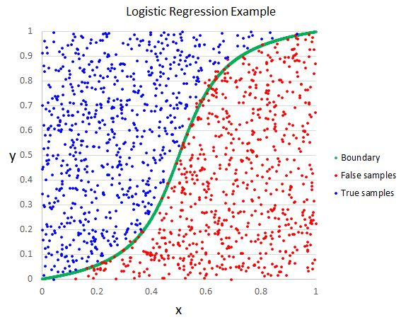
Fig 2.4: Logistic Regression example.[12]
- Support Vector Machines: It is one of the most powerful and popular machine learning methods, which can be used in either classifications and regression tasks, and is usually used for classification problems. SVM can process both linear separable and non-separable data. In the second case, SVM uses a kernel to transfer data points to a higher-dimensional space that can be linearly separated.

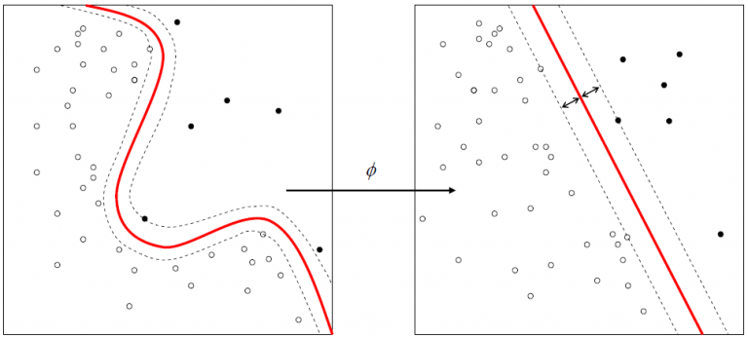
Fig 2.5: Nonlinear and linear SVM classification example.[13]

- Naïve Bayes: Naive Bayesian classification is a type of simple probabilistic classification. A naive Bayes classifier is an algorithm that uses theorem of Bayes with a strong independence (called naïve) of the hypotheses. These classifiers are widely used for machine learning because they are simple to implement.[14]

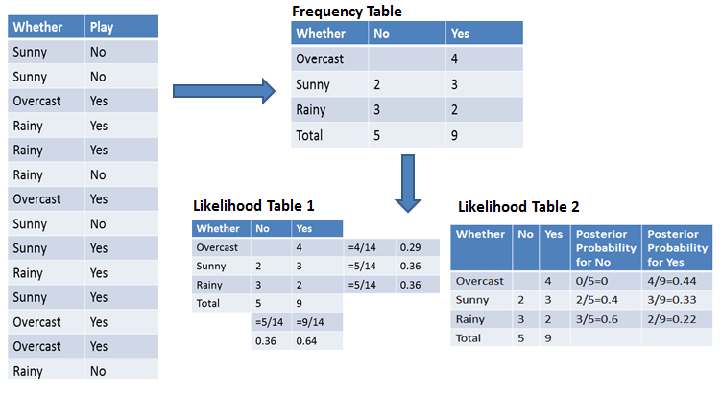
Fig 2.6: Naïve Bayes classification example.[15]

- K-nearest neighbor algorithm: It is a popular classification approach. The approach is too simple, the new data point is classified according to the classes of its nearest k neighbors. The K nearest refers to the similarity or proximity point of the data (in term of distance). there are many methods to calculate this distance, Euclidian distance, Jaccard distance, Manhattan, and K means the number of neighbors. After calculating the distance from the point to its neighbors, the label of the data point will correspond to the labels of the k nearest neighbors.[16]
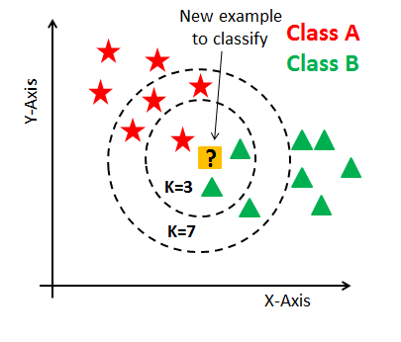
Fig 2.7: KNN classification example.[17]

      - Application of Supervised Machine Learning:
- Bioinformatics
- Quantitative structure
- Database marketing
- Handwriting recognition
- Information extraction
- Object recognition in computer vision
- Optical character recognition
- Spam detection
- Pattern recognition

    - Unsupervised learning:
One important type of machine learning when the data is unlabeled and there is no priori identified classes, then it aims to find in the collection of data if there are clusters, groups or classes to be discovered. usually members of same cluster or group are similar to each other and dissimilar to member of other groups. The process is simple, we try to maximize the distance between the clusters and minimize the distance between the members of each cluster. Unsupervised learning problems can be further grouped into clustering and association problems.

      - Unsupervised algorithms:
- K-Means Clustering
- Gaussian Mixture Model
- Hidden Markov Model
- Principal Component Analysis

      - Application of Unsupervised Machine Learning
- Human Behavior Analysis
- Social Network Analysis to define groups of friends.
- Market Segmentation of companies by location, industry, vertical.
- Organizing computing clusters based on similar event patterns and processes.

    - Semi supervised learning:
In this learning, the given data is a mixture of classified data and unclassified data. This combination of labeled and unlabeled data is used to generate an appropriate model for data classification. In most cases, there is little labeled data and a lot of unlabeled data. The goal of semi-supervised classification is to learn a model that predicts the category of future test data better than a model generated using only labeled data. [18]

    - Reinforcement learning:
Reinforcement Learning is a type of Machine Learning which allows machines to automatically determine the ideal behavior within a specific context, in order to maximize its performance. The reinforcement learning method aims at using observations gathered from the interaction with the environment to take actions that would maximize the reward or minimize the risk. In order to produce intelligent programs (also called agents).[19]

- Deep Learning:
  - Definition:
Deep learning, as a new field of machine learning research, is a process that enables computers to learn to perform tasks inherent in the brain, such as image recognition. Currently, deep learning (DL) methods have had a profound impact on computer vision and image analysis applications, such as image classification, segmentation, and image completion. Deep learning focuses on a specific category of machine learning, called artificial neural networks, which is inspired by the functions of the human brain. Modern deep learning provides a very powerful framework for supervised learning. By adding more layers and more units to the layers, deep networks can represent increasingly complex functions.[20]

  - Deep Neural Network:
An artificial neural network is a network composed of interconnected artificial neurons (or nodes), where each neuron represents an information processing unit. These interconnected nodes transfer information to each other, thereby mimicking the human brain. This operation is performed by a so-called activation function (non-linear). It converts input to output, which can then be used as input for other nodes.
The layer which is before the neuron is called the input layer and the layer which is after the neuron is called the output layer. All the other layers in between are called hidden layers. In a nutshell, an Artificial neuron takes input from other nodes and applies the activation function to the weighted sum of input and then passes the output. A Bias is added to the weighted sum to avoid passing no (zero) output.

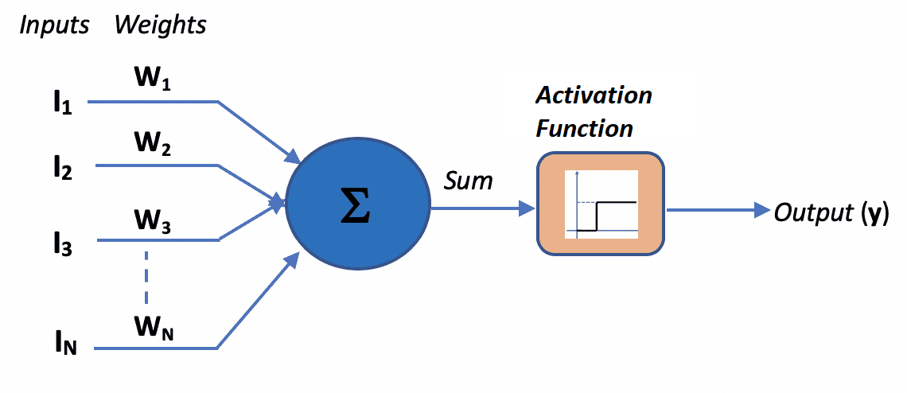
Fig 2.8: Deep Neural Network architecture.[21]

    - Activation function:
Activation functions are an extremely important feature of the artificial neural networks. They basically decide whether the information (Weight, bias) received by the neuron (from the previous layer) is enough for the neuron to be activated or not. This transformed output is then sent to the next layer of neurons as input.

    - Activation function types:
- Sigmoid: A very popular activation function that has proven solving the two-classes classification task since it produces values between 0 and 1. if the instance value’s weight is min threshold, the class is negative and so on.

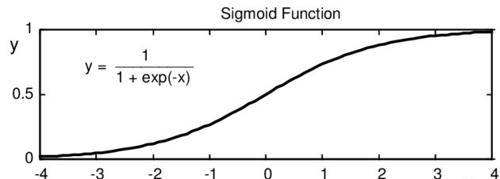
Fig 2.9: Sigmoid function curve.[22]

- ReLU: Stands for Rectified Linear Unit, most widely used activation function in the field of neural networks, is a nonlinear function. The major advantage of ReLU is that it does not activate all the neurons at the same time, meaning that, if the input is negative it will convert it to zero(in other words it returns the highest value between 0 and the weight bias ) and the neuron does not get activated, producing few neurons to be activated at a time.

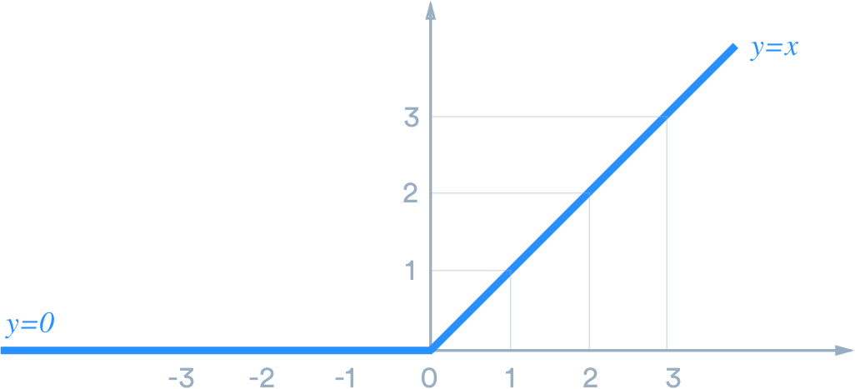
Fig 2.10: ReLU function curve.[23]

- SoftMax: The enhancement of the Sigmoid function, it can perform a variety of classification tasks, the SoftMax function can compress the output of each category between 0 and 1, and can be divided by the sum of the output. This essentially gives the possibility that the input is in a certain category.
- TanH: Hyperbolic tangent is a nonlinear transformation function, works similar to the sigmoid function but is symmetric over the origin. it ranges from -1 to 1.

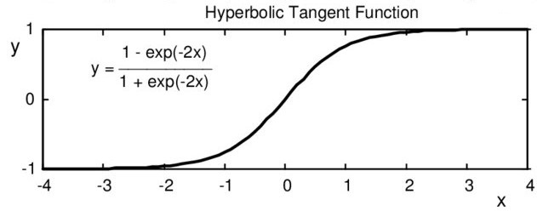
Fig 2.11: TanH function curve.[22]

    - Weights and Bias:
Weight is a number that refers to the strength of a connection between two nodes, weights are what connect the nodes between layers , the weights are initialized randomly initialized ( numbers ) mean of 0 and std of 1 each neurons has its own bias , and these biases are learnable meaning that SGD (Stochastic Gradient Descent) update weights it also updates the bias as well, the bias will determine by whether or not or how much the neuron will fire throw the network ( forward pass ), the bias is passed with the SUM of the weights to the activation function.

  - Deep Neural Network types:
    - Deep Feed-Forward Neural Network:
This is the most common kind of Neural Network architecture wherein the first layer is the input layer, and the final layer is the output layer. All intermediary layers are hidden layers. If there is no “feedback” from the outputs of the neurons towards the inputs throughout the network, then the network is referred as a “feed-forward neural network”.[24]
This is the simplest type of ANN. Here, the connections do not form a cycle and hence has no loops. The input is directly fed to output (in a single direction).

Outputs

Input layer Hidden layer output layer
Fig 2.12: Deep Feed-Forward Network architecture.

      - Deep Feed-Forward Neural Network layers:
- Input layer: Input layer is the first layer in the neural network, composed of input neurons and brings initial data to the hidden layers for further processing.
- Hidden layer: The layer or group of layers between the input and output layer. Deep learning is an optimization problem looks for the optimal solution of a very complex problem, many of these computations are made in the hidden layers. The choice of hidden layers depends on the complexity of the data, when using a less complex data it’s recommended to use few hidden layers, using many hidden layers in a simple problem can lead to overfitting, and using simple architecture in complex problem leads to underfitting. Each hidden layer of the network is typically vector-valued. The dimensionality of these hidden layers determines the width of the model.[25]
- Output layer: Output layer is the last layer in neural network which produces the outputs of the program, in classification tasks, the size of output layer is equal to number of classes.

    - Deep Convolutional Neural Network
Deep Convolutional Neural Network is considered as the most used type of Artificial Neural Nets in image and video recognition, image classification, computer vision and natural language processing. Convolutional networks are simply neural networks that use convolution in place of general matrix multiplication in at least one of their layers. Convolutional networks have played an important role in the history of deep learning. They are a key example of a successful application of insights obtained by studying the brain to machine learning applications. They were also some of the first deep models to perform well, long before arbitrary deep models were considered viable. [25]
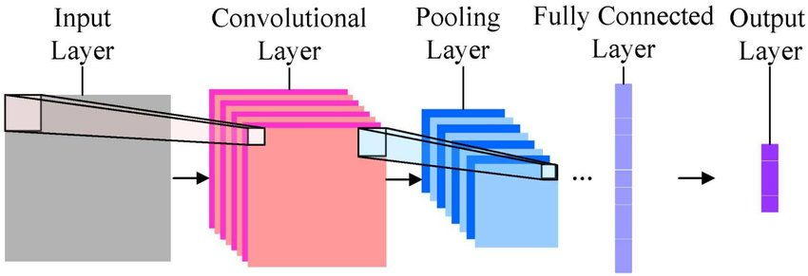
Fig 2.13: Convolutional Neural Network architecture.[26]

      - Deep convolutional Neural Network layers:
There are three main types of layers to build convolutional Neural Network architectures: Convolutional Layer, Pooling Layer, and Fully-Connected Layer.
- Convolutional Layer:
The convolutional layer is the core building block of the convolutional network that performs most of the computationally heavy work. Most generally, we can think of a CNN as an artificial neural network that has some type of specialization for being able to pick out or detect patterns. This pattern detection is what makes CNNs so useful for image analysis. The convolutional layer receives input, converts the input by performing convolution operations, and then outputs the converted input to the next layer.[25]
The convolution operation is performed by sliding the filter over the image. At every location, we do element-wise matrix multiplication and sum the result. This sum goes into the feature map. the layers are organized in 3 dimensions: width, height and depth.
The Conv layer’s parameters consist of a set of filters also known as kernels. The filters are especially designed to detect whether or not the image does contain any such characteristics. Every filter is small spatially (along width and height), but extends through the full depth of the input volume, meaning that it should have the same depth of the input.[27]
- Pooling Layer:
Its function is to progressively reduce the spatial size of the representation in order to reduce the number of parameters and computation in the network, hence to control overfitting. In image classifications task, pooling reduces the dimension of the image by the reducing the number of pixels in the output from the previous convolutional layer.[27]
- Max-pooling: uses the maximum value from each cluster of neurons at the prior layer. Main goal of max pooling is to capture the main features and give them high weights , when these features are found while filtering the image ( in the convolution phase ) these features are returned (because they have the maximum value ) while the no-important features(those who have less value are neglected). [28]
- Average pooling: uses the average value from clusters of neurons at the prior layer.
- Fully-Connected Layer:
Different layers in a neural network are connected to each other. In some cases, all neurons in layer X are connected to neurons in the next hidden layer X+1. This is called a fully connected layer, usually followed by a nonlinear activation function.

    - Deep Recurrent Neural Network:
The idea behind RNN is to use sequential information. In traditional neural networks, we assume that all inputs (and outputs) are independent of each other. But for many tasks, this may not be a good idea. To predict the next word in a sentence, it is best to know which word comes before it.
RNNs are called recurrent because they perform the same task on each element of the sequence, and the output depends on previous calculations. Another way to think about RNNs is that they have "memory" that can capture information about what has been calculated so far. In theory, RNNs can use information in arbitrarily long order, but in reality, they are limited to reviewing some steps.

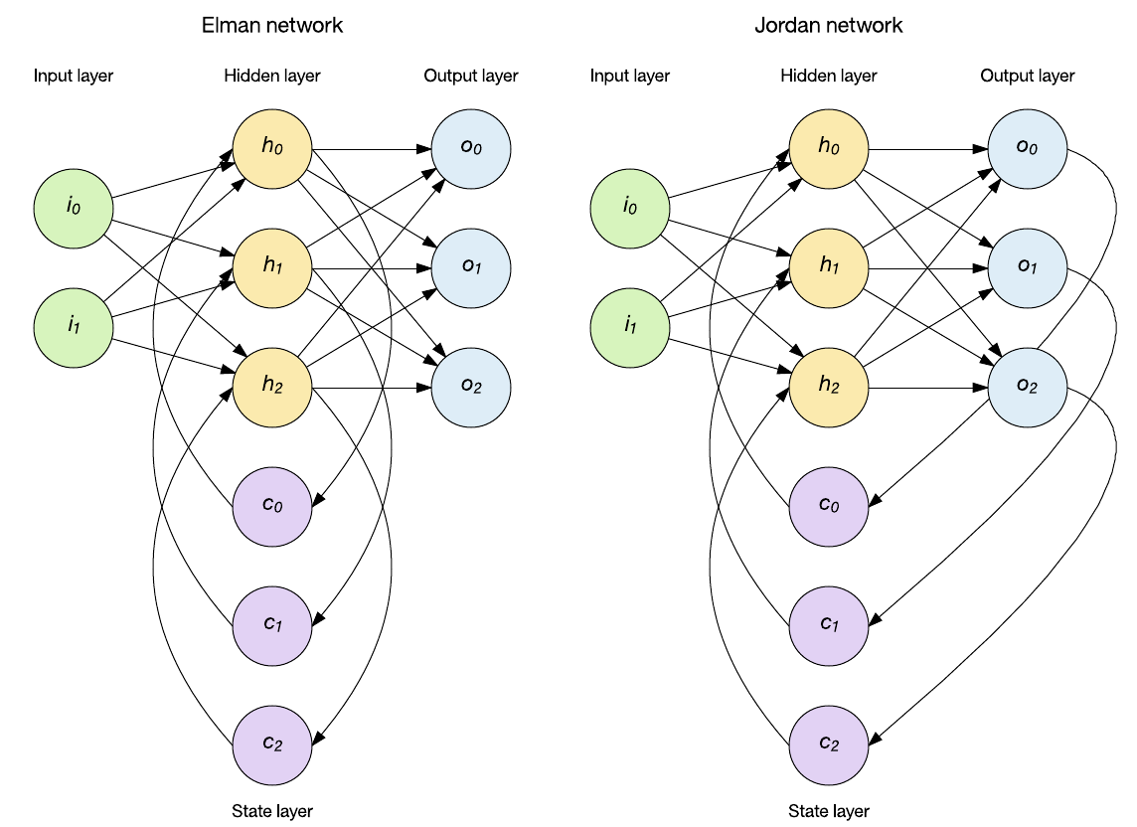
Fig 2.14: Recurrent Neural Network architecture.[29]

- ML vs DL:
- Deep learning is just a subset of machine learning hence why the terms are sometimes loosely interchanged.
- ML has excellent performances on a small/medium dataset and DL has excellent performance on a big dataset.
- In the same experiments, ML gives lesser accuracy than DL.
- ML takes less time to train but DL takes longer to train.

- Conclusion:
This chapter covered definitions of: Artificial Intelligence paradigms ML and DL, their respective techniques, their types, and concepts related to each one. There are other concepts in DL and specially in CNN about the validation we will mention them in the last chapter.

Chapter Three:

Environment tools.
- Introduction:
In this chapter we describe firstly our dataset, after that, we will introduce all environment tools which have used in our experimental work, notably: Anaconda, python and its libraries and needed accessories.

- Dataset:
  - Dataset description:
We have used the BelgiumTSC dataset which is built for traffic sign classification purposes. The collection can be divided into six (06) categories of traffic signs warning signs, priority signs, prohibitory signs, mandatory signs, parking and standing on the road signs, designatory sign. The dataset is divided into two folders (Training and testing), we can see that the training as well as the testing data folders, contain 62 subfolders, which present 62 classes of traffic signs used for classification enumerated by 0 to 61, training folder contain 4575 images and 2520 images for testing folder, All images have the format (.ppm: Portable PixMap). The distribution of the number of identification images contained in the different classifications of the training set is shown in Fig 3.1, The distribution of the number of identification images contained in the different classifications of the testing set is shown in Fig 3.2.
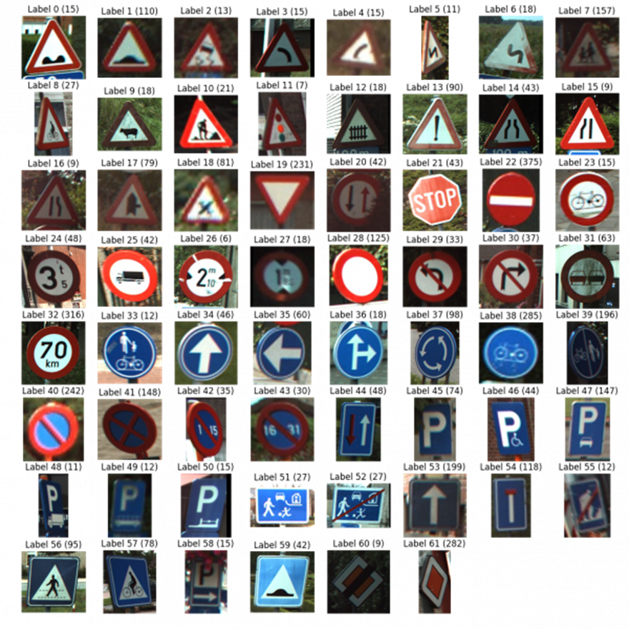
Fig 3.1: Training images distribution.

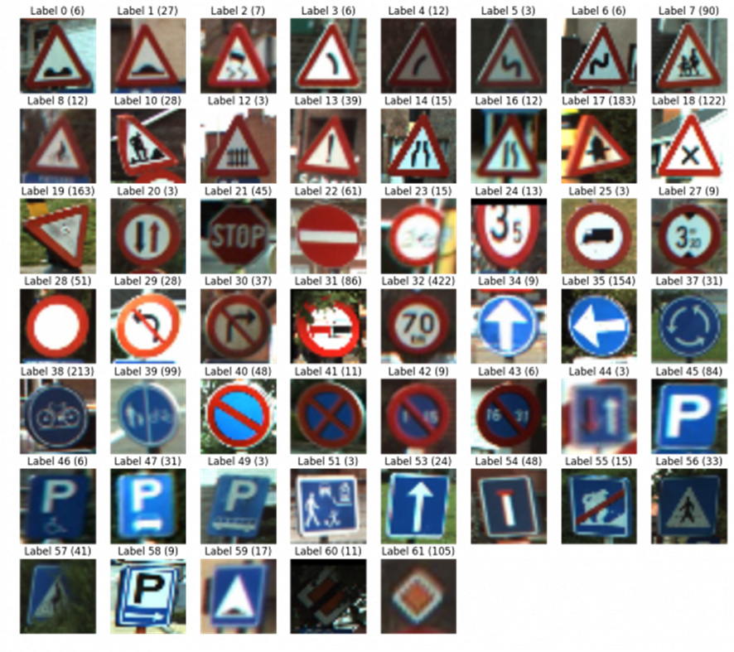
Fig 3.2: Testing images distribution.
  - Dataset Classes:
We put all classes of our dataset in Table 3.1 ordered by IDs and we specific the sign name of each class.
Table 3.1: Dataset classes IDs and labels.
Class ID | Sign | Sign Name | Class ID | Sign | Sign Name
0 | 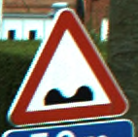 | Poor road surface ahead | 31 | 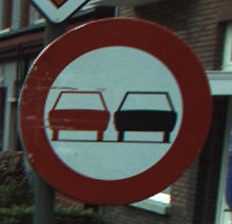 | Overtaking not allowed
1 | 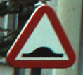 | Speed bumps in road | 32 | 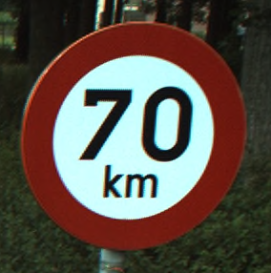 | Speed limit
2 | 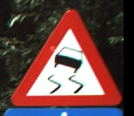 | Slippery road surface ahead | 33 | 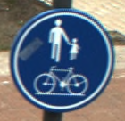 | Mandatory shared path for pedestrians and cyclists
3 | 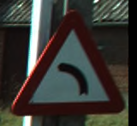 | Road ahead curves to the left side | 34 | 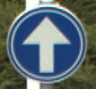 | Ahead Only
4 | 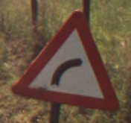 | Road bends to the right | 35 | 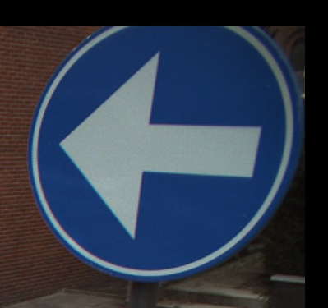 | Mandatory left
5 | 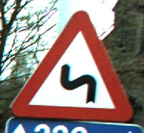 | Double curve ahead, to the left then to the right | 36 | 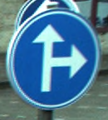 | Driving straight ahead or turning right mandatory
6 | 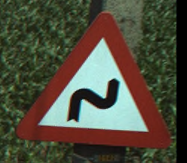 | Road bends right then left | 37 | 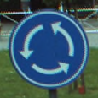 | Direction of traffic on roundabout
7 | 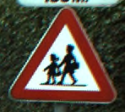 | Warning for children and minors | 38 | 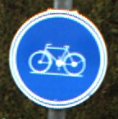 | Cyclist must use mandatory path
8 | 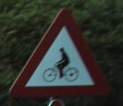 | Warning for bikes and cyclists | 39 | 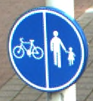 | Path for cyclists and pedestrians divided is compulsory
9 | 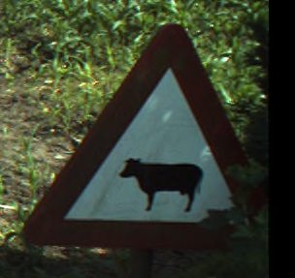 | Cattle crossing | 40 | 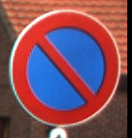 | No parking
10 | 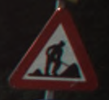 | Roadworks ahead warning | 41 | 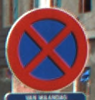 | Stopping and parking forbidden
11 | 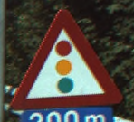 | Traffic light ahead | 42 | 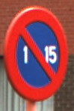 | No parking from the 1st to the 15th of the month
12 | 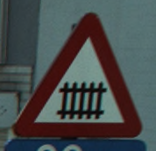 | Railroad crossing ahead with barriers | 43 | 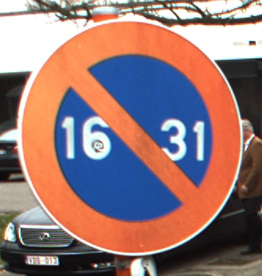 | No parking from the 16th to the 31st of the month
13 | 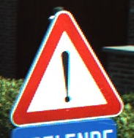 | Cars not allowed - prohibited | 44 | 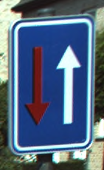 | Priority over oncoming traffic, road narrows
14 | 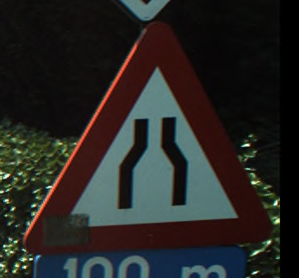 | road narrows ahead | 45 |  | Parking permitted
15 | 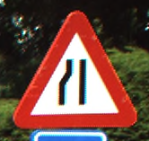 | Road narrows on the left | 46 | 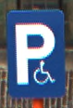 | Reserved parking for disabled badge holders
16 | 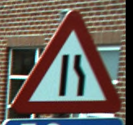 | Road gets narrow on the right side | 47 | 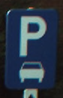 | Cars parking sign
17 | 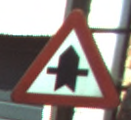 | Crossroad ahead, side roads to right and left | 48 | 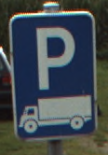 | Goods vehicle parking sign
18 | 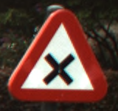 | Uncontrolled crossroad ahead | 49 | 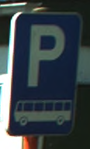 | Buses parking sign
19 | 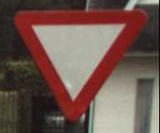 | Give way to all traffic | 50 | 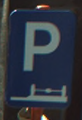 | Parking only allowed on the sidewalk
20 | 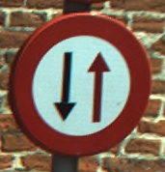 | Give way to oncoming traffic, road narrows | 51 | 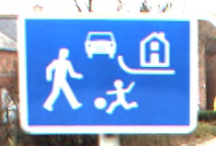 | Begin of a residential area
21 | 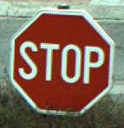 | Stop and give way to all traffic | 52 | 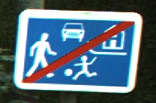 | End of the residential area
22 | 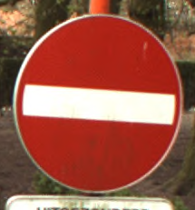 | No entry (one-way traffic) | 53 | 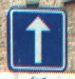 | One-way traffic
23 | 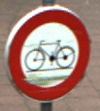 | Cyclists not permitted | 54 | 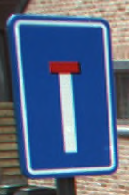 | Road ahead is a dead end
24 | 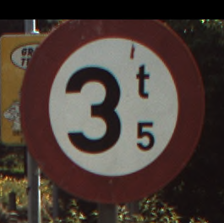 | Vehicles weighing heavier than indicated forbidden | 55 |  | End road work
25 | 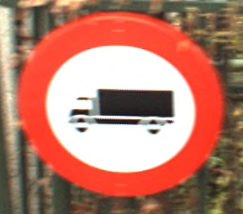 | Lorries - Trucks forbidden | 56 | 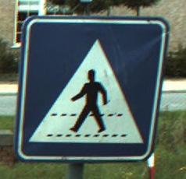 | Pedestrian crossing - People can cross
26 | 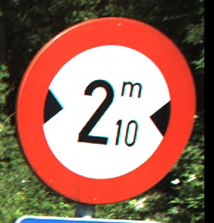 | Any vehicles that are wider that indicated forbidden | 57 | 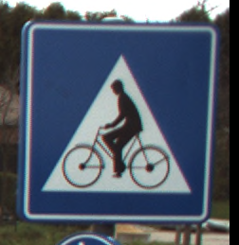 | Crossing for cyclists
27 | 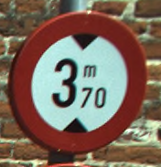 | Height restriction ahead | 58 | 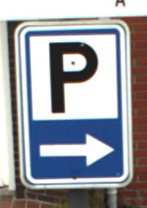 | Parking right sign
28 | 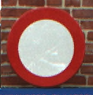 | Entry not allowed / forbidden | 59 | 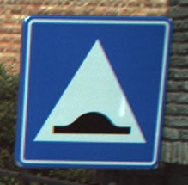 | Speed bump
29 | 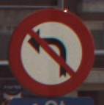 | Turning left prohibited | 60 | 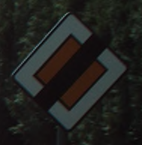 | Priority road ends
30 | 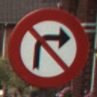 | Turning right prohibited | 61 | 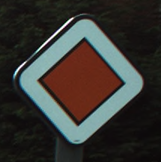 | Priority road ahead
- Anaconda environment:
Anaconda is a packaged compilation of Python and a set of packages containing various libraries, including core libraries that are widely used in data science. The main advantage of this release is that we don't need complicated settings, and can run on all types of operating systems and platforms (especially Windows), which usually causes problems when installing specific Python packages. Therefore, we only need to download and install it once to start our data science journey. Anaconda distributions are widely used in data science environments throughout the industry.[30]
Anaconda comes with a wonderful IDE, Spyder (Scientific Python Development Environment), besides other useful utilities like jupyter notebooks, the IPython console, and the excellent package management tool, conda that let us install, remove, or upgrade any Anaconda package with a single command in Anaconda Prompt. In our experimental work we use Anaconda 5.2.0 which is compatible with python 3.6.[31]

  - Anaconda downloading:
To download Anaconda 5.2.0 for windows10 / 64x:
- Click to this link https://repo.anaconda.com/archive/.
- Choose the anaconda3-5.2.0 from the list as indicated in Fig 3.3.
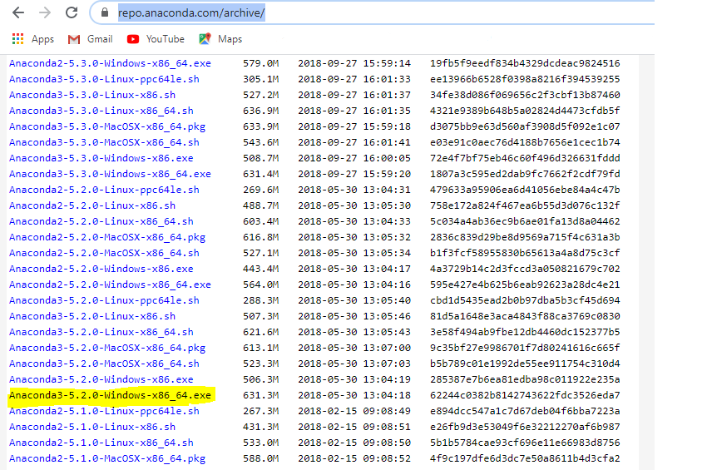
Fig 3.3: Anaconda 5.2.0 downloading.
- Python language:
The most commonly used and well-known programming language in data science is a high-level programming language. Its core design concepts all involve code readability and a syntax that allows programmers to express concepts in a few lines of code. Python is developed under an OSI-approved open source license, free to use and distribute, and even for commercial purposes, and has been successfully used in thousands of real-world business applications around the world, including many large and mission-critical systems. The python version that we used in this work is 3.6.[32]
Python for ML and DL applications is a collection of libraries that enable the developers to extract and transform data, perform data wrangling operations, apply existing robust Machine Learning algorithms and also develop custom algorithms easily. These libraries include NumPy, SciPy, pandas, scikit-learn, TensorFlow, keras, and so on.[33]

  - Python strengths:
- Easy to learn.
- Supports multiple programming paradigms
- Extensible: Extensibility of Python is one of its most important characteristics.
- Active open source community: Python is open source. This makes it robust and adaptive.

- Python libraries:
  - Scikit-Learn:
Formerly scikit-learn and also known as sklearn; Is a free software machine learning library, and it's one of the most important and indispensable Python frameworks for Data Science and Machine Learning in Python. It applies a wide range of machine learning algorithms that cover the main areas of machine learning like classification, clustering, regression, and so on. All the mainstream Machine Learning algorithms like support vector machines, logistic regression, random forests, K-means clustering, hierarchical clustering, and many more. In this work we have installed Sklearn 0.19.1.[34]
To install Sklearn:
- Anaconda prompt.
- Type the command pip install sklearn.

  - SciPy:
SciPy is an open source scientific computing library of numerical routines for the Python programming language that provides fundamental building codes for modeling and solving scientific problems. It provides specialized data structures, such as sparse matrices and k-dimensional trees. In this work we have installed SciPy 0.1.1.[35]
To install SciPy:
1- Anaconda prompt.
2- Type the command conda install scipy.

  - Pandas:
Pandas is a popular Python-based data analysis library, it presents a diverse range of utilities, ranging from parsing multiple file formats to converting an entire data table into a NumPy matrix array. This makes pandas a trusted ally in data science and machine learning. In this work we have installed pandas 0.23.0.[36]
To install pandas:
1- Anaconda prompt.
- Type the command pip install pandas.

  - NumPy:
NumPy stands for "Numerical Python" is an open source package for Python programming language. It is a library consisting of multidimensional array objects, along with a large collection of high-level mathematical functions to operate on these arrays. In our work we have installed NumPy 1.14.3.[37]
To install NumPy:
1- Anaconda prompt.
- Type the command pip install numpy.

  - Matplotlib:
Matplotlib is a Python package, it supports interactive and non-interactive 2D plotting that generates production-quality graphs, and can save images in several output formats. It provides a variety types of plots (lines, bars, pie charts, histograms...etc.). In addition to this, it is flexible and easy to use. In this work we have installed Matplotlib 2.2.2.[38]
To install Matplotlib:
1- Anaconda prompt.
2- Type the command pip install matplotlib.

  - TensorFlow:
TensorFlow is an open-source library for fast numerical computing which implements machine learning methods based on deep neural networks (deep learning). At a high level, TensorFlow is a Python library that allows users to express arbitrary computation as a graph of data flows. We have installed TensorFlow 1.5.1.[39]
To install TensorFlow:
1- Anaconda prompt.
- Type the command pip install tensorflow.

  - Keras:
Keras is a deep learning API written in Python, and its development purpose is to make developing DL models as fast and easy as possible. Keras is used as the backend TensorFlow and Theano. In the implementation part of this work, we have used keras 2.2.4 with the TensorFlow backend.[40]
To install keras:
1- Anaconda prompt.
- Type the command pip install keras.

  - TkInter:
Tkinter, or “Tk interface”, is a module of python that provides an interface GUI (Graphical User Interface). It is famous for its simplicity and it is open-source. The tkinker module is part of the Python standard, as it ships with the interpreter, and the Python documentation documents tkinter as if it were a built-in module.[41]

- Conclusion:
We introduced in this chapter all environment tools that have used in our work. Python is a high-level programming language and the most commonly language in data science and deep learning, this is the reason for which, we have chosen it with their libraries.

Chapter Four:

Realized work and obtained results
- Introduction:
This chapter presents the experimental part, so it contains of the following:
- The preprocessing of the used dataset
- The proposed model
- Our application interface.

- Preprocessing of the used dataset:
- Loading the dataset: by the “load_data” function.
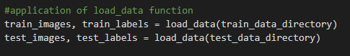
Fig 4.1: Application of load_data function source code

- Images resizing: Importing the images with the original sizes will lead to use big part of hardware resources and the time of processing will highly increase, we decided to reduce the image sizes to 28 X 28 pixels.
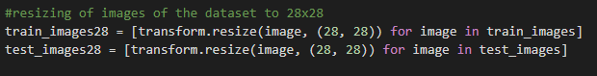
Fig 4.2: Resizing of images source code

- Grayscale: We convert our images from the RGB format to grayscale format.
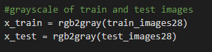
Fig 4.3: Grayscale source code

- Convolutional Neural Network model:
  - The proposed model:
Fig 4.4 presents a detailed architecture of the proposed CNN model:
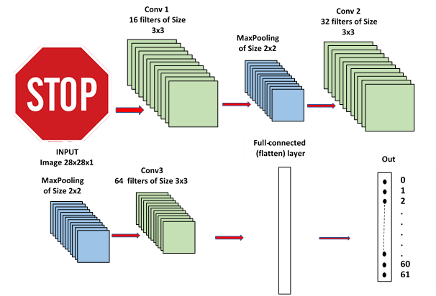
Fig 4.4: Architecture of the proposed CNN model

The main task of our project was to desig a CNN (Convolutional Neural Network) model composed of many layers as it is presented in Fig 4.4.
- A first convolutional layer Conv1 constituted of 16 filters of size (3x3).
- A MaxPooling MaxPool of size (2x2) allowing to reduce dimensions (weigh, high) of images issued of the previous layer after applying the different filters of Conv1.
- A second convolutional layer Conv2 constituted of 32 filters of size (3x3).
- A MaxPooling MaxPool of size (2x2) allowing to reduce dimensions (weigh, high) of images issued of the previous layer after applying the different filters of Conv2.
- A third convolutional layer Conv3 constituted of 64 filters of size (3x3).
- A flatten Layer
- A full connected layer FC of size 100 allowing to transform the output of the previous layer into mono-dimensional vector.
- An output layer represented by a reduced mono-dimensional vector having as size the number of traffic signs classes (62).
- For all the previous layers a Relu activation function and a softmax function are used to normalize values obtained in each layer.
Table 4.1: Description of the Proposed CNN Model
Layer Type | Output Shape | Nb. parameters
conv2d_1 (Conv2D) | (None, 26, 26, 16) | 160
Batch normalization () | (None, 26, 26, 16) | 64
max_pooling2d_1 (MaxPooling2) | (None, 13, 13, 16) | 0
Batch normalization () | (None, 13, 13, 16) | 64
conv2d_2 (Conv2D) | (None, 11, 11, 32) | 4640
Batch normalization () | (None, 11, 11, 32) | 128
max_pooling2d_2 (MaxPooling2) | (None, 5, 5, 32) | 0
Batch normalization () | (None, 5, 5, 32) | 128
conv2d_3 (Conv2D) | (None, 3, 3, 64) | 18496
Batch normalization () | (None, 3, 3, 64) | 256
flatten_1 (Flatten) | (None,576) | 0
Batch normalization () | (None,576) | 2304
dense_1 (Dense) | (None, 62) | 35774
Total parameters |  | 62,014
Trainable parameters |  | 60,542
Non-trainable parameters |  | 1.472

Table 4.2 bellow summarizes the obtained results after applying the proposed CNN model

Table 4.2: Loss value and accuracy value obtained.
 | Loss value | Accuracy value
Training set | 0.0026 | 0.9997
Test set | 0.1157 | 0.9720

Fig 4.5 shows the evaluation of training loss and validation loss over time in function of the number of epochs. Fig 4.6 plots the evolution of training accuracy and validation accuracy in function of the number of epochs.
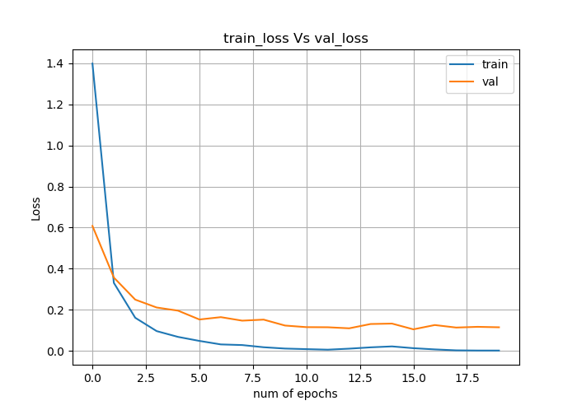
Fig 4.5: Training loss Vs Validation loss of the CNN model
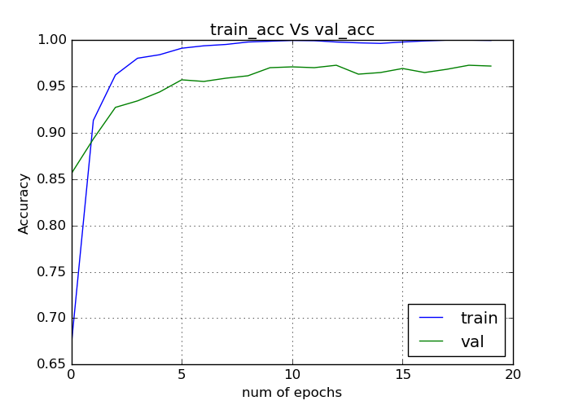
Fig 4.6: Training accuracy Vs Validation accuracy of the CNN model

  - Model evaluation concepts:
- Accuracy:
Accuracy is an evaluation metric used to evaluate classification models, so it tells how the model is accurate. This is just the ratio of the correctly predicted observations to the total observations. For example, the accuracy is 0.97, or 97% (97 correct predictions out of a total of 100 examples).[42][48]

- Loss:
The loss function is used to optimize the parameter values ​​in the neural network model. The loss function maps a set of parameter values ​​of the network to scalar values, which indicate the degree to which these parameters complete the tasks that the network intends to complete. It calculates the error for a single training example.[43]

- Optimizer:
An optimizer is an algorithm or method used to change neural network properties (such as weights and learning rate). Optimization algorithms or strategies are responsible for reducing losses and providing the most accurate results. There are many types of optimizers.[44]

- Batch size:
Batch refers to the quantity being produced or planned to be produced. It is the total number of training examples present in a single batch.[45]

- Epochs:
In terms of artificial neural networks, an epoch refers to a cycle of the entire training data set. An epoch is often mixed with an iteration. The number of iterations is the number of batches or steps required to complete a partitioned data packet of training data. Epoch parameters refers to how many times the models aim to use the complete dataset for training.[46]

- Batch normalization:
Batch normalization is one of the most exciting latest innovations in optimizing deep neural networks. Batch normalization allows each layer of the network to learn independently of other layers. Because it has a slight regularization effect, it reduces overfitting.[47]

- Application interface:
Our interface is composed of three pages: home page, tools page and about page. Home page contains the classification of traffic sign images, tools pages presents the used tools: the dataset, the CNN model and the anaconda environment, and the last page which is “about page” gives a brief definition of the interface. Also, there are three buttons for each page and exit button for quit the window.

  - Home page:
In the home page there are three buttons upload, classify and clear.
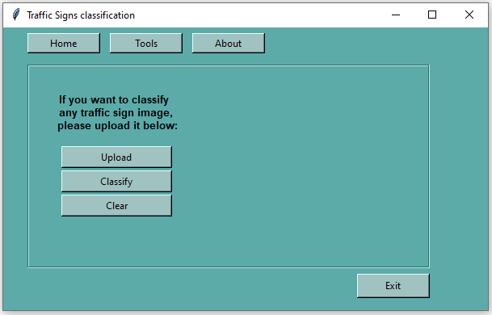
Fig 4.7: Home page.

The “upload” button when you click it gives you the access to choose any image in your computer, when choosing the traffic sign image, it will present in the home page.
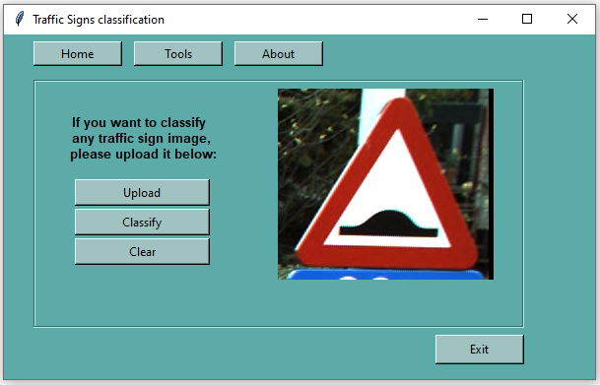
Fig 4.8: Upload event in home page.
After choosing the traffic sign image to classify by the “upload” button, you must click on the “classify” button. The “classify” button will print the class id and the class name of the traffic sign on the home page.

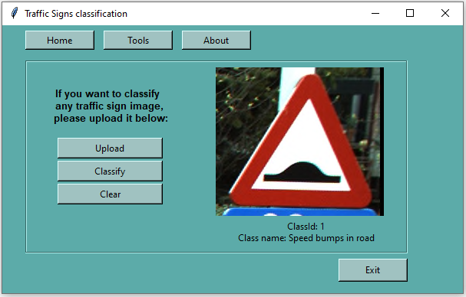
Fig 4.9: Classify event in home page.

  - Tools page:
Tools page contains three links: the first for downloading the BelgiumTSC dataset, the second to open our CNN model file and the last one for downloading anaconda environment.
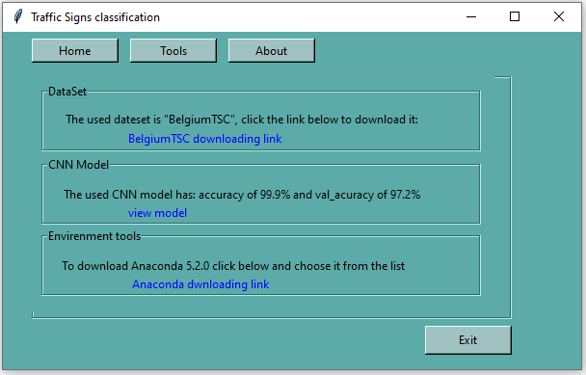
Fig 4.10: Tools page.

  - About page:
About page is the last page in our interface which is just a label presenting a brief definition of our interface.
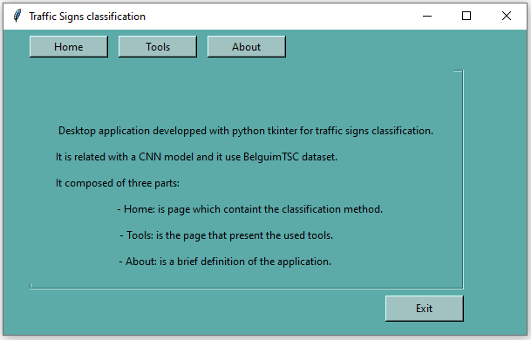
Fig 4.11: About page.

- Conclusion:
Our work can be divided into two main parts: the built CNN model and our application interface, so in this chapter we presented the experimental work, is embodied in the following: Describing the proposed model, the estimation of the proposed CNN model, the interpretation of the results obtained, we also defined Some concepts, in the last we have presented our application interface.

General Conclusion
General conclusion:
Our work is focused on traffic sign recognition which is one of the most important background research topics for the realization of autonomous driving systems. Few years ago, traffic sign detection is basically based on ML methods that provide high performance. During the last decade, some important advances have been made in the field of machine learning, especially after the emergence of a new subfield called deep learning. It is mainly based on a neural network that uses many simple interconnected units to extract meaningful patterns from large amounts of data to solve this kind of complex problems.
Traffic signs recognition has two main phases, in this work we have focused on the traffic signs classification by neural networks. We proposed a CNN model composed of: A first convolutional layer constituted of 16 filters of size (3x3)., MaxPooling layer of Size 2x2, A second convolutional layer of 32 filters of Size 3x3, another MaxPooling layer of Size 2x2, then a convolution layer of 64 filters of Size 3x3, in the last a flatten layer. As input, we have resized images to 28x28.
The obtained results when applying the proposed CNN model on the training set and the test set are very high. Two performance measures are considered in this case, the loss value and the accuracy value. Our results are: 99.97% for training accuracy, 97.20% for validation accuracy, and the loss: 0.0026 for training set and 0.1157 for the validation set. It is clear that the loss value is very low against the accuracy which is very high and depends on the size of the used set. It is the raison for which the accuracy of the training set is higher than the accuracy of test set.
Traffic signs are affected by external and natural factors, so the images become noisy to the model and this makes the classification process difficult, so I suggest that these signs are placed in the form of a map in the autonomous car system and whenever a sign is added somewhere the system is supplied with it. As for automatic identification methods, it is applied to traffic lights, pedestrians and cyclists, and so on.
Notifications of acceptance of papers at conferences:
- Nour Elhouda ADOUANE, Said GADRI, Hassina TAHMI, Baya LAOUES and Nadjet BOUAFIA: An Efficient CNN Model to Detect Traffic Signs for the Use of Self-Driving Cars, National Conference on Artificial Intelligence and Information Technologies CNIATI'20, Chadli Bendjedid University El Tarf, Algeria, 2020.
“Paper ID: 13
Author(s): ADOUANE Nour ElHouda, GADRI Said, TAHMI Hassina, LAOUES Baya, BOUAFIA Nadjet
Title: An Efficient CNN Model to Detect Traffic Signs for the Use of Self Driving Cars
It is our pleasure to inform you that the paper referenced above has been accepted for Poster presentation at the CNIATI'2020, to be held in El-Tarf, Algeria 17 March 2020.”
- Nour Elhouda ADOUANE, Said GADRI, Hassina TAHMI, Baya LAOUES and Nadjet BOUAFIA: An Efficient CNN Model to Detect Traffic Signs for the Use of Self-Driving Cars, 4th Edition of the National Study Days on Computer Sciences Research JERI'2020, University of Saida, May 20, 2020.
“We are pleased to inform you that your paper “An Efficient CNN Model to Detect Traffic Signs for the Use of Self-Driving Cars” to JERI’2020 has been accepted for Oral Presentation.
We look forward to seeing you in Saida!
Best regards,
JERI’2020 PC chairs.”
- Hassina TAHMI, Said GADRI, Baya LAOUES, Nour Elhouda ADOUANE and Nadjet BOUAFIA: Handwritten Digit Recognition:
Developing an Efficient ML and DL Model to Recognize Handwritten Digits, National Conference on Artificial Intelligence and Information Technologies CNIATI'20, Chadli Bendjedid University El Tarf, Algeria, 2020.
“Paper ID: 14
Author(s): TAHMI Hassina, Said GADRI, LAOUES Baya, ADOUANE Nour ElHouda, BOUAFIA Nadjet
Title: Handwritten Digit Recognition: Developing an Efficient ML and DL Model to Recognize Handwritten Digits
It is our pleasure to inform you that the paper referenced above has been accepted for Oral presentation at the CNIATI'2020, to be held in El-Tarf, Algeria 17 March 2020.”
- Nadjet BOUAFIA, Said GADRI, Hassina TAHMI, Nourelhouda ADOUANE and Baya LAOUES:
Efficient Clothes Categorization Based on Deep Learning Predictive Model, 4th Edition of the National Study Days on Computer Sciences Research JERI'2020, University of Saida, May 20, 2020.
“Dear Authors:
We are pleased to inform you that your paper “Efficient Clothes Categorization Based on Deep Learning Predictive Model,” to JERI’2020 has been accepted for Poster Presentation.
We look forward to seeing you in Saida!
Best regards,
JERI’2020 PC chairs “

References:
[1] Madarász, N. and Szikora, P., 2019. Hungary's role in developing autonomous cars. In: MEB 2019. Budapest, Hungary: Szikora Péter, p.86.
[2] Szikora, P. and Madarász, N., 2020. Self-driving cars – the human side. In: 2017 IEEE 14TH INTERNATIONAL SCIENTIFIC CONFERENCE ON INFORMATICS. Budapest, Hungary: IEEE, p.43.
[3] Gebresenbet Bayyou, D., 2019. Artificially Intelligent Self-Driving Vehicle Technologies, Benefits and Challenges. International Journal of Emerging Technology in Computer Science & Electronics (IJETCSE), 26(3), p.6,7.
[4] Ionita, S., 2017. Autonomous vehicles: from paradigms to technology. IOP Conference Series: Materials Science and Engineering, 252(012098), p.2.
[5] Zhao, J., Liang, B. and Chen, Q., 2018. The key technology toward the self-driving car. International Journal of Intelligent Unmanned Systems, 6(1), pp.4-12.
[6] Pofuk, T., 2017. Autonomous Vehicles and the Future of Private Vehicle Ownership. In: MIC 2017: Managing the Global Economy. Monastier di Treviso, Italy: University of Primorska Press Titov trg 4, 6000 Koper, Slovenia, pp.558,559.
[7] Threlfall, R., 2018. Autonomous Vehicles Readiness Index. KPMG International, p.6.
[8] Saadna, Y. and Behloul, A., 2017. An overview of traffic sign detection and classification methods. International Journal of Multimedia Information Retrieval, 6(3), pp.8, 19.
[9] Tom M. Mitchell. Machine Learning. McGraw-Hill series in computer science. McGraw- Hill, 1997
[10] Kotsiantis, Sotiris. (2007). Supervised Machine Learning: A Review of Classification
Techniques. Informatica (Slovenia). 31. 249-268.
[11] "Decision Tree", Medium, 2020. [Online]. Available: https://medium.com/@shubhamkumarhjp/decision-tree-42e000704092.
[12] "Logistic Regression (LR) - PRIMO.ai", Primo.ai, 2020. [Online]. Available: http://primo.ai/index.php?title=Logistic_Regression_(LR).
[13] A. Candelieri, R. Sormani, G. Arosio, I. Giordani and F. Archetti, "A Hyper-solution SVM Classification Framework: Application to On-line Aircraft Structural Health Monitoring", Procedia - Social and Behavioral Sciences, vol. 108, pp. 57-68, 2014.
[14] Webb G.I. (2011) Naïve Bayes. In: Sammut C., Webb G.I. (eds) Encyclopedia of Machine Learning. Springer, Boston, MA.
[15] "Naive Bayes Classification using Scikit-learn", Medium, 2020. [Online]. Available: https://medium.com/@avinashnvln8/naive-bayes-classification-using-scikit-learn-60bc5176f868.
[16] Jiawei Han. (2006). Data Mining Concepts and Techniques (2nd Edition).
[17] "Heart Disease - Classifications (Machine Learning)", Kaggle.com, 2019. [Online]. Available: https://www.kaggle.com/cdabakoglu/heart-disease-classifications-machine-learning.
[18] Mohammed, M., Khan, M. and Bashier, E., n.d. Machine Learning. p.10.
[19] ResearchGate. 2020. (PDF) Dive into Machine Learning. URL: https://www.researchgate.net/publication/328614973_Dive_Into_Machine_Learning.
[20] Ian Goodfellow, Yoshua Bengio and Aaron Courville. Deep learning. MIT Press, 2016.
[21]"Introduction to Artificial Neural Networks — esantus", esantus, 2019. [Online]. Available: https://www.esantus.com/blog/2019/9/4/introduction-to-artificial-neural-networks-in-python.
[22] "Complete Guide of Activation Functions", mc.ai, 2019. [Online]. Available: https://mc.ai/complete-guide-of-activation-functions/.
[23] "A Practical Guide to ReLU", Medium, 2017. [Online]. Available: https://medium.com/@danqing/a-practical-guide-to-relu-b83ca804f1f7.
[24] Sazlı, M.H. A (2006) Brief Review of Feed-Forward Neural Networks. Commun. Fac. Sci. Univ. Ank, pp 11.
[25] Ian Goodfellow,Yoshua Bengio and Aaron Courville. Deep learning. MIT Press, 2016.
[26] M. Peng, C. Wang, T. Chen, G. Liu and X. Fu, "Dual Temporal Scale Convolutional Neural Network for Micro-Expression Recognition", Frontiers in Psychology, vol. 8, 2017.
[27] CS231n Convolutional Neural Networks for Visual Recognition, cs231n.github.io/.
[28] Scherer, Dominik & Muller, Andreas & Behnke, Sven. (2010). Evaluation of pooling operations in convolutional architectures for object recognition. 92-101. 10.1007/978-3-642-15825-4-10.
[29]"Recurrent neural networks deep dive", IBM Developer, 2020. [Online]. Available: https://developer.ibm.com/articles/cc-cognitive-recurrent-neural-networks/.
[30] Sarkar, D., Bali, R. and Sharma, T., n.d. Practical Machine Learning with Python, p69.
[31] In: Researchgate. 2018. PYTHON CON ANACONDA. Bolivia: Aldo Ramiro Valdez Alvarado, pp.6, 7.
[32] Python 3.6. URL https://docs.python.org/.
[33] Raschka, S. and Mirjalili, V., n.d. Python Machine Learning. 2nd ed. p.58.
[34] F. Pedregosa, G. Varoquaux, A. Gramfort, V. Michel, B. Thirion, O. Grisel, M. Blondel, P. Prettenhofer, R. Weiss, V. Dubourg, J. Vanderplas, A. Passos, D. Cournapeau, M. Brucher, M. Perrot, and E. Duchesnay. Scikit-learn: Machine learning in Python. Journal of Machine Learning Research, 12:2825–2830, 2011.
[35] Virtanen, P. et al. SciPy 1.0–Fundamental Algorithms for Scientific Computing in Python, p1.
[36] what-is-pandas-in-python. URL https://www.educative.io/edpresso/what-is-pandas-in-python.
[37] What is NumPy, NumPy documentation. URL: https://numpy.org/doc/stable/user/whatisnumpy.html.
[38] Tosi, S., 2009. Matplotlib For Python Developers. Birmingham, U.K.: Packt Pub., p.8.
[39] TensorFlow, API Documentation. URL: https://www.tensorflow.org/api_docs.
[40] About keras. URL: https://keras.io/about/.
[41] D. Beniz, and A. Espindola. USING TKINTER OF PYTHON TO CREATE GRAPHICAL USER INTERFACE (GUI) FOR SCRIPTS IN LNLS. In: PCaPAC2016. Brazil, p.2.
[42] 2007. International Vocabulary of Metrology: Basic and General Concepts and Associated Terms (VIM) =. 3rd ed. Genève: INTERNATIONAL ORGANIZATION OF LEGAL METROLOGY, p.50.
[43] Theanets.readthedocs.io. 2020. Loss Functions — Theanets 0.7.3 Documentation. URL: https://theanets.readthedocs.io/en/stable/api/losses.html
[44] Medium. 2020. Various Optimization Algorithms for Training Neural Network. URL: https://towardsdatascience.com/optimizers-for-training-neural-network-59450d71caf6.
[45] Swamidass, P., 2006. Encyclopedia of Production and Manufacturing Management. [New York?]: Springer, Boston, MA.
[46] DeepAI. 2020. Epoch. URL: https://deepai.org/machine-learning-glossary-and-terms/epoch.
[47] Ioffe, Sergey & Szegedy, Christian. (2015). Batch Normalization: Accelerating Deep Network Training by Reducing Internal Covariate Shift.
[48] Google Developers. 2020. Classification: Accuracy | Machine Learning Crash Course. URL: https://developers.google.com/machine-learning/crash-course/classification/accuracy.
الملخص: يعد التعرف على إشارات المرور أمرًا مهمًا في مجال السيارات ذاتية القيادة. تم تطوير العديد من الخوارزميات خلال السنوات الماضية في مجال التعلم الآلي والمجال الفرعي الخاص به المسمى التعلم العميق لتقديم أفضل الحلول لهذا المجال. قمنا بتطوير نظام آلي يسمح باكتشاف وتصنيف بعض الصور المعينة التي تمثل إشارات الطريق. تحقيقا لهذه الغاية ، اقترحنا نموذج CNN يتكون من: عدة طبقات تلافيفية وطبقات تلافيفية بحد أقصى وطبقات متصلة بالكامل. كأدوات برمجة ، استخدمنا Python، Tensorflow،و Keras وهي الأكثر استخدامًا حاليًا في هذا المجال.
الكلمات المفتاحية: التعلم الآلي ، التعلم العميق ، التعرف على إشارات المرور ، الشبكات العصبية، السيارات ذاتية القيادة.
Abstract: Traffic signs recognition is an important task in the field of autonomous cars. Several algorithms have been developed during the last years to resolve this critical problem. The ML area and its subfield called DL give the best solutions for this field. In the present work, we have developed an automatic system that allows to detect and classify some given images representing traffic signs panels. For this purpose, we have proposed a CNN model. As programming tools, we have used python, Tensorflow and Keras which are currently the most used in the field.
Keywords: machine learning, deep learning, traffic signs recognition, Neural Networks, autonomous cars.
Résumé : La reconnaissance des panneaux de signalisation est une tâche importante dans le domaine des véhicules autonomes. Plusieurs algorithmes ont été développés au cours des dernières années pour résoudre ce problème critique. Le domaine ML et son sous-domaine DL donnent les meilleures solutions pour ce domaine. Dans le présent travail, nous avons développé un système automatique qui permet de détecter et de classer certaines images données représentant des panneaux de signalisation routière. À cette fin, nous avons proposé un modèle CNN composé de : plusieurs couches convolutionnelles, des couches de maxpooling et des couches entièrement connectées. Comme outils de programmation, nous avons utilisé python, Tensorflow et Keras qui sont actuellement les plus utilisés dans le domaine.
Mots clés : Apprentissage automatique, apprentissage profond, Reconnaissance de panneaux de signalisation, Les réseaux de neurones, voitures autonomes.

