PEOPLE’S DEMOCRATIC REPUBLIC OF ALGERIA
MINISTRY OF HIGHER EDUCATION AND SCIENTIFIC RESEARCH
UNIVERSITY OF MOHAMED BOUDIAF - M’SILA


FACULTY OF LETTERS AND LANGUAGES
DEPARTMENT OF LETTERS AND ENGLISH LANGUAGE
N°:………………………………………..

DOMAIN: FOREIGN LANGUAGES
STREAM: ENGLISH LANGUAGE
OPTION: DIDACTICS OF APPLIED LANGUAGES ONLINE PROGRAMME

Exploring the Role of Online Teacher Communities in Enhancing Summative Assessment Literacy of Middle School EFL Teachers.
The Case of Middle School Teachers in M’sila, Algeria.

Dissertation Submitted to the Department of Letters and English Language in Partial Fulfilment of the Requirements for the Master’s Degree in
Didactics and Applied Languages – Online Programme

Candidates:
Ms. BENLAMRI Sabrina
Ms. BOUCHLALEG Warda

Board of Examiners

Dr. DJAALAB Ilhem | University of M’sila | Chairperson
Dr. CHERIET Imene | University of M’sila | Supervisor
Dr. LADJEL Karima | University of M’sila | Examiner

2025

Dedications

In the name of Allah, the most Gracious, the most Merciful
I am honored to dedicate this dissertation to all those who supported me to complete my humble work. To my beloved parents, BENLAMRI Nadir and BENLAMRI Warda, for their endless love, pray and the strength to realize my dreams, siblings, family, colleagues and supervisor.
A special dedication to my husband, LEBOUAZDA Ibrahim, whose patience and encouragement made this possible, and my children, Mouataz and Meyssam, the source of endless joy. To all those who believe in the power of learning and hard work.
By Ms. BENLAMRI Sabrina

Dedications
This thesis is dedicated to all those who provided the support needed to bring this work to completion, family, colleagues, our university instructors of didactics and applied languages, and our supervisor who provided essential guidance during this research.

By Ms. BOUCHLALEG Warda

Acknowledgement
We would like to express our deepest gratitude to our supervisor, Dr. Cheriet Imene, for her expert supervision, fruitful guidance, valuable recommendations and persistent motivation throughout this research.
Special thanks to the Head of the Department, Dr. Hamoudi Aboubaker, for his continuous efforts to make Didactics Online Program effective and successful.
We would also acknowledge our colleague and delegate, Mr. Bachir Haouache, for his dedication, help and motivation throughout the two years.
Our sincere thanks to the jury members who devoted their time to read and assess this work and to thoughtfully offer constructive feedback.
In addition, we are grateful to the inspector of English and the administrator of District 4 Online Community, Mr. OTHMANI KAMEL, for his insightful knowledge and expertise, and all the participants who made this study possible.
To conclude, we would thank all the staff at the Faculty of Letters and Languages Department of English of M’sila University.

ABSTRACT
Online teacher communities (OTCs) have emerged as effective digital spaces for enhancing EFL teacher’s professional development and assessment practices particularly in an era shaped by a trend of the leveraging of technological tools that redefine educational norms. This study aims to explore the role of OTCs in enhancing Algerian EFL middle school teachers’ summative assessment literacy. It also examines the process by which these teachers transform online interactions into more reflective assessment practices. Descriptive method is utilized to answer the main research question and sub questions. The data were collected through the use of triangulation of instruments. The observation of the Facebook group “District 4 Teacher Corner”, semi-structured interviews of six EFL teachers and their inspector, and a questionnaire administered to over 50 teachers. All of which were conveniently selected to conduct this study. The findings reveal how OTCs effectively impact EFL teacher professional growth particularly in areas like assessment methods. They indicated that OTCs enhance teacher’s assessment knowledge, foster reflective collaboration, improve practical assessment skills, and boost digital literacy. However, challenges like technological barriers and inconsistent engagement hindered their full potential. This study recommends integrating OTCs to enhance teacher’s assessment practices through peer collaboration, mentorship, and action research. Besides, educational stakeholders should formalize OTCs with structured guidance from inspectors and incorporate teachers feedback into curriculum design.
Key words: online teacher communities (OTCs), summative assessment literacy (SAL), teacher professional development, reflective practice

List of Abbreviations
CPD: Continuous Professional Development
PD: Professional Development
EFL: English as a Foreign Language
OTLCs: Online Teacher Learning Communities
OTCs: Online Teacher Communities
CAR: Collaborative Action Research
PLCs: Professional Learning Communities
SA: Summative Assessment
SAL: Summative Assessment Literacy
CBM: Curriculum-Based Measurement
AaL: Assessment as Learning
CoP: Community of Practice
SL: Situated Learning
LPP: Legitimate Peripheral Participation
SC: Social Constructivism
CoI: Community of Inquiry
AT: Activity Theory
TLT: Transformative Learning Theory

List of Figures:

Figure 1 Gibbs's Reflective Cycle (Gibbs, 1988, as cited in Pearce, 2003) 20
Figure 2 Guskey’s Framework of Critical Professional Development 26
Figure 3 Assessment Literacy Framework 80

List of Tables
Table 1 The Biggest Challenges in Professional Development as an English Language Teacher 23
Table 2 The Summary of the Core Principles of each Theory 30
Table 3 Teachers’ Demographic Information 39
Table 4 Description of the Questionnaire 43
Table 5 Aspects Related to Platform Observation 46
Table 6 Key Themes and Findings Related to Teachers Interviews 48
Table 7 Key Themes and Findings Related to Inspector's Interview 50
Table 8 Teachers’ Participation in OTCs 54
Table 9 Distribution of Responses on the Questionnaire’s First Section Likert Scale 60
Table 10 Summary of Descriptive Measures for Likert Scale Items 01 62
Table 11 Summary of Respondents Perceptions about OTCs Usefulness 64
Table 12 Distribution of Teachers’ Agreement Regarding OTCs Role in Enhancing their Ability to Design Assessment Tools 67
Table 13 Likert Scale 02 Descriptive Statistics Summary 68
Table 14 Distribution of Respondents Levels of Agreement on Feedback and Reflective Practice within OTCs 70
Table 15 Likert Scale 03 Descriptive Statistics Summary 71
Table 16 Frequency of Implementing Reflective Assessment Strategies by OTCs Members 75
Table 17 Likert Scale 04 Descriptive Statistics Summary 76
Table 18 Key Findings in Relation to Theoretical Framework 83

List of Graphs:
Graph 1 Teachers’ Gender 53
Graph 2 Teachers' Teaching Experience 54
Graph 3 Teachers’ Participation in OTCs 55
Graph 4 Frequency of Teachers’ Engagement in OTCs 56
Graph 5 Frequency of Teachers’ Engagement in OTCs 57
Graph 6 Distribution of Activities Practiced in OTCs 58
Graph 7 Distribution of Responses on the Questionnaire’s First Section Likert Scale 59
Graph 8 Measures of Central Tendency and Dispersion Summary 63
Graph 9 Perceived Usefulness of OTCs 64
Graph 10 Frequency of Applying Assessment Techniques Shared in OTCs 65
Graph 12 How Teachers Rate the Effectiveness of OTCs 66
Graph 13 OTCs Role in Enhancing Teachers’ Ability to Design Assessment Tools 67
Graph 14 Descriptive Statistics: Mean Ratings and Standard Deviation for Six Aspects of Summative Assessment Tools Design 69
Graph 15 Perception Distribution about OTCs Role in Offering Feedback and Improving Reflective Practices 70
Graph 16 Statistical Summary: Mean and Standard Deviation of Reflective Practices within OTCs 72
Graph 17 Perceived Value of Peer Feedback in OTCs 73
Graph 18 Perceived Level of Support for Developing Reflective Practice-Oriented Assessment Design 74
Graph 19 Frequency of Implementing Reflective Assessment Strategies by OTCs Teacher Practitioners. 75
Graph 20 Mean and Standard Deviation of Frequency of Engaging in Reflective Practices within OTCs. 77
Graph 21 Distribution of Major Obstacles and Difficulties within OTCs 78

Table of Contents
Dedications I
Acknowledgement III
ABSTRACT IV
List of Abbreviations V
List of Figures: VI
List of Tables VII
List of Graphs: VIII
General Introduction
1. Background of the Study 1
2. Statement of the Problem 3
3. Research Questions 3
4. Research Objectives 4
5. Significance of the Study 4
6. Research Methodology 5
7. Thesis Structure 5
8. Operational Definitions of Research Variables: 7
Chapter One
Summative Assessment and Online Teacher Communities
8
Introduction 9
I. Language Assessment 9
1.1. Definition of Assessment 9
1.1.1. Purpose of Assessment 10
1.1.1.1 Assessment for Learning (Formative Assessment) 10
1.1.1.2 Assessment of Learning (Summative Assessment) 11
1.1.1.2.1. Curriculum-Based Assessment: 12
1.1.1.2.2. Structured Summative Assessment (SSA): Standardized Tests 13
1.1.1.2.3. Portfolio Assessment 14
1.1.1.3. Assessment as Learning (Self-Assessment) 14
1.1.2. Assessment Literacy 15
1.1.3. Feedback and Reflection 16
1.1.3.2. Peer and Mentor Feedback 17
1.1.3.3. Reflective Practice 18
1.2. Understanding Current Teacher’s Training Needs 20
II. Online Teacher Communities 23
2.1. Definition of Online Teacher Communities (OTCs) 23
2.2. OTCs and Professional Development 24
2.3. Synchronous and Asynchronous Learning Environments 26
2.4. Holistic Approach 28
2.4.1. Collaborative Culture 28
2.4.2. Inclusivity and Equity 28
2.4.3. Peer Mentoring 29
III. Theoretical Framework: 29
IV. The Role of Online Teacher Communities in Developing Teachers Assessment Literacy 32
Conclusion 35
36
Chapter Two
Methodology, Findings and Discussion
Introduction 37
2.1. Methodology and Research Design 37
2.1.1. Method: 37
2.1.2. The population and study sample: 38
2.1.3. The Study Setting 39
2.1.4. Data Collection Tools 40
2.1.4.1. Platform Observation 40
2.1.4.2. The Interviews 41
2.1.4.3. The Teachers’ Questionnaire 42
2.1.4.3.1. Description of the Questionnaire 42
2.1.4.3.2. Piloting of the Questionnaire 44
2.1.5. The Procedures 44
2.1.6. Data Analysis Techniques 45
2.2. Data Analysis and Interpretation 45
2.2.1. Analysis of Platform Observation 45
2.2.2. Analysis of Interviews 47
2.2.2.1. Teachers’ Interview 47
2.2.2.2. Inspector’s Interview 50
2.2.3. Analysis of Teachers’ Questionnaire 52
2.2.3.1. Analysis of the First Questionnaire Section: Background Information 52
2.2.3.2. Analysis of the Second Questionnaire Section 59
Usefulness, Frequency and Effectiveness of OTCs 63
2.2.3.3. Analysis of the Third Questionnaire Section 66
2.2.3.3.1. Part One: Designing Assessment Skills 66
2.2.3.3.2. Part Two: Feedback and Reflective Practice 69
2.2.3.4. Analysis of the Fourth Questionnaire Section 77
3. Findings Discussion 78
4. Limitations of the Study 85
5. Pedagogical Implications 85
6. Recommendations for Further Research 86
Conclusion 87
88
General Conclusion 89
References 91
Appendices
الملخص

- Background of the Study
Applied linguistics is primarily concerned with solving real-world problems related to language use and learning. It serves as a theoretical and practical foundation to comprehend how language is learnt and taught. Hence, it also emphasizes the importance of language teaching and language-teacher education. With particular emphasis on EFL teaching, it addresses how teachers develop, share and apply their pedagogical knowledge in distinct educational settings. Wilkins (1994) claims that this multidisciplinary field answers questions that highlight “what is not being improved”. Therefore, knowledge about language and skills in teaching and learning are integrated in effective teacher training programs necessary for teacher continuing professional development (CPD).
Teacher development is a continuous and dynamic process that constitutes diverse professional learning experiences. It improves teachers’ subject matter knowledge, skills and practices. Richards and Rodgers (1986) argue that teacher education, preparation and career follow-up encompass the entire professional teacher practices which he also refers to as “the continuing education that keeps the teacher in touch with developments in the field”. Thus, effective teacher development improves significant professional and pedagogical areas in the teaching process. It accentuates adopting appropriate teaching methods, classroom management techniques, consistent assessment implementation and technology integration. As such, it is necessary for teachers to engage in meaningful learning experiences that foster this continuous process.
A key factor that supports CPD is collaboration among teachers. Through transformative ongoing PD, teachers can even contribute to research. They exchange ideas, expertise, materials and feedback on specific topics. Bryan., et al (2001), as cited in (Cordingley et al, 2012) assert that teachers need time to share knowledge about their learners’ outcomes, classroom experiences and invest in received constructive criticism. Therefore, collaborative activities can enhance pedagogical decision-making and foster critical engagement with language teaching theoretical principles. This enables them to critically evaluate language use in their classrooms and purposefully adjust instructional practices.
Additionally, the emergence of digital platforms, such as Online Teacher Learning Communities (OTLCs), is a transformative vital mechanism that has encouraged these collaborative activities. They allow EFL educators to share resources and co-construct professional knowledge across geographical boundaries. Online Teacher Communities (OTCs) are principal spaces that facilitate continuous professional development among language teachers. This is essential for educators to stay updated with the latest research, methodologies and technological progress. Besides, OTCs aid teachers establish effective and engaging language learning environments that aim to mobilize qualified, competent, proficient and well- trained teachers. Vygotsky (1978) claims that mentor or peer collaborative approach encourages team-building skills where common experiences, strategies and perceptions are shared. This can be achieved through collaborative action research (CAR).
Considering the afformentioned factors, collaboration and teamwork are fostered within OTCs. They aid teachers to develop and enhance distinct skills necessary for taking action and critically reflecting on it. One particular area of concern is the competency to assess learners’ outcomes at the end of an instruction, a unit or an entire course and interpret results appropriately. It has been proved that OTCs are effective learning environments where educators learn, implement and critically evaluate summative assessment tools. The present study intends to investigate how engagement in OTCs contributes to Algerian middle school EFL teachers’ aptitude to comprehend and apply summative assessment principles.

- Statement of the Problem
With the rapid integration of digital tools in education, OTCs have become a key resource for collaborative professional development. Learning communities are virtual spaces, such as Facebook and LinkedIn Groups, that enable individuals to share knowledge, communicate and discuss pedagogical purposes. However, little is known about the role of OTCs on developing teachers’ summative assessment literacy. The reviewed literature might have overlooked the potential of digital professional networks in fostering assessment literacy.
In the Algerian context, it is important to identify how these social media platforms can scaffold peer-sharing of knowledge, skills and reflective feedback. In addition, there is a persistent need to clarify the role of interactive members of PLCs in creating dynamic, engaging and effective virtual environments. This research aims to bridge this gap by exploring the role of OTCs, as inclusive spaces, in enhancing Algerian middle school EFL teachers’ knowledge and aptitude to design, implement and evaluate summative assessment tools effectively.
- Research Questions
In adherence to the stated problem, the current study explores the role of OTCs in enhancing teachers’ summative assessment literacy. The main research question guiding this research is:
- How do OTCs enhance Algerian middle school EFL teachers’ Summative Assessment Literacy?
To address the principal question, the study also investigates several sub-questions:
- What are the dynamics through which teachers interact and learn about Summative Assessment Literacy?
- What are EFL teachers’ attitudes towards OTCs effectiveness in areas like summative assessment methods?
- To what extent do Online Teacher Communities enhance Algerian EFL teachers’ knowledge and skills to effectively design and critically refine their summative assessment practices?
- Research Objectives
The current research aims to investigate the structure, purpose and contribution of OTCs to teacher professional development. Despite the increasing interest in collaborative processes within these networks, limited research addressed educators’ literacy in summative assessment practices. Therefore, this study addresses the following objectives:
- to determine the impact of OTCs on Algerian middle school EFL teachers’ summative assessment literacy.
- to observe how teachers interact within OTCs.
- to explore educators’ attitudes about the effectiveness of OTCs in improving their summative assessment literacy.
- to discover the extent to which OTCs improve Algerian EFL teachers’ knowledge and ability to design and evaluate summative assessment tools.
- Significance of the Study
A limited number of research have demonstrated the significance of OTLCs in Algerian educational settings. This study is significant as it focuses on investigating summative assessment literacy as a crucial pedagogical aspect in professional development that offer middle school teachers of English the opportunity to share visions and values as professionals and foster the culture of collaborative action research. Additionally, the study offers a practical and theoretical value for multiple stakeholders. Teacher educators, professional development facilitators and inspectors benefit from the study through using a specific framework as a tool to design training programs that build assessment literacy in contextually relevant ways. This offers a foundation for further inquiry into teacher particular professional learning aspects. In this regard, data analysis and potential outcomes can inform instructional decisions to promote critical thinking and problem-solving skills in EFL education in Algerian middle schools.
- Research Methodology
Due to the nature and objectives of this research, the descriptive method is used to explore the impact of OTCS on the development of teachers’ summative assessment practices. The target population of this study is Algerian middle school EFL teachers who constitute District 4 Teacher Corner Online Community in M’sila. Out of 210 teachers (N=210), a sample of fifty (n= 50) was conveniently selected.
Data necessary to obtain comprehensive and objective information about the role of OTLCs was gathered using qualitative and quantitative data collection tools. Participant observation and semi-structured interviews with middle school teachers and inspector offered a greater clarity about the potential of new technological communities for enhancing EFL learning and teaching. Additionally, a semi-structured online questionnaire was designed and posted on District 4 official Facebook Page to explore respondents’ views and experiences in this virtual network and uncover its impact on teacher professional growth. It is anticipated that these methods will render robust valid and reliable qualitative and quantitative findings to reach the objectives and answer the research questions.

- Thesis Structure
The current study constitutes two chapters. The first chapter, the conceptual and theoretical frameworks of the investigation, is divided into three sections. The first section provides an overview of assessment and its purposes. It is structured around definitions of key concepts such as assessment, summative assessment, formative assessment, assessment as learning, assessment literacy, peer and mentor feedback and reflective practices. It also discusses teachers’ current training needs offered by the inspector of English, Mr. Othmani Kamel.
The second section addresses online teacher communities, types of learning environments, synchronous and asynchronous, collaborative culture, the role of the holistic approach in promoting inclusivity and equity within OTCs and the mindset of lifelong learning that is fostered through teachers’ engagement in collaborative activities and professional discussions.
Secondly, section two attempts to explain key features of online teacher communities, their purposes, main functions, usage and educational significance. In addition, it also presents relevant theories and models that support the pedagogical use of OTLCs. Further, relevant literature about the two variables, summative assessment and online teacher communities, is reviewed in the following section. Previous studies on OTCs effectiveness were thoroughly examined to identify a theoretical foundation for this research and to highlight existing gaps in the literature.
However, a detailed account of the methodological and practical aspects of this research is described in the second chapter. It outlines the research methods and analysis techniques adopted to interpret and discuss the cumulated data. Also, it provides stakeholders some pedagogical implications and concrete suggestions and recommendations to inform educational, professional and research practices. This contributes to the development of meaningful, specific and effective professional learning experiences for teachers.

- Operational Definitions of Research Variables:
Summative Assessment Literacy (SAL): is defined as teachers’ ability to appropriately create, use and interpret valid and reliable assessment tools and using results to inform instructional design. In this research study, summative assessment literacy refers to the extent to which EFL middle school teachers in District 4 Teacher Corner Community possess the knowledge and skills necessary to develop such assessments. It is also associated with the average score on a Likert scale questionnaire measuring level of agreement on mastering summative assessment content knowledge, designing effective methods and using constructive feedback to thoughtfully analyze and synthesize them.
Online Teacher Communities: several definitions have been proposed to conceptualize Online Teacher Communities. This reflects diverse perspectives and research contexts. In this research paper, OTCs denote identifying and measuring District 4 members’ responses about their satisfaction with online teacher communities. This indicates OTCS regular use, effectiveness in sharing assessment instruments, usefulness in supporting teachers to make use of virtually exchanged theoretical concepts while implementing valid summative assessments, utility in engaging in peer and mentor feedback and which promote teachers’ reflective practices. In brief, the current study depicts OTCs as virtual spaces that are utilized for problem-solving and decision-making educational professional purposes.

Introduction
Online teacher communities (OTCs) represent a potentially significant resource for fostering and enhancing educators' assessment literacy through collaborative knowledge sharing and professional development. OTCs offer a unique space for educators to collectively address challenges and refine their assessment literacy, ultimately leading to improved student learning outcomes. This chapter provides the conceptual and theoretical underpinnings for this exploration. The first section defines key concepts related to assessment literacy and online teacher communities. The second section highlights the most relevant theories that offer insights into learning phenomena in general, and online learning in particular.

I. Language Assessment

Definition of Assessment
An essential component of the language teaching and learning process is assessment. In addition to meeting student needs, assessment or evaluation plays a key role in teacher planning, which includes testing. Assessment is thought to be the third side of the educational triangle alongside teaching and learning (Birenbaum, 1997, p. 71). In this vein, it has been viewed as the procedure of gathering data regarding students' performance in order to comprehend and ascertain their current level of proficiency and, accordingly, teachers will be taking a significant step in converting their classrooms into immersive spaces for children where they can acquire knowledge, develop understanding and gain skills and competencies to be important, productive members of society (Arkoudis & O’Loughlin, 2004; Cumming, 2009b; Davison & Leung, 2009 as cited in Celce-Murcia., et al, 2014).
Stiggins (1999) claims that sound assessment practices are pivotal since assessment methods employed determine the effectiveness of instruction and learning. Hence, English teaching and learning didactics place a strong emphasis on the use of a variety of assessment strategies and techniques to assist teachers in tracking students' progress, pinpointing areas for improvement, and informing instructional decisions. It is evident that various types of assessments cater for distinct purposes to measure users’ achievements in diverse settings and at different times. (Stiggins., et al ,2004, p.14).

1.1.1 Purpose of Assessment
Assessment plays a critical role in education and in the teaching process. Utilizing appropriate assessment assists teachers in grouping learners, assigning feedback and tailoring instruction (Tosuncuoglu, 2018). Formative, summative and metacognitive assessments represent different approaches, each serving unique purposes at specific stages of learning. This demonstrates the various ways in which learning and assessment might be connected.
Torrance (2007) argues that: ‘in a very real sense we have moved from “assessment of learning” through “assessment for learning” to “assessment as learning”, for both learners and tutors alike, with assessment procedures and process completely dominating the teaching and learning experience’. Hence, distinguishing between them is a crucial step for educators to appropriately and efficiently design, implement and reflect on testing tools. It is worth mentioning that assessment tools are not inherently summative or formative; rather, their designation is determined by the purpose for which they are employed (Marianne et al, 2014, 2001, 1991).

Assessment for Learning (Formative Assessment)
The concept of formative assessment has been defined in multiple ways. Black & Wiliam (1998) describe formative assessment “as encompassing all those activities undertaken by teachers, and/or students which provide information for feedback to modify teaching and learning activities in which they are engaged” (p.7). The National Research Council (1996) clearly indicates that “assessment becomes formative in nature only when either the teacher or the student uses that information to inform teaching and/or to influence learning.
Further, the Latin verb assidere, which means "to sit beside", is where the word "assessment" originates. This idea is somewhat different from ideas of assessment that prioritize testing and examination (Swaffield, 2011, pp. 433–449). This emphasizes how assessment might be perceived as holistic where teachers evaluate students on a regular basis in order to assist and assess learning. Thus, it is “intended to enrich the learning process by providing nonjudgmental feedback” (Kibble, 2017, pp. 110-119). Moreover, assessment for learning focuses on identifying gaps between current and desired performance and guiding instructional adjustments. As mentioned by Black &William (1998), Sadler (1989) and Popham (2008), they argue that formative assessment is set at first or during the learning process; it scaffolds learning, provides ongoing feedback during instruction and/or student performances and engages students in self-assessment.
Therefore, data from summative assessments can be used for formative purposes. Owing to this continuum of assessment of and for learning, it is evident that holistic responsive teaching practices necessitate reflective carefully constructed performance tasks that permit meaningful interpretation of findings, address gaps and refine the ongoing teaching learning cyclic process.
1.1.1.2 Assessment of Learning (Summative Assessment)
In contrast to formative assessments, summative assessments, which are also known as high stakes, involve some kind of assignments or tasks usually applied at the end of a learning process such as the end of a unit of work over a week, a term or a year. Assessment of learning is a top-down approach that is utilized for grading and measuring the outcome of student learning with the purpose of reviewing, critically discussing and reflecting on what is being assessed (Black & Wiliam, 1998). Also, Higginson (2000) refers to summative assessment (SA) as assessment for grading. According to him, SA is an evaluation that ranks students, indicates what they have achieved and aids in judging their own progress. Hence, summative assessment plays a major role in providing feedback and guiding the teaching learning process.
What is more, when conducting an assessment, a teacher should take into account a number of methods to obtain information about students’ progress such as projects, portfolios, performances, observations, and tests. This can enhance teachers’ instructional practices through action research; teachers keep adjusting their teaching strategies in light of observing and analyzing students’ effort and test scores (Seifert & Sutton, 2019). Hence, high quality assessments ought to be valid and reliable.
Validity refers to “adequacy and appropriateness of the interpretations and uses of assessment results” (Linn & Miller, 2005, p. 68). In other words, it manifests how well the assessment aligns with the learning objectives. On the other hand, reliability is associated with “the consistency” and “the accuracy” of assessment (Engemann, J., & Gallagher, T. , 2006). Results are said to be reliable if different graders achieve similar outcomes under consistent conditions. Consequently, this inter-rater reliability can be improved through collaborative efforts among teacher colleagues.
In a nutshell, the process of measuring learners’ outcomes necessitates a variety of SA tools. This is to develop specific skills that are consistent with relevant learning objectives.

1.1.1.2.1 Curriculum-Based Assessment
Curriculum-based assessment can be defined as the “direct observation and recording of a student’s performance in the local curriculum as a basis for gathering information to make instructional decisions” (Deno, 1985, p. 41). Although curriculum-based assessment is primarily utilized for formative purposes (Black & Wiliam, 1998), it can judge learners’ performance at the end of instructional practices employing what is referred to as curriculum-based measurement (CBM).
Deno (1985) also asserts that CBM entails obtaining valid and reliable students' academic performance measures through utilizing some standardised procedures. Curriculum, which serves as a natural context for assessment, is significantly reflected in what is being tested. Thus, teachers can measure learners’ specific subskill mastery aiming to achieve short-term instructional objectives or assess their overall language level of proficiency across the course content relying on general outcome measurement. These criterion-referenced and norm-referenced items both adopt standardised tests to quantify student performance and address their needs.

1.1.1.2.2 Structured Summative Assessment (SSA): Standardized Tests
A standardized test is claimed to be a variant of structured summative assessment. “A standardized test is any examination that is administered and scored in a predetermined, standard manner” (Popham, 1999, p. 9). In this vein, standardized tests are designed to measure learners’ developed skills and knowledge in a specific subject area (Kuncel & Hezlett, 2007). Moreover, Shepard (2000) argues that this kind of evaluation also focuses on integrating teaching and learning with an aim to develop students' competence and improve their academic performance. It is evident that they are subsequent indicators of learners’ success or failure.
Consequently, standardized tests’ efficacy depends on how they are designed and to what extent they are congruent with educational goals and pedagogical purposes. As the key element of a successful assessment is choosing and implementing appropriate techniques, these structured summative tools necessitate much consideration. Overall, ongoing research and teacher professional development are essential not only to improve scoring practices, but also to inform alternative assessment methods.

1.1.1.2.3 Portfolio Assessment
Portfolio assessment is one of the alternative unstructured assessment practices that prioritize learner-centered environments. This holistic approach focuses on evaluating varied learners’ process and performance of academic achievement unlike tests, which are score-based “one-shot formalized instruments” (Cole, 2000, p. 2) . Several researchers defined a portfolio as the deliberate process of purposefully gathering evidence samples about students’ performance that reflect and measure progress (Arter, 1995). Attempts to shift from quantitative measures to qualitative open-ended structures are more directly linked to the portfolio movement.
Furthermore, research findings prove that portfolio assessment can develop responsible, autonomous and lifelong learners who are eager to self-evaluate their progress. Hence, educators work to motivate and involve learners in their own learning so that self-confidence and self-esteem can effectively be enhanced. For instance, Mitchell (1994) found that students writing skill positively correlate with their feeling toward portfolio assessment. Other studies demonstrated that utilizing portfolios assisted nurturing a positive attitude towards writing (GÜMÜŞ, 2019) , reading and language arts (Calfee, 2012).

1.1.1.3 Assessment as Learning (Self-Assessment)
Existing literature indicates that students have been assessed for learning to be measured, evaluated and fostered. Jennie Sivenbring (2018) claims that assessment, accordingly, ought to be “informative, formative and active”. This points to the fact that assessment forms an integral part of the learning process which reflects how effective were the pedagogical techniques and strategies employed by both teachers and learners. They actively self-regulate and self-assess their feedback-based teaching learning process.
Moreover, research indicates that the best learning outcomes for students occur when teachers become learners of their own instruction as well as when students become their own teachers (through self-monitoring and self-assessment) (Hattie, 2012). Dann (1996, p. 57) argues that self-assessment calls for a deeper understanding of the goal, method, and outcome of learning between the teacher and the students. He also emphasizes the role of metacognition when he defines assessment as learning (AaL) as “a complex interplay of assessment, teaching, and learning which holds at its core the notion that pupils must understand their own learning progress and goals through a range of processes which are in themselves cognitive events. Implicit is the need for pupils to be active in both learning and assessment.” (Dann, 1996, p.57).
Building on this perspective, teachers significantly contribute to shape such assessment-rich environments. Engaging in professional development trainings is required to gain insights into its core principles and to develop an ability to design meaningful tasks and, most importantly, offer and seek analytical actionable feedback.

1.1.2 Assessment Literacy
It is undeniable that sound assessments require skilled and knowledgeable teachers who utilize effective tools and procedures to meet their learners’ needs and expectations. In every classroom, the quality of the assessments employed determines the quality of the instruction (Stiggins, 1999). Stiggins (1999) also claims that assessment at all levels—district, state, national, or international—represents a total waste of time and resources provided that it is not functioning well in classrooms on a daily basis (p. 193). As such, exploring teachers’ assessment skills and practices is an essential step to investigate their contribution to educational proficiency and academic achievement.
As stated by Guskey (1999), skills, knowledge and expertise are what assessment literacy comprises. Guskey (2000) suggests a model based on five levels for staff development. Level four evaluation has taken into account the participants’ use of their new knowledge and skills on instructional or assessment practices which significantly affect students learning outcomes (level five). All aspects above emphasize the role of the participants’ experience, reflection and adaptation in the success of the teaching learning process. It is important to note that assessment literate educators are proficient designers who appropriately apply rationale theoretical foundations to create valid, reliable, holistic and fair assessment tools.
Numerous studies have approached the issue under consideration offering diverse insights. Mertler (2003) reveals that effective pedagogical educational conduct, including assessment, necessitates teacher’s ongoing training. This view is further supported by other studies such as (Apostol et al, 2023). The findings demonstrated that educators have to avoid “teaching for the test” and be adept and accurate test scores interpreters who efficiently assist students' learning and guide their instructional selections to cater for diverse learning developmental needs. This asserts that promoting reflection, critical thinking and problem-solving skills in EFL educators call for instructors who are not “increasingly caught up in a measurement-induced maelstrom” (Popham, 2001), aiming at augmenting learners’ test grades, but for critical thinkers who base their inferences in response to feedback accumulated from reliable data.

1.1.3 Feedback and Reflection
Feedback and reflection are two fundamental teaching methods in English language instructional practices. Feedback, which is a key element of assessment, refers to the information provided about learners and/or teachers’ strengths, delineated gaps or area(s) for improvement enabling them to make adjustments and refine their teaching and/or learning. It must be emphasized that it is essential to practice feedback in educational and training settings as it refers to “the transmission of evaluative or corrective information about an action, event, or process to the original or controlling source” (Merriam-Webster Dictionary, n.d.). In Oxford English Dictionary, it is defined as “advice, criticism, or information about how good or useful something or someone’s work is”.
Moreover, Hattie & Timperley (2007) claim that feedback can negatively or positively influence learning and achievement. Therefore, pertinent questions must be asked in order to provide useful feedback. Although this may seem apparent, it is less clear that in order to provide convenient feedback, a strategy for handling evidence must be developed prior to its collection (Popham, 2001). Feedback, accordingly, is utilized as a tool for motivation, encouragement, metacognition and improvement.
Richards & Lockhart (1996) clarify that reflective teaching is a regular procedure and aspect of second language instruction in which all teachers “collect data about teaching, examine their attitudes, beliefs, assumptions, and teaching practices, and use the information obtained as a basis for critical reflection”. To put it clear, reflective practice aims at collecting data on what is happening in a language course; analyzing it, gaining insights about teaching-learning practices, cooperating with those who are curious about reflective teaching methods and conducting classroom-based action research for the purpose of incorporating evidence-based pedagogical updates.

1.1.3.1 Peer and Mentor Feedback
Instructional practices are revised based on feedback received from peers, mentors and personal reflection. Hattie and Timperley (2007) view feedback as “a consequence of performance”. It is evident that peer and mentor feedback play a crucial role in teacher’s professional development making instruction and feedback in a continuum (Hattie and Timperley, 2007).
Peer feedback refers to any input or insight on teaching methods, assessment literacy, classroom management or communication skills afforded by colleagues or peers. The quality of work can significantly be enhanced in light of shared experiences, diverse perspectives and constructive criticism that aid identify uncovered gaps and peer observations and discussions which create collaborative learning environment. Mentor feedback, on the other hand, is defined as the guidance and evaluation from experienced individuals in a specific field. In teaching, more experienced mentors guide, share expertise, support and offer feedback to less experienced, pre-service or student teachers (Hobson et al., 2009). Thus, the mentee can refine their teaching and assessment strategies and effectively address challenges contributing to personal and professional development.
Esterhazy et al (2023) support the idea that teacher learning communities are a collaborative setting (Wenger, 1999) for implementing Teacher Feedback Literacy (TFL) practices. TFL is something a teacher “does” in specific situations rather than something they “have”. Wexler (2020) also points to the fact that student teachers who receive educational mentoring are more likely to develop into goal-oriented, reflective professionals.
According to Tulgar (2019), a variety of sources, such as supervisors, coordinators and practice school students, can provide teachers with feedback. It is relationship-based, dynamic, and impacted by both institutional and emotional elements. Even though relevant feedback is still necessary and desired for ongoing development, many new teachers report a decrease in it after their student teaching experience. Thus, feedback needs to be frequent, targeted, specific, immediate, accurate, non-judgmental, iterative; “feed forward” and transformative. (Omer, A., & Abdularhim, M, 2017).

1.1.3.2 Reflective Practice
Evaluating one’s own performance, skills and knowledge is referred to as self-assessment. It is a critical ongoing element of professional growth in which teachers reflect on lessons and analyze student outcomes. Schön (1983) proposes three forms of self-reflection: reflection-in-action, reflection-on-action and reflection-for-action. While reflection-in-action takes place during instruction reacting for the unexpected; as decision-making is a part of teaching, reflection-on-action happens following instruction. The latter is usually held after the lesson has been delivered opening the door for synthesizing what has been covered. It aids practitioners to strengthen their workplace skills (Pearce, 2003).
Despite the real-time refection which prioritizes cognitive processes such as activating prior schemata, the retrospective one places greater importance on metacognition (Marianne. C.M et al, 2014, 2001, 1991, p. 615). The third dimension is anticipatory, solution oriented and continuous (Dewy, 1933). It is evidently informed and reinforced by the former aspects leading instructors to plan applying real-world effects of reflective analysis. All kinds of reflection, according to the theorist Schön, allow teachers to analytically consider instructional experiences to foster their professional growth.
For instance, Elfeky et al (2017) demonstrate that delayed feedback is more effective than immediate feedback for improving teachers’ lesson planning, implementing and assessment skills. Relevant evidence is the mean scores differences between participants' performance in both experimental groups regarding student teachers' skill of assessing their students' achievement. Those who received delayed feedback performed higher than (14.20) participants who synthesized immediate feedback (12.16) for training. Allowing more time for reflection and self-regulation emphasizes the significance and effectiveness of delayed corrective feedback in fostering and improving instructional skills.
One theoretical model that students and teachers frequently utilize as a basis for reflective practices is the Gibbs' Reflective Cycle (Pearce, 2003). Gibbs (1988) developed this paradigm to guide participants evaluate their own thoughts, feelings and actions while critically analyzing situations. This experiential learning theory-informed framework consists of six iterative stages that foster deep reflection on experiences, promotes learning and professional development and recommends future actions. By completing a cyclical series of tasks, including describing, feeling, assessing, analyzing, concluding, and action planning, students can connect theory and practice using the reflective learning cycle that Gibbs (1988) outlines in his book Learning by Doing as illustrated in the diagram below. In a nutshell, this proactive paradigm has had a significant impact on programs for teacher development.

Figure 1
Gibbs's Reflective Cycle (Gibbs, 1988, as cited in Pearce, 2003)

1.2 Understanding Current Teacher’s Training Needs
Recognizing and synthesizing a teacher’s training needs is a decisive phase. According to Kaufman et al (1979), the deficit between a practitioner’s actual performance and expected achievements is referred to as a need. To identify and bridge this gap between "what is" and "what should be" (Kaufman et al., 1979) in educational context, qualified, reflective and resourceful teachers require continuing professional development (CPD). CPD is a useful ongoing process for instructors to update and improve their skills and knowledge for their and their pupils’ benefit. Thus, it endeavors to promote professional autonomy, self-confidence and collaborative transformative practice (Kennedy, 2005).
To further comprehend CPD’s significance in mobilizing self-regulated and visionary teachers, an in-depth analysis of the key core characteristics of its models is a necessity (Kennedy, 2005). Teachers, as Kennedy (2005) contends, undergo a shift from transmission, through transitional to transformative CPD for a more professional autonomy progress. At the transmission level, the training model empowers teachers with the necessary current skills in an effort to perform efficiently. It is a skill-based, structured, institutional and top-down process in which trainees receive guidance from experts through distinct formats including online workshops. However, the coaching and mentoring model fosters tailored mentor-mentee counselling (WILLIAMS et al., 2022). Feedback from mentors aids instructors to take charge of identifying their current professional needs. It is also argued that online mentoring is an effective opportunity to guide and support less experienced teachers who face limited actual synchronous accessibility (Knapczyk et al., 2005).
The community of practice model shares considerable similarities with coaching and mentoring, albeit participants’ number exceeds two. Wenger (1988) asserts that members’ interactions within these communities encourage mutual engagement, stimulate reflection and active learning to broaden and refine teacher’s instructional arsenal. Accordingly, communities of practice serve as transformative spaces where practitioners’ repertoire can be collectively fortified (Kennedy, 2005). These collaborative practices are viewed as a key asset in undertaking practical, critical and emancipatory research activities to achieve professional autonomy (Tripp, 1987). It is worth noting that the action research model draws on instructors as active researchers whose practices are oriented towards resolving professional dilemmas and making sound data-driven decisions. In essence, significant and various teacher needs are considered by transformative CPD.
Numerous barriers to effective English language teaching and assessment practices continue to impact instructional practices. A needs assessment process can be carried out by distinct stakeholders such as teachers, mentors, inspectors and even researchers and researcher-practitioners. In a pilot study of District 4 in-service Algerian middle school teachers in M’sila, the English language inspector, Mr. Othmani, obtained 118 responses regarding the challenges EFL may encounter in professional development. As it is illustrated in Table 01 below, feedback indicates that 68% of participants have a lack of practical application. This demonstrates that CPD trainings that they receive are more theory-oriented; they ought to be classroom-focused. However, 54% have restricted access to professional development. These limited training opportunities are due to geographic, financial or institutional barriers. Moreover, 42.4% found technology integration and trends more challenging. They contend with adapting to digital tools, hybrid and online environments and stay updated with evolving methodologies and technologies. Hence, data reveals that teachers find difficulties in engaging in online teacher learning communities (OTLC) for effective continuing professional development (OTLC). Furthermore, prioritizing exam preparation over holistic language skill development is also a major hindrance. 30.5 % of the instructors are required to cope with standardized testing pressures. Most importantly, assessment and feedback rate 23.7% of teacher’s current training needs. This depicts that designing effective evaluations and actionable feedback strategies is less challenging. In a nutshell, the findings highlight the importance of continuing professional development in promoting teacher’s structured summative assessment literacy.
Effective teacher development requires not only content and pedagogical knowledge but also opportunities to bridge the gap between theory and its actual use in EFL classrooms. Assessment techniques implementation in the classroom is paramount to ensure valid and reliable conclusions, seek for, offer, reflect on and tailor feedback accordingly. Thus, practical competences call for recruiting and empowering teachers with critical thinking, self-regulation and creative transformation skills. This enables them to evaluate, recognize and find solutions to solve assessment-related professional problems. Simply put, holistic programs that yield experiential, reflective and interactive continuing professional development are recommended through Online Teacher Learning Communities.
Table 1
The Biggest Challenges in Professional Development as an English Language Teacher
Training Needs | Respondents’ answers
- Technology integration and trends | 42.4 %
- Assessment and feedback | 23.7 %
- Access to professional development | 45.8 %
- Time constraint and workload | 61 %
- Standardized testing pressures | 30.5 %
- Relevance of PD opportunities | 26.3 %
- Lack of practical application | - %

II. Online Teacher Communities

2.1. Definition of Online Teacher Communities (OTCs)
The concept of community pertains to belonging to and exchanging significant notions and practices with others. Online teacher learning communities (OTLC) are examples of virtual contexts that enable individuals to collaborate, share knowledge and discuss pedagogical and methodological issues. Wenger (1988) argues that the “L” in the acronym OLC is theorized as mutually constitutive with community (Lindberg et al., 2009). What is more, Jean Lave (2019) pioneered the idea of “learning through practice”. Learning, according to him, takes place while individuals undertake cooperative tasks. Lindberg et al., (2009) assert that teachers’ CPD has shifted from a “transmission model” from experts to trainers to community-based collaborative “knowledge construcion”. Hence, a teacher’s learning is interwoven with his continuous evolving aptitude of reflection on his own practices be it novice or experienced.
Engaging in research-informed learning communities is advantageous (Cordingley, 2013). Peer mentoring and support enhance teacher’s subject-matter literacy which encompasses knowledge, skills and reflective enquiry. This develops inquisitive, confident, open-minded, innovative and proactive educators. Further, feedback from learners’ assessment examined outcomes, peers’ observations, discussions and needs analysis equips instructors with robust competences to adjust techniques and strategies for a more individualized inclusive learning (Orlich., et al, 2010). As such, practitioners’ co-construction of knowledge, collaboration and reflection on scholarly practices promote learning environments conducive to teacher improvement and learner achievement.

2.2. OTCs and Professional Development
All individuals who influence student learning have to engage in ongoing professional development (Guskey, 2000). Teachers ought to be informed about instructional trends including assessing learners and instructors themselves. Guskey (2000) advocates a structured, reflective and outcome-based approach to evaluating professional development. He highlights the importance of assessing, what he labels staff development courses, actual impact on teaching practices, student outcomes and overall organizational settings. He also emphasizes the pivotal role peer collaboration, mentoring and follow-up training play to sustain and support instructional improvements. To assess the effectiveness of these programs, he suggests five critical levels of professional development which have been briefly addressed earlier in this paper.
Progression through the first four levels critically determines learners’ performance at the fifth level. The first level reveals the participants’ reaction to the experience. In online teacher communities, qualitative insights about participants’ perceptions could be gathered through online immediate feedback forms to reflect on and evaluate the relevance and the quality of the learning opportunity. The second learning level, teacher’s knowledge, serves as an important basis for competency implementation in the classroom which is emphasized in the fourth level of the critical model developed by Guskey; participants’ use of new knowledge and skills.
According to Cochran-Smith and Lytle (1999), as cited in (Darling-Hammond & Bransford, 2007) , teachers require to develop three approaches to knowledge: knowledge for practice, knowledge in practice and knowledge of practice. This reflects the essential contribution of knowledge of practice in enhancing critical inquiry-based practice. In order to transfer knowledge from practice to research and back again, communities of practice are fundamental (Darling-Hammond et al, 2007). As a further dimention that leads to improved student learning outcomes (level 5), as Guskey (2000) asserts, is organization support and change. In brief, approaching proffessional growth constitutes individual, collaborative and institutional endeavors.

Figure 2
Guskey’s Framework of Critical Professional Development
Both Kirkpatrick (1959) and Guskey (2000) hold similar views on the role of professional development in strengthning student achievement as a consequence of refining and optimizing teachers’ classroom practices (Newman, 2010). To test the relationship between the five components in Guskey’s model, Newman (2010) concluded that there is a nomological and positive correlation between Teacher Satisfaction (Level 1), Teacher Knowledge (Level 2)and Teacher Practice(Level 3). This demonstrates the significance of teachers’ theoretical background, practical application and collaborative assessment-driven critical refection on assessing learner competence and performance.

2.3. Synchronous and Asynchronous Learning Environments
Teacher learning environments have been subject to profound changes due to pedagogical and technological trajectory. Individual learning has been replaced by group learning through Internet-based oppostunities (Hayashi., et al , 1998). In group learning environments such as OTLCs, teachers cooperate and collaborate to exchange insights and share and seek feedback that preceed critical reflective practices. Further, interaction and discussion among teachers through online platforms culminated in the emergence of more flexible learning models.
Synchronous discussions require the real-time interaction of both participants and facilitators such as Zoom classes, Google Meet sessions, live webinars and live online workshops. This enables immediate feedback. On the other hand, recorded lectures, online dicussion forums and e-mail exchanges illustrate virtual asynchronous eduactional settings where participants contribute at their own convenience. Marchisio., et al (2018) conducted an investigation to gather insights about the virtual community of Italian secondary school teachers of Mathematics. Findings demonstrated that online asynchronous collaboration is effective for enhancing teacher’s lifelong professional development knowledge and competencies through transformative collaborative practices. McConnell (1999) contends that critical thinking is fostered through asynchronous engagement since it aids individuals to thoughtfully consider learning experiences (McConnell, 2002). According to the socioconstructivist view (Vygotsky, 1962), synchronous virtual discussion spaces are conducive to knowlegde co-construction, teacher collaboration and critical reflection. (Chen., et al, 2009).
What is more, AaL is a process that can be achieved within synchronous and asychronous e-learning environments (McConnell, 2002). Hence, synchronous chat enables participants to “convene” and make decisions on predetermined issues that have been addressed earlier in asychronous forums (McConnell, 2006). It is evident that those interactive learning environments offer teachers an opportunity to be more innovative critical thinkers. Both space models are opportunities for teachers to promote teaching, social and cognitive presence that positively affect instructional practices, including assessment literacy.

2.4. Holistic Approach
Teacher learning transcends the mere adaptation to novel practices or acquisition of discrete skills, it is a holistic process that encompasses personal growth, identity formation, self-regulation, critical reflection and the development of professional values. Tompkin (1998) argues that an educational approach that is holistic acknowledges that learning entails the aptitude to navigate social relationships, express emotions, accept constructive criticism and develop emotional and ethical awareness (Borowski, 2003). According to Darling-Hammond., et al (2017), effective professional development incorporates teacher’s active learning, fosters collaborative engagement, integrates coaching, expert support, feedback and opportunities for reflection. Hence, team approach aligns with holistic education principles by encouraging cooperative decision-making and a unified vision to address diverse student needs.

2.4.1. Collaborative Culture
A key principle underpinning the holistic approach is cultivating a collaborative culture that supports educators’ shared responsibility and mutual growth. Borowski (2003) argues that “the holistic process requires commitment by the entire community if it is to succeed” (p. 57). Thus, teacher PD requires active engagement of all stakeholders within the community. This equips its members with the ability to tackle practical classroom situations employing structured critical thinking techniques necessary for thoughtful decision-making.

2.4.2. Inclusivity and Equity
Inclusivity and equity are two essential elements of the holistic approach. They inform teachers’ professional growth, shaping their interactions within learning communities and their classroom practices. Online teacher communities are inclusive and free from hierarchical relationships (Borowski, 2003), unlike conventional professional learning communities. All community practitioners are encouraged to practice teamwork. This promotes culturally responsive dialogue within digital professional networks.

2.4.3. Peer Mentoring
As a dialogic process, peer mentoring deepens reflective practice and mutual learning which are central to holistic and inclusive professional culture. OTCs provide an accessible space for co-teaching, sharing effective strategies and collaboratively targeting sustainable school improvement goals (Schmoker, 1999, p. 9). Hence, the diverse teaching contexts enable cross-cultural and interdisciplinary exchanges. This empowers both mentors and mentees with theoretical, pedagogical, digital, ethical and analytical competencies to navigate the dynamic demands of 21st century-education, benefiting both teachers and learners.

III. Theoretical Framework
This section integrates multiple interconnected theories: Community of Practice (CoP) (Lave & Wenger, 1991), Situated Learning (SL) (Lave & Wenger, 1991), Social Constructivism (SC) (Vygotsky, 1978), Community of Inquiry (CoI) (Garrison et al., 2000), Activity Theory (AT) (Engeström, 1987), and Transformative Learning Theory (TLT) (Mezirow, 1991). These six theories highlight how OTCs enhance collaborative learning, contextual knowledge construction, and reflective assessment practices. This table summarizes core principles of each theory that contribute to understanding the role of OTCs in enhancing EFL teacher’s assessment practices.

Table 2
The Summary of the Core Principles of each Theory
Theory | Core principles
Community of Practice (CoP)  (Lave & Wenger, 1991) | Learning and skills develop as individuals practice interaction in a dynamic community centered around a shared domain
Situated Learning (SL)  (Lave & Wenger, 1991) | Learning occurs within the context of doing; new comers transition into central members via legitimate peripheral participation (LPP)
Social Constructivism (SC)  (Vygotsky, 1978) | Knowledge is co-constructed and subsequently internalized through social interaction.
Community of Inquiry (CoI)  (Garrison et al., 2000) | Learning depends on three key elements: social presence (interpersonal connections), cognitive presence (critical thinking), and teaching presence (instructional direction)
Activity Theory (AT)  (Engeström, 1987) | Human activities are a complex system mediated by tools available, rules established and community dynamics.
Transformative Learning Theory (TLT) (Mezirow, 1991) | Disorienting dilemmas provoke critical reflection which results in a shift to a new perspective.

The basic principles of learning are derived from CoP and SL theories which emphasize that learning is a social process. CoP identifies three key elements: “domain” (shared interest), “community” (social engagement), and “practice” (collective resources) (Wenger, 1998; Cojorn & Sonsupap, 2024; Mercieca, 2017) that allow EFL teachers to collaboratively refine their assessment practices. SL theory supports this by underscoring authentic contexts and legitimate peripheral participation (LPP). Lave & Wenger (1991) emphasized authentic activities and social interaction to acquire knowledge. Through LPP, newcomers gradually observe and engage in the practices of experienced members moving toward full participation. This process develops a trajectory of learning which fosters meaning-making through active participation and reification (moving from abstract knowledge to concrete forms) (Lave & Wenger, 1991; Priest et al., 2016).
SC and CoI theories further elaborate the social dimensions and collaborative nature of learning. SC posits that knowledge is co-constructed through engagement with others and their environments (Fleury & Garrison, 2014; Saleem et al., 2021). The concept of internalization involves the transformation of socially shared experiences into individual psychological tools and understandings (Leont’ev, 1981; Vygotsky, 1978, 1986). CoI highlights three interconnected presences in online learning environment: social presence that is characterized by emotional and collaborative engagement (Garrison et al., 2000; Kreijns et al., 2022; Weidlich et al., 2022), cognitive presence which encompasses critical discourse and problem-solving (Garrison et al., 1999; Shea et al., 2022), and teaching presence which is established by guidance and facilitation of the two aforementioned presences (Anderson et al., 2001; Garrison & Arbaugh, 2007; Sevnarayan & Vaughan, 2024).
Finally, AT offers lens to understand the complex dynamics of meaningful learning, while TLT underscores deeper shifts in meaning-making (Verenikina, 2001). AT suggests that a human activity is mediated by tools and signs that involve subject, object, mediating elements (tools, rules, community, and division of labour), and outcome (Engeström, 1987, 1993, 2012; Gurmesa et al., 2022). For instance, this framework offers insights into how EFL teachers, as subjects, collectively engage in assessment practices (the object), utilize various tools – and guided by community rules and divisions of labour – achieve improved student comprehension (Mwanza, 2001). TLT sheds light on disorienting dilemmas – such as recognizing flaws in exams design – trigger critical reflection that shifts one’s own perspectives (Mezirow, 1991; Smith & Holtzhausen, 2024).
In general, these theoretical frameworks provide core principles that elucidates the pivotal role of OTCs in enhancing EFL teacher’s summative assessment literacy. In addition, OTCs bridge the gap between theory and practice by fostering collaboration, contextual learning, and critical reflection.
IV. The Role of Online Teacher Communities in Developing Teachers Assessment Literacy
Prior research has extensively explored the role of online teacher communities in various aspects of professional development and empowerment, laying a foundation for understanding their potential impact on teachers' instructional practices, including curriculum development, pedagogical innovation, and the sharing of best practices. However, the specific mechanisms and impact of these communities on the skill of critically evaluating summative assessment literacy represent a less explored dimension, particularly within specific educational contexts. Thus, this study aims to address this gap through a qualitative exploration of teachers’ interactions and reflections within OTCs focused on SA.
A review of recent literature (Abdallah & Waer, 2024) provides a comprehensive overview of the evolving landscape of CPD for in-service English language teachers, with a particular emphasis on the transformative role of technology, notably social media platforms. The review highlights how technology expands access to both formal and informal learning opportunities, fostering collaborative virtual communities where teachers engage in knowledge exchange, problem-solving, and social support. Moreover, these online interactions, facilitated by emerging technologies, encourage reflection and peer challenge, ultimately enhancing professional practices and establishing the value of informal online practices and social media in augmenting teacher development.
Focusing on the Algerian context, the study “Facebook as an Online Self-Directed Professional Learning Platform: EFL Middle Level Education in Algeria” emphasizes the significant role of informal digital platforms, notably Facebook, in facilitating self-directed professional learning among Algerian EFL teachers beyond traditional settings. By identifying Facebook as their primary professional networking tool, the research highlights its capacity to foster supportive communities for knowledge and resource exchange, thereby promoting essential collegiality and the reported positive experiences within these online communities affirm their effectiveness for ongoing professional development, suggesting the value for policymakers in integrating such accessible platforms into formal programs to enhance teacher learning opportunities within the specific Algerian EFL context (Bettahar & Zourgui, 2024).
Building on the understanding of social media's role in education, Alonzo et al. (2023), “Using social media for assessment purposes: Practices and future directions” provide a comprehensive analysis of social media's role in educational assessment, outlining its current uses in task dissemination, feedback, and peer evaluation, while also identifying key challenges such as trustworthiness, platform limitations, and time demands. Furthermore, it highlights emerging issues like workload, inappropriate use, and feedback literacy. Ultimately, the paper calls for further theoretical research to develop effective strategies for integrating social media into educational assessment practices, collectively advancing the understanding of this evolving field.
Furthermore, Behiry et al, (2025) research article entitled “A Program Based on Online Professional Learning Communities to Develop Cognitive Authentic Assessment Skills of EFL Teachers” notably contributes to the field of English as a Foreign Language (EFL) teacher education. The study demonstrates a significant improvement in EFL teachers' cognitive abilities related to creating, implementing, and evaluating authentic assessments through participation in an Online Professional Learning Community (OPLC) program. Moreover, the paper accentuates the importance of addressing technical barriers to ensure equitable access to OPLC-based professional growth opportunities for all educators. Finally, this work demonstrates the potential of OPLCs in enhancing EFL teachers' assessment competencies and suggests directions for future research to optimize online professional learning practices.
Finally, Yildrim et al. (2024), “Developing summative assessment literacy: Novice language teachers’ perceptions in Sweden and Finland”, contribute to the understanding of assessment literacy development by examining novice language teachers’ self-perceptions in these countries. The research reveals a gap between their theoretical understanding gained in teacher education and their perceived need for more practical assessment skills developed through hands-on exercises and school experience. To address this gap, Yildrim et al. (2024) suggest a need for teacher education programs to prioritize practical application and peer feedback, offering implications for policy and practice in teacher preparation.
Integrating the insights from these diverse studies stresses the eclectic dimensions of online platforms and communities in supporting teacher professional development, particularly in areas like assessment literacy and pedagogical innovation, offering valuable directions for future research and the design of effective online learning environments particularly in Algerian EFL education.

Conclusion
This chapter initially explored broad conceptualizations related to assessment. As the discussion progressed, particular emphasis was placed on purposes of assessment, core concepts and key aspects of summative assessment literacy. Addressing teacher’s content knowledge and skills requires a comprehensive understanding of teacher professional development. Additionally, factors such as collaboration, constructive feedback and peer mentoring were critically and thoroughly analyzed, emphasizing their significant contribution to teacher’s reflective, analytical and transformative professional competencies. Further, the key selected theories, frameworks and models discussed collectively stress the importance of collaboration for teacher continuing education. They offer valuable perspectives for comprehending and interpreting Online Teacher Communities, virtual interactive educational networks that foster educators’ growth. Investigating existing literature functioned as a theoretical background for summative assessment literacy significance for effective teaching practices highlighting the potential role of OTCs to support ongoing learning through collaborative platforms. These theoretical insights inform research tools selection and findings interpretation to comprehensively decipher how these digital learning environments aid teachers in evaluating and reflecting on their learners’ outcomes to tailor classroom practices. The frameworks will be demonstrated in the next chapter manifesting consistency between literature-based foundations and research methodology opted for.

Introduction
This study was dedicated to thoroughly explore the role of OTCs in enhancing teachers’ summative assessment literacy. It adopts a methodological approach, primarily rooted in a qualitative paradigm, augmented by systematic data collection instruments. This chapter outlines the strategic design employed to systematically gather, analyze, and interpret empirical data, thereby addressing the key research questions.

2.1. Methodology and Research Design
This section outlines the research methodology, methods and procedures that were utilized to address the study’s aims and research questions. It describes the overall approach, the rationale behind the chosen methods, the participants, and tools to collect, analyze, discuss and interpret data. Following a structured methodology is essential for achieving successful effective results.

2.1.1 Method
This research study adopted a descriptive research design to explore participants’ experiences and perspectives in depth, as it was previously highlighted in the general introduction. Kothari (2004) claims that a descriptive study “is intended to give a clear picture or positioning of the object of study”. Hence, particularly, a case study approach was employed to gain holistic insights about the phenomenon within its real-life context. This inquiry was structured around one main objective; to determine the impact of OTCs on Algerian middle school EFL teachers’ summative assessment literacy. The attainment of the main research aim necessitated a number of focused sub-objectives. Firstly, to observe teachers’ interactions and dynamics within OTCs. Secondly, to explore educators’ attitudes about the effectiveness of OTCs in improving their summative assessment literacy. Thirdly, to discover the extent to which OTCs improve Algerian EFL teachers’ knowledge and ability to design and evaluate summative assessment tools. Hence, in order to explore the participants’ experiences within OTCs and to ensure a thorough understanding of the research problem, a mixed-data collection technique was required. Quantitative data was collected through a questionnaire, whereas qualitative data was gathered using platform observations and semi-structured interviews. This is to support triangulation and strengthen the validity and reliability of the findings.

The population and study sample
Accurately defining the target population size is a crucial step for effective sampling. English as a foreign language (EFL) Algerian middle school teachers constitute the main population of this research. As a targeted population, District 4 hosts (N=210) middle school teachers of English, both male and female, assigned to various schools across M’sila city, Algeria. Out of the accessible population, a sample of fifty (n=50) elements (25%) was selected using convenience sampling. Like the sample, the population under concern, which has been carefully selected, is appropriate for this study for several reasons.
Firstly, purposive sampling allows choosing specific elements with criteria relevant to the research focus. Cohen, Et al (2000, as cited in Kothari C. R., 2004) contend that “researchers handpick the cases to be included in the sample on the basis of their judgement of their typicality. In this way, they build up a sample that is satisfactory to their specific needs”. Hence, this community members are likely to offer in-depth qualitative and quantitative data about OTCs impact on teachers’ summative assessment literacy. What is more, non-random selection of participants is useful for gaining more insightful, context-rich and efficient contribution appropriate to this exploratory inquiry. Additionally, the pilot phase in distinct platforms highlighted the importance of the selection of more knowledgeable, informative and experienced individuals. Most importantly, District 4 Teacher Corner stands as the only formally recognized online teacher community under an inspector’s supervision. This implies standardized practices and consistent monitoring which enhances data reliability and credibility, in contrast to other communities with informal status. In brief, these sampling techniques for selecting District 4 Teacher Corner practitioners were deemed suitable as they aligned with the exploratory nature of the current study and its principal objectives. Table 03 below represents the distribution of teachers’ gender and years of experience.
Table 3
Teachers’ Demographic Information
 | Gender
Years of Teaching experience | Male | Female | Total | Percentage
[0-2] years | 2 | 4 | 6 | 12%
[3-5] years | 5 | 10 | 15 | 31%
[6-10] years | 7 | 2 | 9 | 18%
<10 years | 6 | 12 | 18 | 37%
<20 years | 0 | 1 | 1 | 2%
 | 20 | 29 | 49 | 100%

2.1.3 The Study Setting
The study was conducted over a five-month period, from February to June 2025, with middle school teachers of English who are active members of District 4 Online Community in M’sila, Algeria. Therefore, data was collected from both teachers and the inspector of English, Mr. OTHMANI. K, who is in charge of coordinating and leading this community. Compared to alternative settings, this was selected due to its relevance to research objectives, accessibility of participants and the richness of data provided. Further, key stakeholders’ support, particularly the inspector’s, facilitated access to participants, timely data collection and adherence to ethical considerations throughout the research process.
It is worth mentioning that joining District 4 Online Teacher Community is restricted due to some ethical considerations. It is mandatory for newcomers to answer some questions related to being a teacher or not, the grade for teaching and the district this teacher belongs to. Additionally, the admin set some rules to this Facebook group regarding respect and openness. All members are advised to treat each other with mutual respect of one’s privacy. This offered reliable data from a more representative sample, feasible within the available timeframe and resources.

2.1.4 Data Collection Tools
To collect data relevant for investigating teachers’ perspectives on summative assessment literacy within online professional communities, three complementary and carefully selected tools were employed. Platform observation served obtaining firsthand insights about how teachers engage in online professional communities, a participant observation was conducted on District 4 Teacher Corner community. A semi-structured interview was conducted with some teachers who are active members in this community. Insights from these two initial instruments served as a foundation for constructing the questionnaire highlighting key themes relevant to the study. Both tools were piloted prior to their official use to detect clarity, appropriateness and relevance issues. In addition, a follow-up interview with the inspector provided richer and more detailed accounts.

2.1.4.1 Platform Observation
The Facebook group “District 4 Teacher Corner” was established approximately four years prior, evolving into a significant collaborative digital platform for educators to engage in continuous professional development (CPD). As member-observers since 2021, the researchers’ observation focuses on how teachers exchange knowledge on CPD and assessment practices within the platform's dynamics and shared content. The unstructured observation period was dedicated to examine the dynamics of the group’s activity, post content, and interactions.
Initially, this group was primarily administered by the inspector, Mr. Kamel Othmani. Membership had grown to over 215 middle school teachers by the end of the 2024-2025 school year. Examination of the administrator's posts reveals a focus on two main areas: teachers' training programs and their assessment practices. The administrator's posts vary in style, ranging from official announcements or requests accompanied by deadlines (e.g., workshops, syllabus check-ins, exam paper submissions) to motivational messages and positive or constructive feedback.
Moreover, several posts frequently solicit teachers’ input, feedback, and participation in surveys or tasks. Notably, there is a recurring theme focusing on providing specific guidance related to lesson planning and aligning sub-learning objectives with related assessment, often informed by observations made during school visits where the administrator (the inspector) actively directs teachers on structuring their lesson plans and understanding students through summative assessment outcomes. In summary, the administrator has a significant role in providing instructional guidance, ensuring administrative compliance, and promoting reflective practice among teachers. The content of shared posts emphasizes a structured approach to improving teaching quality through assessment for learning and fostering ongoing professional growth.

2.1.4.2 The Interviews
In this study, interviews served as the qualitative method of data collection. Researchers utilized semi-structured interviews to explore the perspectives of six EFL middle school teachers and their supervising inspector. Participation was voluntary, with each individual providing informed consent to share their experiences, thereby contributing to the accuracy of the study. Data collection involved both in-person and digital channels: teachers were interviewed either face-to-face or via social media chat (e.g., Telegram, Messenger), while the inspector, who administered the Facebook group “District 4 Teacher Corner,” was interviewed via Google Meet.
All interviews were recorded and subsequently transcribed. The interview guide (see appendices B and C) used open-ended questions related to our research questions and designed to elicit rich answers concerning significant domains, including summative assessment methods, engagement in continuous professional development within online teacher communities, and the process of reflection and evaluation of EFL teaching practices. During the interview, participants were encouraged to provide supplementary insights and perspectives, which facilitated understanding their teaching experiences. The resulting transcripts were subjected to a rigorous, iterative process of content analysis.

2.1.4.3 The Teachers’ Questionnaire

2.1.4.3.1 Description of the Questionnaire
The questionnaire is a widely recognized research tool that provides researchers with measurable data. The current study’s questionnaire was designed to gather quantitative data regarding teachers’ perceptions about online teacher professional communities and summative assessment practices. A careful analysis of platform observation, a thorough reading of both literature and interviewees’ responses and a validated pool of items were enough for developing the questionnaire. It consists of 35 questions divided into four main carefully structured sections that align with the specific research questions and objectives. The first section emphasizes general respondents’ demographic information, the frequency of engaging in and effectiveness of OTCs.
Section two comprises 10 closed-ended questions aim to test teachers’ summative assessment overall knowledge within OTCs. The third section entitled “skills” focuses on the ability to design and critically evaluate summative assessment tools through collaborative work. The items include both closed-ended questions using Likert scale, ranging from “strongly disagree” to “strongly agree”, open-ended and other multiple-choice questions. Lastly, four questions were meant to depict challenges faced with respect to OTCs and participants’ reflective practices (See Appendix D). Key ethical issues such as informed consent, confidentiality, anonymity and the volitional nature of the task were thoughtfully incorporated into the study. Table 04 below demonstrates the questionnaire’s sections and items.
Table 4
Description of the Questionnaire
Section |  | Focus | Number of Items | Question Types | Objective
A |  | Demographic information  and attitude, frequency and aim of engagement in OTCs | 07 items | Closed ended  Open ended  Multiple choice | To gather background information necessary for interpretation and discussion
B |  | Knowledge about summative assessment | 10 items | Likert Scale | To explore the impact of OTCs on teachers’ knowledge about summative assessment
C | 1 | Skill 01: Designing summative assessment tools | 06 items | Likert Scale | To test teachers’ ability to design valid and reliable tools
C | 2 | Skill 02: Feedback and Reflective practice | 09 items | Likert Scale | To investigate the role of peer and mentor feedback in critically evaluate tools
D |  | Challenges faced within OTCs | 04 items | Closed ended and open-ended questions | To uncover the obstacles that may hinder the effective investment of OTCs

2.1.4.3.2 Piloting of the Questionnaire
Piloting the tools is a necessary phase in the research process. Before a full-scale implementation, a small-scale pilot study was undertaken to pre-test the questionnaire. This is to establish the clarity, understandability and consistency of the research tool, test the validity and assess the feasibility of the research design. The questionnaire was initially validated by the supervisor of the study where minor modifications were suggested regarding form and content. Moreover, consulting the English language pedagogical inspector for middle school teachers is another important source for face and content expert validity. In addition, two other participant teachers who are part of the targeted population were enquired about their familiarity with specific research-related concepts such as “online communities” and “assessment literacy”. Further clarifications were recommended to enhance clarity and ensure reliability. C.R. Kothari (2004) argues that “valid tools are always reliable” (p. 74). Thus, the questionnaire proved effective as it was expected.

2.1.5 The Procedures
The research procedures followed a sequential triangulated design. Data collection phase lasted for twenty consecutive days. Firstly, this process began with an exploratory observation of District 4 Teacher Corner Community to identify common as well as specific themes related to summative assessment strategies. Later, a semi-structured interview was conducted with six teacher members of this community to draw interpretive conclusions concerning teachers’ experiences within this community. Categorizing key themes from these two tools oriented formulating the questionnaire, which was distributed online using Google Forms. It is essential to mention that all instruments were piloted with a small sample for clear and valid items. Ultimately, the process concluded with another semi-structured online interview with the inspector of English, Mr. Othmani.K. The steps were purposefully and thoughtfully sequenced.

2.1.6 Data Analysis Techniques
Appropriate statistical tools, including descriptive statistics, were used to analyze quantitative data, while qualitative data were thoroughly processed using thematic analysis to provide an overview of participants’ perceptions. Qualitative data initially informed developing quantitative instruments and subsequently offered deeper insights to explain and contextualize its results. Findings obtained from the questionnaire underwent a thorough analysis using EXCEL and SPSS. To summarize respondents’ views on OTCs and their influence on summative assessment practices, frequencies, percentages, means, medians and standard deviations were calculated. Both data sets integration helped interpreting and discussing statistical observations referring to identified qualitative themes. This triangulation increased credibility and validity of results and provided a more comprehensive understanding of the effectiveness of online teacher communities. Below are the formulas of the mean and standard deviation.
Mean | Standard Deviation
x̄ = (Σ xi) / n  Σ = means “the sum”;  Xi = “all of the x-values”;  n = means “the number of items in the sample” | S = √S²,  S = √∑ (Xi – X) ²  n- 1  The square root of the variance “S^{2”} is the standard deviation “S”

Data Analysis and Interpretation

2.2.1 Analysis of Platform Observation
Platform participant observation analysis offers a valuable lens for examining the digital professional practices of EFL middle school teachers within the Facebook group “District 4 Teacher Corner.” Specifically, by applying unstructured methods to this online environment, researchers can gain insights into several key aspects of their professional lives, including the role of the administrator (the inspector), the content shared regarding continuous professional development (CPD) involving assessment practices, and teachers' feedback and collaboration within this platform. The following table organizes the key aspects of observation and the findings.
Table 5
Aspects Related to Platform Observation
Aspects of observation | Key finding
Role of the administrator | conveys information fundamental to teacher’s professional development.
Structured knowledge sharing | fosters lesson planning with clear objectives in relation to assessment practices.
Feedback and collaboration | Encourages reflective practice and professional growth through frameworks and self-assessment.

Firstly, observation reveals that the admin’s role is marked by the dissemination of information crucial to teachers' professional setting. The posting of official announcements or workshops and the confirmation of schedules (Images 1, 2, Appendix A) highlights the perceived significance of monitoring ongoing learning and professional growth within this Facebook community. Furthermore, requests for syllabus coverage, calls for samples of exam papers, and feedback concerning learners’ assessment outcomes (Images 3, 4, Appendix A) highlight the platform's utility for collecting necessary administrative documents and maintaining oversight.
Secondly, participant observation reveals a structured approach to knowledge sharing within the platform, specifically guiding educators towards a dual emphasis: meticulous lesson planning with clearly defined objectives, and a focused approach to assessment and comprehension. This is particularly evident in the recurring discussions about incorporating sub-objectives and their corresponding assessments (Images 5, 6, Appendix A). This emphasis underscores the perceived need to consistently evaluate student understanding through methods such as Concept Checking Questions (CCQs) and Instruction Checking Questions (ICQs). Consequently, the platform appears to actively promote specific teaching practices in the classroom, aiming to ensure the adoption of recommended pedagogical methodologies.
Finally, observation regarding teachers’ feedback and collaboration reveals a strong focus on reflective practice and professional growth. Several posts provide frameworks and key components for reflection, such as identifying what worked well, what hindered learning, and directing educators toward improvement (Images 7, 8, Appendix A). This explicit guidance on reflection fosters a culture of self-assessment and adaptation, encouraging teachers to address identified weaknesses and directly linking self-analysis to continuous enhancement in teaching practices. In conclusion, while the collection of observations highlights a teacher Facebook group that actively leverages feedback mechanisms for meetings, workshops, and assessments and serves as a channel for administrative communications and professional development announcements, the analysis of teacher interactions within this platform underscores its significant role in promoting reflective practice and collaborative professional growth.

2.2.2 Analysis of Interviews

2.2.2.1 Teachers’ Interview
This qualitative interview analysis explores the perspectives of six EFL middle school teachers on the impact of Online Teacher Communities (OTCs) on their assessment practices. The following table lists key themes and findings of the teachers’ interviews.
Table 6
Key Themes and Findings Related to Teachers Interviews
Key themes | Findings
Understanding assessment concepts | OTCs enhance teacher’s understanding of validity, reliability, and alignment with learning objectives.
Diverse perspectives and feedback | Teachers obtain practical insights and peer feedback on assessment tools.
Grading support | OTCs offer means (rubrics, templates) to improve grading consistency and fairness.
Summative assessment improvement | Teachers refine assessment tools through peer feedback, enhancing engagement and effectiveness.
Creativity and innovation | Exposure to new ideas foster creative assessment design.
Digital literacy development | Participation optimizes teacher’s technological skills for efficient assessment practices.

As educators increasingly engage with online platforms for professional development, it is crucial to understand how these communities shape their understanding of key assessment concepts and practices. OTCs facilitate a shift from theoretical knowledge to practical application. Teachers consistently report a significant enhancement in their comprehension of validity, reliability, and alignment with learning objectives through engagement in these online spaces. For instance, one participant stated, “For me, discussions in such communities had a great impact on my understanding…the more I engage with more content, I understand more the criteria of better assessment tools…” (Teacher 1, Appendix B).
Participants also indicated that they leverage these communities to gain diverse perspectives and practical insights. OTCs enable them to share assessment tools and receive critical peer feedback. As one participant noted, OTCs aid in evaluating "the effectiveness of assessment tools in several ways, such as through sharing and feedback,” emphasizing the collaborative process that allows for the identification of whether an assessment truly measures the intended learning outcomes (Teacher 2, Appendix B).
Moreover, participants agreed that OTCs play a crucial role in supporting them in the complex task of grading projects and portfolios. They utilize these platforms to refine their evaluation skills and develop a deeper understanding of student work. For example, one participant stated that OTCs offer valuable resources such as “rubrics, grading templates, and discussions on fair assessment,” which contribute to the adoption of “more objective, transparent, and consistent grading practices”.
Furthermore, these participants utilize OTCs to varying extents in their summative assessment practices; however, they report that these platforms enhance assessment quality and efficiency. As one participant noted, “I sometimes use them. I share my tests or exams and wait for teachers’ feedback. This helps me get more competent in designing more engaging and effective tools” (Teacher 1, Appendix B).
Interviews reveal that OTCs play a significant role in fostering both creativity and confidence among teachers in the development of assessment tools. These platforms expose educators to a wealth of new ideas, diverse formats, and innovative approaches, thereby stimulating their creative thinking. As one participant noted, OTCs “introduce new ideas, different formats, and collaborative brainstorming”.
Finally, interviews reveal that OTCs enhance teachers’ digital literacy. Participation in these platforms fosters increased proficiency in utilizing a range of technological tools, leading to more efficient assessment practices. As one participant emphasized, these platforms provide “practical guidance on tasks such as uploading and downloading assessment tools, effectively providing and receiving feedback on student work, and even navigating new educational software or platforms”.
In summary, the findings highlight the role of OTCs in fostering enhanced assessment knowledge, promoting practical application, and building a collaborative environment for sharing and learning among educators.

2.2.2.2 Inspector’s Interview
The interview with the inspector and the administrator of “District 4 Teacher Corner” offers a valuable qualitative perspective on how OTLCs influence educators’ understanding and application of summative assessment principles. Key themes and findings of the inspector’s interview are organized in this table.
Table 7
Key Themes and Findings Related to Inspector's Interview
Key theme | Findings
Summative assessment literacy | knowledge and skills to design, use, and interpret assessments to foster student learning.
Structured assessment | OTCs facilitate collaboration on exam design, question validation, and refinement of methods.
Unstructured assessment | OTCs encourages creative, real-world evaluation approaches.
Clarifying core concepts | resources (articles, guides) and practical examples to teach validity/reliability are shared via OTCs.
Inclusive assessment design | OTCs provide frameworks/tools to address bias, access, and fairness in assessments.
Peer feedback and data analysis | OTCs improves grading standards through collaborative feedback.
Potential risks | Warns against oversharing or over-reliance on groupthink, urging balanced integration.
Ethical reflection | Stress on critical engagement with OTCs to ensure student-focused application.

The interview commenced with the inspector's comprehensive definition of summative assessment literacy. Far from merely equating it with grading, the inspector posits that it involves equipping teachers with the "knowledge, skills, competencies and confidence to design, use, and interpret final evaluations, like end-of-term tests or exams, in ways that actually boost student learning and growth.” This perspective underscores a pedagogical shift, where assessment results are not terminal judgments but rather transformed into “meaningful feedback” that actively contributes to student progress.
For structured assessments, the inspector’s observations reveal that OTLCs facilitate the exchange of “exam questions, share past papers, and even debate how well those tests actually measure what they are supposed to.”. This collaborative environment, as noted by the inspector, "pushes educators to rethink their methods and learn from each other” suggesting a move towards more refined and validated assessment instruments. Conversely, for unstructured assessments the inspector highlights how OTLCs foster “way more creative” approaches, connecting learning to “the real world.” This indicates that these communities encourage a broader and more authentic conceptualization of student evaluation.
Furthermore, the inspector explains that these communities clarify core summative assessment concepts, including validity and reliability, through the sharing of “articles, research papers, and practical guides.” Crucially, experienced educators within these platforms provide “concrete examples showing what valid assessments look like in practice,” this demonstrates how OLTCs empower teachers to leverage technology effectively for assessment. Beyond knowledge acquisition, OTLCs are instrumental in developing critical assessment skills.
The inspector emphasizes their support in designing “inclusive and equitable summative assessments” by providing access to “inclusive design frameworks and tools” and fostering “critical dialogue about bias, access, and representation”. This indicates that OLTCs enable teachers to move beyond “one-size-fits-all” approaches, ensuring all learners can demonstrate their knowledge effectively. Moreover, the inspector highlights that peer feedback within these communities improves teachers’ analysis of assessment data, leading to a “clearer grip on grading standards.”
Despite these significant benefits, the inspector expressed his cautions regarding potential pitfalls associated with OLTCs. Risks include exposure to accidental oversharing of professional struggles or “over-reliance on hive-mind” which, according to the inspector “risks watering down the quality of your teaching”. Hence, to mitigate these challenges teachers should “blend the creative sparks from online chats with classroom-tested methods they already know work”. (Inspector, Appendix C)
To conclude, the inspector's observations powerfully demonstrate the significant impact of online teacher learning communities on summative assessment literacy. These dynamic platforms are key to both defining the importance of effective evaluation and reshaping teachers' methods for structured and unstructured assessments. By expanding access to knowledge, cultivating skills in areas like inclusive design and constructive feedback, and fostering ethical reflection, OTLCs enable educators to elevate their assessment practices. Yet, the inspector's insights also stress the importance of critical participation, ensuring that the abundant resources and collaborative potential of these communities are applied thoughtfully to truly benefit student learning and development.

2.2.3 Analysis of Teachers’ Questionnaire

2.2.3.1 Analysis of the First Questionnaire Section: Background Information
The first section of the questionnaire describes District 4 participant teachers’ background. It explores demographic variables such as gender and teaching experience, and respondents’ frequency of engagement in OTCs and its effectiveness in teacher professional development. Documenting these aspects enables a more informed analysis of variables that may affect the outcomes of the study.
Male and female teachers answered the questionnaire. Female participants made up a total of 29 (59 %), while males constituted 20 elements, making a percentage of 41 % of the study’s sample. Respondents’ gender is summarized in Graph 01.

Graph 1 Teachers’ Gender
As illustrated in Table 03 above and Graph 02 below, findings demonstrate that more than one-third of respondents 18 (37 %) work for more than 10 years, whereas those with 3-5 years involvement in teaching represent a considerable minority 15 (31 %). While only one “01” teacher (2 %) has an experience of more than 20 years, 6 (12 %) and 9 (18 %) educators pursue a teaching career between 0-2 and 6-10 years respectively.
Results emphasize a variety of professional experience levels in research participants. This point contributes to the subsequent interpretation and discussion of findings concerning OTCs members’ perceptions, knowledge and skills.

Graph 2 Teachers' Teaching Experience
Table 08 and Graph 03 below present teachers’ involvement in online teacher communities. Data clearly indicate that the majority of teachers 41, accounting for 84 % of the total sample, participate in OTCs, while a significant minority 8 (16 %) reported not using it. This suggests a positive level of engagement with this resource for teachers’ professional learning.
Table 8
Teachers’ Participation in OTCs
Response | Number of teachers | Percentage
no | 8 | 16%
yes | 41 | 84%
Total | 49 | 100%

Graph 3 Teachers’ Participation in OTCs
Graph 04 bellow illustrates the frequency of teacher regular engagement with online discussion platforms. Findings reveal that most of the teachers recorded utilizing these learning communities either daily (40 %) or weekly (30 %). This habitual use is a key indicator of OTCs significance in the commitment to collaborative professional development. Only 7 % of teachers reported participating in OTCs on a monthly basis, whereas 23 % stated that they rarely use it. The observed engagement disparity highlights teachers’ access to technological resources.

Graph 4 Frequency of Teachers’ Engagement in OTCs
The clustered column chart “Graph 05” below compares teacher engagement in online teacher communities based on their years of professional experience. Involvement reaches 28 % among teachers whose experience ranges from 3 to 5 years, increasing to 35 % among those with over than ten years. 21 % reports the login rate of teachers having between 6 and 10 years of teaching experience. The three groups mark the highest engagement within OTCs. However, more experienced (2 %) with more than 20 years and novice (14 %) teachers with less than 2 years reported the lowest level.

Graph 5 Frequency of Teachers’ Engagement in OTCs
Varied patterns of teacher engagement in OCTs were noticed. As demonstrated in Graph 06, approximately 37 % of teachers access online communities primarily for participating in discussions. 32 % of them find OTCs useful for refining and adapting others’ ideas, whereas 21 % focused on exchanging instructional resources. In contrast, only 10 % of educators consult these collaborative networks to ask for feedback. This distribution indicates a strong preference for peer support and mutual engagement that are essential for achieving transformative professional autonomy.

Graph 6 Distribution of Activities Practiced in OTCs
When asked about their thoughts whether these online communities offer opportunities for structured summative assessment literacy training programs, most of responses were positive. While only 28 % answered “no” depicting the informality of most of communities, a considerable proportion of District 4 members (72 %) confirmed their effectiveness in enhancing summative assessment literacy. Their justifications were centered around their utility for sharing assessment tools and remedial materials, seeking and giving feedback. They also provide continuous peer collaboration and practical solutions. The results highlight the importance of formalizing these communities’ practices.
In response to open-ended questions regarding their perspectives on OTCs effectiveness in enhancing assessment literacy, respondents offered comparative insights contrasting these online networks with formal professional development programs. 37 % of the participants acknowledged that OTCs are more effective due to multiple factors. Firstly, they provide access to a diverse range of ideas and educational resources. Further, distinct educational needs are met through the provision of peer and mentor feedback. The illustrations provided may have been based on the BEM guide document. In addition to being experience-oriented, OTCs were described as cost-free, easily accessible, time-saving and valuable for practical hands-on training opportunities.
Conversely, only a few participants (16 %) viewed that formal PD programs offer greater effectiveness and structure. However, OTCs were highlighted by a considerable proportion (47 %) as a valuable means of supporting and complementing existing formal professional development programs. This integrated approach reflects a perspective that frames technology as a constructive pedagogical improvement.

2.2.3.2 Analysis of the Second Questionnaire Section
The second section of the questionnaire explores how online teacher communities enhance teachers’ knowledge in relation to summative assessment literacy. The analysis of Likert scale responses, clustered across several items as it is demonstrated in Graph 07 and Table 09 below, reflects an overall positive perception of online teacher communities.

Graph 7 Distribution of Responses on the Questionnaire’s First Section Likert Scale

Table 9
Distribution of Responses on the Questionnaire’s First Section Likert Scale
Statements | Strongly Disagree | Disagree | Neutral | Agree | Strongly  agree | Total
Statements | Frequency and Percentage
1. Online communities promote my understanding of key concepts related to summative assessment. | 00  00 % | 00  00 % | 09  20 % | 32  70 % | 05  10 % | 46  100 %
2. Online teacher communities have improved my knowledge of summative assessment tools. | 00  00 % | 01  02 % | 04  09 % | 41  87 % | 01  02 % | 47  100 %
3. I have discovered new summative assessment methods through online platforms. | 01  02 % | 02  04 % | 06  13 % | 34  72 % | 04  09 % | 47  100 %
4. OTCs support me to have a solid pedagogical background that enables me to distinguish between different summative assessments. | 00  00 % | 05  11 % | 09  20 % | 31  67 % | 01  02 % | 46  100 %
5. I use social media platforms to enhance my assessment practices. | 00  00 % | 01  02 % | 04  09 % | 37  79 % | 05  10 % | 47  100 %
6. Online discussions enhance my understanding of grading rubrics and criteria. | 00  00 % | 02  04 % | 08  17 % | 34  72 % | 03  06 % | 47  100 %
7. I regularly find and apply templates or examples of summative assessments from online sources. | 00  00 % | 03  06 % | 11  24 % | 32  70 % | 00  00 % | 46  100 %

Agreement levels remained consistently high throughout the entire set of statements related to concepts, tools, methods and digital literacy. The first item demonstrates that 70 % of the teachers developed their understanding of summative assessment key concepts within online communities, whereas only 20 % remained uncertain. In the second and third statements, 87 % and 72 % respondents confirmed that OTCs improved their knowledge of summative assessment tools and aided them to discover novel assessment methods.
Furthermore, “OTCs support me to have a solid pedagogical background that enables me to distinguish between different summative assessment” received an agreement level of 67 %. It is evident that the neutral response option did not exceed 20 % within all categories of the scale. Hence, 79 % of participants assumed that they use these social media platforms to enhance their assessment practices. Similarly, 72 % reported utilizing a variety of grading rubrics and criteria discussed within online collaborative forums, and 70 % affirmed that these online sources offer templates of summative assessments for teachers to apply on a regular basis. The responses provided evidence that most respondents valued online teacher communities for enhancing their content knowledge (assessment literacy).
A very low level of disagreement was observed; it ranges from 00 % to 11 % across the whole range of responses (“disagree” and “strongly disagree”). In brief, these findings reveal a strong consensus among respondents. This uniformity suggests consistency, validity and clarity of the items.
Table 10 and Graph 08 below display the central tendency of data as shown through important statistical measures, including the mean, median, mode and standard deviation. These values describe and summarize the main features of the questionnaire’s Likert scale data set. They provide a clear overview of how data is distributed and allow for easier interpretation and discussion of findings about the effectiveness of online teacher communities in enhancing teachers’ summative assessment knowledge.
Table 10
Summary of Descriptive Measures for Likert Scale Items 01
Central Tendency Values | Q 1 | Q 2 | Q 3 | Q4 | Q 5 | Q 6 | Q 7
Mean | 4,5 | 4,74 | 4,44 | 4,26 | 4,65 | 4,46 | 4,32
Standard Error | 0,11 | 0,1 | 0,14 | 0,16 | 0,1 | 0,13 | 0,15
Median | 5 | 5 | 5 | 5 | 5 | 5 | 5
Mode | 5 | 5 | 5 | 5 | 5 | 5 | 5
Standard Deviation | 0,8 | 0,7 | 1,01 | 1,12 | 0,73 | 0,92 | 1,05
Total | 46 | 47 | 47 | 46 | 47 | 47 | 46
Note: Q = Question
The mean value, which represents the average of the overall respondents’ perceptions regarding the efficacy of OTCs, is around “4” across the entire data set. It indicates a moderate overall response. The median of “5”, representing the midpoint of distribution, is closely aligned with the mean. This indicates a relatively symmetrical distribution of valued agreement level. Further, the mode of “5” is the most frequently occurring value among participants, reflecting a convergence of teacher opinions. The relatively low standard deviation, ranging from 0,70 to 1,05, suggests a moderate variability, indicating that while most responses are clustered around the mean level of agreement, there is some spread pointing to minor differing individual experiences or attitudes.
In essence, the findings aid educators, decision makers and stakeholders identify both strengths in current practices and areas where teachers need further support or professional development. Thus, educational policies can be informed referring to such real-world insights

Graph 8 Measures of Central Tendency and Dispersion Summary

Usefulness, Frequency and Effectiveness of OTCs
Graph 09 and Table 11 below illustrates respondents’ perceptions regarding the usefulness of online resources in raising their awareness of valid assessment tools. The data indicates that the majority of participants (60 %) considered OTCs to be “very useful”, while a significant proportion (36 %) rated them as “moderately useful” for introducing effective and reliable assessment instruments to teachers. A small minority (4 %) perceived it as “slightly useful”. Notably, no participants rated online resources as either “not useful at all” or “extremely useful”. Both categories received 0 %.
These findings reveal an overall positive attitude towards OTCs, with greater acknowledgement of their considerable value. The absence of responses at the extreme ends of the scale indicates a consensus around moderate to high usefulness of online teacher learning communities.

Table 11
Summary of Respondents Perceptions about OTCs Usefulness
 | Frequency | Percentage
Not useful at all | 0 | 0%
Slightly useful | 2 | 4%
Moderately useful | 17 | 36%
Very useful | 28 | 60%
Extremely useful | 0 | 0%
Total | 47 | 100%

Graph 9 Perceived Usefulness of OTCs
As demonstrated in Graph 10, data reveal that 43 % of participants reported that they sometimes apply assessment techniques shared in online professional networks, followed closely by those who indicated often engaging in similar activities (38 %). A smaller proportion stated that they rarely (11 %) or always (6 %) integrate such methods into practice, while only a minimal percentage reported never engaging in it (2 %).
The results suggest a generally moderate level of this practice integration into participants’ routines, with most respondents falling within mid-range frequency categories. The evidence that extreme behaviours are uncommon implies implementation practices are adopted in response to specific educational contexts.

Graph 10 Frequency of Applying Assessment Techniques Shared in OTCs
Graph 11 demonstrates teachers’ perceptions of the effectiveness of OTCs in developing assessment knowledge. Most participants (60 %) rated them as very effective, whereas 21 % perceived them as moderately effective. A smaller portion (13 %) considered these communities slightly effective and only 2 % viewed them not effective. Interestingly, a minimal percentage (4 %) affirmed their extreme effectiveness. A generally favorable evaluation of the platforms’ impact is evident in the data, with over than 80 % indicating a positive attitude.

Graph 11 How Teachers Rate the Effectiveness of OTCs

2.2.3.3 Analysis of the Third Questionnaire Section

2.2.3.3.1 Part One: Designing Assessment Skills
The third questionnaire’s section constitutes two parts; the first one is designed to investigate teachers’ aptitude to design summative assessment tools through reflective collaborative practices in online teacher learning communities.
As shown in Graph 12 and Table 12, responses were evenly distributed across the six items of the Likert scale. “Agree” response consistently received the highest percentage, ranging from 60 % to 83% and indicating a strong overall perception of teachers’ skill improvement such as aligning assessment tools with clearly defined learning objectives to ensure valid and purposeful measurement of learner achievement (74 %), adapting and tailoring shared instruments to specific educational contexts (71 %), effectively and appropriately utilizing rubrics and checklists (60 %), giving and seeking constructive feedback (58 %) and reflectively using informative cumulated data while designing assessments (79 %). Most teachers (83 %) acknowledged that they have enhanced their assessment design skills through engagement in OTCs.

Graph 12 OTCs Role in Enhancing Teachers’ Ability to Design Assessment Tools
Table 12
Distribution of Teachers’ Agreement Regarding OTCs Role in Enhancing their Ability to Design Assessment Tools
Statements | Strongly Disagree | Disagree | Neutral | Agree | Strongly  Agree | Total
Statements | Frequency and Percentage
1. I have enhanced my assessment design skills by engaging with online teacher communities. | 00  00 % | 01  02 % | 06  13 % | 40  83 % | 01  02 % | 48  100 %
2.I have developed the ability to consistently align my summative assessments with clearly defined learning objectives. | 00  00 % | 01  02 % | 09  19 % | 35  74 % | 02  04 % | 47  100 %
3. I adapt assessment tools from online sources to suit my teaching context. | 00  00 % | 01  02 % | 02  04 % | 34  71 % | 11  23 % | 48  100 %
4. I effectively use rubrics and checklists after learning from online interactions. | 01  02 % | 03  06 % | 13  27 % | 29  60 % | 02  04 % | 48  100 %
5. I seek and receive constructive feedback on my assessment tools from online peers. | 01  02 % | 05  10 % | 10  21 % | 28  58 % | 04  08 % | 48  100 %
6. I use data from online teacher communities to inform my assessment designs. | 00  00 % | 01  02 % | 05  10 % | 38  79 % | 04  08 % | 48  100 %
As observed earlier in Graph 07 above, the analysis of section three Likert scale items (Graph 12 and Table 12) received a similar pattern of consistency. The recurrence of high agreement rates, alongside relatively steady neutrality (less than 27 %) and limited disagreement (not more than 10 %) across the six statements indicates a coherent and shared positive perception of online resources role in designing valid a consistent assessment tool.
Table 13 and Graph 13 present the central tendency and dispersion measures for six questions related to participants’ skills in assessing achievements. The mean scores, all around 4, reveal a strong positive tendency in participants’ responses, as it was noticed in Graph 12 above. The small standard errors observed across all questions from (0.10 to 0.17) indicate that the sample means are reliable. The uniformity of median values supports the conclusion that predominantly favorable attitudes are symmetrically distributed throughout the Likert scale data set. What is more, low standard deviation values, particularly for Questions 3 (0.67) and 6 (0.76), highlight that participants’ answers are closely clustered around the mean. Overall moderate variability with minor differences in individual interpretations or experiences can inform targeted and impactful future training and professional development. Such data-driven insights can serve as a foundation to help reinforce strengths and address teachers’ specific gaps aiming for further growth.
Table 13
Likert Scale 02 Descriptive Statistics Summary
Central Tendency Values | Q 1 | Q 2 | Q 3 | Q 4 | Q 5 | Q 6
Mean | 4,67 | 4,51 | 4,63 | 4,15 | 4,10 | 4,65
Standard Error | 0,11 | 0,13 | 0,10 | 0,17 | 0,17 | 0,11
Median | 5 | 5 | 5 | 5 | 5 | 5
Standard Deviation | 0,78 | 0,88 | 0,67 | 1,15 | 1,19 | 0,76
Total | 48 | 47 | 48 | 48 | 48 | 48

Graph 13 Descriptive Statistics: Mean Ratings and Standard Deviation for Six Aspects of Summative Assessment Tools Design

2.2.3.3.2 Part Two: Feedback and Reflective Practice
The second part of the questionnaire’s skill-based section focuses on uncovering the efficacy of online teacher interactions in offering constructive criticism which guides summative assessment process. Graph 14 and Table 14 below demonstrates that most of participants confirmed learning effective feedback techniques (68 %), critically considering feedback significance as a pre-assessment process (73 %), encouraging deep reflective practices (65 %) and conducting feedback-based refinements and adjustments (63 %). Although data reflects high levels of agreement on the four topics, the proportion of participants who selected “strongly agree” remains relatively low, spanned from 10 % to 23 %. Additionally, though only a minority of teachers, ranging from 2 % to 8 %, disagreed with the four items, no respondent (00 %) chose “strongly disagree”. Neutral responses were present throughout the data set with proportions of 6 %,10 %, 13 % and 19 % respectively. Evidence reveals that online collaborative and interactive practices promote critical thinking, decision-making and problem-solving skills among educators.

Graph 14 Perception Distribution about OTCs Role in Offering Feedback and Improving Reflective Practices
Table 14
Distribution of Respondents Levels of Agreement on Feedback and Reflective Practice within OTCs
 | Question 01 |  | Question 02 |  | Question03 |  | Question 04
Level of Agreement | Frequency | % | Frequency | % | Frequency | % | Frequency | %
Agree | 32 | 68 % | 36 | 73 % | 31 | 65 % | 30 | 63 %
Strongly agree | 8 | 17 % | 10 | 20 % | 11 | 23 % | 5 | 10 %
Disagree | 1 | 2 % | 0 | 0 % | 1 | 2 % | 4 | 8 %
Strongly disagree | 0 | 0 % | 0 | 0 % | 0 | 0 % | 0 | 0 %
Neutral | 6 | 13 % | 3 | 6 % | 5 | 10 % | 9 | 19 %
Total | 47 | 100% | 49 | 100% | 48 | 100% | 48 | 100%

The statistical results in Table 15 and Graph 15 indicate that participants generally found OTCs a valuable means for fostering collaboration and reflective practice. The mean score for the four related questions ranged from 3.65 to 3.94, indicating positive perceptions regarding the significant relationship between feedback, reflective practice and summative assessment. The median and the mode for all questions were consistently 4, confirming internal concordance in the results. Further, it is evident that the most common response expressed agreement. The standard deviation 0.43, 0.24, 0.41, and 0.64 reflect a low variability in the participants answers. This denotes a limited dispersion of the data set, all centered around the average. All in all, the findings display a cohesive response pattern regarding online collaborative, constructive, reflective and evaluative nature.
Table 15
Likert Scale 03 Descriptive Statistics Summary

Central Tendency Values | Q 1 | Q 2 | Q 3 | Q 4
Mean | 3,83 | 3,94 | 3,85 | 3,65
Standard Error | 0,06 | 0,03 | 0,06 | 0,09
Median | 4 | 4 | 4 | 4
Mode | 4 | 4 | 4 | 4
Standard Deviation | 0,43 | 0,24 | 0,41 | 0,64
Total | 47 | 49 | 48 | 48

Graph 15 Statistical Summary: Mean and Standard Deviation of Reflective Practices within OTCs
The pie chart (Graph 16) confirms respondents’ perception of virtually practiced peer feedback. Findings demonstrate that a significant majority (78 %) of District 4 members acknowledged the pedagogical significance of their community. The identical proportion of those who rated OTCs as moderately valuable and very valuable (39 %) highlights the balanced distribution of perceived importance. An additional 9 % of respondents regarded them as extremely valuable, emphasizing their supportive role in promoting peer feedback. In contrast, only 11 % recognized OTCs as slightly valuable, and a minimal 2 % considered them not valuable.
Hence, most of the participants (66 %) feel supported and confident in developing reflective assessment practices through online networks, as it is illustrated in Graph 17 below. The fact that 23 % of teachers adopted a neutral attitude toward the supportive use of online teacher communities reveals a degree of uncertainty or limited engagement with such platforms. This neutrality reflects unfamiliarity of how OTCs function in educational contexts and lack of direct experience with professional guidance these platforms can provide.
According to the cumulated data, most EFL teachers view online communities as valuable continuous learning environments where a holistic approach considers educators’ diverse perspectives. This promotes knowledge co-construction employing analogical reasoning alongside situational thinking to meet the evolving educational needs.

Graph 16 Perceived Value of Peer Feedback in OTCs

Graph 17 Perceived Level of Support for Developing Reflective Practice-Oriented Assessment Design
Actively applied knowledge is a powerful tool for problem-solving and informed decision-making. Table 16 and the bar chart (Graph 18) illustrates the distribution of teachers’ engagement in reflection on assessment, incorporating self-assessment and peer-assessment strategies and applying specific reflective frameworks. All three categories received the highest rate of responses under “Sometimes” (33 %, 36 % and 32 %) and “Often” (29 %, 38 % and 43 %) options. This indicates an inclination towards moderate to frequent engagement. However, very few respondents reported performing the activity “Consistently”, with only 4 % to 6 % across the three categories. “Never” and “Occasionally” frequency ranges show the lowest percentages, especially in relation to self and peer assessment as well as reflective frameworks adoption. Therefore, data suggests that although reflection and assessment as learning are regularly practiced by the majority, few do it consistently.
Furthermore, as it is confirmed in Table 17 and Graph 19 below, frequency responses to the three statements are moderately spread around the mean (around 3 score), with some variation across participant involvement in reflective practice strategies. The consistent median of 3 implies that educators sometimes engage in reflective analytical practices. Respective standard deviations for the three items, 1.12, 1.01 and 1.03 imply that though data is not tightly clustered, it is not highly dispersed. Slight high variability in the first item makes it evident that OTCs members differed more in how frequently and regularly they reflect on assessments. In contrast, the second and the third items show slight less variation, indicating more consistent responses. Overall, these statistical values reflect a moderate pattern of frequency, aligning with the findings presented in the clustered bar chart, Graph 18.

Graph 18 Frequency of Implementing Reflective Assessment Strategies by OTCs Teacher Practitioners.

Table 16
Frequency of Implementing Reflective Assessment Strategies by OTCs Members
Statements | Never | Occasionally | Sometimes | Often | Consistently | Total
Statements | Frequency and Percentage
Regular Reflection | 07  15 % | 09  19 % | 16  33 % | 14  29 % | 02  04% | 48  100 %
Self and Peer Assessment | 04  09 % | 06  13 % | 17  36 % | 18  38 % | 02  04 % | 47  100 %
Reflective Models | 05  11 % | 04  09 % | 15  32 % | 20  43 % | 03  06 % | 47  100%

Table 17
Likert Scale 04 Descriptive Statistics Summary
Central Tendency Values | Question 07 | Question 08 | Question 08
Mean | 2,90 | 3,17 | 3,26
Standard Error | 0,16 | 0,15 | 0,16
Median | 3 | 3 | 3
Mode | 3 | 4 | 4
Standard Deviation | 1,12 | 1,01 | 1,07
Total | 48 | 47 | 47

Graph 19 Mean and Standard Deviation of Frequency of Engaging in Reflective Practices within OTCs.

2.2.3.4 Analysis of the Fourth Questionnaire Section
Several challenges were reported by participants regarding the engagement in online teacher communities. The majority of respondents agreed with the three obstacles that may negatively impact the efficiency and continuity of this virtual collaborative network. As Graph 20 presents, 52 % confirmed that they find difficulty to apply online recommendations to address particular classroom contexts such as overlooking students’ specific needs. Similarly, 54 % affirmed that participation in online communities is limited by time constraints. Further, privacy concerns prevent 56 % of teachers from sharing student assessment data online.
In contrast, strongly disagree and strongly agree received the lowest percentage across the three difficulties encountered, less than 11 %. However, 25 % strongly disagreed with the idea that learners’ specific needs cannot be addressed when reflecting on feedback received online. Also, 24 % of respondents strongly agreed with challenges related to sharing data due to privacy concerns. A proportion of 15 %, 24 % and 11 % remained neutral towards obstacles that may hinder reflective assessments within OTCs.
What is more, participants were allowed to elaborate on other potential obstacles. The analysis of most common answers generated additional barriers such as limited digital literacy, inactivity of certain communities and lack of structured meetings.
These findings highlight areas that require further attention and structured intervention, following specific frameworks from distinct stakeholders.
Graph 20 Distribution of Major Obstacles and Difficulties within OTCs

Findings Discussion
The addressed problem in this research is the ongoing need for effective professional development for EFL educators, particularly in areas like assessment practices. The understanding of professional development within online learning environments encompasses aspects of knowledge construction, skill development, collaborative learning, and reflective practices. Thus, this study aimed to explore how participation in OTCs specifically the Facebook group “District 4 Teacher Corner” - affects Algerian EFL middle school teachers’ summative assessment literacy. This section presents a comprehensive discussion of findings derived from triangulated qualitative data derived from platform observation, semi-structured interviews with EFL middle school teachers and their supervising inspector – also, the administrator of the previously mentioned platform – and teachers’ questionnaire. Key findings were synthesized in relation to the research questions:
- How do OTCs enhance Algerian middle school EFL teachers Summative Assessment Literacy?
- What are the dynamics through which teachers interact and learn about Summative Assessment Literacy?
- What are EFL teachers’ attitudes towards OTCs effectiveness in areas like summative assessment methods?
- To what extent do Online Teacher Communities enhance Algerian EFL teachers’ knowledge and skills to effectively design and critically refine their summative assessment practices?
Initially, this section discusses major themes and findings. Hence, the framework below summarizes key components of the main finding. Policy makers, inspectors and stakeholders can apply this model to enhance targeted assessment techniques through appropriate teacher continuing professional development. Then, the discussion continues through the lens of theoretical framework and literature review in relation with those findings. Ultimately, it presents implications for EFL educators and recommendations for future studies.

Figure 3 Assessment Literacy Framework
The triangulated qualitative data uncover several key findings allowing for the emergence of the following themes including: knowledge construction through collaborative engagement, reflective practice and transformative learning, and digital affordances and constrains.
Teachers who participated in the interviews reported improved understanding of summative assessment principles such as, validity, reliability, grading practices, and alignment with learning objectives. Teachers stated that discussion in such communities had great impact on their assessment conceptual understanding. These teachers also agreed that OTCs have a crucial role in grading projects and portfolios. The questionnaire supported this, with 70⁒ of teachers developing understanding of key assessment concepts, 87⁒ improving their knowledge of assessment tools, and 72⁒ discovering new assessment methods. Moreover, 79⁒ utilize these platforms to improve their assessment skills, and 72⁒ to leverage grading rubrics and criteria discussed online. Furthermore, the inspector confirmed how OTCs facilitate the exchange of exam questions and the debate on how well those tests measure what they are supposed to. In addition, platform observation showed structured dissemination of several posts related to assessments tools including CCQs, ICQs, rubrics, and educational guide of designing exams.
Observations revealed explicit guidance on reflection within the platform indicated through feedback mechanism for identifying what worked well and what hindered learning. This reinforces teachers’ self-assessment and ongoing improvement. Teacher agreed with this, as these learning communities provide diverse perspectives and practical insights through sharing assessments tools and receiving critical peer or mentor feedback, primarily from the inspector, given that interaction in “District 4 Teacher Corner” is mainly between the inspector and the teachers. Questionnaire data confirmed this with 78⁒ of teachers acknowledged the significance of online peer feedback, and 66⁒ developed reflective assessment practices via OTCs. Furthermore, the inspector highlighted that teachers refine assessment based on peer input, moving beyond one – size – fits – all approaches.
Interviews revealed that most teachers considered that OTCs offer a notable space for introducing new ideas, different formats, and collaborative brainstorming, thereby stimulating creative thinking. These teachers noted that sharing exams and waiting for peer feedback is effective in enhancing their competence in designing valid and reliable assessment tools. The inspector pointed how OTCs foster more creative approaches for unstructured assessments which connects learning to the real world. The high agreement levels in the questionnaire regarding assessment design skills support this finding with 83⁒ of teacher admitting that OTCs led to their assessment skills development.
The study informed how OTCs function as vital online environments for ongoing professional growth. This is affirmed by the analysis of such platform interactions which is evident in the inspector’ s strategic disseminated information concerning official announcements and workshops schedules. This demonstrates that OTCs create opportunities of continuous learning particularly in assessment practices. Moreover, most of the interviewed teachers reported that their participations in these OTCs offered a crucial shift from theoretical knowledge to practical application of summative assessment literacy. The questionnaire data strongly reinforced this with most of teachers admitting increased improvement in comprehending assessment concepts (70⁒), tools (87⁒), and new methods (72⁒). Furthermore, 83⁒ of teachers confirmed enhancement in their assessment skills and reflection on available data (79⁒) through engaging in these platforms. Therefore, these findings highlight a straight trajectory to continuous professional development and intellectual growth within these learning communities.
The interviewed teachers emphasized how OTCs offer insights regarding practical guidance on digital tasks such as uploading and downloading assessment tools, providing and receiving constructive online discussions on students’ achievements, and even establishing new platforms. This is a proficient contribution to support utilizing technological tools for assessment. The questionnaire data reinforced this with 79⁒ of participants leveraging social media platforms to enhance their assessment practices.
Despite the demonstrated advantages, the analysis of qualitative data reveals that OTCs encounter recurring challenges related to time, privacy, and the contextual application of the shared knowledge. The inspector conveyed cautions regarding over-reliance on hive-mind which risks weakening the quality of teaching. Besides, critical adaptation is suggested. Furthermore, questionnaire data reveal that a considerable number of respondents (54⁒) admitted limited engagements in these online communities due to time constrains. In addition, 56⁒ of teachers confirmed that privacy considerations prevent them from sharing their students’ assessment data online. These challenges create a remarkable barrier that impede deeper feedback and collaborative analysis within OTCs.
In conclusion, the findings strongly support the claim that participation in OTCs impact EFL educators’ assessment practices. These findings will be further discussed in light the of theoretical framework and the literature review.
The discussion interprets findings through the lens of theories and recent studies presented in chapter Ⅰ. The connection between them is listed in following table:
Table 18
Key Findings in Relation to Theoretical Framework
Findings | Relevant theory | Key connection
Knowledge exchange | Social constructivism (Vygotsky) | Learning occurs through social interaction (peer discussions via OTCs)
Reflective feedback | Transformative learning (Mezirow) | Disorienting dilemmas (e.g.: flawed assessments) → critical reflection → new practices
Reflective feedback | Community of inquiry (Garisson et al.) | Teachers critically analyze assessment design through discourse → cognitive presence
Community support | Community of practice (Lave & Wenger) | OTCs function as a CoP with shared domain (assessments), community (collaboration), and practice (tools/ rubrics)
Community support | Community of inquiry (Garisson et al.) | Social presence fosters trust for sharing assessment challenges and solutions.
Digital literacy | Situated learning (Lave & Wenger) | Legitimate peripheral participation (LPP): Novice teachers learn through observing experienced ones in OTCs.
Systemic challenges | Activity theory (Engström) | Rules (privacy policies), tools (Facebook group), and division of labour (inspector’s role) shape OTCs effectiveness

The data reveal that collaborative participation in OTCs foster professional knowledge construction including assessment practices. Teachers confirmed gaining deeper understanding of assessment literacy. This finding aligns with social constructivism’s knowledge co-construction through social instruction, Wenger (1998)’s perspective of mutual engagement, and key elements of community of inquiry. For instance, the “District 4 Teacher Corner” functions as community of practice where teachers exchange resources, provide discussions, refine, and adapt new ideas. Besides, social presence of CoI explains how teachers establish trust when they willingly share their assessment tools. Furthermore, this finding is consistent with Abdallah & Waer’s (2024) study on technology-mediated continuing professional development and supported by Bettahar & Zourgui’s (2024) study on Algerian EFL educators which affirms Facebook as an accessible professional collaborative environment.
The data also indicate that OTCs enhance critical reflection on assessment practices. Teachers who participated in this study admitted improvements in their feedback techniques through community engagement. Consequently, they refine their assessment methods based on peer feedback. This finding aligns with Mezirow’s (1991) concept of “disorienting dilemma” when teachers confront gaps in their assessment literacy that lead to “critical reflection” or reevaluating their existing practices. Furthermore, the cognitive presence, a key element in CoI, is evident in the inspector’s observations that teachers’ exposure to diverse assessment methods pushes them to rethink their methods.
The study points the opportunities and challenges that may arise when using OTCs for professional development. On one hand, interviews highlighted that these platforms offer proficiency in utilizing a range of digital tools for assessment. Additionally, teachers engage in discussions and feedback from experienced peers before designing more effective assessment tools. This finding is evident in Lave & Wenger’s legitimate peripheral participation. However, significant barriers such as: time constrains, privacy concerns, and contextual adaptations reflect activity theory’s emphasis on how tools mediate and complicate professional activities (Engeström, 1987). This is consistent with Alonzo et al.'s (2023) systematic analysis of social media-based assessment practices. Finally, Behiry et al.'s (2025) study highlighted the role of structured online professional communities in fostering assessment communities. This supports the study’s recommendation to formalize OTCs under the supervision of more knowledgeable stakeholders. Finally, the whole discussed findings provide insights into the significance of OTCs’ role in enhancing teacher professional development.

4 Limitations of the Study
While this study provides valuable insights on OTCs and their significance as enhancing professional platforms in assessment literacy, several limitations should be considered. Firstly, the study focuses on a single Facebook group which hinder generalizability to other educational contexts and different social media platforms. Secondly, the reliance on self-reported data through participant observation and interviews introduces potential biases. Thirdly, this study requires longitudinal impacts to assess how engagement is these studies evolves as teachers gain experience. Fourthly, the study also requires classroom observation or student outcome measures to verify the application of OTCs learning in the classroom. Finally, these limitations highlight valuable directions for future research.

5 Pedagogical Implications
In light of the current study’s findings analysis, multiple pedagogical implications can be proposed to improve Algerian EFL teacher learning and teaching environments. They can inform distinct strategies across several areas such as instructional methodologies, curriculum development and educators’ continuous professional growth. They can contribute to:
- offer virtual opportunities for teachers to learn, apply and reflect on various summative assessment techniques and methods. These assessments serve as pre and post instructional measurements and strategies that support informed decision-making. This aligns with reflection in, on and for action that Schön (1983) proposed for ongoing professional learning.
- promote mentorship and peer collaboration among pre- and in-service teachers.
- encourage action research as part of relevant and effective instruction. Classroom problem investigation empowers teachers to apply educational theories not only to assess learners but also the validity, reliability and consistency of assessment tools employed.
- address teachers’ as well as students’ needs through collaborative and practice-oriented models that foster reflective practices and peer exchange.
- guide inspectors to invest in online interactions and form completions for conducting needs assessments. This assists them to tailor training programs to target educators’ actual gaps in both assessment knowledge and practice.
- foster innovation and flexibility through sharing and exchanging experiences, ideas and resources. This can offer curriculum developers authentic feedback to refine contents and syllabi, and inspire broader curriculum shifts.
- incorporate team and holistic approaches that boost teachers’ confidence to purposefully discuss, effectively design and critically measure and analyze structured or unstructured summative assessments.

6 Recommendations for Further Research
With reference to the discussion of the study findings and limitations, the researchers recommend the following:
- formalizing online teacher communities under the active supervision of more knowledgeable stakeholders such as inspectors and head teachers.
- planning periodic online formal workshops and meetings to meet educators’ needs in various instructional practices.
- conducting similar studies to explore the impact of online community engagement on primary or university teachers’ assessment literacy.
- replication of the study with other informal OTCs to determine whether similar results can be obtained and to enhance findings generalizability.
- adopting an experimental design to measure the impact of engagement in online communities as an independent variable on novice teachers’ summative assessment practices as a dependent variable.
- implementation of a controlled experiment to compare groups with and without access to virtual learning communities and to establish causal relationship between active membership in OTCs and teachers’ assessment practices.

Conclusion
In conclusion, this chapter presented the research methodology employed in the study, including the research deign, data collection tools, sampling techniques and procedures for data analysis. It involved a qualitative approach that adopted mixed data collection tools to explore the role of engagement in online teacher communities in enhancing teachers’ summative assessment knowledge and skills to effectively formulate and analytically refine tools. The selected methods, participant observation, interviews with teachers and the inspector of English and a questionnaire distributed online to teachers of English members of District 4, were consistent with and appropriate for the aim of the study. They revealed interesting insights into teacher professional learning environments. Themes identified in observation and interviews were qualitatively described, while data obtained from questionnaires were quantitatively analyzed and presented in tables and graphs. Further, the interpretation and discussion of these findings indicated important pedagogical implications for instructional practices, teacher professional learning and curriculum development. Limitations encountered in this research study highlighted some specific gaps recommended for further future research.

General Conclusion
Online Teacher Communities offer EFL teachers continuous, flexible and accessible learning opportunities. In contemporary educational contexts, an increasing number of EFL teachers have virtually set up professional communities to discuss pedagogical challenges and collaboratively develop their instructional practices. These collaborative groups, which can be both formal and informal, are often facilitated through online platforms. The purpose of current research study is to explore the effectiveness of OTCs in improving EFL Algerian middle school teachers’ summative assessment literacy. It intends to examine teachers’ competence in mastering theoretical content knowledge related to assessment, their competency to apply these conceptual foundations in preparing valid and reliable assessment methods and the strategies employed to engage in self or peer assessments as part of learning.
To obtain a comprehensive understanding of the research problem and triangulate the achieved findings, various tools were adopted to collect, analyze and interpret data. Firstly, it constitutes a participant unstructured observation of District 4 Teacher Corner Online Community led by the inspector of EFL middle school teachers in M’sila. This allows researchers to observe what participants do and how they interact to discuss issues and solve pedagogical assessment-oriented problems in authentic virtual settings. Furthermore, face-to-face and online interviews with middle school teachers of English, who are members of District 4, generated insightful findings. They assumed that OTCs are effective in developing their summative assessment competencies. In addition, the inspector, Mr. Othmani Kamel, was interviewed through Google Meet. His experience offered an important, informative and pertinent contribution which strengthened the validity of data collected from the questionnaire. What is more, the questionnaire, which was submitted to EFL teachers online, provided quantitative data that supported objective evaluation of participants’ perceptions, attitudes and behaviours, indicating a widespread agreement on the usefulness of OTCs.
To conclude, all research tools affirmed that collaboration and reflection within OTCs support teachers’ continuous assessment skill development. The findings of this research study offer actionable pedagogical implications for teachers, inspectors and policy makers. They help facilitate teacher training and professional development programs to promote action research and address teachers’ assessment literacy gaps. This study initiates significant future researches about online teacher learning communities that may remarkably benefit didactics of EFL learning and teaching.

References
- Schmitt, N., & Rodgers, M. P. H. (Eds.). (2020). An introduction to applied linguistics (3rd ed.). Routledge. https://doi.org/10.4324/9780429424465
- Juma, S., Lehtomäki, E., & Naukkarinen, A. (2017). Scaffolding teachers to foster inclusive pedagogy and presence through collaborative action research. Educational Action Research, 25(5), 720-736.
- Marzano, R. J., Pickering, D., & McTighe, J. (1993). Assessing student outcomes: Performance assessment using the dimensions of learning model. Association for Supervision and Curriculum Development, 1250 N. Pitt St., Alexandria, VA 22314 (Stock Number 611-93179, $13.95).
- Celce-Murcia, M., Brinton, D. M., & Snow, M. A. (Eds.). (2014). Teaching English as a second or foreign language (4th ed.). National Geographic Learning.
- Banta, T. W., & Palomba, C. A. (2014). Assessment essentials: Planning, implementing, and improving assessment in higher education. John Wiley & Sons.
- Stiggins, R. J., Arter, J. A., & Chappuis, J. (2004). Classroom assessment for student learning: Doing it right, using it well. Assessment Training Institute.
- Swaffield, S. (2011). Getting to the heart of authentic Assessment for Learning. Assessment in Education: Principles, Policy & Practice, 18(4), 433–449. https://doi.org/10.1080/0969594X.2011.582838
- Looney, J. W. (2011). Integrating formative and summative assessment: Progress toward a seamless system?
- Birenbaum, M. (1997). Assessment preferences and their relationship to learning strategies and orientations. Higher education, 33(1), 71-84.
- Popham, W. J. (2008). Transformative assessment. ASCD.
- Sadler, D. R. (1998). Formative assessment: Revisiting the territory. Assessment in education: principles, policy & practice, 5(1), 77-84.
- Black, P., & Wiliam, D. (2009). Developing the theory of formative assessment. Educational Assessment, Evaluation and Accountability (formerly: Journal of personnel evaluation in education), 21, 5-31.
- Engemann, J., & Gallagher, T. (2006). The conundrum of classroom writing assessment. Brock Education Journal, 16(1).
- Higgison, C. (2000). New Assessment Methods.
- Coffey, J., Black, P., & Atkin, J. M. (Eds.). (2001). Classroom assessment and the national science education standards. National Academies Press.
- Kibble, J. D. (2017). Best practices in summative assessment. Advances in physiology education, 41(1), 110-119.
- Beale, J. (2008). Assessing interactive oral skills in EFL contexts. Retrieved March 9th.
- Black, P., & Wiliam, D. (1998). Assessment and classroom learning. Assessment in Education: principles, policy & practice, 5(1), 7-74.
- Deno, S. L. (1987). Curriculum-Based Measurement. TEACHING Exceptional Children, 20(1), 40-42. https://doi.org/10.1177/004005998702000109 (Original work published 1987)
- Popham, W. J. (1999). Why standardized tests don't measure educational quality. Educational leadership, 56, 8-16.
- Shepard, L. A. (2000). The Role of Assessment in a Learning Culture. Educational Researcher, 29(7), 4-14. https://doi.org/10.3102/0013189X029007004 (Original work published 2000)
- Qassimi, Noureddine. (2021). Standardized Testing.
- Muhammadiyeva, H. S., & Soliboyeva, G. (2024). Using a Portfolio as an Example of an Alternative Assessment. American Journal of Language, Literacy and Learning in STEM Education, 2(6), 57-61.
- Arter, J. A. (1995). Portfolios for Assessment and Instruction. ERIC Digest.
- Cole, D. J. (2000). Portfolios across the curriculum and beyond. Corwin Press.
- Gümüş, S. N. (2019). The effect of portfolio keeping on young learners’ writing achievement and their motivation towards writing skills in english as a foreign language (Master's thesis, Pamukkale Üniversitesi Eğitim Bilimleri Enstitüsü).
- Calfee, R. C., & Perfumo, P. (2012). A national survey of writing portfolio practice: What we learned and what it means. Writing portfolios in the classroom, 63-81.
- Sivenbring, J. (2019). Making sense and use of assessments. Scandinavian Journal of Educational Research, 63(5), 759-770.
- Dann, R. (2012). Promoting assessment as learning: Improving the learning process. Routledge.
- Guskey, T. R., & Link, L. J. (2019). Exploring the factors teachers consider in determining students’ grades. Assessment in Education: Principles, Policy & Practice, 26(3), 303-320.
- Guskey, T. R. (2000). Evaluating professional development (Vol. 1). Corwin press.
- Popham, W. J. (2009). Assessment literacy for teachers: Faddish or fundamental? Theory into practice, 48(1), 4-11.
- Mertler, C. A. (2003). Preservice Versus Inservice Teachers' Assessment Literacy: Does Classroom Experience Make a Difference?
- Stiggins, Richard J. “Assessment, Student Confidence, and School Success.” The Phi Delta Kappan, vol. 81, no. 3, 1999, pp. 191–98. JSTOR, http://www.jstor.org/stable/20439619. Accessed 5 Apr. 2025.
- Apostol, Enrique & Sereño, Raiza Rhea & Cuevas, Gloria & Sumicad, Rulthan & Pinatil, Milphene. (2023). Evaluating Educators: A Comprehensive Study of Teachers' Assessment Skills and Practices. Journal of World Englishes and Educational Practices. 5. 56-69. 10.32996/jweep.2023.5.3.5.
- Popham, W. J. (2001). The truth about testing: An educator's call to action. ASCD.
- Pearce, R. (2003). Profiles and portfolios of evidence. Nelson Thornes.
- Graham Gibbs (1988). Learning by doing: a guide to teaching and learning methods. Oxford Centre for Staff and Learning Development, 1988

- Gibbs, G. (2010). Using assessment to support student learning. Leeds Met Press.
- Tulgar, A. T. (2019). Four Shades of Feedback: The Effects of Feedback in Practice Teaching on Self-Reflection and Self-Regulation. Alberta Journal of Educational Research, 65(3).
- Feedback. (n.d). In Merriam -Webster.com dictionary. Retrieved April 9, 2025 from https://www.merriam-webster.com/dictionary/feedback
- Oxford University Press. (n.d). Oxford Learner’s Dictionary. Retrieved April 9, 2025 from feedback noun - Definition, pictures, pronunciation and usage notes | Oxford Advanced Learner's Dictionary at OxfordLearnersDictionaries.com
- Wiliam, D. (2013). Feedback and instructional correctives. In SAGE handbook of research on classroom assessment (pp. 196-214). SAGE Publications, Inc..
- Gibbs, G. (1988). Learning by doing: A guide to teaching and learning methods. Further Education Unit.
- Hattie, J., & Timperley, H. (2007). The power of feedback. Review of educational research, 77(1), 81-112.
- Richards, J. C., & Lockhart, C. (1994). Reflective teaching in second language classrooms. Cambridge university press.
- Hattie, J. (2012). Visible learning for teachers: Maximizing impact on learning. Routledge.
- Adeyanju, A. S. A., Samuel, A., Aderibigbe, A. E. A., & Elizabeth, A. (2024). A REVIEW OF THE ROLE OF SHARED LESSON OBJECTIVES IN SHAPING THE ACADEMIC ACHIEVEMENTS OF SENIOR SECONDARY SCHOOL STUDENTS. LAJOCSE: LAGOS JOURNAL OF CONTEMPORARY STUDIES IN EDUCATION, 2(2).
- Ellis, R. (1995). Interpretation tasks for grammar teaching. Tesol Quarterly, 29(1), 87-105.\
- Schunk, D. H., & Zimmerman, B. (Eds.). (2011). Handbook of self-regulation of learning and performance. Taylor & Francis.
- Esterhazy, R., de Lange, T., & Damşa, C. (2023). Performing teacher feedback literacy in peer mentoring meetings. Assessment & Evaluation in Higher Education, 48(2), 227-240.
- Wexler, L. J. (2020). How feedback from mentor teachers sustained student teachers through their first year of teaching. Action in Teacher Education, 42(2), 167-185.
- Hobson, A. J., Ashby, P., Malderez, A., & Tomlinson, P. D. (2009). Mentoring beginning teachers: What we know and what we don't. Teaching and teacher education, 25(1), 207-216.
- Omer, A., & Abdularhim, M. (2017). The criteria of constructive feedback: The feedback that counts. Journal of Health Specialties, 5(1), 45-45.
- Kuvaas, B., Buch, R., & Dysvik, A. (2017). Constructive supervisor feedback is not sufficient: Immediacy and frequency is essential. Human Resource Management, 56(3), 519-531.
- Sadler, I., Reimann, N., & Sambell, K. (2023). Feedforward practices: a systematic review of the literature. Assessment & Evaluation in Higher Education, 48(3), 305-320.
- Lu, X., Sales, A., & Heffernan, N. T. (2021). Immediate versus delayed feedback on learning: Do people’s instincts really conflict with reality. Journal of higher education theory and practice, 21(16), 188-198.
- Metcalfe, J., Kornell, N., & Finn, B. (2009). Delayed versus immediate feedback in children’s and adults’ vocabulary learning. Memory & cognition, 37(8), 1077-1087.
- Masada, T. S. Y. (2017). Immediate versus delayed feedback in promoting student teachers skills for lesson plan implementation. Thouqan Saleem Yakoub Masadeh and Abdellah Ibrahim Mohammed Elfeky (2017) Immediate Versus Delayed Feedback in Promoting Student Teachers Skills for Lesson Plan Implementation, British Journal of Education, 5(8), 43-58.
- Richards, J. C., & Farrell, T. S. (2005). Professional development for language teachers: Strategies for teacher learning. Cambridge University Press.
- Freeman, D. (1989). Teacher training, development, and decision making: A model of teaching and related strategies for language teacher education. TESOL quarterly, 23(1), 27-45.
- Freeman, D. (2023). Rethinking teacher professional development: Designing and researching how teachers learn. Routledge.
- Orchard, J., & Winch, C. (2015). What training do teachers need?: Why theory is necessary to good teaching. Impact, 2015(22), 1-43.
- Shukshina, T. I., Gorshenina, S. N., Buyanova, I. B., & Neyasova, I. A. (2016). Practice-Oriented Teachers' Training: Innovative Approach. International journal of environmental and science education, 11(16), 9125-9135.
- Vernez, G., Culbertson, S., Constant, L., & Karam, R. (2016). Assessing Teacher Training. In Initiatives to Improve Quality of Education in the Kurdistan Region—Iraq: Administration, School Monitoring, Private School Policies, and Teacher Training (pp. 69–82). RAND Corporation. http://www.jstor.org/stable/10.7249/j.ctt1b67wq3.13

- Collin, K., Van der Heijden, B., & Lewis, P. (2012). Continuing professional development. International journal of training and development, 16(3), 155-163.
- Kaufman, R. A., & English, F. W. (1979). Needs assessment: Concept and application. Educational Technology.
- Kennedy, A. (2005). Models of continuing professional development: A framework for analysis. Journal of in-service education, 31(2), 235-250.
- Hustler, D., McNamara, O., Jarvis, J., Londra, M., Campbell, A., & Howson, J. (2003). Teachers' perceptions of continuing professional development. London: Department for Education and Skills.
- Srinivasacharlu, A. (2019). Continuing Professional Development (CPD) of Teacher Educators in 21st Century. Shanlax International Journal of Education, 7(4), 29-33.
- Lessing, A., & De Witt, M. (2007). The value of continuous professional development: teachers' perceptions. South African journal of education, 27(1), 53-67.
- Cordingley, P., & Buckler, N. (2012). Mentoring and coaching for teachers’ continuing professional development. The Sage Handbook of Mentoring and Coaching in Education, Sage, Los Angeles, CA, 215-227.
- Looi, C. K., Lim, W. Y., & Chen, W. (2008). Communities of practice for continuing professional development in the twenty-first century. In International handbook of information technology in primary and secondary education (pp. 489-505). Boston, MA: Springer US.
- Williams, R., Kamarulzaman, M. S., & Cuthrell, K. M. (2022). Reviewing Kennedy's Models of CPD and the Relevance in TEL. Asian journal of advances in research, 17(1), 28-34.
- Mooney Simmie, G., O’Meara, N., Forster, A., Ryan, V., & Ryan, T. (2024). Towards a model of teachers’ continuing professional development (CPD): A border crossing journey with embedded contradictions, ethical dilemmas and transformative possibilities. Professional Development in Education, 50(1), 46-58.
- Burns, M. (2023). Distance Education for Teacher Training: Modes, Models, and Methods. Education Development Center, Inc.
- Omoseebi, A., Owen, J., & Loveth, Q. (2024). Importance of mentorship and faculty support.
- Knapczyk, D. R., Hew, K. F., & Frey, T. J. (2005). Evaluation of online mentoring of practicum for limited licensed teachers. Teacher Education and Special Education, 28(3-4), 207-220.
- Spanorriga, C., Tsiotakis, P., & Jimoyiannis, A. (2018, June). E-mentoring and novice teachers’ professional development: Program design and critical success factors. In EdMedia+ Innovate Learning (pp. 1315-1324). Association for the Advancement of Computing in Education (AACE).
- Bakar, R. A. (2016). The relationship between mentoring program and mentees psychological and emotional support: personality as a moderator. Journal of Cognitive Sciences and Human Development, 1(2), 84-98.
- Tripp, D. (1987). Action research and professional development. Better teachers for better schools, 201-222.
- Zahid Iqbal, M., & Khan, R. A. (2011). The growing concept and uses of training needs assessment: A review with proposed model. Journal of European Industrial Training, 35(5), 439-466.
- Lindberg, J. O., & Olofsson, A. D. (Eds.). (2009). Online learning communities and teacher professional development: Methods for improved education delivery: Methods for improved education delivery. IGI Global.
- Cordingley, P. (2015). The contribution of research to teachers’ professional learning and development. Oxford review of education, 41(2), 234-252.
- Lave, J. (2019). Learning and everyday life. Cambridge University Press.
- Newman, D. O. (2010). An empirical validation of Guskey's Professional Development Evaluation Model using six years of student and teacher level reading data.
- Darling-Hammond, L., & Bransford, J. (Eds.). (2007). Preparing teachers for a changing world: What teachers should learn and be able to do. John Wiley & Sons.
- Borowski, C. (2003). A holistic approach to teacher education.
- Darling-Hammond, L., Hyler, M. E., & Gardner, M. (2017). Effective teacher professional development. Learning policy institute.
- Tam, A. C. F. (2015). The role of a professional learning community in teacher change: A perspective from beliefs and practices. Teachers and Teaching, 21(1), 22-43.
- Terry, L., Zafonte, M., & Elliott, S. (2018). Interdisciplinary Professional Learning Communities: Support for Faculty Teaching Blended Learning. International Journal of Teaching and Learning in Higher Education, 30(3), 402-411.
- Basit, A., Khan, Z.A., Rehman, I., & Iqbal, A. (2024). Analyzing how Social Media Platforms, Driven by AI, can serve as Spaces for Teachers' Professional Development by Facilitating Networking, Knowledge Sharing, and Real-time Collaboration. Review of Applied Management and Social Sciences.
- de Roest, H. (2020). Continuing Education in Community: Lifelong Learning in Communities of Practice. In Collaborative Practical Theology: Engaging Practitioners in Research on Christian Practices (pp. 74–89). Brill. http://www.jstor.org/stable/10.1163/j.ctv1sr6h8g.6
- Huitt, W. G., & Monetti, D. M. (2017). Openness and the Transformation of Education and Schooling. In R. S. Jhangiani & R. Biswas-Diener (Eds.), Open: The Philosophy and Practices that are Revolutionizing Education and Science (pp. 43–66). Ubiquity Press. http://www.jstor.org/stable/j.ctv3t5qh3.8
- ettahar, K., & Zourgui, M. (2024). Facebook as an Online Self-Directed Professional Learning Platform: EFL Middle Level Education in Algeria. جسور المعرفة, 10(2), 71-82. https://asjp.cerist.dz/en/article/245370
- Rupere, T. (2012). Collaborative Learning in an ICT Text Based Synchronous and Asynchronous Learning Communities. What Impact Does it Have on Learning Outcomes?
- Hayashi, T., Nakanishi, Y., & Hayashida, Y. (1998). Group Learning Environment Linking Synchronous and Asynchronous Learning.
- Zeng, H., & Luo, J. (2024). Effectiveness of synchronous and asynchronous online learning: a meta-analysis. Interactive Learning Environments, 32(8), 4297-4313.
- Marchisio, M., Barana, A., Fioravera, M., Fissore, C., Brancaccio, A., Esposito, M., ... & Rabellino, S. (2018). Online asynchronous collaboration for enhancing teacher professional knowledges and competencies. In Proceedings of the 14th International Scientific Conference eLearning and Software for Education (Vol. 1, pp. 167-175). Advanced Distributed Learning Association.
- Chen, Y., Chen, N. S., & Tsai, C. C. (2009). The use of online synchronous discussion for web-based professional development for teachers. Computers & Education, 53(4), 1155-1166.
- McConnell, D. (2002). The experience of collaborative assessment in e-learning. Studies in continuing education, 24(1), 73-92.
- McConnell, D. (2006). EBOOK: E-learning groups and communities. McGraw-Hill Education (UK).
- Schmoker, M. J., & Schmoker, M. (1999). Results: The key to continuous school improvement. ASCD.
- Drago-Severson, E. (2004). Becoming adult learners: Principles and practices for effective development. Teachers College Press.
- Mercieca, Bernadette. (2017). What Is a Community of Practice? 10.1007/978-981-10-2879-3_1.
- Dippenaar, H., & Hibbert, L. (2017). Communities of practice in the design of a curriculum for student teachers of English. Per Linguam, 33, 63-75.
- Ali Bin-Hady, W.R., Ahmed Busabaa, N., & Abdulrahman Hasan Abdullah, L. (2024). The Role of Communities of Practice in Developing Yemeni EFL Teachers' Continuous Professional Development. Traduction et Langues.
- Cojorn, K., & Sonsupap, K. (2024). Impact of Community of Practice and Lesson Study on Fostering the Student Thinking Competency. International Journal of Education and Literacy Studies.
- Cannanure, V.K., Ngoon, T.J., Wolf, S., Jasińska, K.K., Brown, T., & Ogan, A. (2024). Understanding the Longitudinal Impact of a Chatbot to Facilitate a Virtual Community of Practice for Teachers in Rural Côte d?Ivoire. ACM Journal on Computing and Sustainable Societies.
- Min, H.J., Noh, H.J., & Paik, S. (2017). Communities of Practice for Student Assessment in a South Korean Middle School. Eurasia journal of mathematics, science and technology education, 13, 6369-6394.
- Picón-Jácome, Edgar, and Juan Carlos Montoya López. ‘Consolidating a Culture of Assessment for Learning: EFL Teachers’ Appropriation of an Assessment Policy through a Virtual Community of Practice’. Colombian Applied Linguistics Journal, vol. 26, no. 2, Nov. 2024, pp. 102–17. DOI.org , https://doi.org/10.14483/22487085.20961.
- Besar, P. H. S. N. binti P. H. (2018). Situated Learning Theory: The Key to Effective Classroom Teaching? HONAI: International Journal for Educational, Social, Political & Cultural Studies, 1(1), 49–60.
- Yao, Cheng, et al. ‘Enhancing ESL Learners’ Executive Function and Cognitive Ability: A Hybrid Approach of Situated Learning and Task-Based Language Teaching’. Australian Journal of Applied Linguistics, vol. 7, no. 2, June 2024, p. 1522. DOI.org, https://doi.org/10.29140/ajal.v7n2.1522.
- Knipp, S. A. (2019). A Case Study of Communities of Practice in Schools. Education Dissertations, 43. https://digitalcommons.spu.edu/soe_etd/43
- Priest, K., Saucier, D. A., & Eiselein, G. (2016). Exploring Students’ Experiences in First-Year Learning Communities from a Situated Learning Perspective. The International Journal of Teaching and Learning in Higher Education, 28(3), 361–371. https://files.eric.ed.gov/fulltext/EJ1125098.pdf
- Pereira, G. (2023). Situated learning, communities of practice and pedagogical innovation. Revista Científic@, 10(1), 1–6. https://doi.org/10.37951/2358-260x.2023v10i1.6541
- Clancey, W. J. (1995). A Tutorial on Situated Learning. http://www.uni-koeln.de/hf/konstrukt//didaktik/situierteslernen/clancey_situated_learning.PDF
- Norman, Z. (2015). Situated Learning: A Legitimate Peripheral Participation in Learning Mathematics in Public Schools.
- Negi, D.S. (2020). Constructivist approach of Vygotsky for innovative trends in learning and teaching. International Journal of Advanced Academic Studies.
- Shi, H. (2017). The Theoretical Interpretation of EFL Teacher’s Professional Development from the Perspective of Sociocultural Theory. Theory and Practice in Language Studies, 7, 10591064.
- Saleem, A., Kausar, H., & Deeba, F. (2021). Social Constructivism: A New Paradigm in Teaching and Learning Environment. PERENNIAL JOURNAL OF HISTORY.
- Nugroho, K.Y., Anwar, C., & Hartono, H. (2024). Social Constructivist Mentoring Program to Support Teacher Professional Development: An Action Research Approach. The Qualitative Report.
- O’Connor, Kevin. ‘Activity Theory’. The International Encyclopedia of Language and Social Interaction, edited by Karen Tracy et al., 1st ed., Wiley, 2015, pp. 1–10. DOI.org, https://doi.org/10.1002/9781118611463.wbielsi188.
- Trust, T. (2014). A Cultural Historical Activity Theory Perspective of Teacher Learning in the Edmodo Math Subject Community.
- Lim, C.P., Juliana, & Liang, M. (2020). An activity theory approach toward teacher professional development at scale (TPD@Scale): A case study of a teacher learning center in Indonesia. Asia Pacific Education Review, 21, 525 - 538.
- Barab, S.A., Schatz, S., & Scheckler, R. (2004). Using Activity Theory to Conceptualize Online Community and Using Online Community to Conceptualize Activity Theory. Mind, Culture, and Activity, 11, 25 - 47.
- Gurmesa, D.B., Birbirs, D.T., Hussein, J.W., & Tsegaye, A.G. (2022). Ethiopian Secondary School EFL Teachers’ Classroom Assessment Conceptions and Practices from an Activity Theory Perspectives. East African Journal of Education Studies.
- Kaulback, B.G. (2012). Professional development and innovative pedagogy in an online community through the lens of activity theory. Proceedings of the International Conference on Networked Learning.
- Chen, K., Tseng, J., & Oakley, B. (2024). Transforming Online Teacher Training Through Expansive Learning: A Case Study Applying Cultural-Historical Activity Theory and the Change Laboratory Method. The Asia-Pacific Education Researcher.
- Hashim, Nor Hazlina, and Michael Jones. Activity Theory: A Framework for Qualitative Analysis. Jan. 2007. ro.uow.edu.au, https://ro.uow.edu.au/articles/conference_contribution/Activity_theory_a_framework_for_qualitative_analysis/27796473/1.
- Smith, N., & Holtzhausen, S. (2024). A transformative theory-based framework for intermediate phase pre-service language teachers’ application of transformative assessment practices. Perspectives in Education.
- Wang, Victor X., editor. Critical Theory and Transformative Learning: IGI Global, 2018. DOI.org, https://doi.org/10.4018/978-1-5225-6086-9.
- Forté, K.S., & Blouin, D.D. (2016). Fostering Transformative Learning in an Online ESL Professional Development Program for K-12 Teachers. The Qualitative Report, 21, 781-797.
- Ade‐Ojo, G.O., & Duckworth, V. (2020). Moments in Transformation: Newly Qualified Lifelong Learning Teachers’ Reconceptualization of Assessment in Practice. Creative Education.
- Cochrane, K.E. (2016). Transformative learning in online professional development: a program evaluation.
- Mei, W.K., Khair, Z., & bin Othman, M.F. (2022). Transformational Learning in Teacher Context. International Journal of Academic Research in Business and Social Sciences.
- Abdallah, M.M., & Waer, H. (2024). Exploring the Informal Online Practices of In-service English Language Teachers on Facebook as part of their Continuing Professional Development. CDELT Occasional Papers in the Development of English Education.
- Bettahar, Keltoum & Zourgui, Malika. (2024). Facebook as an Online Self-Directed Professional Learning Platform: EFL Middle-Level Education in Algeria. p71.
- Alonzo, Dennis, et al. ‘Using Social Media for Assessment Purposes: Practices and Future Directions’. Frontiers in Psychology, vol. 13, Jan. 2023, p. 1075818. DOI.org, https://doi.org/10.3389/fpsyg.2022.1075818.
- Mohamed Behiry, N., Naguib, S.M., & El Bassuony, J. (2025). A Program Based on Online Professional Learning Communities to Develop Cognitive Authentic Assessment Skills of EFL Teachers. Port Said Journal of Educational Research.
- Yildirim, A., Stjernkvist, M.P., Hildén, R., Fröjdendahl, B., & Oscarson, A.D. (2024). Developing summative assessment literacy: Novice language teachers' perceptions in Sweden and Finland. Review of Education.
- Kothari, C. R. (2004). Research methodology: Methods and techniques. New Age International.

Appendices

Appendix A

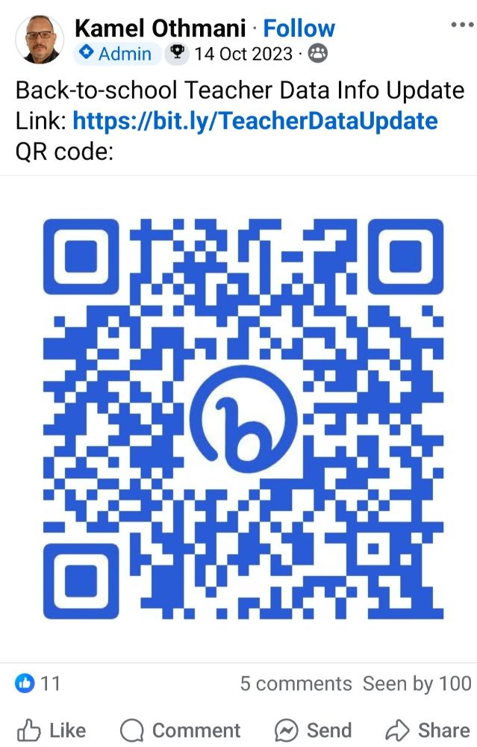
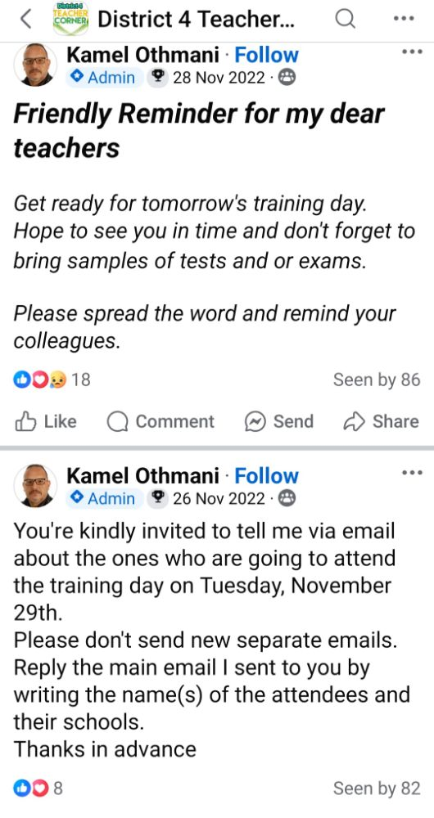
Image 1
Image 2

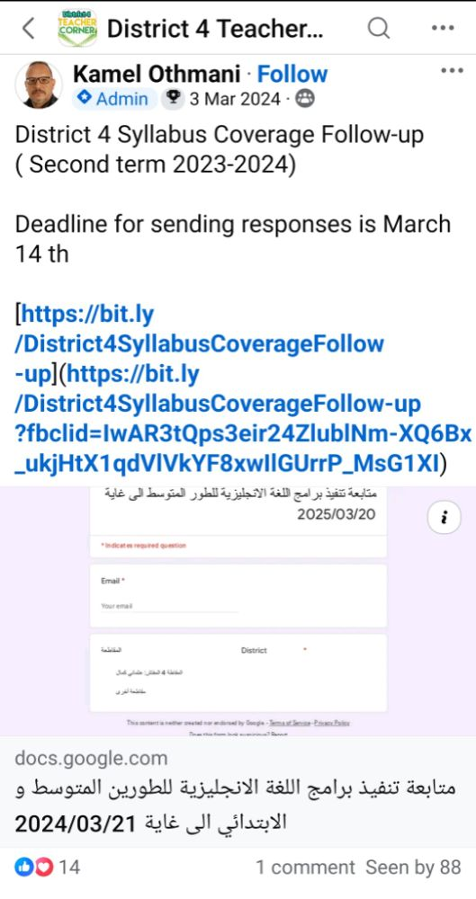
Image 3
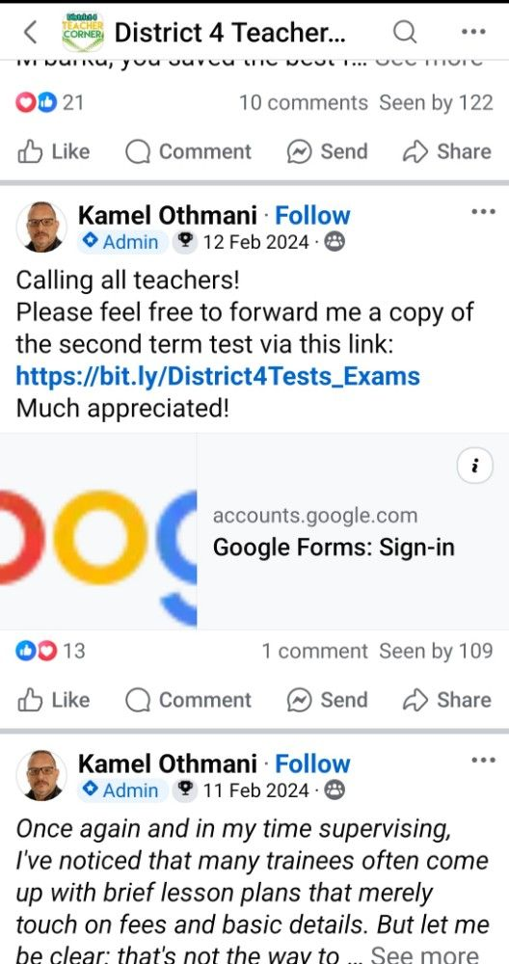
Image 4

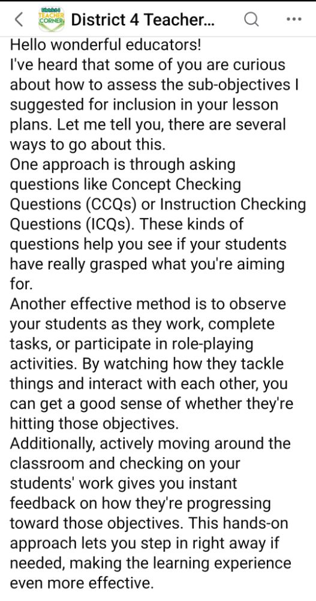
Image 5
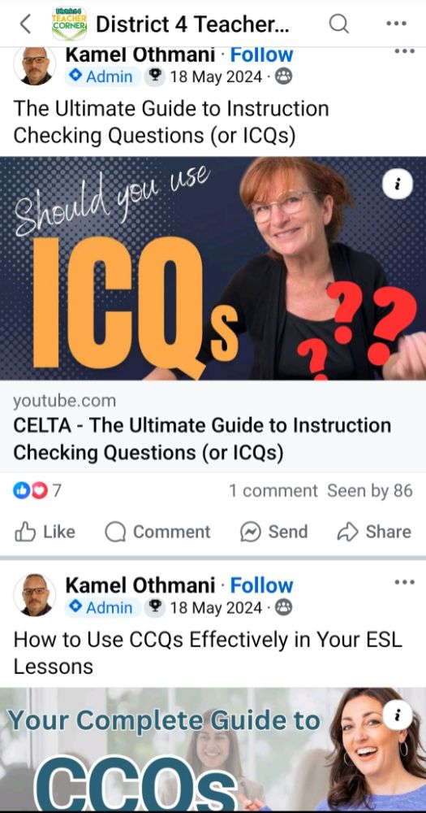
Image 6
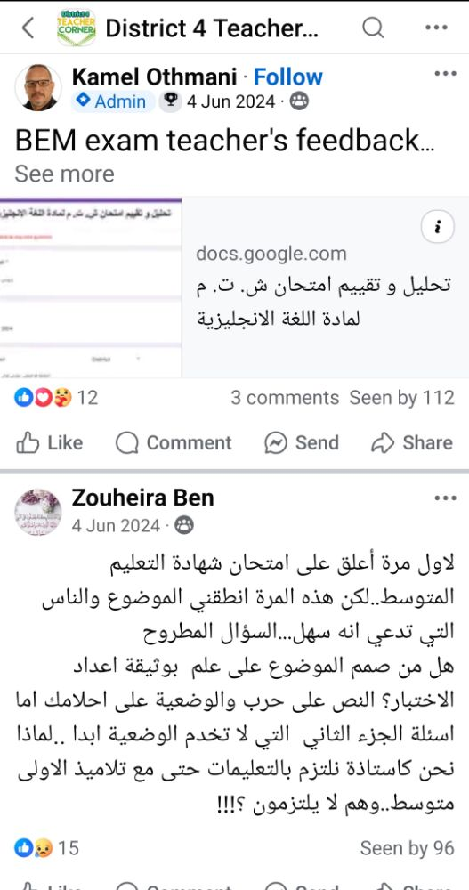
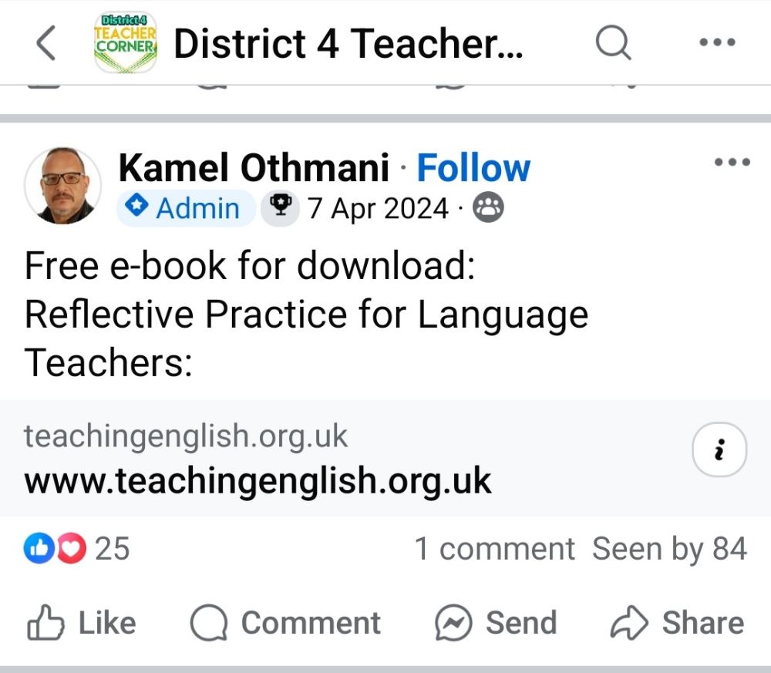

Image 7
Image 8

Appendix B
Interview with Middle School Teachers of English

Interview 1 Sample:
Interviewer: Have discussions in online teacher communities shaped your understanding of assessment concepts like validity, reliability and consistency with learning objectives?
Teacher 1: For me, discussions in such communities had a great impact on my understanding to these concepts because the more I engage with more content, I understand more the criteria of better assessment tools like: validity of my tests, how reliable are they, to what extent they align with the learning objectives... etc.
Interviewer: How do OTC help you evaluate the effectiveness of assessment tools?
Teacher 1: These communities indeed help a lot because the more engagement, the more feedback I receive about how reliable are my assessment tools. This is due to the availability of different experienced teachers in such communities through which we novice ones learn from.
Interviewer: How do they help you to grade projects and portfolios?
Teacher 1: These communities indeed help in grading projects and portfolios since sharing my students works and receiving more feedback in addition to mine helps my evaluation skills get more sharpened, focused and effective.
Interviewer: To what extent do you use OTC in your summative assessment practices?
Teacher 1: I sometimes use them. I share my tests or exams and wait for other teachers’ feedback. This helps me get more competent in designing more engaging and effective tools.
Interviewer: How do these communities influence your creativity and confidence in developing assessment tools?
Teacher 1: They are supper helpful indeed. Because the more I receive constructive feedback, it reshapes my skills and helps in addition to fosters my creativity in designing better tools in the future.
Interviewer: How has participation in OTC enhanced your digital literacy (use of technology) in relation to summative assessment practices?
Teacher 1: Participating in such communities helped me indeed in developing my ability to use technology because the more I use them, the more skills I get on how to use technical tools like
the computer, internet and tools of creating tests and exams. The engagement with using those communities creates kind of a connection between me and technology, and yet this led to the development of my technical competence more likely. Also, this connection led to developing my skills in designing creative tests and exams either or the level of technology use (use computer or word or designing tools and sites) or the competence level.

Appendix C
Interview with inspector of Middle School Teachers of English

Interviewer: Hello Mr. Othmani. We would like to thank you for devoting your time to respond to my questions today. We are currently conducting research on the role of online teacher communities in enhancing teacher’s language summative assessment literacy. Online teacher learning communities (OTLC), such as District 4 Teacher Corner, are virtual spaces in which teachers engage in to collaborate, share experiences and discuss issues. This interview aims to gather and explore participants’ perceptions to fully comprehend how teachers engage with and benefit from such communities. Your responses will be kept confidential and used only for research purposes. If you permit, we would like to initiate the interview now.
Inspector: Let me kick things off by saying a huge thank you to both of you: Sabrina and Warda for inviting me to chat about such an important topic—how online communities are transforming the way teachers design and rethink assessments like tests and exams. It’s truly an honor to contribute to your master’s dissertation research, especially as you dive into this game-changing aspect of modern education.
The chance to explore how educators are adapting their methods, swapping ideas in digital spaces, and pushing assessment strategies into the 21st century is not only fascinating but super relevant today. I’m excited to unpack these ideas with you and see how they might inspire smarter, more creative approaches to evaluating student learning. Let’s get into it!
General Opening Questions
Interviewer: From your perspective as an inspector, how would you define "summative assessment literacy" for teachers, and why is it critical in today’s educational landscape?
Inspector: Ok! …. Let’s start by breaking down what summative assessment literacy really means. At its core, it’s about equipping teachers with the knowledge, skills, competencies and confidence to design, use, and interpret final evaluations, like end-of-term tests or exams, in ways that actually boost student learning and growth. It’s not just about grading; it’s about understanding how to turn assessment results into meaningful feedback.
Knowing how to use summative assessments – like end-of-term exams – is super important for teachers. When teachers understand these big-picture evaluations deeply, they can grade students more fairly and give feedback that actually helps kids grow. By learning the nuts and bolts of these assessments, teachers turn grades into more than just scores – they become tools that help students improve; while making sure everyone gets a fair shake and the results truly reflect what students know.
Interviewer: Have you observed differences in how teachers approach structured versus unstructured summative assessments? If so, how do online communities influence these approaches?
Inspector: Eh, not exactly! … Most aren’t actively using those platforms. But I do think online communities have seriously changed how both formal and informal assessments work. Here’s how:
For structured assessments (like tests or exams), they let teachers swap exam questions, share past papers, and even debate how well those tests actually measure what they are supposed to, based on official formats. It pushes educators to rethink their methods and learn from each other’s wins and mistakes.
On the flip side, for unstructured assessments, things get way more creative. Think project-based grading, digital portfolios, or students sharing their work with real audiences beyond the classroom. Suddenly, assessment is not just a grade—it is about connecting learning to the real world.
So yeah…., online spaces might not be buzzing with constant interaction, but they’ve quietly reshaped how we measure learning.
Chapter 1: Knowledge
Focus: Concepts, Tools, Methods, Digital Literacy
Concepts
Interviewer: How do online teacher communities help teachers clarify core summative assessment concepts (e.g., validity, reliability, alignment with learning outcomes)? Are there common misunderstandings you have seen addressed through these platforms?
Inspector: Online teacher communities play a crucial role in helping teachers develop deeper understanding of core summative assessment concepts through several key mechanisms:
Teachers often share articles, research papers, and practical guides that break down complex assessment concepts like validity and reliability into accessible language.
Experienced teachers, teacher trainers and supervisors share concrete examples showing what valid assessments look like in practice and how to evaluate an assessment's reliability.
Teachers can score sample work together, discuss, and develop shared understanding of quality standards.
You will often notice that in online teacher groups, certain myths about assessment literacy just keep coming up—and these misunderstandings can really shape how educators approach their work in the classroom:
Online communities sometimes conflict ‘valid’ with ‘difficult’: Teachers often share experiences of revising “rigorous” assessments that were not actually aligned with learning outcomes.
They assume all tests are valid; an assessment might be valid for one purpose but not another.
They sometimes mistake ‘Consistency’ for ‘Fairness’; There is misconception that a reliable test is automatically fair.
Interviewer: In your inspections, have you noticed gaps in teachers’ conceptual understanding of summative assessments that online communities could help bridge?
Inspector: Yeah! …., most of the time. Noting that online groups or forums can be a game-changer for teachers. They can help educators get a better grip on the theory behind assessments, design tests that measure critical thinking (not just memorization), and set up grading that is fair and actually shows what students have learned. Basically, they are a space to swap ideas so everyone is on the same page about what truly counts as success in the classroom.
Tools and methods
Interviewer: What digital tools (e.g., rubric generators, data analytics platforms) promoted in online communities do you see teachers adopting for summative assessments? How do these tools align with institutional or national standards?
Inspector: From what I have observed, most teachers I oversee are mainly using Microsoft Excel for their work. While it gets the job done, I’ve noticed Google Sheets could handle these tasks just as well—if not better—especially for data analysis. It is more user-friendly and offers some real advantages, like smoother collaboration features, that Excel does not match as easily. Some of them create and share customized templates and spreadsheets collaboratively to perform data analysis tasks.
Interviewer: How do online communities help teachers navigate the challenges of using structured tools (e.g., standardized tests) versus unstructured tools (e.g., projects and portfolios)?
Inspector: Eh! … Online communities empower teachers to navigate the structured-unstructured assessment divide by:
Democratizing access to innovative tools and research.
Providing a space to troubleshoot challenges and advocate for balanced assessment systems.
Reinforcing both structured and unstructured tools, when used thoughtfully, can coexist to support equitable, meaningful evaluation of student learning.

Digital Literacy
Interviewer: How do online communities enhance teachers’ digital literacy for designing, administering, or analyzing summative assessments?
Inspector: Em! ….. Communities introduce educators to platforms along with tutorials on their use. So, they act as dynamic ecosystems where teachers rapidly acquire and refine digital literacy skills. By fostering collaboration, democratizing access to expertise, and promoting adaptive learning, these spaces empower teachers to leverage technology effectively—ensuring summative assessments are valid, equitable, and aligned with curriculum outcomes that fit 21st-century demands.
Chapter 2: Skills
Section 1: Designing Summative Assessment Tools
Interviewer: How do online communities support teachers in designing inclusive and equitable summative assessments, particularly for diverse learners?
Inspector: Ok! … Online communities empower teachers to design inclusive and equitable summative assessments by:
Providing access to inclusive design frameworks and tools.
Creating spaces for critical dialogue about bias, access, and representation.
Fostering innovation through collective problem-solving.
By engaging with these communities, teachers move beyond "one-size-fits-all" assessments, ensuring all learners—regardless of ability, or resources—can demonstrate their knowledge in ways that respect their competencies, identities and potential.
Interviewer: In your experience, do teachers using online communities demonstrate stronger alignment between assessment tools and curriculum goals compared to those who do not? Inspector: Well! … While studies have not looked closely at whether teachers in online professional groups design tests differently compared to others, new clues—including what I have seen while supervising teachers—hint that those active in digital communities tend to make clearer links between what they teach and how they test. Being part of these groups seems to help. Teachers swap ideas, share materials, and troubleshoot challenges together, which naturally strengthens this key part of their teaching plans.
Interviewer: How do these communities help teachers address potential biases in structured assessments (e.g., standardized tests) or improve creativity in unstructured ones (e.g., portfolios)?
Inspector: These communities function as both practical resource hubs and professional learning networks where teachers can simultaneously address the limitations of both structured and unstructured assessments. The collective wisdom helps bridge the gap between assessment theory and classroom reality, enabling teachers to implement more equitable structured assessments and more rigorous creative assessments than they might develop in isolation.
By leveraging the collective wisdom and diverse experiences of teachers worldwide, these communities transform assessment practices into tools for equity, engagement, and authentic learning.
Section 2: Feedback and Reflective Practice
Interviewer: How do online communities shape teachers’ ability to provide meaningful feedback based on summative assessment results? Are there trends in reflective practice you’ve observed?
Inspector: Online communities empower teachers to transform summative assessment results into catalysts for growth by:
Handing access to innovative feedback tools and research.
Providing emotional support to navigate high-stakes environments.
Promoting equity through bias-aware, student-centred practices.
By tapping into these communities, teachers can step away from vague grades like '15/20' or 'B+' and instead give personalized, practical feedback. This helps students see where they shine, work on weaker spots, and take charge of their own growth—turning learning into something they actively shape, not just scores they receive.
Interviewer: Have you seen examples where peer feedback from online communities improved teachers’ analysis of assessment data (e.g., identifying learning gaps or trends)?
Inspector: Sure, for many times. Lots of teachers in my district are teaming up these days, bouncing ideas off online groups they are part of while creating quizzes and tests. It is helping them get a clearer grip on grading standards and how to break down student results. We are seeing cool shifts in how teachers tweak their feedback methods, too—like using those online spaces as springboards for fresh ideas. Take the “portfolio method,” for example: educators keep a running log of their comments over time, pairing real student work with notes about what worked, what did not, and how they have adjusted their approach. It is basically like a playbook for getting better at guiding students.
Interviewer: How do these platforms encourage teachers to reflect on the ethical implications of their summative assessment practices (e.g., fairness, transparency)?
Inspector: These platforms give teachers a space to step back and think deeply—not just about how they grade students, but about the bigger questions of fairness and ethics behind those grades. They help teachers spot biases, ask tough questions, and rethink their methods in ways that put equity front and center. This is not just about adjusting a few guidelines—it is about earning real trust, having honest talks, and pushing teachers to move past old methods and create ones that truly serve every student.
Challenges and Recommendations
Interviewer: What risks or challenges do online teacher communities pose to summative assessment literacy (e.g., misinformation, over-reliance on trends)?
Inspector: Online teacher communities can be a goldmine for educators looking to figure out how to assess learners effectively—but they are not without their pitfalls. While these forums buzz with fresh ideas and shared experiences, they are often swamped with questionable advice, create situations where teachers might accidentally share too much about their struggles, and can even lead to accidentally breaking school rules. Here is the thing: Relying too much on the "hive mind" of these groups risks watering down the quality of your teaching. The real magic happens when teachers blend the creative sparks from online chats with classroom-tested methods they already know work. This means staying curious about new ideas but always double-checking them against common sense, research, and what is right for students. By thinking critically (“Does this actually help kids learn?”), staying true to their professional values, and keeping school policies in mind, educators can build assessment plans that do more than just look good on paper—they stand up to tough questions from parents or colleagues and, most importantly, earn students’ trust. It is like cooking: You take inspiration from others’ recipes, but you tweak them to suit your own kitchen and taste-test every step of the way.
Appendix D

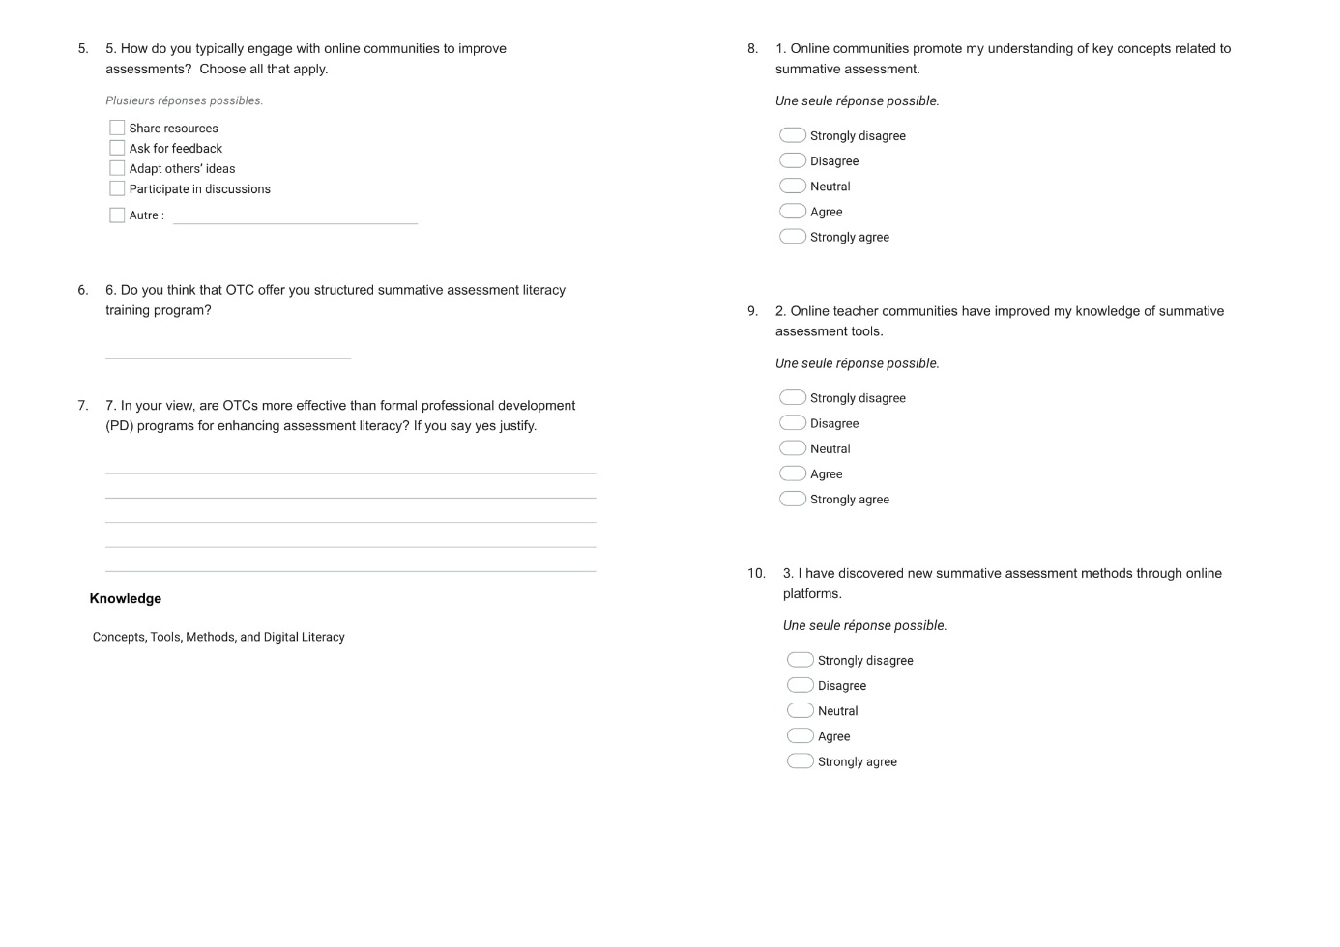
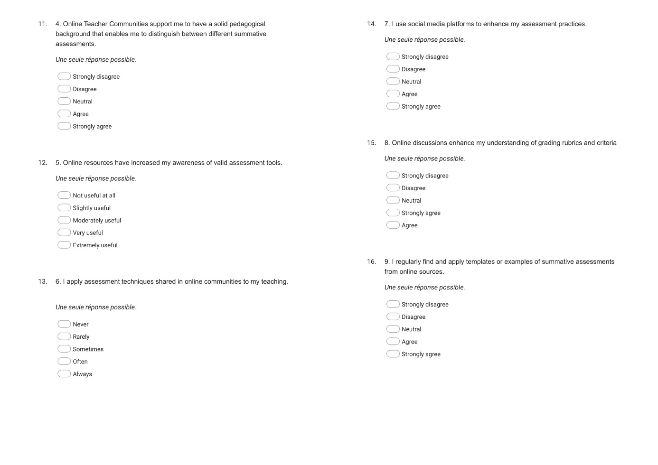
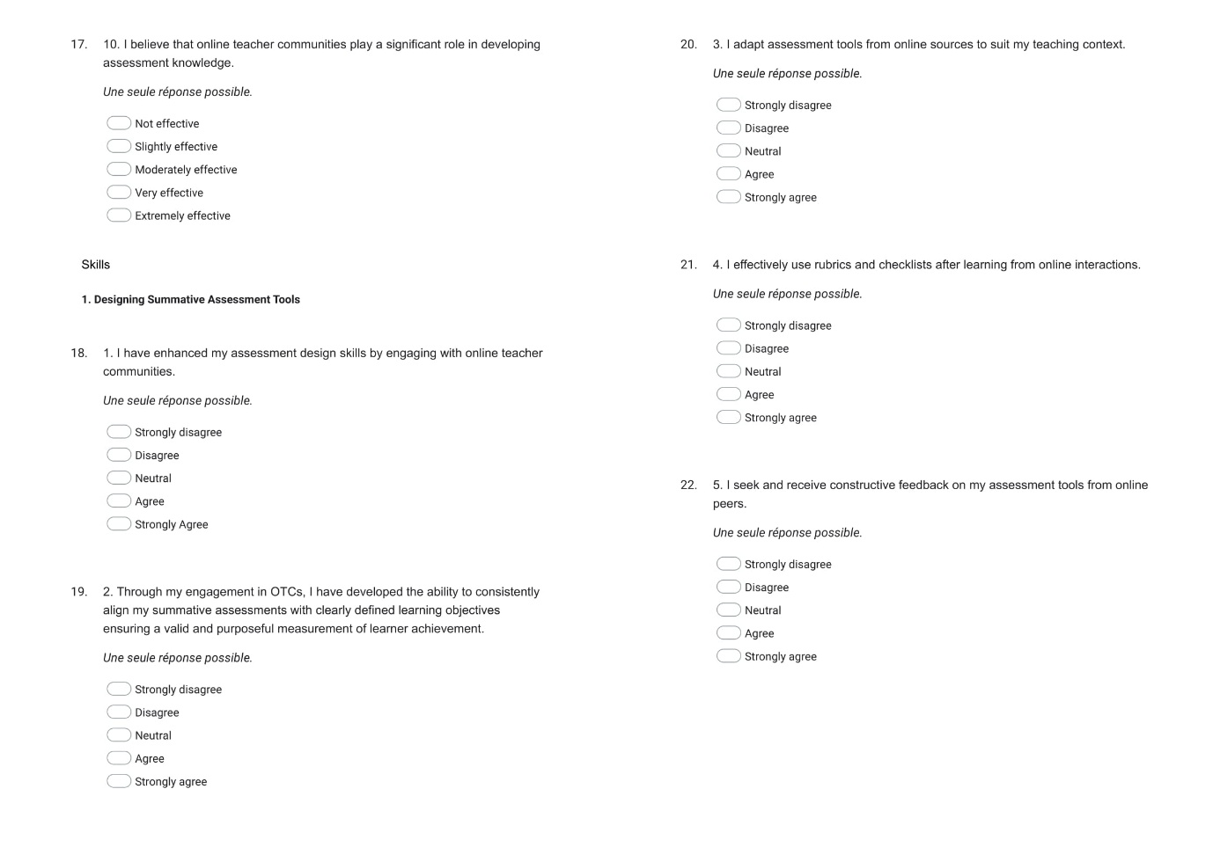

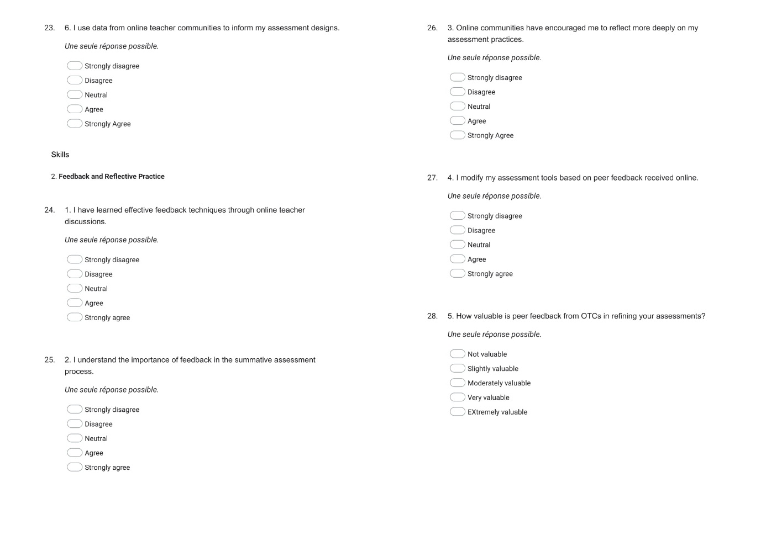
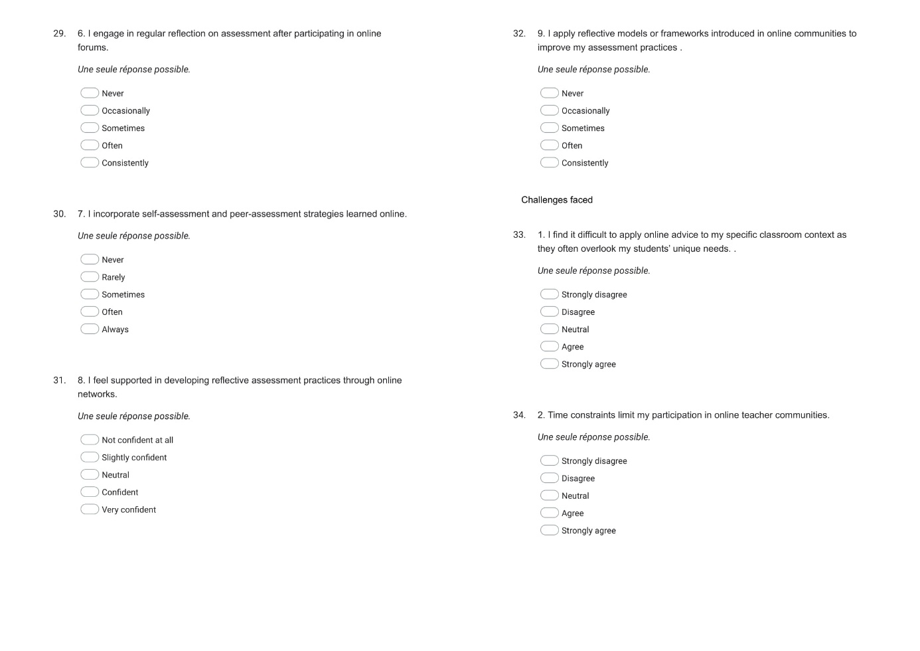
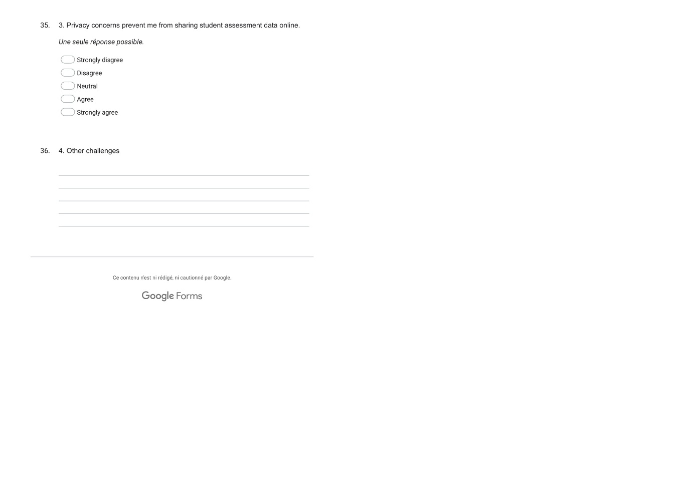

الملخص

برزت المجتمعات التعليمية عبر الأنترنت كفضاء رقمي فعَّال لتعزيز التَّطور المهني وممارسات التّقييم لدى أساتذة اللغة الإنجليزية كلغة اجنبية، خاصة في عصر يتسم بنزعة نحو استخدام وسائل التكنولوجيا التي اعادت تعريف المعايير التربوية. تهدف هذه الدراسة بشكل خاص إلى استكشاف دور هذه المجتمعات في تعزيز الإلمام بالتقييم التجميعي لدى أساتذة اللغة الإنجليزية كلغة اجنبية في الطور المتوسط بالجزائر. كما تبحث في العملية التي يحوَّل فيها هؤلاء الأساتذة التفاعلات عبر الأنترنت إلى ممارسات تقييمية يغلب عليها التفكير والتأمل. تم استخدام المنهج الوصفي للإجابة على أسئلة البحث. جُمعت البيانات من خلال النهج الثلاثي أي استخدام عدة ادوات. شمل ذلك ملاحظة مجموعة الفيسبوك التالية“District 4 Teacher Corner”، ومقابلات شبه منظمة مع ستة من مدرسي اللغة الإنجليزية ومفتشهم، واستبيان وُزّع على أكثر من 50 عضواً. وقد تم اختيار جميع المشاركين بشكل عشوائي لإجراء هذه الدراسة. تكشف النتائج عن مدى التأثير الفعال لهذه المجتمعات التعليمية على الأساتذة ونموّهم المهني، خاصة في مجالات مثل أساليب التقييم. أشارت الدراسة إلى أن المجتمعات التعليمية عبر الإنترنت تعزز معرفة المدرسين بالتقييم، وتدعم التعاون التأملي، وتحسن مهارات التقييم العملية، وتزيد من المعرفة الرقمية. ومع ذلك، ثبَّطت تحديات مثل الحواجز التكنولوجية والمشاركة غير المنتظمة من الإمكانات الكاملة لهذه المجتمعات. توصي هذه الدراسة بدمج المجتمعات التعليمية عبر الإنترنت لتعزيز ممارسات التقييم لدى المدرسين من خلال التعاون بين زملاء العمل، والقائمين على التكوين، والبحث الإجرائي. بالإضافة إلى ذلك، ينبغي على الساهرين على الشأن التربوي إضفاء الطابع الرسمي على هذه المجتمعات التعليمية من خلال اشراف المفتشين عليها واخذ ملاحظات المدرسين بعين الاعتبار في تصميم المناهج الدراسية.
الكلمات المفتاحية
المجتمعات التعليمية عبر الأنترنت، معرفة التقييم التجميعي، التطور المهني للأستاذ، ممارسة التأمل

