order number: . . . . .
Thesis submitted to the

UNIVERSITY OF MOHAMED BOUDIAF – MSILA

FACULTY OF MATHMATICS AND COMPUTER SCIENCE
DEPARTEMENT OF COMPUTER SCIENCE

In partial fulfillment of the requirements for the degree of
Master in Computer science

By
Abdelhafid Souad

Title of the thesis

In-Flight Energy-Driven Composition of Drone

Under the supervision of
Sayad Lamri

Composition of the jury

Barkat Abdelbasset | University of Msila | President
Benazi Makhlouf | University of Msila | Examiner

September, 2023

رقم: ................



Abstract:
This project explores the innovative concept of In-Flight Energy-Driven Composition of Drones to improve the capabilities and sustainability of unmanned aerial vehicles (UAVs). By harnessing renewable energy sources such as solar cells and using genetic algorithms in Python, the goal is to optimize the in-flight composition of drones, resulting in longer operational life, lower carbon emissions, and increased payload capacity.
Key words: UAVs (Unmanned Aerial Vehicles); Genetic Algorithms; Optimization.

الملخص:
يستكشف هذا المشروع المفهوم المبتكر لتكوين الطائرات بدون طيار التي تعتمد على الطاقة أثناء الطيران لتحسين قدرات واستدامة المركبات الجوية بدون طيار (UAVs). ومن خلال تسخير مصادر الطاقة المتجددة مثل الخلايا الشمسية واستخدام الخوارزميات الجينية في لغة بايثون، فإن الهدف هو تحسين تكوين الطائرات بدون طيار أثناء الطيران، مما يؤدي إلى عمر تشغيلي أطول، وانخفاض انبعاثات الكربون، وزيادة سعة الحمولة. الكلمات المفتاحية: الطائرات بدون طيار (المركبات الجوية بدون طيار)؛ الخوارزميات الجينية؛ التحسين.

Résumé :
Ce projet explore le concept innovant de "In-Flight Energy-Driven Composition of Drones" (composition des drones en vol en fonction de l'énergie) afin d'améliorer les capacités et la durabilité des véhicules aériens sans pilote (UAV). En utilisant des sources d'énergie renouvelables telles que les panneaux solaires et en recourant à des algorithmes génétiques en Python, l'objectif est d'optimiser la composition des drones en vol, ce qui se traduit par une plus grande autonomie, une réduction des émissions de carbone et une augmentation de la capacité de charge utile.
Mots clés : UAVs (véhicules aériens sans pilote) ; Algorithmes Génétiques ; Optimisation.

Dedications
"I am deeply grateful to my parents, family, and friends Especially Samah, whose unwavering support, encouragement, and love have played an instrumental role in my journey of completing this thesis. Their constant belief in me, even during the most challenging times, has been a constant source of inspiration and motivation. I owe them everything for their guidance, sacrifice, and faith in my abilities. This achievement would not have been possible without their love and unwavering support. With heartfelt appreciation and immense love, I dedicate this work to them, acknowledging their immeasurable impact on my life."

Acknowledgments
I am extremely grateful to Doctor Allaoua Hemmak and Sayad Lamri, my supervisor, for their exceptional guidance, unwavering support, and constant encouragement throughout the entire duration of this research and the writing process of this thesis. Their expertise, valuable insights, and constructive feedback have been instrumental in shaping the quality and direction of my work. Their dedication to my success and their commitment to excellence have truly inspired me to push my boundaries and strive for academic excellence.

Additionally, I would like to express my appreciation to the members of the jury, Barkat Abdelbasset and Benazi Makhlouf, for their time and effort in carefully reviewing and evaluating my thesis. Their valuable feedback and insightful comments have greatly contributed to the improvement and refinement of my research.

I would also like to extend my sincere thanks to the University of "Mohamed Boudiaf – Msila" for providing me with the necessary resources, facilities, and academic environment conducive to conducting this research. Their support has played a vital role in the successful completion of my thesis.
I would like to acknowledge and express my deep appreciation to everyone mentioned above for their contributions and support, which have been indispensable in the successful completion of this thesis.

Contents
Introduction 1
Drones 3
1. Introduction 3
2. Historique 4
3. Drone definition 4
4. Definition of Drone Squadrons 5
5. Uses of Drones 5
6. Shipping Methods 7
7. Classification of UAV 7
8. Positives of Drones 8
9. Negatives of Drones 8
Optimization 11
1. Introduction 11
2. Optimization definition 11
3. Types of Optimization Problems 11
4. Optimizations classification 11
4.1. Optimization problem formulation 13
4.2. The Genetic algorithm 14
4.3. Initial Population 15
4.4. The Selection Stage 15
4.5. Crossover Stage 16
4.6. Mutation Stage 16
5. The Vehicle Routing Problem (VRP) 17
5.1. Genetic Algorithms in the VRP 17
6. Advantages and limits of heuristic algorithms 18
Association work 20
1. Drone-as-a-Service (DaaS) for COVID-19 self-testing kits delivery in smart healthcare setups: A technological perspective 20
2. Using drones for parcels delivery process 22
3. Package Delivery Using Autonomous Drones in Skyways 22
4. wo echelon vehicle routing problem with drones in last mile delivery 23
5. Robust Composition of Drone Delivery Services under Uncertainty 23
6. Constraint-based Formation of Drone Swarms 24
Programming aspect 26
2. Define the problem 28
3. Create a mathematical model 28
4. Algorithm 29
5. Implementation 30
5.1. The Input 33
5.1. The otput 33
Conclusion 34
Bibliography 35



Introduction

Introduction
In recent years, drone technology has undergone rapid advancements, offering promising prospects for revolutionizing various industries. Drones present a multitude of benefits, including rapid, convenient, and cost-effective services across sectors such as agriculture, surveillance, healthcare, shipping, and shopping. Particularly during the COVID-19 pandemic, drones have emerged as vital tools for monitoring social distancing, aerial spraying, and goods delivery. Major corporations like Google and Amazon have begun testing drones for goods delivery, with parcel delivery standing out as a particularly promising application that could significantly reduce both transportation costs and time.
However, one significant challenge hindering the widespread adoption of drones for delivery services is their limited flight time due to battery capacity constraints. To address this challenge, this research proposes a novel framework for drone delivery services with in-flight energy recharging capabilities. The primary objective is to enhance delivery times by minimizing the need for stopovers and reducing recharging times at intermediate stations. To achieve this goal, we will utilize simulation techniques to model and optimize the proposed system, including the development and implementation of efficient algorithms.
How can the implementation of a framework for drone delivery services with in-flight energy recharging capabilities improve delivery times and overcome the challenge of limited flight time?

Chapter1: Drones

Drones
- Introduction
The in-flight power supply of drones refers to the use of renewable energy sources such as solar cells or fuel cells for the flight of unmanned aerial vehicles (UAVs). This technology is becoming increasingly popular as it can help reduce carbon emissions and increase flight time. It can also improve the capabilities of UAVs by enabling them to carry heavier payloads or fly longer distances. The development of in-flight powered composition is a significant advancement in drone technology and offers numerous potential applications in industries such as agriculture, surveillance and transportation.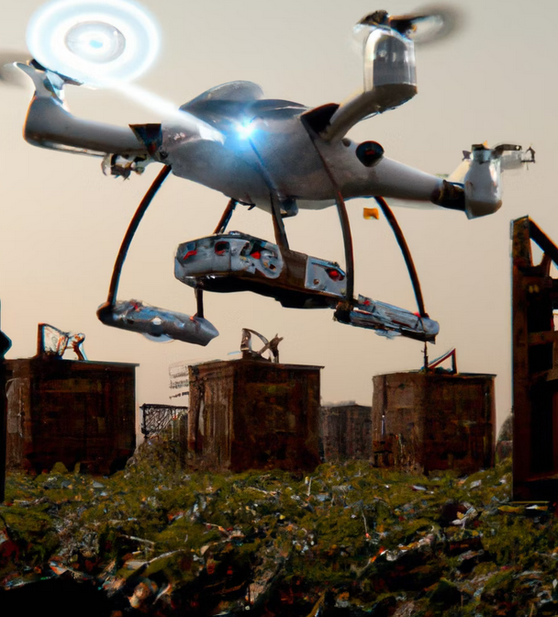
Fig. 1: Skyward Drone.

- Historique
Drones, also known as unmanned aerial vehicles (UAVs), have a long and varied history dating back several decades.
The first drone, known as the "Queen Bee", was developed in the United States in the 1930s. It was essentially a modified, radio-controlled aircraft that could be used for aerial target practice. The Queen Bee was used extensively by the British military during the Second World War.
In the years that followed, drones were mainly used for military purposes such as reconnaissance, surveillance and target practice. Over time, they became more advanced and were able to carry weapons and perform more complex tasks.
In the 1980s, drones also began to be used for civilian purposes, such as scientific research and environmental monitoring. This led to the development of smaller, lighter drones that could be used for a variety of applications.
In the early 2000s, drones became accessible to the general public. Amateur photographers
- Drone definition
Drones, also known as unmanned aerial vehicles (UAVs), are aircraft that operate without a pilot on board. Drones can be controlled remotely or fly autonomously using software-controlled, pre-programmed flight plans.

UAVs are controlled by a ground-based or airborne controller or are pre-programmed. UAVs that only have a control option are referred to as Remotely Piloted Vehicles (RPVs). UAVs come in a variety of designs, from model airplanes to rockets to spherical vehicles with helicopter blades. Sizes vary from a vehicle small enough to fit in a backpack to one with a wingspan larger than a Boeing 747.
Drones offer numerous benefits, including fast, convenient and cost-effective services in a variety of sectors. Key areas include agriculture, surveillance, healthcare, shipping and shopping. During the COVID-19 pandemic, drones have been used extensively for social distancing monitoring, aerial spraying and goods delivery. Large companies such as Google and Amazon are testing drones for parcel delivery. [1]

- Definition of Drone Squadrons
A drone squadron or drone swarm is a group of drones that operate together and are usually controlled by a single operator or a team of operators. Drone squadrons are often used in military operations for surveillance, reconnaissance and targeted attacks. [2]
- Uses of Drones
Drones have a wide range of applications in various industries. Here are a few examples:
- Military applications: Drones are used extensively in the military sector for surveillance, reconnaissance and targeted attacks.
- Commercial applications: Drones are used for aerial photography, surveying, inspecting infrastructure such as power lines and bridges, and delivering packages.
- Recreational applications: Drones are used for photography and video recording as well as for races and other competitions.
- Agricultural applications: Drones can be used for crop monitoring, irrigation management and pesticide spraying.
- Photography and videography: One of the most popular applications for drones is photography and videography. Drones can capture stunning aerial images and videos that would not be possible with a conventional camera. They are therefore ideal for everything from real estate photography to videography of weddings.
- Mapping and surveying: Drones can be used to create detailed maps and surveys of an area. To do this, the drone is flown over the area and photos or videos are taken. The data collected can then be used to create a map or survey.[3]
- Search and rescue: Drones can be used to search for missing persons or objects. They can also be used to assess damage after a natural disaster. Drones can be equipped with thermal imaging cameras that can help locate people or objects in low light conditions.[3]
- Delivery: Drones are used to deliver parcels and food. This is a relatively new area of application for drones, but one that is rapidly gaining popularity. Drones can deliver parcels to remote areas or to areas that are difficult to reach by car. [2]
- Security: Drones can be used for security purposes, e.g., to monitor properties or crowds. They can also be equipped with cameras and other sensors to prevent crime.
- Agriculture: Drones can be used for a variety of agricultural purposes, such as crop monitoring, irrigation and pesticide spraying. Drones can help farmers increase crop yields and reduce costs.
- Construction: Drones can be used for various purposes in construction, such as surveying, mapping and inspecting buildings. Drones can help improve safety and efficiency on construction sites.
- Mining: Drones can be used for various purposes in the mining industry, e.g., for surveying, mapping and inspecting mines. Drones can help improve safety and efficiency in mining.
- Military: Drones are widely used by the military for various purposes, such as surveillance, reconnaissance and attack. Drones can provide valuable information and contribute to the safety of troops.
Drones have attracted a lot of attention from leading online retailers such as Walmart, DHL, Google and Amazon. Due to the ever-growing popularity of online shopping, which can have a significant impact on customers' purchases, users are increasingly demanding fast delivery services. As a result, online retailers are looking for ways to improve delivery times. Retailers, in turn, are facing a major challenge to provide environmentally friendly, cost-effective and efficient last-mile deliveries. Several leading companies, including Sky catch, Yuneec, DJI and Amazon, are focusing on drones in terms of load transportation efficiency, parcel delivery and surveillance, etc. "Amazon Prime Air" was initiated by Amazon to deliver packages of five pounds within thirty minutes at a distance of 10 miles.[1]
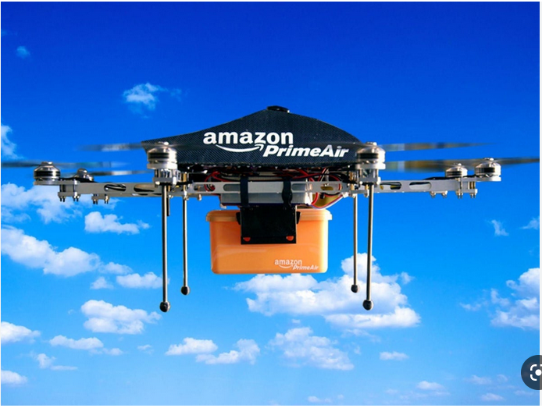
Fig. 2: The Amazon Drone Fleet: Pioneering Autonomous Delivery Technology.

- Shipping Methods
Drones have the potential to revolutionize the shipping industry by providing fast and efficient delivery services. There are two main types of shipping methods for drones:
- Ground-based delivery: in this method, drones take off and land on a ground-based delivery vehicle, which then transports the parcel to its final destination.
- Direct delivery: With this method, the drones fly directly to the delivery location and drop off the parcel. Federal aviation regulations stipulate that the payload per drone must not exceed 2.5 kg...
- Classification of UAV
- fixed-wing UAVs: Information on fixed-wing UAVs and their applications can be found in the relevant aviation and drone technology literature.
- rotary-wing UAVs: These UAVs use rotating wings to provide lift and maneuverability. These include quadcopters, hex copters and octocopters. They are typically used for aerial photography, search and rescue missions and inspections.
- hybrid UAVs: These UAVs combine the characteristics of fixed-wing and rotary-wing UAVs to achieve higher performance in terms of endurance, speed and range.
- single-rotor helicopter UAVs: These UAVs have a single rotor blade that provides lift and allows them to fly in different directions. They are commonly used for military operations, surveillance and aerial photography.
- multi-rotor helicopter UAVs: These UAVs have multiple rotors that provide lift and allow them to hover in place or fly in different directions. They are commonly used for aerial photography, surveying, search and rescue missions.
- nano/micro-UAVs: These are small drones that can easily be carried in a backpack or bag. They are usually used for indoor surveillance or as toys.
- tethered UAVs: These drones are attached to a tether that provides power and communication links between the drone and the ground station. They are usually used for security purposes at events or in crowded places.
- solar-powered UAVs: These drones use solar cells to generate electricity to power their flight systems. They can fly continuously for days or even weeks without needing to be refueled or recharged.
- autonomous/semi-autonomous drones: These drones can operate without human intervention using pre-programmed instructions or artificial intelligence algorithms to perform specific tasks such as mapping, inspection or delivery.
- amphibious UAVs: These drones can operate both in the air and on the water. They are often used for marine research, environmental monitoring and search and rescue operations.
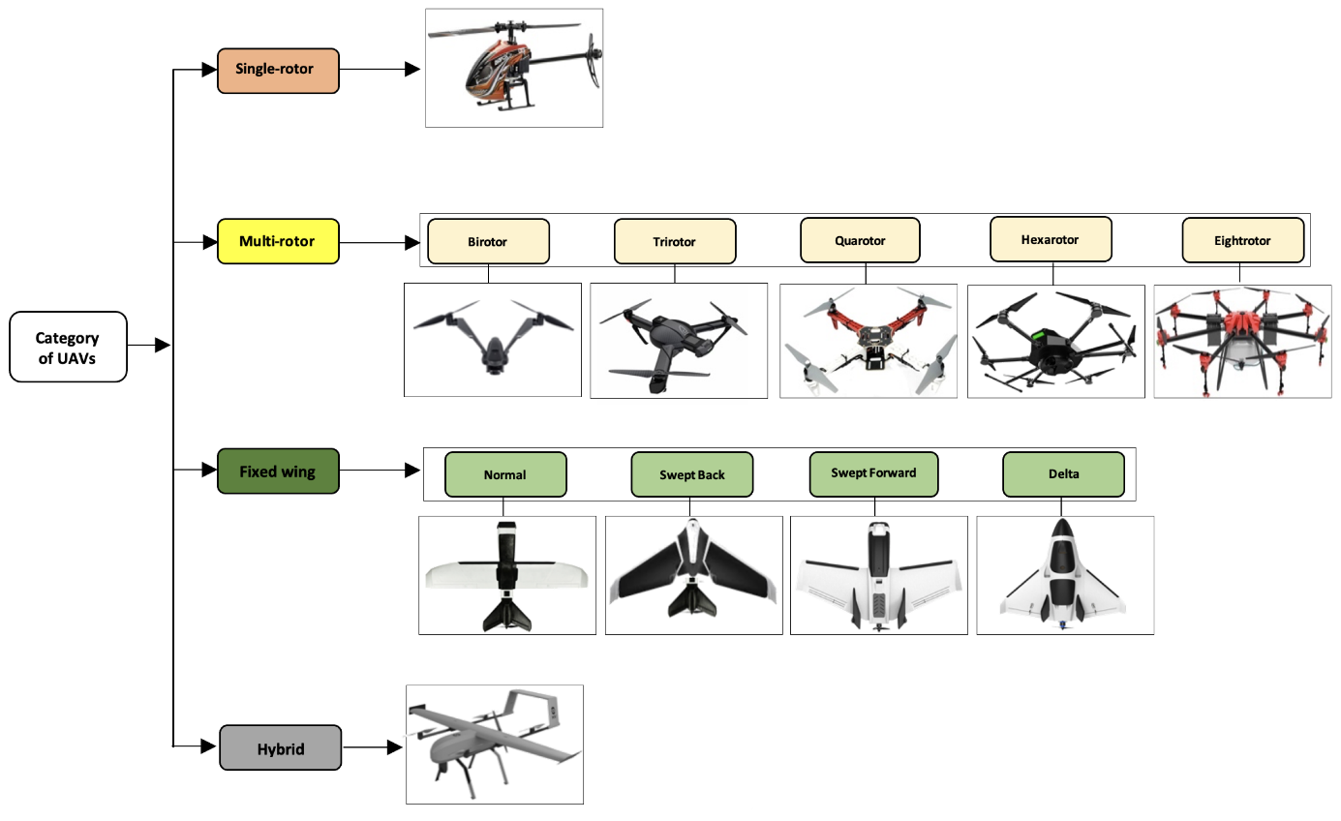
Fig. 3: Different categories of UAVs.

- Positives of Drones
- Efficient: Drones can provide fast and efficient delivery services, especially for small parcels that need to be delivered urgently.
- Cost-effective: Drones can significantly reduce the costs associated with shipping and delivery, especially in remote or hard-to-reach locations.
- Safety: Drones can be used in hazardous environments, reducing risks to operators.
- Versatility: Drones can be used in a wide range of applications in different industries.
- Negatives of Drones
- Regulatory challenges: The use of drones is subject to strict regulations in many countries, which can make legal operation difficult.
- Limited range: Drones have a limited flight range and cannot be operated for long periods without recharging.
- Safety concerns: The use of drones raises data protection and safety concerns, particularly in relation to air traffic control and possible collisions with other aircraft.
- Technical challenges: Drone technology is advancing rapidly, but there are still technical challenges to overcome in the areas of navigation, communication and autonomy.
- The limited battery: capacity of drones is a major challenge in swarm-based drone delivery services: limited battery endurance, limited mobility, limited autonomy and limited flight time. The limited flight time is due to several factors, including sensor accuracy, difficult atmospheric conditions, the size of the fixed-wing aircraft and battery endurance.

Chapter2: Optimization

Optimization
- Introduction
Optimization is about making things work really well. It helps us to find the best solution to a problem, taking into account the limitations and rules. It can be used in different areas, such as improving things in engineering, making more money in business and solving tricky math problems. Optimization involves steps such as figuring out the problem, creating a plan, solving the problem and looking at the results. It uses math and computers to help us make the best decisions.
- Optimization definition
Optimization is a powerful technique used in various fields to find the best possible solution to a given problem. Optimization is about finding the best possible solution to a problem given a set of requirements or constraints. All possible solutions are examined and the one that best fulfills the given criteria is selected. Optimization is used in a variety of fields, including mathematics, computer science, engineering and economics. [5].
- Types of Optimization Problems
Optimization is a method of finding the best solution to a problem. It is used in many different areas such as engineering and finance.
There are three types of optimization problems: linear programming, nonlinear programming and integer programming.
Each type has its own characteristics and possible solutions. In linear programming, the objective function and the constraints are linear. Non-linear programming involves curves. Integer programming means that the decision variables must be integers. Different methods are used to solve the individual problem types. Overall, optimization helps us to find the best solution to a problem.
  - Example
- Linear programming: A company wants to determine the optimal production quantities for its three products (A, B and C) in order to maximize profit. The company has limited resources, such as labor and raw materials. The goal is to find the production quantities that maximize profit while meeting the resource constraints.
- Nonlinear programming: An engineering team wants to optimize the design of a mechanical component. There are various design parameters, such as dimensions and material properties, that directly affect the performance of the component. The goal is to find the optimal values for these parameters that maximize the strength of the component while minimizing its weight.
- Integer programming: A delivery company has multiple delivery routes and needs to determine the optimal route assignment for its drivers. Each route has different distances, delivery time slots and customer preferences. The goal is to assign drivers to routes in a way that minimizes total travel time while meeting all time and customer constraints. The decision variables in this case would be binary (1 if the driver is assigned to the route, 0 otherwise).

- Optimizations classification
Optimization is a method for finding the best solution to a problem. There are two types of methods: exact and heuristic.
Exact methods are guaranteed to find the best solution, but they can take a long time. One way to do this is called branch and bound. This involves breaking the problem down into smaller parts and using rules to find the best answer. Another method is linear programming, where mathematical equations are used to find the best solution.
Heuristic methods are not guaranteed to find the best solution, but they are faster and good enough for many problems. One possibility is genetic algorithms, which are similar to natural selection. They start with different solutions and change them to find the best solution. Another method is simulated annealing, which is comparable to the slow cooling of metal. Here, a solution is assumed and various options are tried out to find the best one. Finally, there are different methods for optimization, such as exact and heuristic methods. Exact methods are guaranteed but slow, while heuristic methods are fast but not guaranteed. There are different methods such as branch and bound and genetic algorithms. The method depends on the problem and how difficult it is.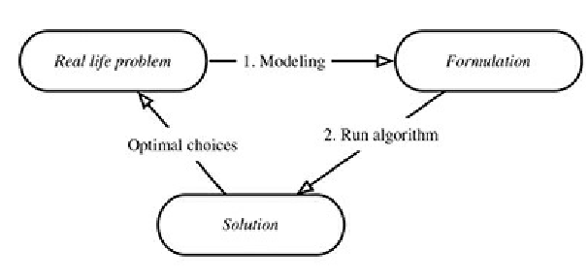
Fig. 2: Modeling and solving optimization problems.

  - Optimization problem formulation
Mathematical formulation means that we use mathematical symbols to solve problems. We learn about variables, which are symbols for unknown things, and functions, which show how one thing depends on another. We also learn how to turn words into mathematical equations or formulas. This helps us to solve problems and understand math better.
Heuristic algorithms are a way of solving problems quickly and efficiently. They don't always find the best answer, but they find a good answer in a reasonable amount of time. They use rules of thumb or guesses to help find a solution. These algorithms are used in computer science, artificial intelligence and other fields. They are helpful when a problem is too large or difficult to solve precisely. Examples of heuristic algorithms are the A* algorithm, simulated annealing and genetic algorithms.
An example of a heuristic algorithm is the genetic algorithm, which is based on the process of natural selection and evolution. It starts with a population of potential solutions and iteratively applies selection, crossover and mutation operations to generate new generations of solutions. By using a fitness function to evaluate the quality of each solution, the algorithm is able to evolve towards better solutions over time.

  - The Genetic algorithm
A genetic algorithm is a search heuristic inspired by Charles Darwin's theory of natural evolution. This algorithm mirrors the process of natural selection, where the fittest individuals are chosen to reproduce in order to produce offspring for the next generation [6].
Four phases are considered in a genetic algorithm:
- Initialization: the initialization of the necessary elements to start the algorithm.
- Selection: In this process, the chromosomes in the population are selected for reproduction by evaluating them with the fitness function. The more fit the chromosome is, the more often it is selected.
- Crossover: Two individuals are selected, then a random point is selected and the parents are cut, then their tails are crossed.
- Mutation: A gene, usually a bit, is randomly added to a chromosome. The probability of this happening is very low, as the population can fall into chaotic disorder.
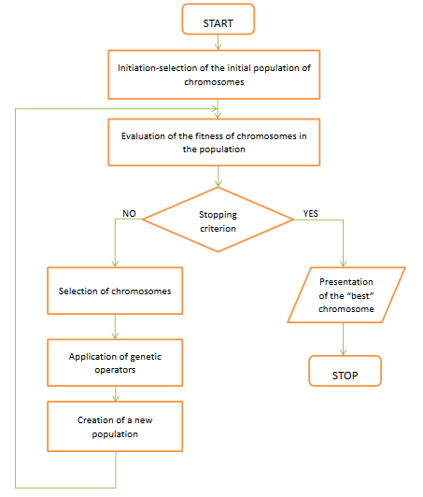
Fig. 3: Solving procedures of GA [7].

  - Initial Population
The process starts with a group of individuals called a population. Each individual is a solution to the problem you want to solve. An individual is characterized by a set of parameters (variables) called genes. The genes are linked together in a chain to form a chromosome (solution). In a genetic algorithm, the set of genes of an individual is represented by a string in the form of an alphabet. Usually binary values are used (string of 1s and 0s). We say that we encode the genes in a chromosome [6].
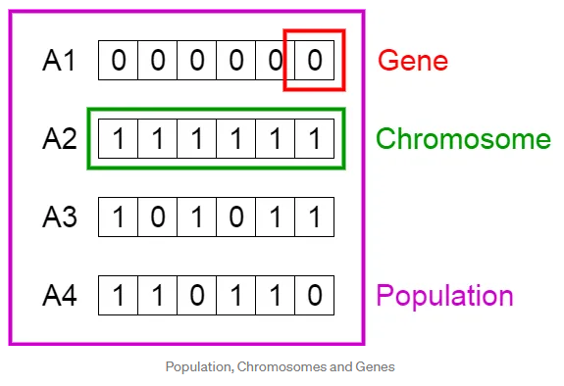
Fig. 4: Population, Chromosome and Genes [6].
  - The Selection Stage
The selection phase is a crucial mechanism in evolutionary algorithms where "parents" are selected to produce offspring for the next generation. The selection process aims to select the best individuals as parents, as the absence of a single, particularly suitable individual can lead the search process astray. To evaluate the performance of the individuals, a fitness function is used to explicitly measure the performance of each chromosome. The selection phase plays a crucial role in maximizing the performance of individuals in the population. The most popular selection method is the roulette wheel. It resembles a roulette wheel with 37 colored and numbered compartments into which a small marble is thrown to randomly select a number. Each chromosome has a sector in the roulette wheel, the size of which is proportional to the fitness value of the respective chromosome. The chromosome that has a higher score therefore occupies a larger area of the sector in the wheel. If we consider the entire roulette wheel as an interval of numbers [0, 100), we draw a random number from this interval to select a chromosome [4].
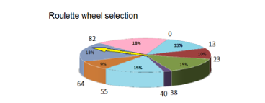
Fig. 5: Roulette wheel selection [8].
  - Crossover Stage
- The crossover operation is used to increase population diversity.
- In crossover operations, the selected individuals are recombined by combining the segments of the chromosomes that correspond to the parents.
- The crossover probability (CP) is compared with a random number between (0,1) to check whether a crossover will occur or not. If a crossover occurs, the positions at which the parents are to be cut at a random point are swapped. [4]

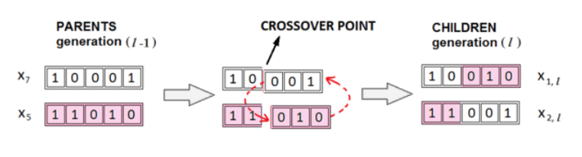
Fig. 5: Crossover between two chromosomes [8].
  - Mutation Stage
- In classical genetics, a mutation can be recognized by an altered phenotype, and in molecular genetics, a mutation refers to any change in a DNA segment.
- The mutation causes "slight" random changes in some or all of the offspring of the next generation.
- -The effect of this operator is to change a single position (gene) within a chromosome. Without the mutation, no further individuals could be produced by other mechanisms, which are then introduced into the population. One of the simplest executions of mutation is when the mutation probability (MP) is compared with a random number between (0,1). If it is going to be a mutation, a randomly chosen bit of the string is inverted. [4]
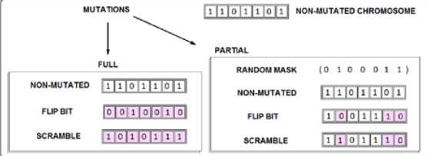
Fig. 6: Mutation between two chromosomes [8].
The genetic algorithm differs from a classical optimization algorithm based on derivations in two essential points, which are summarized in the following table:
Classical Algorithm | Genetic Algorithm
Generates a single point at each iteration, The sequence of points approaches an optimal solution. | Generates a population of points at each iteration. The best point in the population approaches an optimal solution
Selects the next point in the sequence by a deterministic computation | Selects the next population by computation which uses random number generators.
Typically converges quickly to a local solution | Typically takes many function evaluations to converge. May or may not converge to a local or global minimum.
fig. 7: The difference between genetic algorithm and classical algorithm [9].
- The Vehicle Routing Problem (VRP)
This is an optimization problem in logistics and operations research. It is about finding the best routes for a fleet of vehicles to deliver goods or services to a set of customers, taking into account constraints such as vehicle capacity, time windows and minimizing costs or distances. The goal is to optimize routes to efficiently meet customer demand and minimize operating costs. Different optimization algorithms are used to solve different variants of the VRP, resulting in improved resource utilization and cost savings in transport and logistics management.
  - Genetic Algorithms in the VRP
Genetic algorithms are a type of computer program that can help solve complex problems. One problem they can solve is the so-called vehicle routing problem, which is about finding the best way to deliver things to different places using trucks. Genetic algorithms work with ideas from nature, such as natural selection and evolution. They start with a group of possible solutions and then select the best ones to create new solutions. By doing this over and over again, they can find a really good solution to a problem. These algorithms are helpful because they can tackle large and difficult problems and find efficient solutions. However, they don't always guarantee the perfect answer, but they get close to it in a reasonable amount of time. Scientists and experts use genetic algorithms to solve these types of problems and find good solutions.
- Advantages and limits of heuristic algorithms
Heuristic algorithms are special techniques that help solve really difficult problems. They can find solutions that are pretty close to the best ones, and they do it quickly. They work by following certain rules or ideas to find a good answer, but they can't always find the best answer. They are very useful when we need to make decisions quickly, for example when looking for the best route to a particular destination. But sometimes they can also make mistakes or find answers that are not the best. It all depends on how the rules are set up. Heuristic algorithms are helpful, but we need to be careful when using them and know that they have some limitations.

Chapter 03:

Association work

Association work

The researchers' interest in the issue of delivering orders by drone in the shortest possible time is due to the potential benefits of using drones for delivery. These benefits include:

* The potential for faster delivery times: Drones can potentially deliver parcels much faster than traditional delivery methods, such as land or air freight. This is because drones can fly in a straight line and do not face traffic congestion.

* The potential for lower delivery costs: Drones can deliver parcels at a lower cost than traditional delivery methods. This is because drones do not require drivers or pilots and can be operated more efficiently.

* The potential for greater convenience: Drones can deliver parcels to places that are difficult to reach with conventional delivery methods. This can be especially beneficial for people who live in rural areas or who have difficulty reaching a store.

Below you will find some articles that deal with this topic:

Drone-as-a-Service (DaaS) for COVID-19 self-testing kits delivery in smart healthcare setups: A technological perspective
In this prospective study, a drone-based sample collection system is proposed in which COVID-19 self-test kits are delivered to and collected from potential patients. This is achieved with a drone as a service (DaaS). A mobile application is also proposed to help navigate the drone and destination to facilitate the process. Through this app, the patient could contact the hospital and provide information about their health condition and the nature of the emergency. A hypothetical case study was conducted for Geelong, Australia, and the drone path was optimized using the Artificial Bee Colony (ABC) algorithm. [3]
Bee Colony (ABC) algorithm optimized. The proposed method aims to reduce human-to-human contact, help patients at home and deliver any medication, including first aid kits, to support patients until further assistance is provided. Artificial intelligence and machine learning based
algorithms in combination with drones will enable cutting-edge technology for healthcare systems. [3]
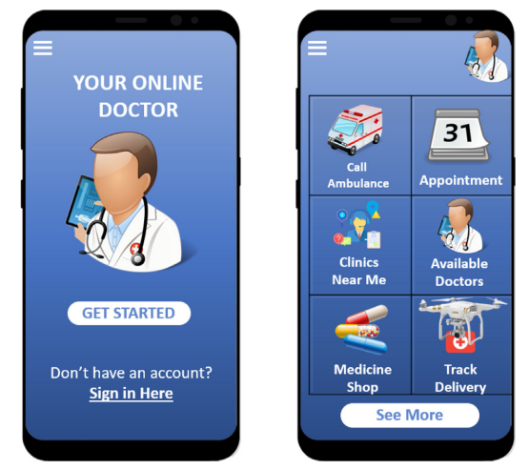
Fig. 8: Mobile interface for “your online doctor” application. [3]
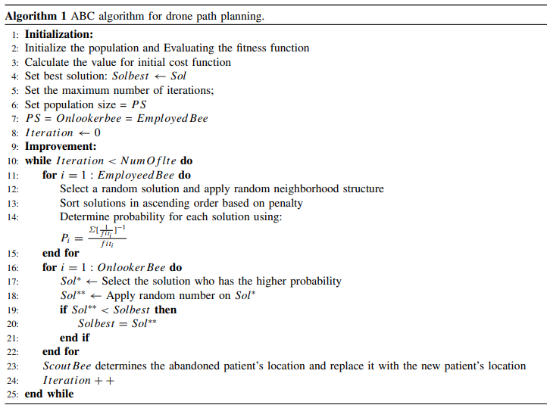
Fig. 9: ABC algorithm for drone path planning. [3]

Using drones for parcels delivery process
The authors. Published by Elsevier
In this paper, a qualitative and quantitative analysis of the advantages and disadvantages of using drones for parcel delivery is conducted. Three different transport systems with incremental use of drones for delivery are analyzed. In particular, we address the problem of parcel delivery without a drone, the so-called vehicle routing problem, the problem in which delivery is carried out by a fleet of drones from a central depot, and a hybrid transportation system in which the classic vehicles are equipped with drones. In the latter case, the classic vehicles carry out the deliveries and the drones can take over some deliveries. The drone takes off from the vehicle, carries out the delivery and lands at any location on the same vehicle. While the drone delivers, the classic vehicle continues its work. The three transport systems are formalized by mathematical programming models. The solutions obtained by solving the models with a general-purpose solver are compared, and insights into the use of drones in urban areas are provided. [10]

Package Delivery Using Autonomous Drones in Skyways
Current drone delivery systems mostly focus on point-to-point delivery of parcels. A multi-stop drone system is being introduced that can deliver parcels anywhere and at any time within a specific geographical area. It defines an airway network that takes into account flight regulations, including flight restrictions and no-fly zones. Skyway nodes typically represent building rooftops that can serve as both recharging stations and delivery destinations. A heuristic-based A* algorithm is used to calculate an optimal path from source to destination, taking into account a number of constraints, including delivery time, availability of charging stations, etc. The project deploys our drone delivery system in an indoor test environment with a 3D model of downtown Sydney. [11]
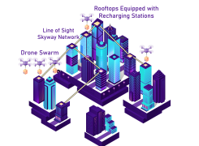
Fig. 10: Drone Delivery in a Skyway Network. [11]

wo echelon vehicle routing problem with drones in last mile delivery
- In this research, a new routing model is presented that accounts for synchronized truck-drone operations by allowing multiple drones to fly from a truck, serve one or more customers, and return to the same truck to change the battery and pick up the package. The model considers two levels of delivery: primary truck routes from the main depot to serve assigned customers, and secondary drone routes from the truck acting like a moving intermediate depot to serve other customer groups. The model considers both truck and drone capacities with the goal of finding optimal routes for both trucks and drones that minimize the total arrival time of both trucks and drones at the depot after completing deliveries. The problem can be solved by formulated mixed integer programming (MIP) for the small problem, and two efficient heuristic algorithms have been developed to solve the large problems: Drone Truck Route Construction (DTRC) and Large Neighborhood Search (LNS).

Robust Composition of Drone Delivery Services under Uncertainty
A novel robust composition system for drone delivery services is proposed that takes into account changes in wind conditions in urban areas. The proposed framework considers the dynamic arrival of drones at recharging stations. We propose a Probabilistic Forward Search (PFS) algorithm to select and compose the best drone delivery services under uncertainty. A series of experiments with a real drone dataset are conducted to illustrate the effectiveness and efficiency of the proposed approach. [12]
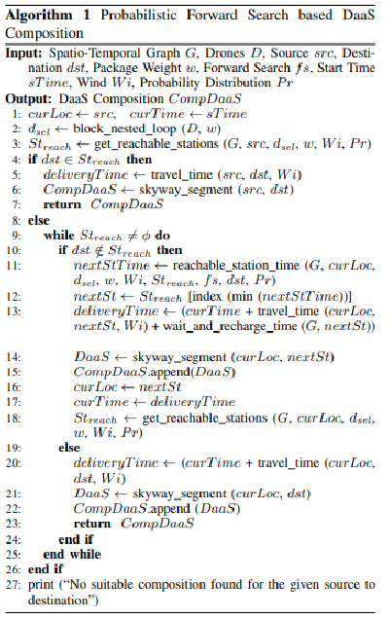
Fig. 8: Probabilistic Forward Search based DaaS Composition. [12]

- Constraint-based Formation of Drone Swarms
Drone swarms are required for the simultaneous delivery of several parcels. A drone swarm-based delivery with multiple stops in a smart city is demonstrated. Formation flying is used to save energy and increase the flight range of a drone swarm. An adaptive formation is presented in which a swarm adapts to the external conditions and changes the formation pattern during the flight. It utilizes the existing building rooftops in a city and establishes a line-of-sight airway network to safely operate the swarms. It uses a heuristic A* algorithm to route a swarm of drones in an airway network. [13]
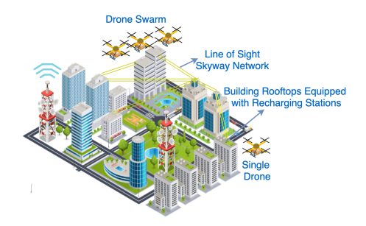
Fig. 8: A Skyway Network Infrastructure. [13]

Chapter 04:

Programming aspect

Programming aspect
In this work, we propose a framework for drone delivery services with in-flight energy recharging. The goal is to improve delivery times by reducing the number of stops and recharging times at intermediate stations. We will use simulations to model and optimize the system, including the algorithm to be implemented. Drones are becoming increasingly popular for a variety of tasks, including parcel delivery. However, one of the biggest challenges of drone delivery is the limited flight time of drones due to their battery capacity. This can be a problem for long-distance deliveries, as the drones have to stop and recharge several times along the way. Our proposed framework solves this problem by recharging the energy during the flight. This means that the drones can recharge their batteries while in flight, which can significantly reduce the number of stops and recharging times required. This can lead to faster delivery times and greater efficiency. We will use simulations to model and optimize the system. This will allow us to test different scenarios and parameters and find the best way to implement the system. We will also develop an algorithm that controls the drones and manages the recharging process.
- Python Library Imports
In this work, we have used several Python libraries to facilitate our research and analysis. One of these important libraries is "networkx", which is imported with the statement
import networkx as nx
Networkx is a powerful Python library for creating, editing and analyzing complex networks and graphs. We use this library to model and analyze various network structures, which makes it an important tool in our research.

In addition, we have integrated the library "time" to manage time-related operations, "random" to generate random numbers and "NumPy" to perform numerical calculations efficiently. With these libraries, we can perform various tasks and calculations required for our study.
We have also imported the "Permutations" function from the "itertools" module. This function is useful to create permutations of elements that can be useful in scenarios such as combinatorial optimization problems.

To summarize, the import instructions in the provided code snippet incorporate important Python libraries that are crucial for our research and allow us to perform data analysis, simulations and calculations effectively.
- Define the problem
In this task, a graph is given that represents a city with N nodes and M edges. Each edge has a weight that indicates the distance between the two nodes it connects. Also given is a list of customers, each weight indicating the amount of goods to be delivered to that customer. Finally, there is a list of drones, each with a flight time and a weight capacity.
The goal is to find a route for each drone that minimizes the total distance while satisfying the following conditions:
* Each customer must be visited exactly once.
* The total weight of goods delivered by each drone must not exceed its weight capacity.
* The total flight time of each drone must not exceed its flight time.
The VRP is a combinatorial optimization problem in which the goal is to find the shortest route for a drone delivering goods to a set of customers. The goal is to minimize the total distance traveled by the vehicles.
- Create a mathematical model
n: is the number of customers.
m: is the number of drones.
Cij: the cost of delivering goods from customer i to customer.
Xij: a binary variable that indicates whether or not customer i is visited by drone.
Wi: the weight of the goods to be delivered to customer i.
W: the weight capacity of each drone.
ti: the flight time to deliver goods to customer i.
T: the flight time capacity of each drone.
The following is a mathematical model for the drone delivery problem:

Minimize F= $\sum_{i=1}^{n}{\sum_{j ∈m}{ Cij. Xij}}$ (*)
Subject to:
$\sum_{i=1}^{n}{ Xij=1}$, i=1,….n (1)
$\sum_{i=1}^{n}{Wi. Xij<W}$, j=1…..m (2)
$\sum_{i=1}^{n}{ti. Xij<T}$ , j=1…..m (3)
$Xij∈\left(0,1\right)$, i=1,….n , j=1…..m (4)

The objective function (*) minimizes the total cost of delivering goods to all customers.
The first constraint (1) ensures that each customer is visited exactly once.
The second constraint (2) ensures that the total weight of goods delivered by each drone does not exceed its weight capacity.
The third constraint (3) ensures that the total flight time of each drone does not exceed its flight time capacity.
The fourth constraint (4) ensures that the decision variables are binary.

- Algorithm
The algorithm used to solve this problem is a genetic algorithm. A genetic algorithm is a search algorithm inspired by the process of natural selection. It works with a population of candidate solutions and then iteratively evolves them by applying genetic operators such as crossover and mutation. The algorithm is finished when a solution has been found that fulfills all conditions or when a maximum number of generations has been reached.
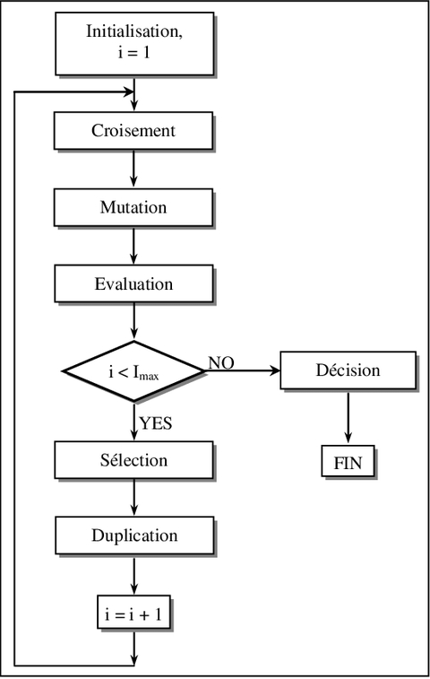
Fig. 9: Process of Genetic Algorithm.

- Implementation

Here is a Python implementation of the genetic algorithm for the drone delivery problem:

- First, create a VRP class that contains all the functions you can work with
class GeneticAlgorithmVRP:

- Function initialization

def __init__(self, graph, customers, drones, population_size, num_generations, mutation_rate):
self.graph = graph
self.customers = customers
self.drones = drones
self.population_size = population_size
self.num_generations = num_generations
self.mutation_rate = mutation_rate

- Function calculate distance
def calculate_distance(self, route):
total_distance = 0
for i in range(len(route) - 1):
distance = self.graph[route[i]][route[i+1]]['weight']
total_distance += distance
return total_distance

- Function calculates fitness

def calculate_fitness(self, chromosome):
num_requests_delivered = 0
total_time_taken = 0
total_weight = 0
current_node = start
for gene in chromosome:
# Add the following line to add the edge between 'start' and gene to the graph
self.graph.add_edge(start, gene, weight = self.customers[gene]['weight']) # Replace some_weight with the actual weight

weight = self.customers[gene]['weight']
distance = self.graph[current_node][gene]['weight']
time_taken = distance / self.drones[0]['flight_time']
if total_time_taken + time_taken <= self.drones[0]['flight_time'] and total_weight + weight <= self.drones[0]['weight_capacity']:
num_requests_delivered += 1
total_time_taken += time_taken
total_weight += weight
current_node = gene
else:
break
return num_requests_delivered, total_time_taken

- Function creates initial population

def create_initial_population(self):
population = []
nodes = list(self.graph.nodes)
nodes.remove(start) # Exclude starting node from permutation
for _ in range(self.population_size):
chromosome = [start] + list(np.random.permutation(nodes))
population.append(chromosome)
return population

- Function crossover
def crossover(self, parent1, parent2):
point1 = random.randint(1, len(parent1) - 1)
point2 = random.randint(point1, len(parent1) - 1)
child = [start] + parent1[point1:point2]
for gene in parent2[1:]:
if gene not in child:
child.append(gene)
return child

def mutate(self, chromosome):
point1 = random.randint(1, len(chromosome) - 1)
point2 = random.randint(1, len(chromosome) - 1)
chromosome[point1], chromosome[point2] = chromosome[point2], chromosome[point1]
return chromosome

- Function run genetic algorithm
def run_genetic_algorithm(self):

  - The Input
- Create the graph
graph = {}

- Adjust flight time and weight capacity of drone
drones = [
{'flight_time': 30, 'weight_capacity': 15}
]

- Adjust Settings of genetic algorithm
population_size = 100
num_generations = 200
mutation_rate = 0.2

Finally, we apply the class to the inputs to display the result
ga=GeneticAlgorithmVRP(graph,customers,drones,population_size,num_generations,mutation_rate )
ga.run_genetic_algorithm()

  - The Output
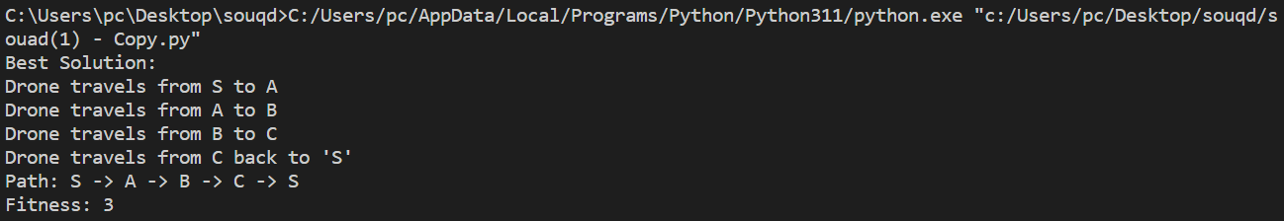

Conclusion
The project "In-Flight Energy-Driven Composition of Drones" has explored an innovative approach to improve the capabilities and sustainability of unmanned aerial vehicles (UAVs) through the use of renewable energy sources, in particular solar cells, and the implementation of genetic algorithms in Python.

Our application of genetic algorithms to optimize the composition of drones during flight has yielded promising results. These algorithms have enabled drones to autonomously adapt their configurations, resulting in longer flight duration and higher payload capacity. These improvements open up new possibilities for more efficient drone operations in a variety of industries, from agriculture to surveillance to transportation and beyond.

In summary, our project represents an important step towards a more sustainable, versatile and effective use of drones in a variety of fields. Further research and practical implementation can build on these results to drive the development of drone technology for a more sustainable and efficient future.

Bibliography
[1] | Y. Bouali, B. Mohammed, and K. Ahmed. Review of renewable energy sources. Ran-dom journal
[2] | Alkouz, Balsam, and Athman Bouguettaya. "Provider-centric allocation of drone swarm services." 2021 IEEE International Conference on Web Services (ICWS). IEEE, 2021.‏
[3] | Pugliese, Luigi Di Puglia, Francesca Guerriero, and Giusy Macrina. "Using drones for parcels delivery process." Procedia Manufacturing 42 (2020): 488-497.‏
[4] | Genetic Algorithms Prof. Kasim M. Al-Aubidy.

[5] | Guenin, B., Könemann, J., & Tuncel, L. (2014). A gentle introduction to optimization. Cambridge University Press.‏
[6] | Mallawaarachchi, Vijini. "Introduction to genetic algorithms—including example code." Towards Data Science 8.7 (2017).‏
[7] | Wang, Min. "Description and Application of Genetic Algorithm." (2012).‏
[8]  [9]  [11]  [10]  [13] | Hižak, Jurica, and Robert Logožar. "An overview of the genetic algorithm and its use for finding extrema-with implementations in MATLAB." Tehnički glasnik 10.3-4 (2016): 55-70.‏  https://www.mathworks.com/help/gads/what-is-the-genetic-algorithm.html  Munawar, Hafiz Suliman, et al. "Drone-as-a-Service (DaaS) for COVID-19 self-testing kits delivery in smart healthcare setups: a technological perspective." ICT Express 9.4 (2023): 748-753.‏Alkouz, Balsam, Athman Bouguettaya, and Abdallah Lakhdari. "Density-based pruning of drone swarm services." 2022 IEEE International Conference on Web Services (ICWS). IEEE, 2022.‏  Liu, Xijing, et al. "Constraint-based formation of drone swarms." 2022 IEEE International Conference on Pervasive Computing and Communications Workshops and other Affiliated Events (PerCom Workshops). IEEE, 2022.‏  Shahzaad, Babar, Athman Bouguettaya, and Sajib Mistry. "Robust composition of drone delivery services under uncertainty." 2021 IEEE International Conférence on Web Services (ICWS). IEEE, 2021.‏

